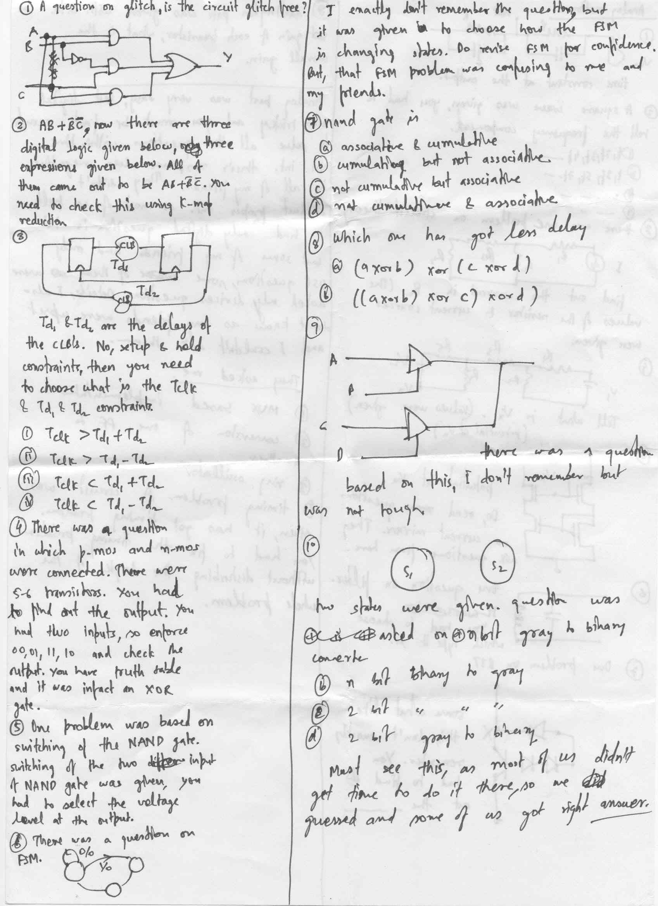

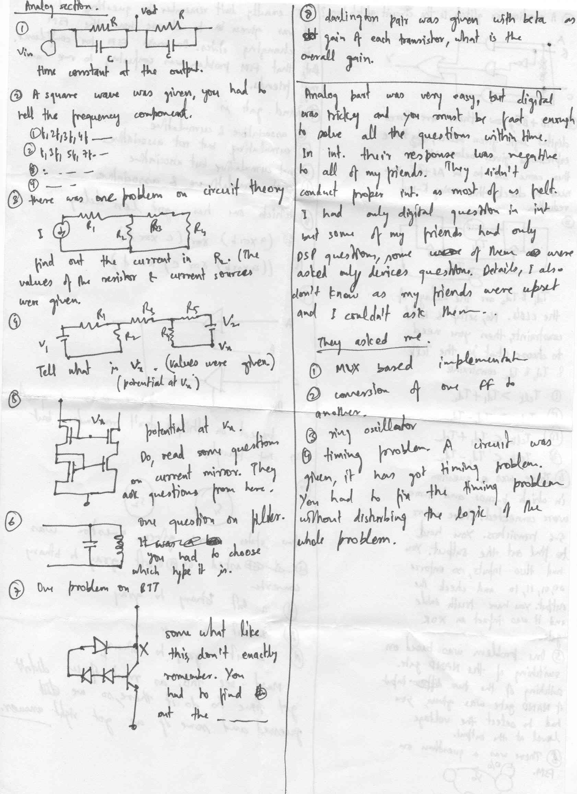
TI paper2004 (EE section only)
These questions are not in the order as in the paper. All were multiple choice types with negative marking. DSP section did not have analog and 5 questions on DSP. Rest all was same.
1) If the probability of 0 being received as 1 is p₁ and that of 1 being received as 0 is p₂. What is the prob of receiving at least one 1 if two consecutive zeroes are sent?
1-p₁²
2) For symbols a, r, and p having a prob of occurrence as 0.4, 0.2, and 0.2 and t being another symbol, what is the length of code for ‘a’ in huffman binary coding?
1
3) For probability of 0.25,0.25,0.5, find the entropy.
3/2
4) How many multiplications will be required for multiplying two p×p upper triangular matrices.
sigma p³ (I am not sure of the answer)
5) How many cycles are required for a N,M convolution given that each addition, mult and mac requires one cycle?
I ticked (N-M+1)M/2 (not sure of the answer)
6) For 62db of SNR, what it the channel capacity? (think they meant per unit BW)
use C=B log₂(1+SNR)
7) One question on odd-parity detector. (‘what is this’ type)
8) One question on bistable multivibrator using 741. (again ‘what it this’ type)
9) The above is a 4 bit shift reg. The feedback path has an XOR gate. Tell the value of the reg after two shift right.
10) A simple C program. What will be the output of i&j where i=10, j=20.
0
11) For Vcc =20 V and beta =100 find Ie for V_{be}= 0.6 V. Take Ic = Ie.
9.6 mA
12) The propagation delay of each AND gate is 10 ns. What could be the max clock frequency.
10⁸ Hz
13) The current across 20 ohm res is
0.5
14) Block diagram (find the Transfer Function):
15) Find I for t=0 when the switch S is closed. Also dI/dt.
0A, 5A/s
16) There was a question about the causality and non-linearity of a system given its difference equation.

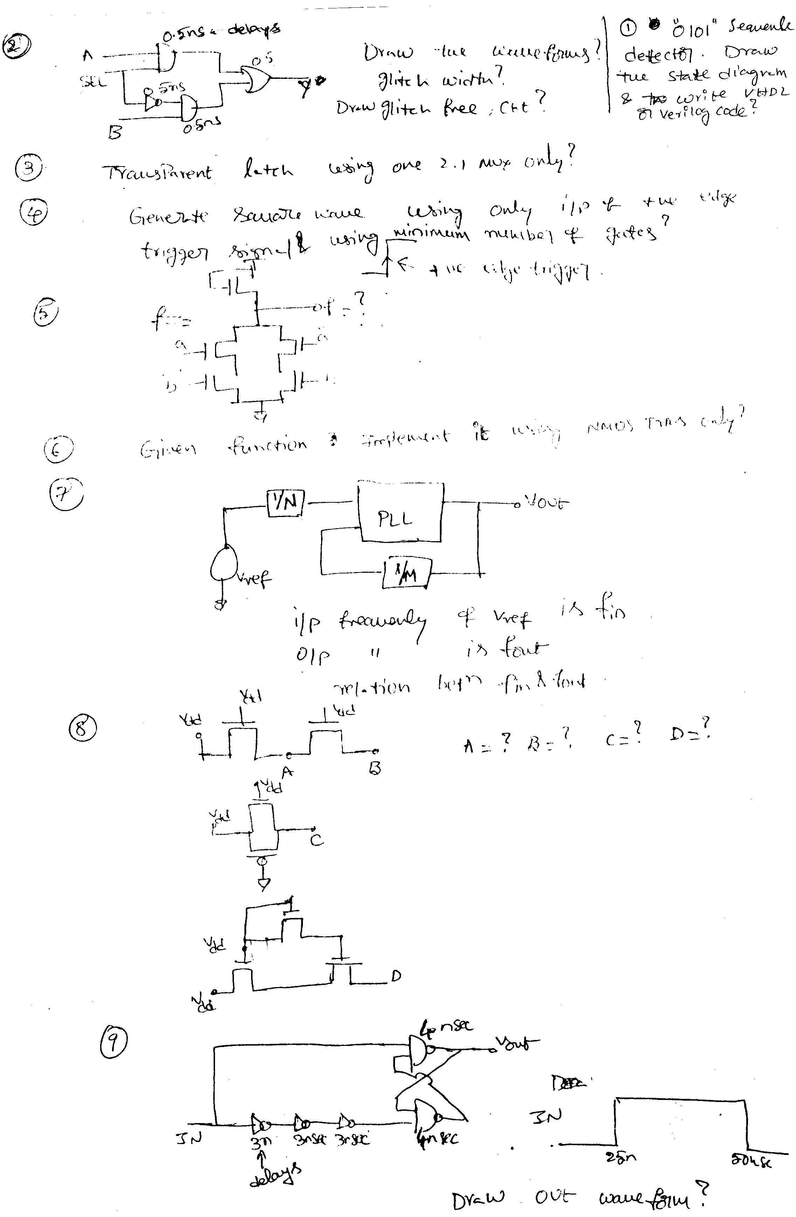
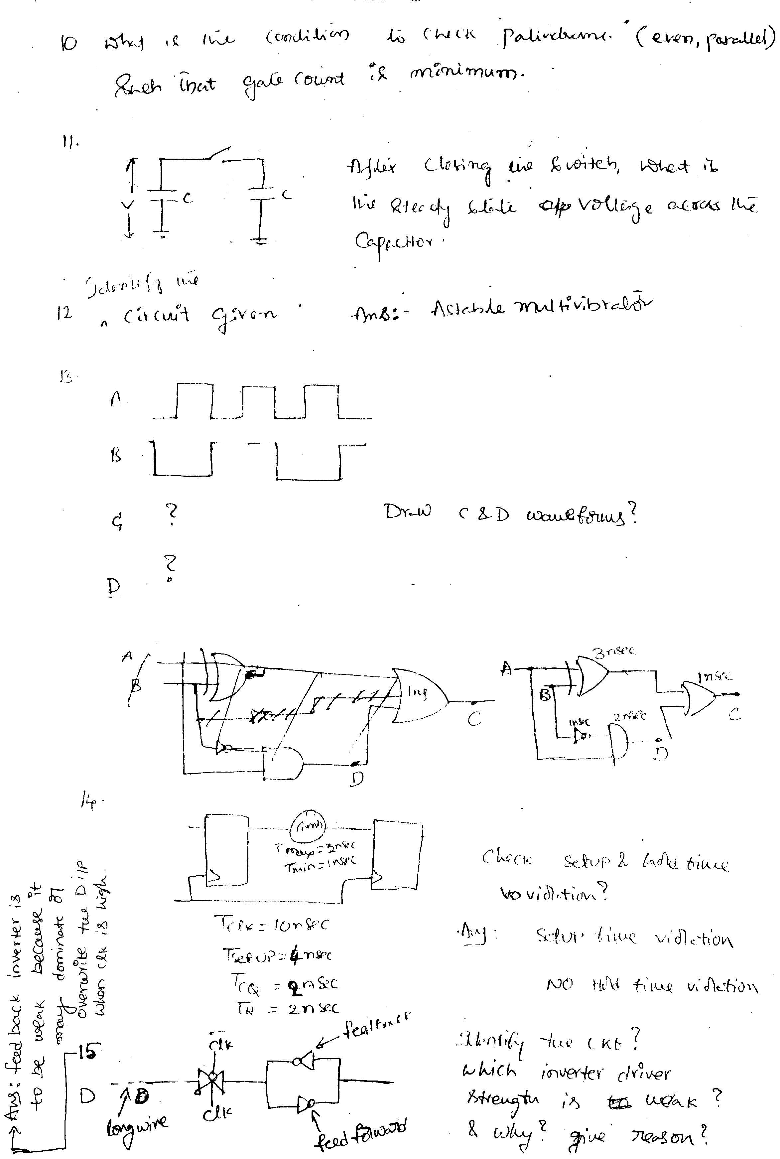
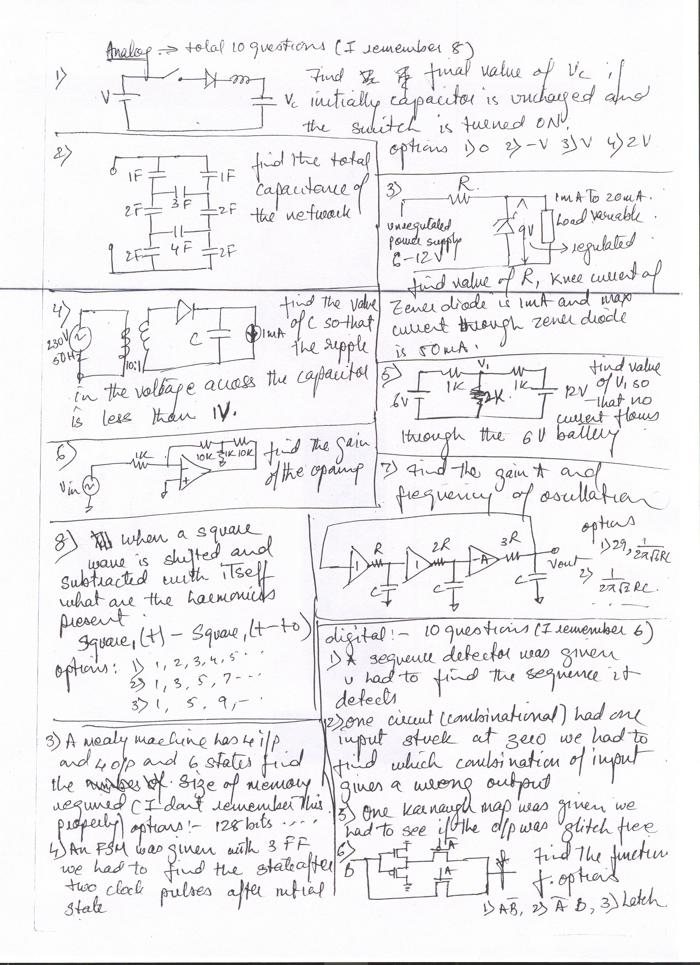

75 qs in 60 min.....
-- 2 reading comprehesion.. 5 qs each...
-- quanta....5 qs.
-- data sufficiency..5 qs.
Q..u have weights only in power of 3... based on
it answer 5
qs. like for given weight what are the combination of
available
weight..
-- data interpretation 2 qs..5 qs each
Q..one qs witin a circle population % is given
based on it 5
qs.(PI chart)
-- analitical
Q.. one tour is shedhuled for 9 countries..each
country have 2
days shedhule....tour held on for 12 days..
some cond'n are given..like if u visit ROME u
have to visit
australia .....
based on it 5 qs...like which 3 countries
missed...
Q..4 metals are given..each year % price of these
metals are
increasing..some more cond'n.....based on it 4 qs..
answer of one qs is 13.6%
Q.. {x}=greater real of x
[x]=least real of x
x mod y = some expression is given
based on it 5 qs...like calculate 5 mod 3....

Here is Texas paper for you.
in this paper there was 20 questions as follows in 60 minutes .
second part consists of 36 que. in 30 minutes all questions are
diagramatical.(figurs)..

1. if a 5-stage pipe-line is flushed and then we have to execute 5 and
12
instructions respectively then no. of cycles will be
a. 5 and 12
b. 6 and 13
c. 9 and 16
d.none

2. k-map

ab
----------
c 1 x 0 0
1 x 0 x

solve it

a. A.B
B. ~A
C. ~B
D. A+B

3.CHAR A[10][15] AND INT B[10][15] IS DEFINED
WHAT'S THE ADDRESS OF A[3][4] AND B[3][4]
IF ADDRESS OD A IS OX1000 AND B IS 0X2000

A. 0X1030 AND 0X20C3
B. OX1031 AND OX20C4
AND SOME OTHERS..

4. int f(int *a)
{
int b=5;
a=&b;
}

main()
{
int i;
printf("\n %d",i);
f(&i);
printf("\n %d",i);
}

what's the output .

1.10,5
2,10,10
c.5,5
d. none

5. main()
{
int i;
fork();
fork();
fork();
printf("----");
}

how many times the printf will be executed .
a.3
b. 6
c.5
d. 8

6.
void f(int i)
{
int j;
for (j=0;j<16;j++)
{
if (i & (0x8000>>j))
printf("1");
else
printf("0");
}
}
what's the purpose of the program

a. its output is hex representation of i
b. bcd
c. binary
d. decimal

7.#define f(a,b) a+b
#define g(a,b) a*b

main()
{

int m;
m=2*f(3,g(4,5));
printf("\n m is %d",m);
}

what's the value of m
a.70
b.50
c.26
d. 69

8.
main()
{
char a[10];
strcpy(a,"\0");
if (a==NULL)
printf("\a is null");
else
printf("\n a is not null");}

what happens with it .
a. compile time error.
b. run-time error.
c. a is null
d. a is not null.

9. char a[5]="hello"

a. in array we can't do the operation .
b. size of a is too large
c. size of a is too small
d. nothing wrong with it .

10. local variables can be store by compiler
a. in register or heap
b. in register or stack
c .in stack or heap .
d. global memory.

11. average and worst time complexity in a sorted binary tree is

12. a tree is given and ask to find its meaning (parse-tree)
(expression tree)
ans. ((a+b)-(c*d)) ( not confirmed)
13. convert 40.xxxx into binary .

14. global variable conflicts due to multiple file occurance
is resolved during
a. compile-time
b. run-time
c. link-time
d. load-time

15.
two program is given of factorial.
one with recursion and one without recursion .
question was which program won't run for very big no. input because
of stack overfow .
a. i only (ans.)
b. ii only
c. i& ii both .
c. none

16.
struct a
{
int a;
char b;
int c;
}

union b
{
char a;
int b;
int c;
};
which is correct .
a. size of a is always diff. form size of b.(ans.)
b. size of a is always same form size of b.
c. we can't say anything because of not-homogeneous (not in ordered)
d. size of a can be same if ...

bye..
p.sreenivasa rao

______________________________________________________

--- In teluguiitians@y..., hari prasad <b_hariprasad@y...> wrote:
1.two transistors are connected Vbe is 0.7volts
.thisis simple ckt.one
>transistor is diode equivalent. & asked the o/pacross
the 2 nd transistor.
>2.simple k map ans is Bbar.>3.>>
Emitter
>---R-------transistorbase| -->
| ---
> collector
> in above capacitor is connected
parallelwith resistance
>r.capacitor is not shown> infig.capacitor
is used for in this ckt:
>>> ans:a.speedupb.active bypass
c.decoupling> 4.>
> -----R------I----------o/p> |___R____ |
> in above r
isresistence.I is cmos inverter.
> then ckt is used for:>>
> a.schmitt triggerb.latch
c.inverter
>d.amplifier>>> 5.simple amplifier ckt openloop
gain of
amplifier is 4.V in >=1v.asked for V x?
> amplifdier + is connected to base. -
isconnected to i/p in between
>5k is connected.> from o/p feedback connected to
- of amplifier
with 15k.this is ckt.>>> 6.resistence inductot
cap are serially
connected to ac voltage 5 >volts.voltage across>
inductor is given.R I C
values are given & asked for> voltages across
resistence & capacitor.>
7.> ___ R_____> |
|
> ---R------OPAMP ----------> |---
> R1 R1 is for wjhat i mean what
isthe purpose of R1.
> |>> ground>>
> 8.asked for Vo at the o/p.it is like simple
cmosrealization that is n
>block is above> & p block is below.Vdd is 3 volts
at supply.V
threshold 5 volts.> 9.2 d ffs are connected in
asyncro manner .clock
10 MEGAHZ.gate delay >is 1 nanosec.> A B are the
two given D FFs.asked
for AB output is:>>> a.updown
> b.up c. updown glitching like that (take careabt
glitching word)>
> 10.>>>
----------------|subtractor|---------o/p>
|___HPF____|
>> the ckt is LPF ,HPF or APF ?>
> 11.in a queue at the no of elements removed
isproportional to no of
>elements in> the queue.then no of elements in
thequeue:
> a.increases decreases exp or linearly(so these
arethe 4 options given
>choose 1 option)> 12.with 2 i/p AND gates u have to
form a 8 i/p AND
gate.which is the >fastest in the> following
implementations.
> ans we think ((AB)(CD))((EF)(GH))
> 13.with howmany 2:1 MUX u can for 8:1
MUX.answeris 7.
> 14. there are n states then ffs used are log n.
> 15.cube each side has r units resistence then
theresistence across
>diagonal of cube.> 16.op amp connections asked
foro/p
> the answer is (1+1/n)(v2-v1).check it
out.practisethis type of model.
> 17.> _____________ supply> ---|__
___|
> Ii >________ |___ Tranistot>
> _______Vo
> |> |
> R |>
| | Io
> ground.>>>>
> asked for Io/Ii=? transistor gain is beta.>>
> a.(1+beta)square b.1+beta c. beta>>
> 18.y=kxsquare. this is transfer function of
ablock with i/p x & o/p
>y.if i/p is> sum of a & b then o/p is :-->>
a.AM b.FM c. PM> 19.
> ------MULTIPLIER--- |>
| |
> _____R__|__OPAMP______________________Vo>
---
> |> ground.
> v in = -Ez then o/p Vo =?
> answer is squareroot of-Ez.multiplier
i/ps are a & b then
>its o/p> is a.b;>>>

__________________________________________________

paper of TI 1999
Hard ware part only. There was one part of reasoning and there was separate paper for software persons.

1. o Vcc
_________|
| |
| |
Res | C
|_______Tr NPN
| B |
|+ | E
D |
| |
| |
|________|
_|_
_ _
-

Find the current I delivered by the battery.

2. |----Res---|
| |
in----Res----+--Inv-----+--- out
CMOS
What is the given circuit
a) Latch b)Amplifier c)Schmitt trigger. d)

3. The total no of flip flop required for N stage sequential circuit
N N-1 N
a)2 b)2 c) Log N d) 2 -1

4. o Vdd
|
--------+
| |
B |C |
o------- Tr NPN |
|E |-------------o
| |
| B |C
+------ Tr NPN
|E
|
o---------------+-------------o
the gain of the circuit is
a) beta square b)beta + 1 c) (beta+1) ka square d)

5. If the o/p and i/p are related by y=k(x square) and i/p is a sum of 2 waveforms
then the modulation scheme is
a) FM b)AM c)PM and d)None
Ans. B

6.Function of C in the circuit below is
a) Improve switching b)dc coupling c) ac coupling d) None
o
C |
+------||--+ |
| | |C
o------+----Res---+------Tr NPN
|E
|
_|_
__
_
7. ----R----o---+
+ | |
V(L)L |
- | |
| O 100 Hz, 5V
| |
C |
| |
+--------o---+
if the ckt is at resonance and V(L)= (constant) V (given)
the value of V(R) and V(C) is
a)100V,5V b)-100V,5V c)5V,5V
(Use V(L)=5 /_100 and V(C)=5/_-100, V(R)=5V

8. Minimize the K-map
A'B' A'B AB AB'
\_________________
c'| 1 X 0 1 |
|----------------|
c| 1 X 0 1 |
|----------------|
a) A'B' b) A'+B' c)B' d)A'+B'+C'

9. IF the rate of removal of elements in a queue containing N elements is
proportional to the no of elements already existing in the queue at that
instant then the no. of elements----
a)decrease linearly b)Exponetialy decrease b) Logarithmcally

10. One question on CMOS ckt.
11. Two question on OP-AMP.

Hi friends

here is the full paper of TI India IITB 20/07/2001.

the paper had 4 sections in which we have to attend
2 sections
i attempted digtal and analog

and in apti, there was 75 Qs in 60min. be prepare for
it also, apti was very tough.

Regards
Vijay Mathur

DIGITAL
------

1. nand gate is
a) associative &cumulative b)cumulative but not
associative
c)not cumulative but associative d)not cumultive
and associative

Ans. b

2. which imp has les delay
a) (a xor b) xor (c xor d)
b) (((a xor b) xor c) xor d)
(think on the situation when input a, b, c, d are
comes in ascending (i.e. a frist then b then c and
then d) and desending (opposite order)

3) one inverter cmos circuit was given with a
variable as enable
signal
ans. tristate inverter with b as enable

4)a logic cell which dertermines(op =1) for odd no..
of 1s in the
given seq is
ans. one xor gate

5)circuit
--------
| ttl q
logic |---+diode-
-------inverter----res----+led- --gnd
----------

led should glow when q=0 and off when q=1
the choices are
a.ckt will funct as given
b.it wont funct as given
c.q cant drive ttl inverter
d.non of these

6)n nets are givenin how many ways can wemodel each
of the stuck at
fault in n nets in single(one at a time) and w....
ans.n and 2 pow n
7) circiut with 2 d ffs was given

dff1 op(complement)
as d1 ip (q1 bar) | |op of dff2(com)
given as dff2ip

clk
| DFF1
|q1--------------> DFF2---q2 b
CLK -------->

XOR
DFF2 o\p (q2)

whaT is the relation between b and
clk?

8)3 dffs was given with common clk
setup time 3ns
hold time 1ns
clk to q delay 2ns find the maximum frequency of
operation

9)fsm question
thre states given ques what is the
machne called

s1---------------
if 0 same state 1 goes to s3

s2<-------------s3 if 1 same
state s3
0
if 1 same state s2

10. consider a adder and multiplier
question ios some what like can both implemented in
same fsm or cant

these are the 10 ques asked in digitl section and
we are in a
situation to attend 2 section i attented analog part
and i am giving the ruogh idea of analog section

***********
Analog part 10questions

1. input is sine wave
what is the op in the middle of serially connected 2
rc parallel ckts

-------------
r c
sine wave ------------op
r c
-------------

a. cos wave
b.sine wave with 0 phase shift
etc

2.square wave as input given to the ckt

-------res------
L and C
IN PAR

----------------
What is the op in the cap

3.in 5v wave --------
+5v |
--- C
---
|vo=5V (intially)
|
--- C
- ---
|
GND------

to the circuit in which two cap are
connected in series
what is the op at the vo at time T
intially it was at 5v
4.darlinton pair was given
with beta as ct gain of each trans
what is the overall gain
hi all

_______r_____
| |
5. GND----r---- -
opamp ----v0
vin----r---- + |
| |
I -----r--------
|
gnd
what isI? ans Vin/R
6. -----10K------R-----10K-----
| | 20V
10V 10K 10K
------------| |------------
WHAT IS THE I IN R? ans. I=0Amp

7. IF THE INPUT SGL IS 95khz and it is sampled
at 120samples
per sec the at what freq wil the fft opt
fundemental freq will come
totally there were 10 questions in
analog ssection also
the numbering is not right

8. 6C 4C 4C
---||------||-------||---- Vo
| | | |
+ | | |
Supply 6V -- -- -- 4C
DC - -- 2C -- 2C --
| | | |
| | | |
----------------------------GND

find out Vo=? (caps vaule may be changed).

9. Vo
-----R-----|------Switch-----
| | |
+| | |+
5V DC ---C 2V DC
-| --- |
| | |
----------------------------------GND
Switch is open at t=0, what is the value of Vo at
t=infinity. Ans. 5V

10. one Qs on current mirror. there are n current
mirrors are connected in series, you have to find out
the condition for whitch current mirrors will be in
linear region.
(a)Vt
(b)Vt+ deta V
(c)n*Vt+ (n-1)* delta V
(d)n(Vt+delta V)

M.N.R.E.C TI PAPER (2000)

about all interviews in brief they are asking about n/w's so prepare well.

20 tech q's (1 hr)
tech:
multiple choice , q's are not in order

1)Reentrant os required
a)multitasking
b)multiuser
c)both
d)none
ans: c (check)

2)identify a DFA for all strings which ended with string '00'
4 dfa's have given , u can simply identify
3)dfa has given we have to find the string accepted by that.

4)in a memory hierarchy, M1,M2
M1 access time is 2 ns ,M2 accesstime is 100 ns . the hit ratio for
M1 is .97, then what's the avg access time
ans: 500 ns

5) Interrupts main use is for elimination of
a) spooling
b)polling
c)job scheduling
d)....

6)A coprocessor for floating point operations has given. after that the execution of the
floating point ops has incresed by 20 times. if 20% floating pt ops are there then
what's the sped up?

7) two heaps of sizes m,n are given,
then the time needed to merge them
a)m
b)n
c)m+n
d) none
8)context switching is useful in
a) spooling
b) polling
c)interrupt handling
d) interrupt servicing

9) if 2^n leaves are given in a tree then no.of internal nodes
a)2^n
b) 2^n -1
c);......

10) semaphores used for
a)to prevent deadlocks
b) to sycronize critical activities
c)....

remaining q's i have forgot, but some q's are about c (easy)

u can do 18 q's in this section ( i.e this sec is that much easy)

anal:
it's some what difficult.
in this sec they has given big passeges, analytical reasoning,some apti bits
i have forgot many of the q's
so i am giving here few q's
but it's very easy to shortlist in this TI, if u done this sec well.

1) derivative of e^sinx
2)x=2yt y=2t^2
dy/dx? (figures may not correct)

x mod y=x-y[x/y]
=x-y{x/y} some conditions are given
[x/y] means floor operation.
{x/y} ceal op.

based on this 4 or 5 q's are given u can do the all the q's except
one q.
that's why iam giving only one q from this

3)xmod 3=2, xmod5=10 then xmod15=?

i can't give the remaining q's those are very lengthy i have forgot those.

about TI interview:

Ti is asking v.....very basic fundaasssss
for me they have asked only in c, but some other persi\ons they asked in ds,os,ip etc.

in c they have asked
if u have given a 32 bit no. u have to set m th bit without using any arithmetic ops
and u must have to write in a single expr. (hint: use &,<< ops)
they asked the same for reset.

they have asked to print 2^0 to 2^16 with out using any arith. ops. (same as above)
if u have given two seperate c files u have toexecute these two in one by linking how
u can achieve this (hint: make utility)

about ds:
they have asked how u can print levelwise in a tree ( hint: bfs)

DIGITAL

1. nand gate is
a) associative &cumulative b)cumulative but not associative
c)not cumulative but associative d)not cumultive and associative

2. which imp has les delay
a)(a xor b) xor (c xor d)
b) (((a xor b) xor c) xor d)

3) one inverter cmos circuit was given with a variable as enable
signal
ans. tristate inverter with b as enable

4)a logic cell which dertermines(op =1) for odd no.. of 1s in the
given seq is
ans. one xor gate

5)circuit
--------
| ttl q
logic |---+diode- -------inverter----res----+led- --gnd
----------

led should glow when q=0 and off when q=1
the choices are
a.ckt will funct as given
b.it wont funct as given
c.q cant drive ttl inverter
d.non of these

6)n nets are givenin how many ways can wemodel each of the stuck at
fault in n nets in single(one at a time) and w....
ans.n and 2 pow n
7) circiut with 2 d ffs was given

dff1 op(complement)
as d1 ip (q1 bar) | |op of dff2(com)
given as dff2ip
clk
| DFF1 |q1--------------> DFF2---q2 b
CLK -------->
XOR
DFF2 o\p (q2)

whaT is the relation between b and clk?

8)3 dffs was given with common clk
setup time 3ns
hold time 1ns
clk to q delay 2ns find the maximum frequency of operation

9)fsm question
thre states given ques what is the machne called

s1---------------
if 0 same state 1 goes to s3

s2<-------------s3 if 1 same state s3
0
if 1 same state s2

10. consider a adder and multiplier
question ios some what like can both implemented in same fsm or cant

these are the 10 ques asked in digitl section and we are in a
situation to attend 2 section i attented analog part
and i am giving the ruogh idea of analog section

analog part 10questions

1. input is sine wave
what is the op in the middle of serially connected 2 rc parallel ckts

-------------
r c
sine wave ------------op
r c
-------------

a. cos wave
b.sine wave with 0 phase shift
etc

2.square wave as input given to the ckt

-------res------
L and C
IN PAR

----------------
What is the op in the cap
3.in 5v wave --------
5v
--------

to the circuit in which two cap are connected in series
what is the op at the middle of two cap at time T
intially it was at 5v
4.darlinton pair was given
with beta as ct gain of each trans
what is the overall gain

5. GND----r---- -
opamp ----v0
vin----r---- + |
| |
I -----r--------
|
gnd
what isI?
6. -----10K------R-----10K-----
| | 20V
10V 10K 10K
------------| |------------
WHAT IS THE CT IN R?

7. IF THE INPUT SGL IS 95khz and it is sampled at 120samples
per sec the at what freq wil the fft opt fundemental freq will come
totally

8. simple RC series circuit transient. this is very simple.
9. capacitor ladder. input 12v given in one side asked to caliculate
output at out side. very simple question. ANS. 0.75
10. current mirror question. some what hard.
ANS. M delta-v + (M-1)Vth

paper of TI 1999
Hard ware part only. There was one part of reasoning and there was separate paper for software persons.

1. o Vcc
_________|
| |
| |
Res | C
|_______Tr NPN
| B |
|+ | E
D |
| |
| |
|________|
_|_
_ _
-

Find the current I delivered by the battery.

2. |----Res---|
| |
in----Res----+--Inv-----+--- out
CMOS
What is the given circuit
a) Latch b)Amplifier c)Schmitt trigger. d)

3. The total no of flip flop required for N stage sequential circuit
N N-1 N
a)2 b)2 c) Log N d) 2 -1

4. o Vdd
|
--------+
| |
B |C |
o------- Tr NPN |
|E |-------------o
| |
| B |C
+------ Tr NPN
|E
|
o---------------+-------------o
the gain of the circuit is
a) beta square b)beta + 1 c) (beta+1) ka square d)

5. If the o/p and i/p are related by y=k(x square) and i/p is a sum of 2 waveforms
then the modulation scheme is
a) FM b)AM c)PM and d)None
Ans. B

6.Function of C in the circuit below is
a) Improve switching b)dc coupling c) ac coupling d) None
o
C |
+------||--+ |
| | |C
o------+----Res---+------Tr NPN
|E
|
_|_
__
_
7. ----R----o---+
+ | |
V(L)L |
- | |
| O 100 Hz, 5V
| |
C |
| |
+--------o---+
if the ckt is at resonance and V(L)= (constant) V (given)
the value of V(R) and V(C) is
a)100V,5V b)-100V,5V c)5V,5V
(Use V(L)=5 /_100 and V(C)=5/_-100, V(R)=5V

8. Minimize the K-map
A'B' A'B AB AB'
\_________________
c'| 1 X 0 1 |
|----------------|
c| 1 X 0 1 |
|----------------|
a) A'B' b) A'+B' c)B' d)A'+B'+C'

9. IF the rate of removal of elements in a queue containing N elements is
proportional to the no of elements already existing in the queue at that
instant then the no. of elements----
a)decrease linearly b)Exponetialy decrease b) Logarithmcally

10. One question on CMOS ckt.
11. Two question on OP-AMP.

for TI aptitude test consist of all pictorial questions. ie in
each question he will give 8 diagrams and ask to find the
9'th diagram in that sequence.
You go through RS Agarwal. These aptitude questins are
very easy. Just pratice them. In RS Agarwal gothrough
SERIES chapter. It is suffient. There are 35 aptitude
questions. First 25 are very easy. Do these questions
in just 15 or 20 minutes. Because last questions are
very touch.

TECHNICAL TEST:
-------------------------

1)3 flipflops are connected so that after 0 to 5 count occured
next number is zero. So what is the counter?
Ans: mod 6 counter

2)simplication of some boolean expression which is simple.
Boolean Expression is A+A'B.
Ans:A+B

3)Given inorder sequence and preorder sequence and asked to
find out postorder sequence.

4)Some question on value of a static variable.

5) Given an interger in binary form,find the number of ones in
that number without counting each bit.(This questin is not
multiple choice question. This question carries more
marks. So please take care for this question.)

6) 1-way set associative memory is called-----
a)direct b)something c)1-way set associative 4)something
Ans: c

7)Fastest IPC mechanism is

a)shared memory b)pipes c)named pipes d)semaphores
Ans:c

8)Some page references are given. You are asked to implement
it with Least Frequently Used algorithm.

9)Some diagram is given.
Iam describinmg the diagram. A 2*1 MUX is given. The inputs
are A,B. Output is C. C and A are tied together. What is
the diagram.?

Ans:Latch.

**************************************************************

This paper is for Electrical & Electronics students. There is
separate test for computer Science Students. There are 20
questions.

1)Some circuit is given. Iam describing the circuit.
A resistor R & a capacitor C are connected in parallel.
To this circuit another circuit which is having a capacitor
of capacity 2C & an impedence Z, is connected in series.
You are asked to find out the value of Z? Note that 2C & Z
are connected in series.
a)Z=2C
b)Z=2L
c)Z=L/2
d)Z=2R

2)Some circuit which consist of only resistors R is given.
This is a repetative circuit. U have to find the effctive
resistance of the entire circuit.
A)Rin=R
B)Rin=(5+sqrt(3))/7
C)Rin=(19+sqrt(3))/8
D)None.

3)Two wave forms are given. You are asked to write the cirsuit
to get B(second wave form) from A(first wave form).

4)#define SUM(a,b) a+b

main()
{
a=2;
b=3;
x=SUM(a,b)*2;
printf("x=%d\n",x);
}
Ans:8.

5)number(int i)
{
number++;
printf("%d\n",number);
}

main()
{
static int i=0;
number(i);
}
Ans: I don't know.

6)Some circuit is given. I can't describe the circuit. There are
3 resistors,3 capacitors & one inverter.. The question is
What is the value of the frequency such that the circuit oscillates.
A)f=RC
B)f=sqrt(3)/(Pi*R*C)
C)f=1/(Pi*R*C)
D)something
Ans:I don't know the answer.

7)Question on flipflop. So gothrough all flipflops.

8)There are 5 questions on Nmos & Pmos circuits.

**************************************************************
This Paper is for Computer Science Students. THis paper is
very easy. You can definitely do it in one hour.
**************************************************************

(1) The fastest memory is
(i) DRAM, (ii) ROM, (iii) SRAM, (iv) Main memory
Ans : SRAM

(2) Programing exceptions are
(i) Asynchronous, (ii) Synchronous, (iii) None
Ans : Asynchronous

(3) DSP which architecture is used
(i) MIMD, (ii) SIMD, (iii) Nueman, (iv) Harvard Architecture
Ans : Harvard Architecture

(4) C prog. for searching for an element in linked list

(5) main()
{
unsigned char i;
int sum;

for(i=0; i<300; i++)
sum+ = i;
printf("\nSum = %d\n", sum);
}

Ans : infinite loop

(6) void fn(int *p)
{
static int val = 100;
p = &val;
}

main()
{
int i=10;
printf("i=%d\n", i);
fn(&i);
printf("i=%d\n", i);
}

Ans : i=10 i=10

(7) int a[10[15];
char b[10[15];
(a) location g a[3][4], if base location g a[0][0] is ox1000
(b) location g b[3][4], if base location g b[0][0] is ox2000
int taken 32 bits and char taken 8 bits.

Ans : (a) ox10C4 (b) ox2031

(8) Implement OR gate function with 2*1 MUX

Ans : A ___________
--------|2*1 MUX |
B | |--------o/p
--------| |
| |---------|
| _________|C

Ans: B=C

(9) Implement 4*1 MUX with 2*1 MUXES

(10) Swapping without using a temporary variables. (2 methods)

(i) x = x+y;
y = x-y;
x = x-y;

(ii) x = x^y;
y = x^y;
x = x^y;

(11) Count no of 1's in a word without using bit by bit.
(This question carries more marks. It is not a multiple choice
question.)

(12) Code 1 :
for(i=0; i<1000; i++)
for(j=0; j<100; j++)
x = y;

Code 2 :
for(i=0; i<100; i++)
for(j=0; j<1000; j++)
x = y;

Which code will execute faster
(i) Code 1 and Code 2 are of same speed,
(ii) Code 1,
(iii) Code 2,
(iv) None.

Ans : Code 2

(13) main()
{
int a[10] = {1, 2, 3, ...., 10}, i, x=10, temp;

for(i=0; i<x; i++){
temp = a[i];
a[i] = a[x-i-1];
a[x-i-1] = temp;
}
(i) All contents of array a are reversed
(ii) Only some portions are altered
(iii) Remains same
(iv) None

Ans : (iii)

(14) An array is stored in row major order. The memory capacity is
30 MB. And in unix system demand paging is used. Which one will
give more page faults?

#define V_L_I 10000
int i, j, array[V_L_I][V_L_I];

Code 1 :
array[i][j] = 1;

Code 1 :
for(j=0; j<V_L_I; j++)
for(i=0; i<V_L_I; i++)
array[i][j] = 1;

Ans : Code 2

(15) In C which parameter passing technique is used?
(i) call by value,
(ii) call by reference,
(iii) both

Ans : call by value

(16) A circuit is given with 2 exclusive OR gates whose boolean
expression will be y = '(AB) + AB
(' indicates bar)

(17) main()
{
int i = 1;
fork();
fork();
printf("\ni = %d\n", i+1);
}

Ans : 4 printfs will occur and i = 2

(18) Compute the complexity of Binary search.
Ans : O(lg n) ( Answer in detail. This is not a multiple choice question.
It carries more marks.)

(19) Write expression for the tree graph :
Ans : ((a-b) + c*d)/x

(20) # define MAX(a, b) a>b ? a:b
main()
{
int m, n;
m = 3 + MAX(2, 3);
n = 2 * MAX(3, 2);
printf("m = %d, n = %d\n", m, n)
}

Ans : m=2, n=3

>
> THIS IS TI 1999 jadavpur for ECE students.for cs another paper is
>given
>
>1.two transistors are connected Vbe is 0.7volts .this is simple ckt.one
>transistor is diode equivalent. & asked the o/p across the 2 nd transistor.
ans: 6.28v
>2.simple k map ans is Bbar.
>3.
>
> Emitter
>---R-------transistorbase| --
> | ---
> collector
> in above capacitor is connected parallel with resistance
>r.capacitor is not shown
> in fig.capacitor is used for in this ckt:
>
>
> ans:a.speedupb.active bypass c.decoupling
ans: speed up
> 4.
>
> -----R------I----------o/p
> |___R____ |
> in above r is resistence.I is cmos inverter.
> then ckt is used for:
>
>
> a.schmitt trigger b.latch c.inverter
>d.amplifier
>
>ans amplifier

> 5.simple amplifier ckt openloop gain of amplifier is 4.V in
>=1v.asked for V x?
> amplifdier + is connected to base. - is connected to i/p in between
>5k is connected.
> from o/p feedback connected to - of amplifier with 15k.this is ckt.
>
>ans -1.5v
> 6.resistence inductot cap are serially connected to ac voltage 5
>volts.voltage across
> inductor is given.R I C values are given & asked for
> voltages across resistence & capacitor.
> ans:-100,5
7.
> ___ R_____
> | |
> ---R------OPAMP ----------
> |---
> R1 R1 is for wjhat i mean what is the purpose of R1.
> |
>
> ground
>
>ans: reduce offset voltage
> 8.asked for Vo at the o/p.it is like simple cmos realization that is n
>block is above
> & p block is below.Vdd is 3 volts at supply.V threshold1.5 volts.
> ans; 3v
9.2 d ffs are connected in asyncro manner .clock 10 MEGAHZ.gate delay
>is 1 nanosec.
> A B are the two given D FFs.asked for AB output is:
>
>
> a.updown
> b.up c. updown glitching like that (take care abt glitching word)
>ans: up counter with (check glithes)
> 10.
>
>
> ----------------| subtractor|---------o/p
> |___HPF____|
>
> the ckt is LPF ,HPF or APF ?
>ans lowpass
> 11.in a queue at the no of elements removed is proportional to no of
>elements in
> the queue.then no of elements in the queue:
> a.increases decreases exp or linearly(so these are the 4 options given
>choose 1 option)
ans exponential dec
> 12.with 2 i/p AND gates u have to form a 8 i/p AND gate.which is the
>fastest in the
> following implementations.
> ans we think ((AB)(CD))((EF)(GH))
> 13.with howmany 2:1 MUX u can for 8:1 MUX.answer is 7.
> 14. there are n states then ffs used are log n.
> 15.cube each side has r units resistence then the resistence across
>diagonal of cube.ans 5r/6
> 16.op amp connections asked for o/p
> the answer is (1+2/n)(v2-v1).check it out.practise this type of model.
> 17.
> _____________ supply
> ---|__ ___|
> Ii >________ |___ Tranistot
> > _______Vo
> |
> |
> R |
> | | Io
> ground.
>
>
>
>
> asked for Io/Ii=? transistor gain is beta.
>
>
> a.(1+beta)square b.1+beta c. beta
>
>ans( 1+beta)*2
> 18.y=kxsquare. this is transfer function of a block with i/p x & o/p
>y.if i/p is
> sum of a & b then o/p is :--
>ans am
> a. AM b.FM c. PM
> 19.
> ------MULTIPLIER--- |
> | |
> _____R__|__OPAMP______________________Vo
> ---
> |
> ground.
> v in = -Ez then o/p Vo =?
> answer is squareroot of -Ez.multiplier i/ps are a & b then
>its o/p
> is a.b;
>

TEXAS INSTRUMENTS: TECHNICAL TEST

Date: 20th December 2003
Venue: TAJ LANDS END, BANDRA-WEST, MUMBAI
Note: Out of 100 candidates only 7 were short-listed)

1. For a CMOS inverter, the transition slope of Vout vs Vin DC characteristics can be increased (steeper transition) by:

- Increasing W/L of PMOS transistor
- Increasing W/L of NMOS transistor
- Increasing W/L of both transistors by the same factor
- Decreasing W/L of both transistor by the same factor

2. Minimum number of 2-input NAND gates that will be required to implement the function: Y = AB + CD + EF is
- 4
- 5
- 6
- 7

3. Consider a two-level memory hierarchy system M1 & M2. M1 is accessed first and on miss M2 is accessed. The access of M1 is 2 nanoseconds and the miss penalty (the time to get the data from M2 in case of a miss) is 100 nanoseconds. The probability that a valid data is found in M1 is 0.97. The average memory access time is:
- 4.94 nanoseconds
- 3.06 nanoseconds
- 5.00 nanoseconds
- 5.06 nanoseconds

4. Interrupt latency is the time elapsed between:
- Occurrence of an interrupt and its detection by the CPU
- Assertion of an interrupt and the start of the associated ISR
- Assertion of an interrupt and the completion of the associated ISR
- Start and completion of associated ISR

5. Which of the following is true for the function (A.B + A’.C + B.C)
- This function can glitch and can be further reduced
- This function can neither glitch nor can be further reduced
- This function can glitch and cannot be further reduced
- This function cannot glitch but can be further reduced

6. For the two flip-flop configuration below, what is the relationship of the output at B to the clock frequency?
- Output frequency is 1/4th the clock frequency, with 50% duty cycle
- Output frequency is 1/3rd the clock frequency, with 50% duty cycle
- Output frequency is 1/4th the clock frequency, with 25% duty cycle
- Output frequency is equal to the clock frequency

A B
Q
D

CLK
Q’

D Q

CLK
Q’

XOR

7. The voltage on Node B is:
- 0
- 10
- –10
- –5

10Ω

10Ω
10Ω
10Ω

10Ω

+ +
10V 20V
_ _

GND B

8. A CPU supports 250 instructions. Each instruction op-code has these fields:
  - The instruction type (one among 250)
  - A conditional register specification
  - 3 register operands
  - Addressing mode specification for both source operands

The CPU has 16 registers and supports 5 addressing modes. What is the instruction op-code length in bits?
- 32
- 24
- 30
- 36

9. In the iterative network shown, the output Yn of any stage N is 1 if the total number of 1s at the inputs starting from the first stage to the Nth stage is odd. (Each identical box in the iterative network has two inputs and two outputs). The optimal logic structure for the box consists of:
One AND gate and one NOR gate
One NOR gate and one NAND gate
Two XNOR gates
One XOR gate

I 1 I 2 I n I n +1 I n + 2

0

Y1 Y2 Yn Yn+1 Yn+2

10. Consider a circuit with N logic nets. If each net can be stuck-at either values 0 and 1, in how many ways can the circuit be faulty such that only one net in it can be faulty, and such that up-to all nets in it can be faulty?
- 2 and 2N
- N and 2^N
- 2N and 3^N-1
- 2N and 3N

11. In the circuit shown, all the flip-flops are identical. If the set-up time is 2 ns, clock->Q delay is 3 ns and hold time is 1 ns, what is the maximum frequency of operation for the circuit?

D1 Q1 D2 Q2 D3 Q3

CLOCK SIGNAL
- 200 MHz
- 333 MHz
- 250 MHz
- None of the above

12. Which of the following statements is/are true?
  - Combinational circuits may have feedback, sequential circuits do not.
  - Combinational circuits have a ‘memory-less’ property, sequential circuits do not.
  - Both combinational and sequential circuits must be controlled by an external clock.

- I only
- II and III only
- I and II only
- II only

13. Consider an alternate binary number representation scheme, wherein the number of ones M, in a word of N bits, is always the same. This scheme is called the M-out-of-N coding scheme. If M=N/2, and N=8, what is the efficiency of this coding scheme as against the regular binary number representation scheme? (As a hint, consider that the number of unique words represent able in the latter representation with N bits is 2^N. Hence the efficiency is 100%)
- Close to 30%
- Close to 50%
- Close to 70%
- Close to 100%

14. A CPU supports 4 interrupts- I1, I2, I3 and I4. It supports priority of interrupts. Nested interrupts are allowed if later interrupt is higher priority than previous one. During a certain period of time, we observe the following sequence of entry into and exit from the interrupt service routine:
I1-start---I2-start---I2-end---I4-start---I3-start---I3-end---I4-end---I1-end
From this sequence, what can we infer about the interrupt routines?
- I3 > I4 > I2 > I1
- I4 > I3 > I2 > I1
- I2 > I1; I3 > I4 > I1
- I2 > I1, I3 > I4 > I2 > I1

15. I decide to build myself a small electric kettle to boil my cup of tea. I need 200 ml of water for my cup of tea. Assuming that typical tap water temperature is 25 C and I want the water boiling in exactly one minute, then what is the wattage required for the heating element?
[Assume: Boiling point of water is 100 C, 1 Calorie (heat required to change 1 gm of water by 1 C)= 4 joules, 1 ml of water weighs 1 gm.]
- Data given is insufficient
- 800 W
- 300 W
- 1000 W
- 250 W

16. The athletics team from REC Trichy is traveling by train. The train slows down, (but does not halt) at a small wayside station that has a 100 mts long platform. The sprinter (who can run 100 mts in 10 sec) decides to jump down and get a newspaper and some idlis. He jumps out just as his compartment enters the platform and spends 5 secs buying his newspaper that is at the point where he jumped out. He then sprints along the platform to buy idlis that is another 50 mts. He spends another 5 secs buying the idlis. He is now just 50 mts from the other end of the platform where the train is moving out. He begins running in the direction of the train and the only other open door in his train is located 50 mts behind the door from where he jumped. At what(uniform) speed should the train be traveled if he just misses jumping into the open door at the very edge of the platform?
Make the following assumptions
  - He always runs at his peak speed uniformly
  - The train travels at uniform speed
  - He does not wait (other than for the idlis & newspaper) or run baclwards

- Data given is insufficient
- 4 m/s
- 5 m/s
- 7.5 m/s
- 10 m/s

17. State which of the following gate combinations does not form a universal logic set:
- 2-input AND + 2-input OR
- 2-to-1 multiplexer
- 2-input XOR + inverter
- 3-input NAND

18.For the circuit shown below, what should the function F be, so that it produces an output of the same frequency (function F1), and an output of double the frequency (function F2).

F

IN OUT INVERTER

- F1= NOR gate and F2= OR gate
- F1=NAND gate and F2= AND gate
- F1=AND gate and F2=XOR gate
- None of the above

19. The FSM (finite state machine) below starts in state Sa, which is the reset state, and detects a particular sequence of inputs leading it to state Sc. FSMs have a few characteristics. An autonomous FSM has no inputs. For a Moore FSM, the output depends on the present state alone. For a Mealy FSM, the output depends on the present state as well as the inputs. Which of the statements best describes the FSM below?

- It has two states and is autonomous
- The information available is insufficient
- It is a Mealy machine with three states
- It is a Moor machine with three states

SC
SB
SA

0 1 0 1 0

20. In the circuit given below, the switch is opened at time t=0. Voltage across the capacitor at t=infinity is:
- 2V
- 3V
- 5V
- 7V

R= 10KΩ

C=2F
t = 0

+
+
2V
5 V
_
_

21. What is the functionality represented by the following circuit?
- y= ! (b+ac)
- y= ! (a+bc)
- y= ! (a(b+c))
- y= ! (a+b+c)
Vcc

A

B
Y

C

22. The value (0xdeadbeef) needs to stored at address 0x400. Which of the below ways will the memory look like in a big endian machine:

0x403 0x402 0x401 0x400
a. be ef de ad
b. ef be ad de
c. fe eb da ed
d. ed da eb fe

23. In a given CPU-memory sub-system, all accesses to the memory take two cycles. Accesses to memories in two consecutive cycles can therefore result in incorrect data transfer. Which of the following access mechanisms guarantees correct data transfer?
- A read operation followed by a write operation in the next cycle.
- A write operation followed by a read operation in the next cycle.
- A NOP between every successive reads & writes
- None of the above

24. An architecture saves 4 control registers automatically on function entry (and restores them on function return). Save of each registers costs 1 cycle (so does restore). How many cycles are spent in these tasks (save and restore) while running the following un-optimized code with n=5:

Void fib(int n)
{
if((n==0) || (n==1)) return 1;
return(fib(n-1) + fib(n-2));
}
- 120
- 80
- 125
- 128

25. The maximum number of unique Boolean functions F(A,B), realizable for a two input (A,B) and single output (Z) circuit is:

- 2
- 6
- 8
- None of the above

A
B
f(A,B)

I did not clear the AD's written test. 15 students attended and they
selected 8 for interview. The paper was not very tough. Mainly MOS
circuits and
Digital circuit design. There were 12 questions for 50 marks and 6
questions in analytical ability for 7marks. there were two papers :
Technical for 90 minutes and Analytical for 45 minutes.

Analytical was very easy..any one could do all..i solved 6..
In technical,
1. pass transistors
2. current mirror
3. capacitor transients
4. k-map solution and implementation
5. timing diagrams
6. sequential design
7. a layout is given..we were asked to draw cmos circuit with W / L ratios
of all transistors (it was very simple : ( A + B ) C )
8. two metal lines are coming from two Vdd supplylines to a logic block..
lengths and widths of themetal line and Sheet Resistance are given ..we
have to find out the voltage available at the logic block ( that means we
have to calculate the voltage drop in the metal line
9. simple boolean eqn proof
10. some sequential design
11. a sequential ciruit ( group of reg.s ) is given with clock skew..
we have to draw waveforms//

According to my friends, they asked about MOS circuits, Digital design,
Microelectronics and some Testing. NO DSP at all..
all were simple questions..basic funda...
They are looking for candidates to work at low level..( circuit design,
layouts, testing etc..)

Pay scales : Rs 5.00 lakhs per annum...

According to AD representatives in their PPT, AD will not hesitate to send
the employees out, if they won't get results of the given projects...
they mentioned it twice or thrice ..
presently, in B'lore AD centre, there are 20 vlsi design engineers and 25
software dsp engineers..

i will send the exact questions tonight..i wrote down all the questions..

who is facing AD next......
let me know....but, be cool..no need to prepare anything, if u r just
strong in ur basics..

