Ethernet Basics

History
- Xerox PARC in 70's
- Later DIX standardized Ethernet I & II (II still in use)
- IEEE then took over (802.3 Working Group)
- Now 802 Committee submits standards to IEEE Computer Society
Who submits standards to ANSI
Who submits standards to OSI

IEEE Sublayers
- IEEE subdivided data link layer into MAC & LLC sublayers
- MAC sublayer controls access to the medium & governs MAC layer frame
- LLC sublayer handles
Error control (in actual practice usually done higher in the stack)
Flow control
Sending received frames up to appropriate network layer protocol
- NIC + NIC Driver implement the physical, MAC, and LLC layers

Ethernet Physical Layer
- Topology = order in which nodes receive transmitted bits
- Pure Ethernet hubs use bus topology
Based on near-simultaneous broadcasts
Hub sends incoming packet out on all other ports
Only a fraction of full bandwidth is actually available to each device
- Switched Ethernet uses switches instead of hubs
Switch sends incoming frame out only on destination port
Switches must learn what device is on each port
Full-duplex, switched Ethernet eliminates collisions
Entire bandwidth is available to each device
Soon all Ethernet will be switched

802.3 Physical Layer Media Standards
- 10Base-T, 100Base-TX, 1000Base-T
10/100/1000 Mbps
Baseband signaling
UTP cabling
- Autosensing
100Base-TX NICs, hubs & switches can drop back to 10Base-T
1000Base-T NICs, Hubs, & Switches can drop back to 100Base-TX
- Cabling
10Base-T => CAT 3, 4, 5 (2 pairs used)
100Base-TX => CAT 5 (2 pairs used)
1000Base-T => CAT 5 or 5E (4 pairs used)
- EIA/TIA wiring standards
10Base-T & 100Base-TX
NICs use pins 1 & 2 to transmit, pins 3 & 6 to receive
vice versa for hubs/switches
1000Base-T uses all 4 pairs to transmit & receive
can be full-duplex to a switch
NIC subtracts what it's transmitting from what it receives
- Electrical signaling is a version of Manchester Encoding
1 = low to high transition (ends high)
0 = high to low transition (ends low)
Guaranteed transition makes signal self-clocking

802.3 MAC Sublayer
- CSMA/CD ensures only one station transmits at a time
- CSMA/CD is not designed for switches
NICs are built to implement it in case hubs are used
With switch, collisions only occur between NIC and switch
Full-duplex operation eliminates even these collisions with switches
- CSMA/CD
Any NIC can attempt to transmit at any time
Must "listen before transmit"
If medium is busy, NIC must wait until it's free
If 2 NICs start process simultaneously, collisions can occur
Transmitting NICs monitor for collisions
When collision is detected
Jamming signal is sent throughout network segment
Each NIC generates random number seeded by its MAC address
NICs idle for time = random number
CSMA/CD process restarts in normal fashion
If collision re-occurs, NICs generate larger random number & repeat
If after 16 retrys collision still re-occurs, packet is dropped

802.3 MAC Layer Frame Format
- Preamble (7 octets of 10101010 for synchronizing send & receive clocks)
- Start of frame delimiter (1 octet of 10101011 signals start of info fields)
- Destination MAC address (6 octets)
- Source MAC address (6 octets)
- Length of data field (2 octets)
Maximum data field is 1,500 octets; minimum is 46
- Data (variable length)
Contains LLC frame
- PAD (as needed; 00000000 octets to pad data field to 46 octet minimum)
- Frame check sequence (4 octets = 32-bit CRC on all other fields)
NIC typically discards frame if error is detected
Error correction typically done higher in stack
New 802.1Q and 802.1p standards will incorporate priority information ("tags")

Receiving 802.3 Frames
- Receiving NIC synchronizes clock using Preamble and Start of Frame Delimiter
- Receiving NIC compares its own MAC address with destination address in frame
- If MAC addresses do not match, frame is ignored
- Otherwise, Frame Check Sequence is processed
- Frame is passed to LLC (sub)layer

802.2 LLC Sublayer
- Provides interface to next layer up (e.g., IP or IPX)
- Provides optional error correction
Usually not implemented in LLC (handled higher up, e.g., TCP or SPX)
- Provides flow control
Governs traffic so that sender does not overwhelm receiver

1 Goals
- To understand the Ethernet protocol.
- To implement a simplified IEEE 802.3 (Ethernet) MAC protocol.

2 Layered architecture
For the purpose of this lab, assume that each node in the network has three layers: physical layer, datalink layer (DLC), and application layer. Datalink layer (DLC) is composed of the media access control sublayer and the logical link sublayer (Figure 1). The nodes in the network are connected via a bus. Each layer in a node can be thought of as an abstract entity that performs certain functions.



Figure 1 | Layered Architecture

3 Protocol Data Units
Each layer communicates through Protocol Data Units (PDU). The application layer PDU is called A PDU, the DLC PDU is called D_PDU, and the physical layer PDU is called PH_PDU. The A_PDU, D PDU and PH_PDU formats are defined below. These definitions, together with some others are provided to you in the file pdu.h .
typedef struct { int snode; /* source node address */ int dnode; /* destination node address */ char data[DATASIZE]; /* data */ } A_PDU_TYPE; typedef struct { int curr_node; /* address of this node */ int next_node; /* address of next node */ A_PDU_TYPE a_pdu; /* application pdu */ enum boolean error; } D_PDU_TYPE; typedef struct { int type; D_PDU_TYPE d_pdu; /* dlc pdu */ } PH_PDU_TYPE; typedef struct { union { /* structure containing a_pdu */ A_PDU_TYPE a_pdu; /* d_pdu or ph_pdu as a union */ D_PDU_TYPE d_pdu; PH_PDU_TYPE ph_pdu; } u; int type; /* One of: TYPE_IS_A_PDU, TYPE_IS_D_PDU, TYPE_IS_PH_PDU */ } PDU_TYPE; You will need the followigs variable in your function. #define ATTEMPLIMIT 16 /* Maximum number of retransmission attempts */ #define time_slot 51200.0 /* Time in nanoseconds to transmit 512 bit on a 10 Mbps */ typedef struct{ .......... int numb_of_coll_per_frame; /* number of current collision occurred to a frame*/ int max_numb_of_coll_per_frame; /* number of all the collisions occurred to a frame */ int tot_numb_of_coll_per_node; /* total number of collisions occurred to */ /* all the frames transmitted by this node*/ } Data_Link_Connectiont;

The application layer sends an a_pdu to the DLC layer. The DLC layer receives this a_pdu and encapsulates it within a d_pdu. It then performs its functions on the d_pdu and sends the d_pdu to the physical layer. In the same manner, the physical layer receives the d_pdu, encapsulates it within a ph_pdu and sends it to the link entity. The link entity receives a ph_pdu from one physical layer and delivers it to the physical layer at the other end. When a physical layer receives a ph_pdu from the link, it extracts the d_pdu from it and sends it to the dlc layer. The dlc layer checks the d_pdu for errors, extracts the a_pdu and sends it to the application layer.

4 Media Access Control
Under the IEEE 802 series of standards, the data link layer of the OSI Reference Model is subdivided into two sublayers: Logical Link Control (LLC) and the Medium Access Control (MAC). The MAC sublayer is responsible for checking the channel and transmitting data if the channel is idle, cheking for occurrence of a collision, and taking a series of predefined steps if a collision is detected. The MAC layer is an interface between user data and the physical placement and retrieval of data on the network. In our lab we will focus more on one of major functions performed by the MAC sublayer: transmission medium access management. The activities associated with this function are:
- Defer transmission if the medium is busy.
- Delay transmission for a specified interframe gap period.
- Present a serial bit stream to the physical layer for transmission.
- Halt transmission when a collision is detected.
- Transmit a jam signal to ensure that the news of a collision propagates throughout the network.
- Reschedule retransmission after a collision until successful, or until a specified retry limit is reached.

5 Transmission Media Access Management
CSMA/CD can be described as a listen-before-acting access method. Thus, the first function associated with transmission media access management is to find out whether any data is already being transmitted on the network and, if so, to defer transmission. During the listening process, each station attempts to sense the carrier signal on the bus, hence the name carrier sense (CS) is used for this access method.

5.1 Collision Detection
Under Manchester encoding, a transition occurs at the middle of each bit period. Also a binary 1 is represented by a high-to-low transition, while a binaty 0 is represented by a low-to-high voltage transition. Thus, an examination of the voltage on the medium of a base-band network enables a station to determine whether a carrier is present. If a carrier signal is found, the station with data to transmit will continue to monitor the channel. When the current transmission ends, the station will then transmit its data, while checking the channel for collisions. Since Ethernet and IEEE 802.3 Manchester encoded signals have a 1 volt average DC voltage level, a collision results at an average DC level of 2 volts. Thus, a tranceiver or network interface card can detect collision by monitoring the voltage level of the Manchester line signal.

5.2 Jam Pattern
If a collision is detected during transmission, the transmitting station will cease transmitting of data and initiate transmitting of a jam pattern. The jam pattern consists of 32 to 48 bits. These bits can have any value other than the CRC value that corresponds to the partial frame transmitted before the jam. The transmission of the jam pattern ensures that the collision lasts long enough to be detected by all stations on the network.

5.3 Collision backoff and retransmission
Once a collision is detected, the transmitting station waits a random number of time slots before attempting to retransmit. The term "time slot" represents 512 bits on a 10-Mbps network. The actual number of slot times the station waits is selected by a randomization process, formaly known as truncated binary exponential backoff. Under this randomization process, a randomly selected integer r defines the number of slot times the station waits before listening to determinate whether the channel is clear. At the selected slot, the station begins to retransmit the frame, while listening for another collision. The number of time slots to delay before the n-th retransmission attempt is chosen as a uniformly distributed random integer r in the range between 0 and , where k=min(n,10). After a user-defined maximum number of attempts, the MAC entity assumes that some problem exists, gives up, and reports failure to LLC.

5.4 Waiting time
If the cable is busy, the station waits until it goes idle; otherwise it transmits immediately. If two or more stations simultaneously begin transmitting on an idle cable, they will collide. All colliding stations then terminate their transmission, wait a random time, and repeat the whole process all over again.

6 Function description
In this lab you are going to implement the collision backoff and retransmission function.
cn collision_detect(Data_Link_Connectiont *mac_layer).
This function will be based on the algorithm explained in Section 5.3.
Here there are the explanations for some variables and functions you may use (in addition to those described in Section 3).
Data_Link_Connectiont *mac_layer /* This is a pointer to the data structure of MAC layer */
int min(int a, int b) /* Returns the minimum of a and b */
float ran_numb() /* Returns a uniformely distributed random float in the range 0 to 1 */
retransmit(mac_layer, int delay) /* Call this function to retransmit */
Your code should calculate the variable delay, which gives in nanoaseconds the retransmission time and it should be a multipler of time_slot interval.



Figure 2 | Three Node Configuration

7 Methodology
In this lab, you will design the cn_collision_detect function. for the mac sublayer.
- In directory /usr/class/cis677/Lab3/Files/, you can find these files:
  - pdu.h: header file containing some declarations and definitions. You don't need to include this file anywhere in your source code because it is already included in dlc_layer.h
  - physical_layer.c: file containing the outline for the lab. Note that in this lab, the MAC functions are implemented in the physical layer file.
  - Makefile: makefile for the lab.
  - The configuration files: Enet-3nodes.config. This file specifies the configuration of the network. In this lab you will only use a 3 node configuration . App1 sends to App2, App2 sends to App3 and App3 sends to App1. After sending a frame they wait for an acknowledgment before sending another. The configuration is shown in figure 2.
- Copy the above files to your directory.
- Experiment with enet_demo. See section 8 for instructions on how to run your program.
- Part 1: Aswer the following questions using enet_demo:
  - What happens after the station has detected a collision ?
  - Why must the station continue to transmit for some time even after the collision detection ?
  - What is the purpose of the minimum frame size? What is its implication with the network segment size ?
- Part 2 Study the source code files carefully. (don't worry about the config file).
- Now you are ready to write your program for the mac sublayer. All you have to do in this lab is fill in the appropriate code for cn_collision_detect() in physical_layer.c(don't worry about name of this file. In this lab it represents the mac sublayer).
- To compile your program, type make. This will produce an executable called lab3_exec in your working directory.
- Now execute your version of the code and use the configuration file to make sure it works.
- Your code should produce some statistics about collisions. So you have to calculate the total number of collisions per node and the maximum number of collisions per frame for each node. In the outline there are directions on how to produce these statistics. You must submit hard copies of these statistics.

8 Running your program: The Graphical User Interface
Login to an HP machine. NOTE: This program works only on HP machines. At your unix prompt, type enet_demo. A window with the simulator interface will open on your terminal.
Figure 2 shows the the 3-nodes configuration bus. Each node has 3 layers denoted by three squares. All the three nodes are connected to the same bus.
The top of the main simulator window has a menu bar that has the following selections.
Menu | Submenu | Description
File | Load | Load config file
 | Exit | Stop the program and exit
Edit | Raise | Raise the node graphs and space-time diagrams
 |  | to the front of main window. Useful when you cannot see the
 |  | graphs.
Run | Run | Start the simulator. You need to send msg/graph
 |  | to see further animation.
 | Single Step | Enters single step mode. Use the space bar for a step.
 | Pause | Pause the simulation.
 | Resume | Resume the simulation.
 | Delay | Set delay between events. The default is 50. 5 is pretty fast.
 | Stop Time | The simulation time to stop.
 | Inc/Dec Debug Level | Increament/Decrement Debug Level, which is used in dprintf().
Help | About | About the CISE Project.
 | How to use | Help text.

- First, load the config file. This can be done by File/Load or by putting the config file at the command line of this program. Use "Run/Run" to start running. You wil see the nodes sending frames to each others. When a collision occurs the line change color, indicating the position of the collision.

MAC Sublayer and LANs

1. Introduction | a. multiplexing  b. multiple access:
2. Multiple Access Control | a. Pure aloha.  b. Slotted Aloha
3. CSMA
4. CSMA/CD | a. 10BASE-2 Ethernet  b. 10BASE-T Ethernet  c. Switched Ethernet
5. Fast Ethernets | a. 100BASE-TX Ethernet  b. 10BASE-T4 Ethernet  c. Gigabit Ethernet
6. Ethernet Limitations
7. Token Ring Networks | a. Multistation Access Unit  b. Basic TRN operation  c. TRN Token and Frame Format  d. TRN Operation
8. FDDI | a. FDDI Frame
9. Speed of LANs
10. DLL Switching
11. LAN’s Interconnection | a. Repeaters  b. Bridges  c. Routers and Switches  d. Gateways
12. Point-to-Point Links | a. Bandwidth
13. Appendix | a. LAN Topologies
14. Conclusion

MAC Sublayer, Local Networks.
Ethernet, Token ring; (T. 247-292; 317-340)

1. Introduction

Network can be divided into two categories with:
- Point-to-point communications
- Broadcast communications

In broadcast network, the important issue is to determine who gets right to use the channel when there is competition for it. Many protocols for solving the problem are known. In the literature, broadcast channels are sometimes referred to as multicasts channels or random access channels.

To access the shared medium in a broadcast computer communication network, a transmission node needs to know:
1. When it can start data transmission
2. How long it can transmit

There are two types of medium-access control:
A. multiplexing and
B. multiple accesses:
- A. In multiplexing, a centralized device or multiplexer is used for medium access control. It is between the transmission nodes and the shared medium, see Figure 1&2. Because the shared medium has a much higher speed than the user data rate, the medium access control protocol can be considered as an interface between the low speed user data and the high-speed network backbone.
There are two widespread method of multiplexing:
1. Time Division Multiplexing (TDM) combines many digital bit streams with relatively low bit rates into a single bit stream with a relatively high bit rate. It is a way for many slow communications channels to "time share" a very fast channel. The advantage is that the cost per bit transmitted on a single fast channel is lower than on multiple slower channels. TDM is accomplished by simply interleaving data from several bit streams. This can be done on a bit basis or byte basis, called "bit interleaving" or "byte interleaving," respectively. The TDM Diagram in Figure 1 illustrates this concept.

2a. Frequency Division Multiplexing (FDM) was developed to allow several voice signals to be transmitted simultaneously over a single trunk, Figure 2. Long-distance trunk lines were expensive to build; the simple copper wires used for the first long-distance lines were capable of carrying an electrical signal with a much wider bandwidth than was required for voice transmission. FDM was developed to allow a trunk line with only two pairs of wires to carry many voice conversations simultaneously.

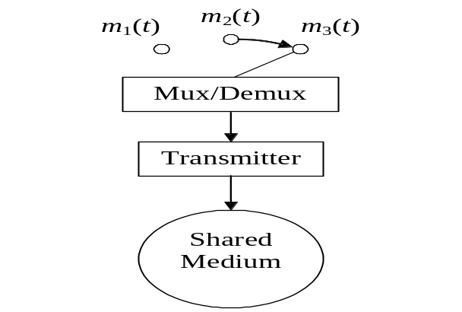
Figure 1: Multiplexing in a TDM system
60.6-
64 kHz
96.6-
100 kHz
100.6-
104 kHz
104.6-
108 kHz
Channel 3
3003.4 Hz voice

Channel 2
3003.4 Hz voice

Channel 1
3003.4 Hz voice
MUX/DEMUX
Channel 12
3003.4 Hz voice

FDM output
60608 kHz
Overall output Bandwidth
Ch 1 Ch 2 Ch 3 Ch 12

Figure 2. Multiplexing in FDM System.
Figure 2. Multiplexing in a FDM System system

Because of limitations in the technology first developed for FDM, a voice channel was standardized at 4,000 Hz of bandwidth. An additional 600 Hz, between 3,400 and 4,000 Hz, were necessary to separate the channels on a multiplexed line, so one channel would not interfere with the next. This vacant frequency band is also known as a guard band.

2b. Wavelength Division Multiplexing. Another types of FDM is wavelength-division multiplexing (WDM) and particular case of WDM: Dense Wavelength-Division Multiplexing (DWDM). WDM and DWDM use multiple light wavelengths to transmit signals over a single optical fiber, Figure 3. Each wavelength carries high rate information. With optical technology advances, DWDM has seen more and more wavelengths, or channels, compressed (squeezed) into an optical fiber. Aggregate rates as high as 1 terabit, or one trillion bps, are possible with this technology. Thus, WDM is actually more like FDM in that separate channels within a transmission pipe are each carrying a stream of data. These technologies are utilized in moving Internet Protocol (IP) traffic on the Internet backbone.

Figure 3. Wavelength Division Multiplexing

Figure 12. Wavelength Division multiplexing

- B. In multiple access is used time-sharing (division) among the users. Time Division Multiple Access (TDMA), all nodes are directly connected to the shared medium, as shown in Figure 4.
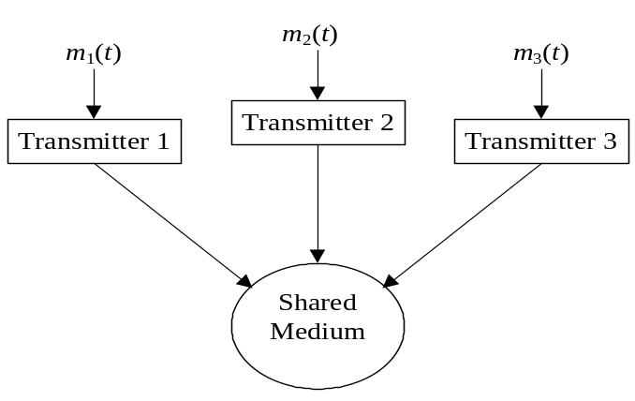
Figure 4: Multiple accesses in a TDMA system

The protocols used to determine who goes next on a multi-access channel belong to a sublayer of the Data Link Layer called Medium Access Control (MAC) sublayer. MAC determines how a transmission node sends data to the shared medium. MAC sublayer is especially important in LANs, many of which use a multicast channel as the basis for communication.

Because multicast channels and LANs are so closely related, we will discuss MAC in general for LANs.

In TDMA, there is no multiplexer to determine who has access to the medium. Each workstation must determine if the medium is free before transmitting. The two widespread TDMA methods are:
• Carrier Sense Multiple Access with Collision Detection (CSMA/CD)
• Token Passing

2. Multiple Access Protocols

- Pure ALOHA.

In ALOHA system the basic idea is applicable to any system in which uncoordinated users are competing for the use of single shared channel. Let users transmit whenever they have data to be sent. There will be collision, of course, and the colliding frames will be damaged. However, due to the feedback property of broadcasting, a sender can always find out whether its frame was destroyed by listening to the channel, the same way other users do. With a LAN, the feedback is immediate; with a satellite, there is delay of 270 msec, before the sender knows if the transmission was successful. If listening while transmitting is not possible for some reason, acknowledgements are needed. If the frame was destroyed, the sender just waits a random amount of time and sends it again. The waiting time must be random or the same frames will collide over and over. Systems in which multiple users share a common channel in a way that can lead to conflict are widely known as contention system. A sketch of frame generation in an ALOHA system is given in Figure 5.
Pure ALOHA efficiency of signal transmitting is: 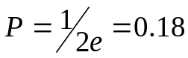

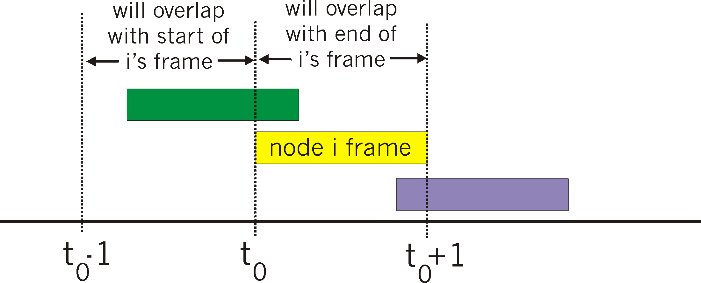
Pure Aloha characteristics:
simpler, no synchronization
when frame first arrives, transmit immediately
collision probability increases numbers of users.
frame sent at t₀ collides with other frames sent in [t₀-1,t₀+1]

Figure 5. Pure ALOHA frames

- Slotted Aloha.

In Slotted Aloha protocols, time is divided into discrete intervals, each interval corresponding to one frame. This approach requires the users to agree on slot boundaries. One way to achieve synchronization would be to have one special station emit a pip at the start of each interval, like clock. For transmitting is required to wait for the beginning of the next slot see Figure 6. Thus, the pure (continues) ALOHA is turned into discrete one. Stations are sending signals without paying attention what the other stations are doing. There could be many collisions, and achieve channel utilization equal to 1/e.

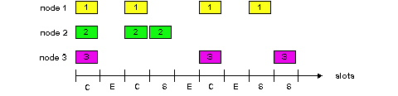
Figure 6. Frames of Slotted ALOHA

The relation between the traffic and the throughput of the pure and slotted ALOHA is shown in Figure 7. The maximum throughput occurs at G (transmission attempt per frame time) =0.5.

Slotted ALOHA is important for reason that may not be initially obvious. It was devised in 1970s.
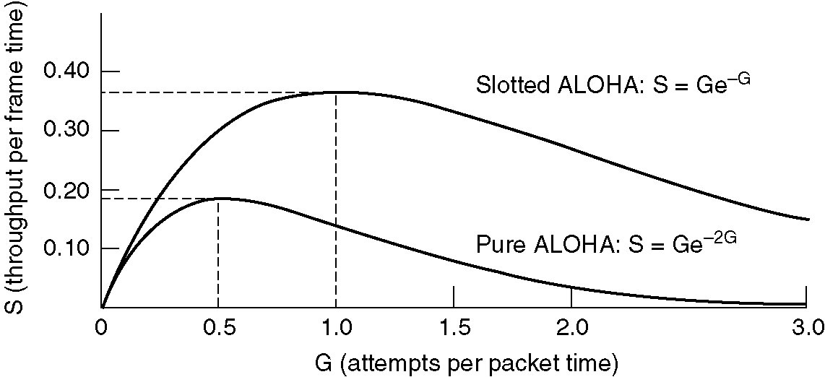
Figure 7. Throughput versus traffic for ALOHA systems

Efficiency of Slotted ALOHA is the long-run fraction of successful slots when there’s many nodes, each with many frames to send.
Probability that 1st node has success in a slot = p(1-p)^{N-1}
Probability that any node has a success = Np(1-p)^{N-1}

Suppose N nodes with many frames to send, each transmits in slot with probability p. For max efficiency with N nodes, find p* that maximizes For many nodes, take limit of Np*(1-p*)^{N-1} as N goes to infinity, gives 1/e =0.37. At best success: channel used for useful transmissions 37% of time!

3. Carrier Sense Multiple Access

In LANs, it is possible for stations to detect what other stations are doing. Protocols in which stations listen a carrier, and act accordingly, such protocols are called carrier sense protocols. Such protocols achieve a much better channel utilization then 1/e.

A LAN is a collection of data communication equipment in which communication occurs in a limited geographical area, such as a building or a campus. The communication equipment are computers (supercomputers, mainframes, mini-computers, workstations, personal computers), peripherals (modems, printers, plotters), and terminals. Every station on the network can communicate with all other stations attached to the network.

LANs are used to share resources. Resources are computers, programs, files, workstations, terminals, printers, plotters. The resources sharing reduce cost of network. Many software vendors have special networking prices for their software. The software is on a network file server hard drive, and the server sends that required part of the software to the user as needed. A file server is a computer with a large hard drive, whose purpose is to send (transfer) data and program files to and from the users on the LAN as required.

4. Carrier Sense Multiple Access / Collision Detection
(CSMA/CD)

CSMA/CD is used on all Ethernet LANs. Ethernet uses a bus topology, (see Appendix). In CSMA/CD, each station has equal access to the network, but it can broadcast only when the network is idle. Before transmitting, a station first listens to the network to sense if another workstation is transmitting carrier sense. If the network is still idle after a certain period, the station will transmit.

It is possible that two stations will listen and sense an idle network at the same time. Each will then transmit its message on the network, where the messages will collide. Neither message will be usable if a collision occurs. While transmitting, a station must perform collision detection to detect if its message was destroyed. If a collision is detected, the detecting station broadcasts a collision or jam signal to alert other stations that a collision has occurred. Each transmitting station then waits a random amount of time (ranging from 10 to 90 ms) before attempting the transmission again.

The CSMA/CD Ethernet protocol defined by IEEE standard 802.3. All information on an Ethernet network is organized into frames (also called packets). A frame includes all information necessary for successful transmission of the packet, plus the data to be transmitted. Figure 8 shows the frame format for Ethernet data transmission.
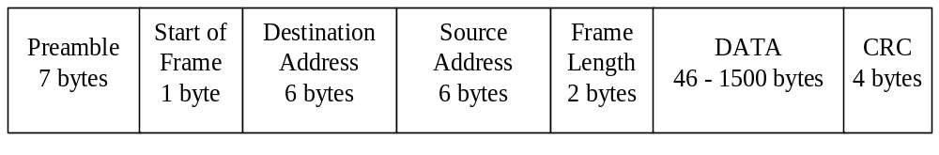Figure 8: Contents of an Ethernet frame.

The preamble indicates the beginning of a transmission. It is a series of alternating 1’s and 0’s that allows the receiving stations to synchronize signal detection to the transmission.

The start of frame is a special eight-bit signal pattern, “10101011”, that signals the start of the packet information.
The destination address is the Ethernet address the station that is to receive the message. All Ethernet addresses are 6 bytes long, and every Ethernet station is manufactured with a unique Ethernet address. A destination address of all 1’s is the “broadcast” address; all stations on the network will receive a message sent to that address. The network can also define “multicast” addresses for groups of workstations. Each station listens for its own address, the broadcast address, and any multicast addresses for groups to which it belongs. The source address identifies the station initiating the transmission. The frame length indicates how many bytes are in the data portion of the packet. The data is the information transmitted.

The cyclic redundancy check (CRC) is found from the bit pattern of the entire previous contents of the packet, using a mathematical formula. If the CRC is incorrect, there was a transmission error somewhere in the packet, and the entire packet must be retransmitted.

All bits in an Ethernet frame are encoded in Manchester code. This code represents a 0 as a high-to-low voltage transition, and a 1 as a low-to-high voltage transition. This coding scheme is much more reliable than NRZ coding, but requires twice the bandwidth, since each bit is encoded as a two-bit NRZ sequence (0 becomes 1-0, and 1 becomes 0-1).
The frequency of collisions will limit the efficiency of an Ethernet network. If too many simultaneous data transmissions are attempted, the rate of collisions will become probable high. An Ethernet is optimal for networks where each station transmits only intermittently, and the probability of many stations transmitting simultaneously is fairly low. In typical Ethernet implementations, collisions will limit the efficiency to about 40% of the maximum possible packet transmission rate. If only one station is transmitting, the efficiency can increase to about 90% (since it must provide inter-frame spaces to monitor the network for other traffic).
a. 10BASE-2 Ethernet
In a 10BASE-2 Ethernet, RG 58/u coaxial cable is used for transmission of the data in both directions along the network. Elimination of reflections is essential to proper functioning of the network. Each segment must be properly terminated at both ends with a 50 Ω terminator (see Figure 9). A segment may be as long as 185 meters, and can connect up to 30 devices (either workstations or repeaters). If a terminator is removed from one end of the segment, signals will reflect back along the cable from the non-terminated end. A transmitting workstation will interpret the reflected voltage as a colliding signal.

In a 10BASE-2 network, the cable must be connected directly to the Network Interface Card (NIC) by a T-connector. It would be incorrect to allow any length of cable between the T-connector and the NIC, because this cable would generate reflections and propagate them onto the main segment. If longer than 4 centimeters, these “cable stubs” can degrade the performance of the Ethernet by increasing the number of collisions, Figure 10. Network timing requirements limit the number of repeaters that can be used in an Ethernet.
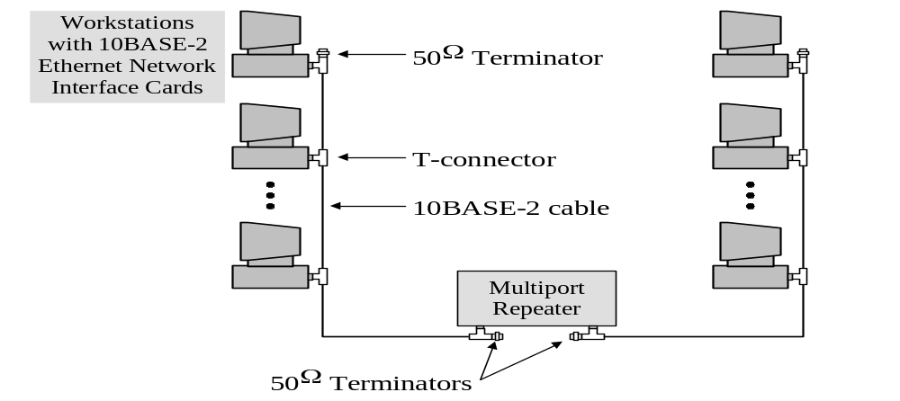
Figure 9: 10BASE-2 Ethernet system.

If any user disconnects the Ethernet cable from the T-connector, or removes the terminator, all workstations on that cable will lose their network connection. Such a cable interruption can be very difficult to locate.
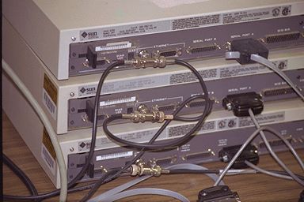

Figure 10. Three computers, all using thin Ethernet.

In a two-node Ethernet, we can connect the two stations directly with a crossover cable; this directly connects the transmit pair of one station with the receive pair of the other station. Most Ethernet networks have more than two nodes, so a multiport repeater or “hub” is used that reads the signal on the transmit lines of each station, and sends this signal to the receive lines of all other stations. The multiport repeater eliminates the need for crossover cables.
b. 10BASE-T Ethernet

Because of the configuration and maintenance difficulties of 10BASE-2 Ethernet, nearly all new Ethernet systems use twisted pair cable instead of coaxial cable. Also, coaxial cable is limited to a transmission rate of 10 Mbps, while category 5 twisted pair cable can support data transmission at 100 Mbps.

In a 10BASE-T Ethernet, UTP cable is used for data transmission. The average characteristic impedance Z for a twisted pair inside a UTP cable is 100 Ω, but this figure can vary by as much as ±15 Ω over the useful frequency range of the cable. Despite proper termination with a 100 Ω resistance, reflections in the twisted pair will not be eliminated. If we were to use UTP cable in a network structure such as that shown in Figure 11 (with 100 Ω terminators), false collisions due to reflected voltages would greatly impair the performance of the network.

To eliminate the problem of reflected voltages, a 10BASE-T Ethernet transmits signals in only one direction along any twisted pair (see Figure 11). Each segment connects only two devices, generally one workstation and one multiport repeater. Each device transmits on one twisted pair and listens on another twisted pair. If a workstation detects a signal on its receive line while transmitting, it will assume a collision has occurred and abort its transmission.

The time delay 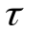of a twisted pair cable depends on the amount of inductance and capacitance of the wire pair:
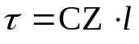
The transmission speed in twisted pair wiring generally expressed as being from 0.59 to 0.65 times the propagation speed of light. Therefore, the time delay will be between 5.13 and 5.65 nanoseconds per meter of distance.

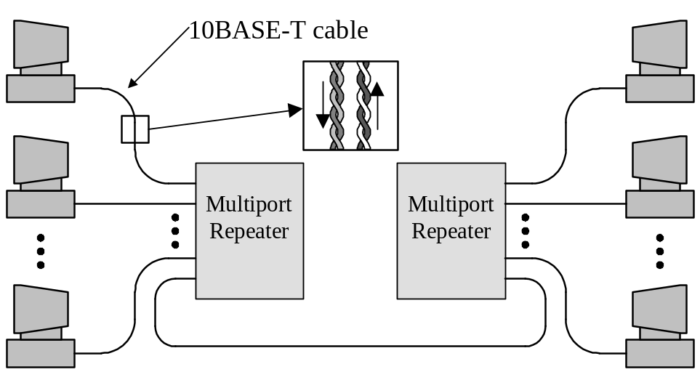
Figure 11: 10BASE-T Ethernet system.

c. Switched Ethernet

As more and more stations are added, the traffic will go up and LAN will saturate. One way out is to go to higher speed, from 10 Mbps to 100 Mbps. But with growth of multimedia, even 100 Mbps or 1 Gbps Ethernet can become saturated. There is a additional way to deal with increased load: Switched Ethernet. The hearth of system is a switch connecting a high-speed backbone and room for typically 4 to 32 plug-in card, each containing one to eight connectors. Most often, each connector has a 10Base-T twisted pair connection to a single host computer.

When a station wants to transmit an Ethernet frame, it outputs a standard frame to the switch. The plug-in card getting the frame may check to see if it is destined for one of the other stations connected to the same card, if so, the frame is copied there. If not, the frame is sent over the high-speed backbone to the destination’s card. The backbone typically runs at many Gbps, using a proprietary protocol. If two machines attached to the same plug-in card transmit frames at the same time, depending on how the card has been constructed:

1. One possibility is for all the ports on the card to be wired together to form a local on-card LAN. Collisions on this on-card LAN will be detected and handled the same as any other collisions on a CSMA/CD network. With this kind of plug-in card, only one transmission per card is possible at any instant, but all the cards can be transmitting in parallel. With this design, each card forms its own collision domain, independent of the others.

2. With the other kind of plug-in card, each input port is buffered, so incoming frames are stored in the card’s on-board RAM as they arrive. This design allows all input ports to receive (and transmit) frames at the same time, for parallel, full-duplex operation, something not possible with CSMA/CD on a single channel. Once a frame has been completely received, the card can then check to see if the frame is destined for another port on the same card or for a distant port. In the former case, it can be transmitted directly to the destination. In the later case, it must be transmitted over the backbone to the proper card. With this design, each port is a separate collision domain, so collisions do not occur. The total system throughput can often be increased by an order of magnitude over 10Base5, which has a single collision domain for the entire system.

Since the switch just expects standard Ethernet frames on each input port, it is possible to use some of the ports as concentrators. In Figure 12, the port 1 is connected not to a single station, but to a 12-port hub. As frames arrive at the hub, they contend for the ether in the usual way, including collisions.

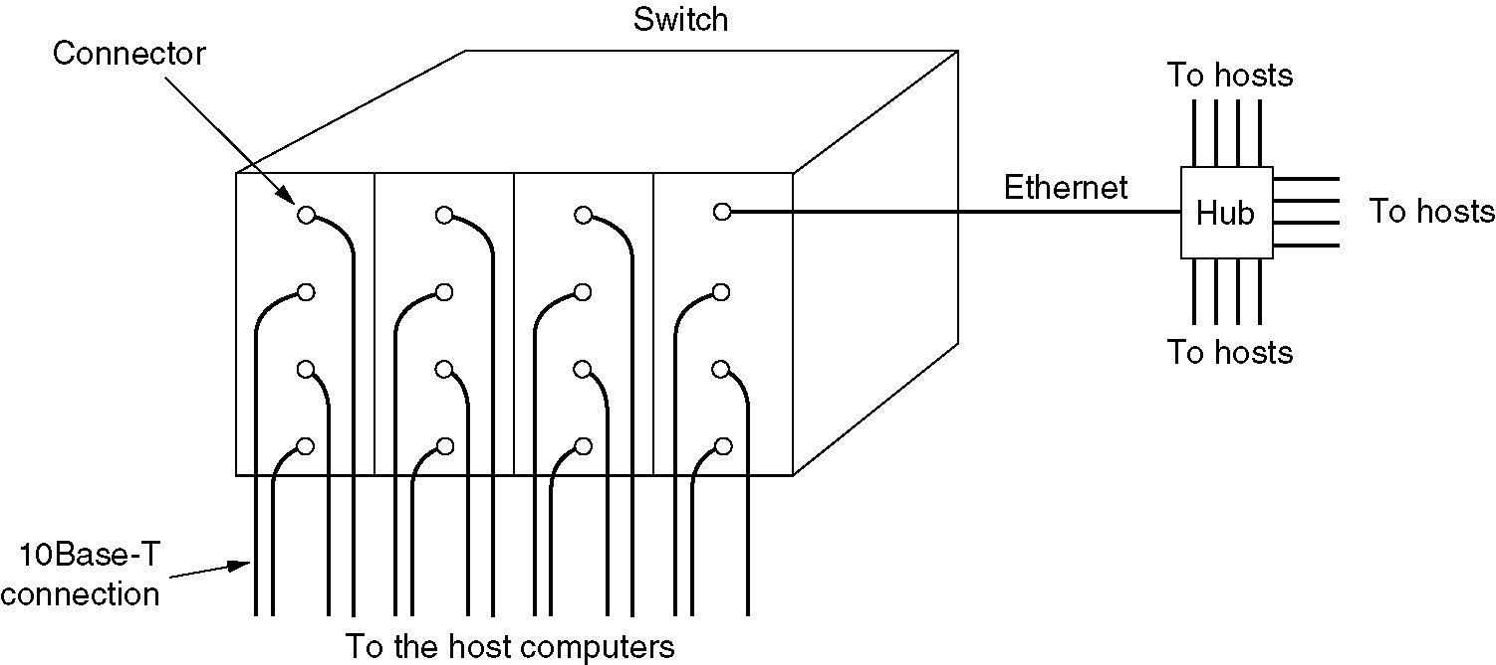
Figure 12. A example of switches Ethernet
5. Fast Ethernets (802.3 standard)

a. 100BASE-TX Ethernet

To increase the speed of Ethernet transmission to 100 Mbps, different encoding strategies are required to reduce the bandwidth of the transmission. Encoding data at 100 Mbps using Manchester encoding would create a bit stream of 200 Mbps, which would require at least 100 MHz of analog bandwidth. Category 5 UTP cable is rated up to 100 MHz, but transmitting a signal of 100 MHz bandwidth would be unreliable. To reduce the bandwidth of the signal, a different encoding scheme is required.

Because negative voltages are as easy to transmit and detect as positive voltages, 100BASE-TX Ethernet uses a multiple level encoding scheme (see Figure 13) called MLT-3 (Multiple Level Transition - 3):
0: No transition
1: Signal transition (low to zero, high to zero, zero to low or high)

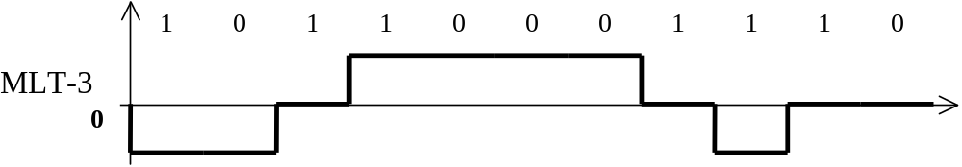

Figure 13. Multiple Level Transition – 3

The bandwidth required to transmit this signal is one-half the bandwidth required for a two level scheme. However, a long stream of zeros (common in most data streams) will cause the line to hold a constant voltage. During this time, the receiver may lose the clocking synchronization necessary to read the signal. For this reason, the data is encoded at the physical layer (in the hardware) to encode each 4-bit sequence as a 5-bit pattern. This scheme is called 4B5B encoding (see Table 1).

It increases the bit rate to 125 Mbps, but it allows the receiver to read a steady stream of zeros without losing synchronization. No more than 2 consecutive zeros will be transmitted in any encoded stream.

The bandwidth necessary to transmit 100BASE-TX data is only 31.25 MHz. This is greater than the bandwidth of Category 3 or Category 4 cable, but well below the bandwidth of Category 5 cable.

Table 1: 4B/5B Encoding.
Hex Data | 4B Binary Data | 5B Encoded Data
0 | 0000 | 11110
1 | 0001 | 01001
2 | 0010 | 10100
3 | 0011 | 10101
4 | 0100 | 01010
5 | 0101 | 01011
6 | 0110 | 01110
7 | 0111 | 01111
8 | 1000 | 10010
9 | 1001 | 10011
A | 1010 | 10110
B | 1011 | 10111
C | 1100 | 11010
D | 1101 | 11011
E | 1110 | 11100
F | 1111 | 11101

b. 100BASE-T4 Ethernet

For installations where a great deal of Category 3 or Category 4 cable has been installed, transmission at a rate of 100 Mbps is still possible by using all four twisted pairs in the UTP cable, Figure 14. Three pairs will transmit data, while the fourth pair is used by each station to listen for collisions.
As in 100BASE-TX, a three-level signal is transmitted in 100BASE-T4, but the data rate must be minimized further. Therefore, the signal is broken into 8-bit sequences, and each 8-bit sequence is represented as 6 three-level signals.
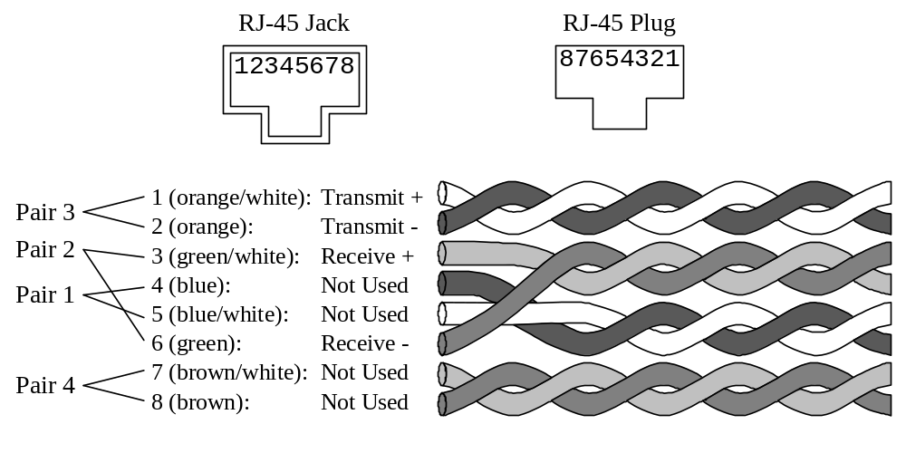
Figure 14: Pinouts for ANSI/EIA/TIA TSB-40 standard UTP cable.

This scheme is called 8B6T encoding. Of the 729 possible 6T sequences, 256 are used for data encoding, 9 are control signals, and the rest are unused. Table 2 shows a few examples of this encoding:

Table 2: 8B/6T Encoding.
Hex Data | 8B Binary Data | 6T Tri-state Data
00 | 0000 0000 | + − 0 0 + −
01 | 0000 0001 | 0 + − + − 0
… | … | …
0E | 0000 1110 | − + 0 − 0 +
… | … | …
FE | 1111 1110 | − + 0 + 0 0
FF | 1111 1111 | + 0 − + 0 0

The 100 Mbps data stream is converted to a superposition of two 75 Mbps data streams (one for negative symbols and one for positive symbols), which requires 37.5 MHz of analog bandwidth. However, the sequences are fanned out among three twisted pairs, so three 6T sequences are simultaneously transmitted over three twisted pairs in the cable. Each twisted pair carries only two superimposed 25 Mbps data streams, requiring an analog bandwidth of only 12.5 MHz, within the bandwidth of Category 3 cable. The Ethernet preamble is modified to notify the receiving station of the pair transmit order so the packet can be properly reassembled.

c. Gigabit Ethernet

The simplest gigabit Ethernet configuration, (802.3z standard), illustrated in Figure 15 (a), two computers are directly connected to each other. The more common case, however, is having a switch or a hub connected to multiple computers and possibly additional switches or hubs, as shown in the Figure (15b). In both configurations each individual Ethernet cable has exactly two devices on it, no more and no fewer.

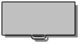
Ethernet
Switch or hub
Ethernet

Figure 15 (a) A two-station Ethernet, (b) A multistation Ethernet

Gigabit Ethernet supports two different modes of operation: full-duplex mode and half-duplex mode. The normal mode is full-duplex mode. This mode is used when there is a central switch connected to computers. In this configuration, all lines are buffered, so each computer and switch is free to send frames whenever it wants to. The sender does not have to sense the channel to see if anybody else is using it because contention is impossible. On the line between a computer and a switch, the computer is the only possible sender on that line to the switch and the transmission succeeds even if the switch is currently sending a frame to the computer (the line is full-duplex). Since no contention is possible, the CSMA/CD protocol is not used, so the maximum length of the cable is determined by signal strength issues rather than by how long it takes a noise burst to propagate back to the sender. Switches are free to mix and match speeds. Auto configuration is supported just as in fast Ethernet.

The other mode of operation, half-duplex, is used when the computers are connected to a hub rather than a switch. A hub does not buffer incoming frames. Instead, it electrically connects all the lines internally, simulated the multidrop cable used in classic Ethernet. In this mode, collision is possible, so the standard CSMS/CD protocol is required. Because a minimum (i.e. 64-byte) frame can now be transmitted 100 times faster than classic Ethernet, the maximum distance is 100 times less, or 25 meters, to maintain the essential property that the sender is still transmitting when the noise burst gets back to it, even in the worst case. With a 2500-meter-long cable, the sender of a 64-byte frame at 1 Gbps would be long done before the frame got even tenth of the way to the other end, let alone to the end and back.

Gigabit Ethernet supports both cupper and fiber cabling. Signaling at or more 1Gbps over fiber means that the light source has to be turned ON and OFF in under 1 nsec. LEDs simply cannot operate this fast, so lasers are required. Two wavelengths are permitted: 850 nm and 1300 nm. Lasers at 650 nm are cheaper but do not work on single mode fiber.

Three fiber diameters are permitted: 10, 50 and 62.5 microns. The first is for single mode and the last two are for multimode. Not all six combinations are allowed, however, and the maximum distance depends on the combination used, see Table 3.
Table 3.
Name | Cable | Max. segment | Advantages
1000Base-SX | Fiber Optic | 550 m | Multimode fiber (50, 62.5 microns)
1000Base-LX | Fiber Optic | 5000 m | Single (10 mkm) or (50, 62.5 mkm)
1000Base-CX | 2 Pair of STP | 25 m | Shielded twisted pair
1000Base-T | 4 Pairs of UTP | 100 m | Standard category of 5 UTP

Gigabit Ethernet uses new encoding rules on the fibers. Manchester encoding at 1 Gbps would require a 2 Gbps signal, which was considered too difficult and also too wasteful of bandwidth. Instead a new scheme, called 8B/10B, was chosen, based on fiber channel. Each 8-bit byte is encoded on the fiber as 10 bits. Since there are 1024 possible output codeword for each input byte, some freedom was available in choosing which codeword to allow.

6. Ethernet Limitations

The “topology” of a network refers to the pattern of workstations, cables, and repeaters. In an Ethernet, there are two primary limitations to the topology: transmission accuracy and end-to-end transmission time.

In a network consisting of 10BASE-T (twisted pair) cabling, the maximum distance for accurate transmission is determined by signal attenuation along the cable. The maximum possible transmission distance along a Category 5 twisted pair cable is somewhat more than 100 meters, but to preserve the ability to upgrade to 100BASE-TX, 100 meters is generally the maximum cable length.

In a 10BASE-T or 100BASE-TX network, the maximum distance along any segment is determined by signal attenuation. This distance is approximately 100 meters; additional length may cause network failure, since the most distant station will be unable to receive transmissions.

In large number of segments transmission time becomes the limiting factor. Multiport repeaters require some time to receive and retransmit the signal, and the total transmit time from one end of the network to the other must be less than one-half the time to transmit the minimum size frame. In a 10BASE-T Ethernet, a signal can travel no more than 500 meters, because transmission time limitations allow no more than 4 repeaters to be included in any signal path. Longer signal paths will require more repeaters, which will introduce too much delay into the transmission.

Most computers in Boelter Hall use 100BASE-TX networking. The same type of UTP cable is used as in 10BASE-T networks, and the signals travel on the same two sets of wires. Since 100BASE-TX sends data at a rate of 100 Mbps, a Category 5 cable is required. Due to timing constraints, the multiport repeaters must be much faster than in a 10BASE-T Ethernet.

Transmission over fiber optic cables also increases the capacity of an Ethernet network. Transmission capacity of 1 gigabit per second (10 times the capacity of 100BASE-TX) is widely available, using either fiber optic cables or simultaneous transmission over several wire pairs in a UTP cable.

In a 100BASE-TX network, the maximum allowable length is determined by the transmission bandwidth. Transmission of Manchester encoded data at a bit rate of 100 Mbps requires a transmission bandwidth of 400 MHz. A 100 meter long Category 5 twisted pair cable has a bandwidth of approximately 400 MHz, so 100 meters is the longest allowable length for reliable data transmission.

The addition of a multiport repeater after a distance of 100 meters allows transmission over longer distances, since the repeater regenerates and retransmits the signal. However, the process of regeneration and retransmission introduces additional delay into the system. The end-to-end transmission time becomes the limiting factor in system design.

A 10 Mbps Ethernet transmits data at a bit rate of 0.1 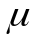s per bit. A transmitting station (#1) must be able to detect a collision inside the 576-bit minimum packet length (72 bytes), which takes 57.6 s to transmit. If a station at the furthest point in the network (#2) starts sending a packet just before it receives the signal from station #1, the signal will be received by station #1 at time 2T after it starts transmitting, where T is the end-to-end transmission time. Therefore the end-to-end transmission time must be less than 28.8 s.

Table 4 shows typical transmission delays for different 10 Mbps Ethernet cabling types, receiver interfaces, and repeaters. When calculating the end-to-end transmission time, a safety margin of about 0.5 s should be added to account for additional interface and cabling delays.

Figure 16 shows the delays for a 10 Mbps Ethernet with 10BASE-T end segments connected by a 10BASE-FL middle segment. All segments are assumed to be the maximum length: 100 m for the 10BASE-T segments, and 2000 m for the 10BASE-FL segment.

Table 4: Transmission delays for 10 Mbps Ethernet cabling and repeater
 | Delay at  repeater  (s) | Receiver  delay  (s) | Maximum  length  (m) | Delay per meter  (s/_{m})
10BASE-T | 2.1 | 7.0 | 100 | 0.0057
FOIRL | 1.5 | 6.5 | 1000 | 0.005
10BASE-FP | 3.1 | 6.7 | 1000 | 0.005
10BASE-FB | 1.2 | N/A | 2000 | 0.005
10BASE-FL | 1.7 | 6.8 | 2000 | 0.005

The end-to-end transmission time of the system is 21.94 s; with an 0.5 s safety margin, the transmission time of 22.44s is well under the maximum end-to-end transmission time of 28.8 s.

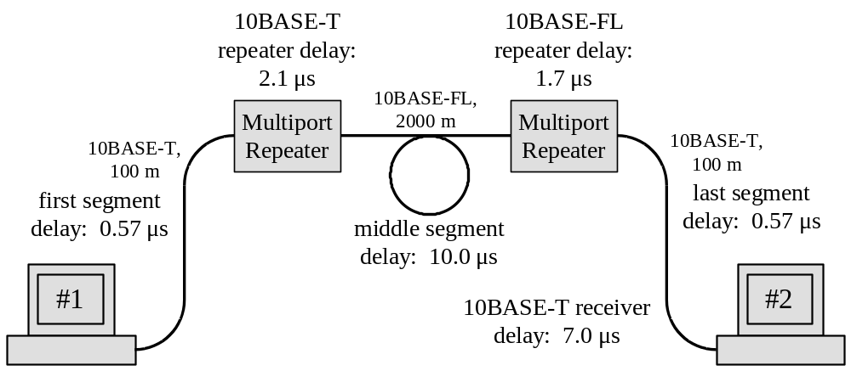

Figure 16: 10 Mbps Ethernet with 10BASE-T and 10BASE-FL segments.
A 100 Mbps Ethernet transmits data at a rate of 0.01 s per bit, so the time to transmit the smallest possible packet is only 5.76 s. The end-to-end transmission time must therefore be less than 28.8 s. Table 5 shows transmission delays in a 100 Mbps Ethernet. Repeater and receiver delays are approximately equal for 100BASE-TX (twisted pair) or 100BASE-FX (fiber optic) cables. The receiver in a 100 Mbps Ethernet must be able to detect collisions much faster than a 10BASE-T receiver, due to the faster bit rate. If a Class I repeater is used in a 100BASE-TX communication link, only one repeater can be in the transmission path. Using Class II repeaters allows two repeaters to be in the transmission path, greatly expanding the possible network topology.

Table 5: Characteristics of a 100BASE-T Ethernet system
100BASE-TX | delay per meter | 0.0057 /m
100BASE-TX | maximum length | 100 m
100BASE-FX | delay per meter | 0.0050 /m
100BASE-FX | maximum length | 412 m
Class I Repeater Delay |  | 1.40 s
Class II Repeater Delay |  | 0.92 s
Receiver Delay |  | 0.50 s

To avoid the need to restrict the size of an Ethernet network, a packet switch can be used to connect two or more Ethernet networks. A packet switch will examine the destination address of all packets on any network to which it is connected. If the packet destination is on another network, the packet switch will transmit that packet on the target network.

A multiport repeater simply connects the transmission wires of every port to the receiving wires of every other port. A packet switch is much more complicated; it must store the addresses on each network to which it is connected, read the destination address of each incoming packet, and store and retransmit packets in case a collision occurs. Some packet switches also can interface between 10 Mbps and 100 Mbps Ethernet systems. Packet switches are quite similar to Internet gateways, only they switch packets based on the 6 byte Ethernet address, rather than the 4 byte Internet Protocol (IP) address.

As an example of LAN let us consider the CS 117 laboratory LAN. In the LAN fiber optic cable is used as a backbone cable for two sets of twisted-pair Ethernet cables, connected at a multiport repeater. Each multiport repeater contains several ports that permit attachment of workstations or another concentrator through 10BASE-T cabling (see Figure 17).

The multiport repeater also has an attachment unit interface (AUI) port, which allows different transceivers for other cabling types. In the laboratory LAN, the AUI port is connected to 10BASE-FL fiber optic transceiver. The transceiver is attached to two fibers, one for transmitting and one for receiving. To reduce the number of fiber optic cable required, a wavelength-independent coupler connects the transmit and receive fibers to allow two-way transmission through the same fiber optic cable.
Table 6 summarizes the principal optical characteristics of the 10BASE-F network. There are three standards for Ethernet transmission over fiber optic cables.
Table 6: Fiber optic cabling for Ethernet
 | 10BASE-FP |  | 10BASE-FB |  | 10BASE-FL
 | Min | Max | Min | Max | Min | Max
Optical Wavelength (nm) | 800 | 910 | 800 | 910 | 800 | 910
Spectral Width (nm) | 75 |  | 75 |  | 75
Rise time (ns) | 10 |  | 10 |  | 10
Launch Power (dBm) | -15 | -11 | -20 | -12 | -20 | -12
Received Power (dBm) | -41 | -27 | -32 | -12 | -32 | -12
Maximum. Length (m) | 500 |  | 2000 |  | 2000

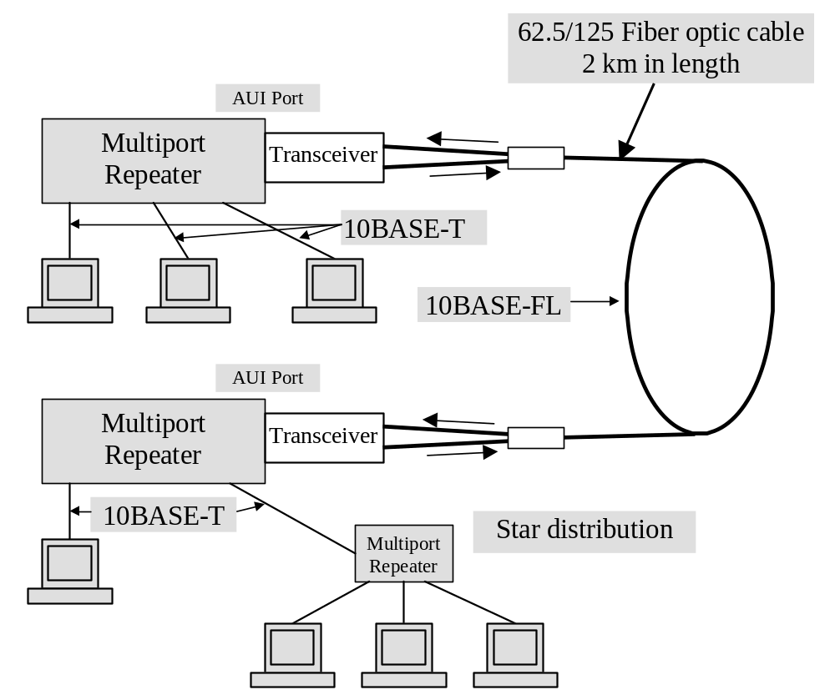

Figure 17: Diagram of CS 117 Lab Ethernet network

7. Token Ring Network

A token ring network (TRN) (IEEE 802.5 standard) circulates an electronic token around a closed electronic loop; its topology is shown in Figure 18). Each node on the network reads the token and repeats it to the next node. The token circulates around the ring even when there is no data being transmitted. The token allows many different stations to allocate space on the network without the risk of a collision.

Host or
mainframe
database
database

Figure 18.Token Ring topology

A node wishing to transmit waits for the token. Once it receives the token, it retransmits the token followed by a packet (frame), which contains the destination address, source address, and data. When the next node reads the token, it also reads the packet. If this node is the destination, it makes an acknowledgement of the data packet, and appends this acknowledgement to the token. If this node is not the destination, it forwards the data packet to the next node. In this way, the data frame can circulate around the ring until it reaches the destination node.

When the transmitting node again receives the token, it checks for the acknowledgement of the transmitted packet. If the acknowledgement is received, the transmitting node removes this acknowledgement and retransmits the token. If it has another packet to transmit, it appends this packet to the token. If no acknowledgement was received, the original packet will still be circulating with the token. The transmitting node will remove this original packet, and report an error to the process that generated the packet.
Two Token Ring LANs with fiber optic channels are Fiber Distributed Data Interface (FDDI) Token Ring Network (TRN). TRN uses one ring, but FDDI has two counter-rotating rings. The data in FDDI travels in opposite directions. In a TRN, each node has equal access to the ring. It can transmit one packet every time it receives the token, so it will not be blocked by collisions with other nodes that are sending packets. In a network with a large amount of traffic and a limited number of nodes, a token ring network will use a large portion of the network capacity, and it can be much more efficient than an Ethernet. However, in a very large network, the token will have to pass through many nodes, and the transmission time between nodes will limit the network efficiency.

a. Multistation Access Unit

A TRN is logically connected in a ring, however, all the nodes are connected to a Multistation Access Unit (MAU) or concentrator, so that the connection looks like a star (see Figure 19). This TRN MAU is not the Media Access Unit (MAU) of 10Base5 Ethernet systems.

TRN is called a star wired ring. The Token Ring MAU is a passive device, having no amplifiers, only relays. Each working node sends a +5V control signal to the MAU. The +5V control signal closes a relay and connects that working node into the ring. If a node is not functioning, it will not send the +5V control signal to the MAU, the relay will not be energized, and the node will be disconnected from the ring. (see Figure 20).

MAUs are usually designed for eight nodes but can be expended through the Ring In (RI) and Ring Out (RO) connectors.

RI MAU RO
Host or
mainframe

Figure 19. TRN physical topology.

Figure 20. Multistation access unit for token ring, connected as a star wired ring. The operational nodes send +5V to the MAU, opening a relay and connecting that working node into the token ring network.

b. Basic TRN Operation

When the TRN is first turned on, it must determine which node is the “boss” or active Monitor for all nodes. The Active Monitor is usually the node, which the highest address. The Active Monitor provides synchronization. After an Active Monitor is selected, it will purge the ring of all token or frames, generate a new token, and monitor ring activity at least every 10 milliseconds. If no activity is detected, the Active Monitor generates a new token, marking the system “fail-safe”. An analogy is a cargo train on a circular track with a sign on the engine signifying whether the train is carrying cargo (data) and a petroleum tender stating the names of the destination and sending stations, Figure 21. If the train is carrying cargo (data), it is a frame. If the train does not have any cargo (data), it is token. If the train is carrying cargo (data), the addressed station will unload the cargo as the train is passing through. The addressed station will put a flag on the engine telling the sending station that the freight was delivered. The CRC or FRC error detection field can be considered the train’s caboose

Destination address
Source address
CRC and ending
delimiter

Starting
delimiter

Figure 21. Token Ring as a cargo train analogy.

c. TRN Token and Frame Format

A token, shown in Figure 22, has only the Starting Delimiter (SD), Access Control (AC), and Ending Delimiter (ED) fields. There is no need for address fields since data is being sent. Tokens do not carry data, but frames carry data. SD “JK0JK000” field synchronizes and alerts the downstream node that a token or frame is arriving. The AC field is a control field and will be discussed shortly. The ED “JK1JK1E” field denotes the end of the token. If the “E” bit in the ED is set, it means that a node has discovered an error, and if “I” bit is set, it means there are more frames coming.

A frame format is shown in Figure 22 and is described in the Table 7. The AC field has three “P” priority bits, a ”T” bit (which is “1” for s frame and “0” for a token), and three reservation bits for a node to reserve use of a token to send data.
SD (1) AC (1) FC (1) DA(6) SA(6)

SD –Starting Delimiter, AC-Access Control,
FC-Frame Control, DA-Destination Address,
SA-Source Address, FS-Frame Status.

RIF (0-30) info (n) FCS (4) ED (1) FS (1)
JK0JK000 PPPTMRRR FFZZZZZZ
JK1JK1IE ACrrACrr
DSAP SSAP Control Information

MAC LLID MAC subvector
Figure 22. TRN frame format. SD–Starting Delimiter, AC-Access Control, FC-Frame Control, DA-Destination Address, SA-Source Address, FS-Frame Status. FC-Frame Control, DA-Destination Address, SA-Source Address, FS-Frame Status, RIF-Routing Information Field, FCS-Frame Check Sequence, A-Address recognized, C-frame Control, R-Reserved bits, DSAP-Destination Service Access Point, SSAP-Source Service Access Point, LLID-MAC Length ID.
Table 7. TRN Format
1. Starting Delimiter (SD) “JK0JK000”
2. Access Delimiter (AD) “PPPTMRRR”
Priority P-three bits, 0 to 7 encoded priority
Token T bit- “1” for frames, “0” for token
Monitor M bit- used to detect persistently circulating frames
Reservation bits- to reserve use of a token
3. Frame Control (FC) “FFZZZZZZ”
If “FF” is “01”, it is an LLC frame
If “FF” is “00”, it is a MAC frame
“Z”s are coding various types of MAC frames
4. Destination Address (DA)
5. Source Address (SA)
6. Routing Information Field (RIF)- * used when
interconnecting LANs with routers and bridges
7. Info
8. Frame Check Sequence (FCS) or CRC
9. Ending Delimiter (ED)-* includes E bit, a node
detected an error in reading the frame
10. Frame Status
Copy ( C ) bit- receiving node successfully copied frame
Address Recognized (A) bit- node recognizes that the frame
was meant for itself

It is possible for a frame or token to keep circulating forever in the ring, and the “M” bit prevents this from happening.

In LANs the DLL is subdivided into two parts: the Medium Access Control (MAC) and the Logic Link Control (LLC) sublayers. TRN frames are one of two types: MAC frames for housekeeping and control, or LLC frames to send data. The Frame Control (FC) field “FFZZZZZZ” tells the frame type. If “FF” is “01”, the frame is an LLC type. If “FF” is a “00”, the frame is a MAC type. “ZZZZZZ” encodes various types of MAC frames.

The DA and SA fields are each six bytes. The Routing Information Field (RIF) is used when interconnecting LANs with routers and bridges, and is from zero to thirty bytes long.

The Information Field contents will vary depending on whether the frame is an LLC or MAC. If it is a MAC frame, the first subfield is the MAC LLID (MAC Length Identification), and the second subfield is the MAC subvector. If the frame is an LLC, the first field is the Destination Service Access Point (DSAP), and the second field is the Source Service Access Point (SSAP). Next is the control subfield and finally the information. The Service Access Point (SAP) is the addresses in level 3 that the data is sent from or sent to.

The FCS field is a 32- bit CRC (CRC32) for error control.

The ED field tells receiving node that the FS field is the only field left to be received. The ED, like the SD, has “J” and “K” control characters. The SD’s zeros are replaced with ones in the ED. The ED has an “E” bit indicating when a node has detected an error and an “I” bit telling the receiver that more frames will follow.

The Frame Status (FS) field has the “A” and “C” bits. The “A” bit is set by the receiving node telling that it has recognized that frame was meant for itself. The “C" bit is set the receiving node telling that it has successfully copied the frame.

d. TRN Operation

Referring to Figure 23, node 30 has been designed the Active Monitor because it has the highest address. Node 30 generates a token and passes it to Node 10. The "T" bit is not set, indicating a token. Node 10 has no data to transmit but examines the token for errors. Node 10 finds no errors, regenerates the token, and sends it to Node 20.

Node 20 has data to send, so it seizes the token and sets the "T" bit, changing the token to a frame. Node 20 wants to send the data to Node 10 and thus sets the DA to 10, the SA to 20, and resets the "A" and "C" bits.

The frame goes next to Node 30. Node 30 notes that the frame is not addressed to itself and does not read the data. However Node 30 examines the frame for errors. Finding no errors, Node 30 sends the frame to Node 10.
Node 10 notes that the frame is addressed to itself and therefore sets the "A" bit and checks for errors. Node 10 finds no errors and thus copies the data. Node 10 sets "C" copy bit and sends the frame to Node 20.
Node 20 examines "A" and "C" bits and notes that they are set, meaning that Node 10 has recognized the address and successfully copied the data. The frame has served its purpose, so Node 20 generates a new token. The new or "fresh" token will now be available for any node to seize, create a frame, and transmit data within that frame. In case if some Node detects errors, the Node will set "E" bit and send to SA.

If Node 30 wishes to reserve a frame for future data transmission and sets the "R" (reserve) bit to "2". Node 10 receives the token and sets the "P" (priority) bits to "2" to prevent lower priority nodes from using the token. Node 20 cannot use the token because Node 20 has a lower priority. The token comes back to Node 30, which grabs the token and puts data onto it, making the token a frame. Node 10 sees that the frame is addressed to itself and sets the "A" (address recognized) bit, reads the data, and sets the "C" (copied) bit. Node 20 sends the frame unchanged, and Node 10 resets the "P" bits and generates a new token.
PTMR DA SA EAC
1 1 0 2 0 0 0 0
PTMR DA SA EAC
1 1 0 2 0 0 1 1
PTMR E
0 0 0 0 0
PTMR E
0 0 0 0 0
PTMR E
0 0 0 0 0
PTMR DA SA AC
1 1 0 2 0 0 0
30 notes frame (T=1) not 10 notes frame addressed 20 generates
for 30, does not find to 10, copies data, sets new token.
any errors A (Address Recognized),
C (Copy Successfully).

30 sends token 10 doesn't 20 wishes to send data to 10,
to 10 transmit grabs token, sets A,C.
Sets T making the token into
A frame

30
Host or
mainframe
Active monitor
10
20
Figure 23. TNR operation model
8. Fiber Distributed Data Interface

The Fiber Distributed Data Interface (FDDI) standard is the most common fiber optic network. FDDI is arranged as a token-passing ring topology. Fiber optic cables allow a much higher transmission capacity than twisted pair cables. FDDI operates with two concentric token rings, each operating at 100 Mbps. The primary ring carries information around the ring in one direction, while the secondary ring carries information in the opposite direction.

FDDI using a token system is allowing many frames to exist simultaneously on the ring. This differs from Token Ring Network, which can have only one token on the ring. Also TRN has one Active Monitor. In FDDI control is distributed around the ring, and all nodes have maintenance responsibility.

FDDI can handle synchronous traffic (such as voice and video), control information, and asynchronous traffic (such as data). The synchronous traffic requires guaranteed bandwidth and delay times; delay must be minimal and uniform. Asynchronous is delay-insensitive, allowing variable delays.

The reason for two rings is redundancy. If one ring fails, the other is still available for data transmission. If there is a complete break in the ring, transmissions are redirected from the outer ring to the inner ring just before the break, to maintain the ring necessary for token-passing network architecture.

Each node connected to the FDDI network can be a normal node or a bridge to another type of LAN, such as an Ethernet. The maximum circumference of the ring is 100 km, with a maximum 2 km between nodes. A maximum of 1000 nodes can be connected to the network (500 per ring). For very large networks, FDDI is an effective way to provide high connectivity and high reliability.

Using fiber optics in a LAN is attractive for three reasons:

• Fiber optics extend transmission distances (from 100 meters in a 10BASE-T network to 2000 meters in a 10BASE-FL network).
• Increased information capacity; fiber optic transceivers allow transmission rates of up to 1 Gbps (1000 Mbps).
• Immunity to Electro-Magnetic Interference (EMI) and noise.

- FDDI Frame

The FDDI frame format shown in Figure 24 is similar to the format of TRN. The PA (Preamble) field consists of sixteen I (Idle) pulses. The SD field is a "J" and "K" character. The FC (Frame Control) field has eight bits. The first bit indicates the class of service; synchronous or asynchronous. The L (Length) bit indicates two- or six-byte address fields. Usually the address fields are six bytes long. The FE and ZZZZ bits indicate token, and LLC, MAC, or SMT frames. SMT frames are housekeeping frames.
PA SD FC DA SA info FCS ED FS
I symbols JK C L FE ZZZZ
Figure 24. FDDI frame format.

The FCS (Frame Check Sequence) is used for error control. The ED frame has one "T' for frames and two "T's for tokens. In the Frame Status (FS) field the "E" bit indicates an error detected, the "A" bit means a node has recognized a frame addressed to itself. And the "C" confirms that the addressed node has successfully copied the frame.

9. Speed of LANs

Most LANs operate at relatively modest speeds (such as 10 Mbps) over limited distances (several hundred meters). There are also three 100 Mbps LANs: 100BaseT (fast Ethernet), 100BaseVG ("Any LAN"), and FDDI.

100BaseT uses the existing MAC layer of 10BaseT, meaning it is also a CSMA/CD system. These are summarized in Table 8.

Table 8
Parameter | FDDI | 100BaseT | 100BaseVG
Data rate  Max segment length  Total network length  Max nodes  Max node spacing  Physical medium  Coax impedance  IFFF spec  Topology  Signaling  Collision detection | 100 Mbps  100 Km  500 m  2 Km  Optical fiber  NA  None  Dual ring  NRZI-4B5B  NA, uses token | 100Mbps  205 m  UTP or fiber  NA  TBD  Bus, or star  Manchester  Excess current | 100BaseVG  UTP or fiber  NA  TBD  Star  NA

10. Data Link Layer switching

The interconnection of networks is known as internetworking (or Internet). Each part of an Internet is a subnetwork. TCP/IP is a pair of protocols, which allow one network to communicate with another. A protocol is set of rules, which allow the orderly exchange of information. The IP part corresponds to the Network layer of the OSI model and the TCP part to the Transport layer. Their operation is transparent to the Physical and Data Link layers and can thus be used on Ethernet, FDDI or token ring networks.

Internet uses TCP/IP to transfer data. Each node on the Internet is assigned a unique network address, called an IP address. Note that any organization can have its own network, but if it is to connect to the Internet then the addresses must confirm to the Internet addressing format.

Many organizations have multiple LANs and wish to connect them. LANs can be connected by devices called bridges, which operate in the DLL. Bridges examine the DLL addresses to do routing. Since they are not suppose to examine the payload field of the frames they route, they can transport IPv4 (used now), and IPv6 (will be used in the Internet in the future), In contrast, routers examine the addresses in packets and route based on them. We will look at bridges and switches for connecting different 802 LANs. LANs then are connected to subnets via gateways as it is shown in the Figure 25.
Advantages of interconnecting of networks are to allow:
- two or more networks to be managed as a single network, even when they are located over a large distance, or within the same building;
- one type of computer to communicate with another, possibly over large physical distances;
- electronic mail to traverse through the Internet;
- multiple routes between nodes help to create alternative communication routes when links either are not operating or if they are busy;
- to have the capacity to isolate traffic from other networks;
- access to information on remote sites;

Internet

G/W - gateway

Commerce
Industry
G/W
G/W

G/W

G/W
University

School
G/W

Government

Figure 25. Internet via gateway
This chapter summarizes the most popular Physical Layer protocols that exist for providing connectivity to WAN and MAN networking environments. LANs interconnection could be based on a low-speed technologies, such as dial-up and leased lines, or higher-speed technologies, such as T3 and OC-3.
11. LANs Interconnections
As an organization grows, its data processing and network needs often increase also. LANs must be expanded, but there are limits to LAN expansion. These limits are those of the LAN itself (each type has a maximum length and number of nodes) and the amount of traffic. If the traffic load becomes too large, few messages will reach their destination, so large LANs must be split into smaller LANs and somehow still be connected. Also LAN users merely want access to the Internet or a WAN. There are four devices to connect one LAN to another LAN. These are: Repeaters, Bridges, Routers, and Gateways.

In typical scenario, the user generates some data to be sent to a remote machine. These data are passed to the transport layer, which then adds a header, for example, a TCP header, and passes the resulting unit down to the network layer. The network layer adds its own header to form a network layer packet, for example, an IP packet. Then the packet goes to the data link layer, which adds its own header and checksum (CRC) and gives the resulting frame to the physical layer for transmission, for example, over a LAN.

Let us look at a variety of ways to interconnect different networks to each others.

a. Repeater

A repeater (same as a hub) merely boosts the signal strength between LANs or segments of a LAN. It can be used to extend the total length of a LAN. The maximum segment length of a 10Base 5 LAN is 500 meters. Repeaters do not understand frames, packets, or headers. They understand volts. By using repeaters, one may connect as many as four segments together, Bringing the total LAN length to 2,500 meters. A repeater operates at the physical level only, see Figure 26. It has no intelligence or routing capability.

A hub has a number of input lines that it joins electrically. Frames arriving on any of the lines are sent out on all the others. If two frames arrive the same time, they will collide, just as on a coaxial cable. In other words, the entire hub forms a single collision domain. All the lines coming into a hub must operate at the same speed. Like repeaters, hubs do not examine the 802 addresses.
Transport

Network

Data Link

Physical

Transport

Network

Data Link

Physical
LAN Segment LAN Segment
Physical

Figure 26. Repeaters operate at the physical level only.

b. Bridge

A bridge separates LANs. For instance it may be desirable to have one LAN for engineering, another LAN for computer science LAN. We want each group's traffic to remain within its own LAN. Bat still there are occasions when these different groups will want to communicate with each other via the LANs. Bridges will make this possible. At the DLL (level 2, see Figure 27) bridges examine the destination addresses of the frames and determine whether to pass the frame from one LAN to another departments LAN or keep the frame within the originating LAN.

At the physical level the bridge boosts the signal strength like a repeater or completely regenerates the signal. At the DLL the bridge checks the frame destination address to see if the frame should be passed on to another LAN.

Bridges usually use the same protocol on either side-for example, Ethernet-to-Ethernet, or Token Ring-to-Token Ring, or convert between protocols, for example Ethernet-to-Token Ring.

Bridges are fine for medium-sized organizations but are totally inadequate for large installations.
802.11
802.3
Pkt
Pkt
802.11 Pkt
802.11 Pkt
Pkt
Pkt
802.3 Pkt
802.3 Pkt
802.3 Pkt
802.3 Pkt
802.11 Pkt
802.11 Pkt
Pkt
Bridge
N
L
.
L
L
C
M
A
C

P
h
Host A
Host B
Figure 26. Operation of a LAN bridge from 802.11 to 802.3.

Host A on a wireless (802.11) LAN has a packet to send to a fixed host, B, on an (802.3) Ethernet to which the wireless LAN is connected. The packet descends into the LLC sublayer and acquires an LLC header. Then it passes into the MAC sublayer and an 802.11 header is pretended to it. This unit goes out over the air and is picked up by the base station, which sees that it needs to go to the fixed Ethernet. When it hits the bridge connecting the 802.11 network to the 802.3 network, it starts in the physical layer and works its way upward. In the MAC sublayer in the bridge, the 802,11 header is stripped off. The stripped packet (with LLC header) is then handed off to the LLC sublayer in the bridge. In this example, the packet is destined for an 802.3 LAN, so it works its way down the 802.3 side of the bridge and off it goes on the Ethernet. Note that a bridge connecting k different LANs will have k different MAC sublayer and k different physical layers, one for each type.

A common use of bridges is to connect two (or more) distant LANs. Ideally, all the LANs should be interconnected, so complete system acts like one large LAN. This goal can be achieved by putting a bridge on each LAN and connecting the bridges by point-to-point lines (lines leased from Telephone Company).
c. Routers and Switches

A router does everything a bridge does, but it can connect different types of LANs-for example, Ethernet-to-Token Ring, or Token Ring-to-FDDI, or LAN-to-WAN. Therefore routers can consider as a Layer 3 protocol converters (see Figure 27). By using routers, LANs in widely separated geographical locations can be connected via a WAN. Routers also find the best routing for a frame passing from one LAN to another. Level 3 hardware performs this routing.
The network nodes are called switches in an ATM network, and they are called routers within the Internet. Routers handle the IP (Internet Protocol) addressing.
Transport
Network

Data Link

Physical

Transport
Network

Data Link

Physical
Data Link
Physical
Network

LAN LAN

Figure. 27. Routers are operate at the network level to find the best rout to send a frame to the destination LAN.

d. Gateway

Gateways connect two computers that use different connection-oriented transport protocols. For example, suppose a computer using the connection-oriented TCP/IP protocol needs to talk to a computer using the connection-oriented ATM transport protocol. The transport gateway can copy the packets from one connection to the other, performing them as need be.

Application gateways understand the format and contents of the data and translate messages from one format to another. A gateway is a converter between different protocols can use all five layers. This conversion in level 2 can be between different LAN types (Token Ring-to-Ethernet), different WAN protocols (X.25-to-SNA), or LAN-to-WAN (SNA or X.25).

So, a gateway can make protocol conversion and can convert between different network formats.
12. Point-to-Point Links
Point-to-point links establish a physical connection between local and remote stations. These links come in a variety of data rates, and as speed and capability increase, cost increases as well. Because a point-to-point link provides dedicated bandwidth for the life of the circuit, the cost of moving data this way is usually much higher than with switched services. In addition, when constructing a MAN or WAN using point-to-point links, we must buy these dedicated facilities for each line of communication we want to establish. This means the number of links increases rapidly with the number of nodes: 3 links for 3 nodes, 10 links for 5 nodes, 15 links for 6 nodes, and so on. Switched services let us establish the necessary number of dedicated links as virtual circuits over a shared communications service. Switched services: as Asynchronous Transfer Mode (ATM) and Frame relay are primary alternatives when connecting remote networks.
Local exchange carriers (LECs) offer traditional telecommunications services that use existing telephone company voice network facilities and the copper local loop between a customer and central office (CO). The bottom level of the point-to-point ladder is the analog connection, using modems to carry data over leased or switched lines. Leased lines are full-time connections between two specified locations; switched lines are regular telephone lines. Modems became extremely popular in the first half of the 1990s; however, they have reached their maximum speed due to the dictates of physical law. The fastest modems today, using the V.90 standard, operate near 56 Kbps.
Dataphone Digital Service (DDS) is also called "digital data service." Connections are made to DDS using a special box called a "Channel Service Unit/Data Service Unit (CSU/DSU)." A CSU/DSU replaces the functions of a modem in an analog scenario. DDS provides speeds ranging from 2.4 to 56 Kbps. DDS lines are full-time leased connections between two specified locations and support a fixed bandwidth. They are usually used to construct private digital networks.
Next on the point-to-point ladder, after DDS, is Switched-56 (SW56) service, which enables dial-up digital connections to any other SW56 subscriber in the country. SW56 service uses a CSU/DSU just as a leased-line DDS; however, it includes a dialing pad for entering the telephone number of the remote SW56 system.
And finally, at the top of the point-to-point ladder are the truly high-speed digital services, including:

Fractional T1 (FT1)

T1

T3

Synchronous Optical Network (SONET)

a. Bandwidth
Bandwidth of transmission line is the difference between the highest and lowest frequencies that can be transmitted across a transmission line or through a network. It is measured in Hertz for analog networks, and bits per second (bps) for digital networks.
Different types of applications require different bandwidths for effective use. Some typical applications and traditional speeds are given in Table 1:
Table 1
Application | Speed
PC communication | 300 bps to 56 Kbps
Digital audio | 1 to 2 Mbps
Compressed video | 2 to 10 Mbps
Document imaging | 10 to 100 Mbps
Full-motion video | 1 to 2 Gbps
The greater the range of frequencies a medium can handle, the greater its information-carrying capacity. Another goal of modem design work is to minimize data losses while transferring larger amounts of data.
11. Conclusion

Most (80%) of the communications among data terminals and data equipment occurs within a relatively small local environment. A LAN provides the most economical and effective means of handling local data communication needs. A LAN is typically a privately owned data communications systems in which the users share resources, including software. LANs provide two-way communications between a large variety of data communications terminals within a limited geographical area such as within the same room, building, or building complex.

In LAN several PCs could be connected to a LAN to share common resources such as a modem, printer, or server. The server may be a more powerful computer than the other PCs.

The capabilities of a LAN are established primarily by three factors: topology, transmission medium, and access control protocol. Together these three factors determine the type of data, rate of transmission, efficiency, and applications that a network can effectively support. The topology or physical architecture of a LAN identifies how the stations are interconnected. The most common LAN topologies are the star, bus, tree, and ring.

The transmission media used with LANs include metallic twisted-wire pairs, coaxial cable, optical fiber cable, and wireless (radio wave) method of communication. Fiber systems can operate at higher transmission bit rates and have a larger capacity to transfer information than the other communication means.

A LAN access control methodology describes and provides method of communications among several users through the network at any given time. The two most prominent recommended standards are IEEE Standard 802.3, which address an access method for bus topologies called CSMA/C), and IEEE Standard 802.5, which describes an access method for ring topology, called Token Ring.

The Ethernet protocol is a CSMA/CD protocol. The timing requirements of CSMA/CD limit the size of an Ethernet network, and the possibility of collisions limits the useful network capacity to about 40% of the maximum possible network capacity. Packet switches allow extensive Ethernet networks, but are considerably more complex than multiport repeaters.

A Fiber Distributed Data Interchange (FDDI) network is arranged as a token-passing ring topology that uses two counter-rotating rings. FDDI is typically set up as a sub-network that connects high-speed computers and their peripheral devices, or as backbone network that connects many smaller subnetworks.

Some networks have a single channel that is used for all communication. In these networks, the key design issue is the allocation of this channel among the competing stations wishing to use it. Numerous channel allocation algorithms have been devised. A summary of some of the more important channel allocation methods is given in Figure C 1.

Method | Description
FDM | Duplicate a frequency band to each station
WDM | A dynamic FDM scheme for the fiber
TDM | Duplicate a time slot to each station
Pure ALOHA | Unsynchronized transmission at any instant
Slotted ALOHA | Random transmission in well-defined time slots
1-persistant CSMA | Standard carrier sense multiple access
Nonpersistant CSMA | Random delay when channel is sensed busy
P- persistant CSMA | CSMA, but with a probability of p of persisting
CSMA/CD | CSMA, but abort on detecting a collision
Bit map | Round-robin scheduling using a bit map
Binary countdown | Highest-numbered ready station goes next
Three walk | Reduced contention by selective enabling
MACA, MACOW | Wireless LAN protocols
Ethernet | CSMA/CD with binary exponential backoff
FHSS | Frequency hopping spread spectrum
DSSS | Direct sequence spread spectrum
CSMA/CA | CSMA with collision avoidance

Figure C 1. Channel allocation methods and systems for a common channel.

The simplest allocation schemes are FDM and TDM. These are efficient when the number of stations is small and fixed and the traffic is continuous. Both are widely used under these circumstances, for example, for dividing up the bandwidth on telephone trunks.

When the number of stations is large and variable or the traffic is fairly bursty, FDM and TDM are poor choices. The ALOHA protocol, with and without slotting, has been proposed as an alternative. ALOHA and its many variants and derivatives have been widely discussed, analyzed, and used in real systems.

When the state of the channel can be sensed, stations can avoid starting a transmission whole another station is transmitting. This technique, carrier sensing, has led to a variety of protocols that can be used on LANs and MANs.

A Class of protocols that eliminates contention altogether, or at least reduce it considerably, is well known. Binary countdown completely eliminates contention. The tree walk protocol reduces it by dynamically dividing the stations into two disjoint groups, one of which is permitted to transmit and one of which is not. It tries to make the division in such a way that only one station that is ready to send is permitted to do so.

Wireless LANs (the subject of the second half of CS117 class) have their own problems and solutions. The biggest problem is caused by hidden stations, so CSMA/CD does not work. One class of solutions, typified by MACA and MACAW, attempts to stimulate transmissions around the destination, to make CSMA work better. FHSS and DSSS are also used. IEEE 802.11 combines CSMA and MACAW to produce CSMA/CA (Collision Avoidance).

Ethernet is the dominant form of local area networking. It uses CSMA/CD for channel allocation. Older versions used a cable that snaked from machine to machine, but now twisted pairs to hubs and switches are not common. Speeds have risen from 10 Mbps to 1 Gbps and are still rising.

Wireless LANs are becoming common, with 802.11 dominating the field. Its physical layer allows five different transmission modes, including infrared, various spread spectrum schemes, and multichannel FDM system. It can operate with a base station in each cell, but it can also operate without one. The protocol is a variant of MACAW, with virtual sensing.

Wireless MANs are starting to appear. These are broadband system that use radio to replace the last mile on telephone connections. Traditional narrowband modulation techniques are used. Quality of service is important, with the 802.16 standard defining four classes (constant bit rate, two variable bit rate, and one best efforts).

The Bluetooth is also wireless but aimed more at the desktop, for connecting headsets and other peripherals to computers without wires. It is also intended to connect peripherals, such as fax machines, to mobile phones. Like 802.11, it uses FHSS. Due to expected noise level of many environments and need for real-time interaction, elaborate forward error correction is built into its various protocols.

With so many different LANs, a way is needed to interconnect them all. Bridges and switches are used for this purpose. The spanning tree algorithm is used to build plug-and-play bridges. A new development in the LAN interconnection world is the VLAN, which separates the logical topology of the LANs from their physical topology. A new format for Ethernet frames (802.1Q) has been introduced to ease the introduction of VLANs into organizations.

