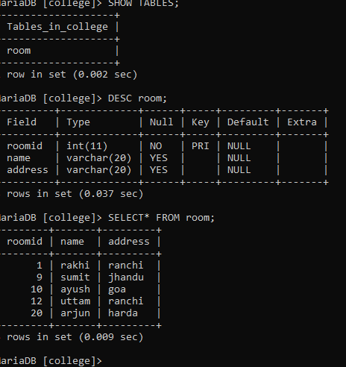

After the creation of the table room from the pthon program

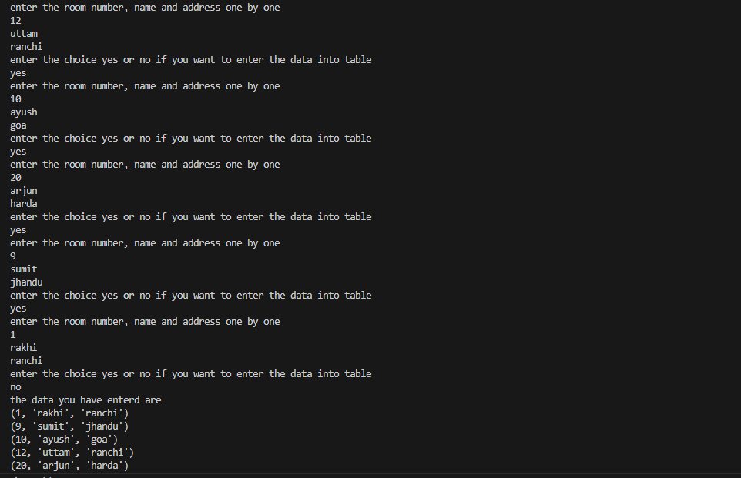

Entering the data one by one in table created by me above.



Here we show my table data that I inserted

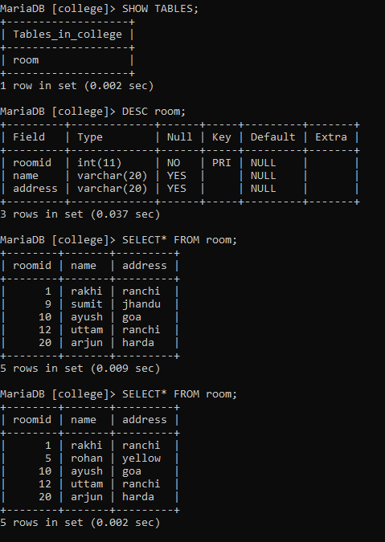

After updation of sumit to rohan in the table through the program python

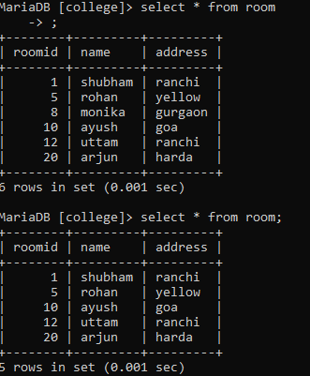

Firstly I insert the tuple monika then we delete the tuple of monika