Query 1: Write a query to display name, job, hiredate and employee number for each employee with employee number appearing first.

# Solution

## SELECT empno, ename, job, hiredate FROM emp;

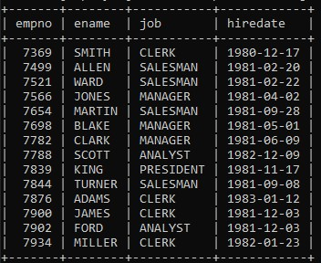

Query 2: Write a query to display unique jobs from the employee table.

# Solution

## SELECT DISTINCT job FROM emp;

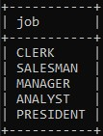

Query 3: Write a query to display name concatenated by a job separated by a comma.

# Solution

## SELECT CONCAT(ename, ", ", job) FROM emp;

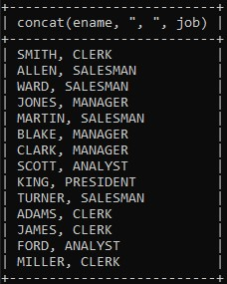

Query 4: Write a query to display the name and salary of employees earning more than $2850.

# Solution

## SELECT ename, sal FROM emp WHERE sal > 2850;

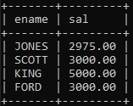

Query 5: Write a query to display the name and department number for employee number 7900.

# Solution

## SELECT ename, deptno FROM emp WHERE empno = 7900;

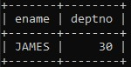

Query 6: Write a query to display the name and salary of all employees whose salary is not in the range of $1500 and $2850.

# Solution

## SELECT ename, sal FROM emp WHERE sal NOT BETWEEN 1500 AND 2850;

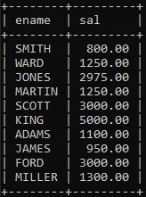

Query 7: Write a query to display the name and department number of all employees in departments 10 and 30 in alphabetical order by name.

# Solution

## SELECT ename, deptno FROM emp WHERE deptno = 10 OR deptno = 30 ORDER BY ename;

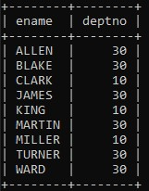

Query 8: Write a query to display the name and salary of employees who earned more than $1500 and are in department number 10 or 30.

# Solution

## SELECT ename, sal FROM emp WHERE sal > 1500 AND (deptno = 10 OR deptno = 30);

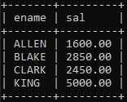

Query 9: Write a query to display the name and hire date of every employee who was hired in 1981.

# Solution

## SELECT ename, hiredate FROM emp WHERE hiredate LIKE "1981%";

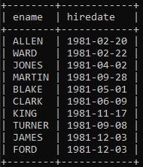

Query 10: Write a query to display the name and job of all employees who do not have a manager.

# Solution

## SELECT ename,job FROM emp WHERE NOT (job='Manager');;

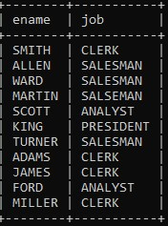

Query 11: Write a query to display the name, salary and commission for all employees who earn commission. Sort the data in descending order of salary.

# Solution

## SELECT ename, sal, comm FROM emp WHERE (comm IS NOT NULL) AND (comm <> 0.00) ORDER BY sal DESC;

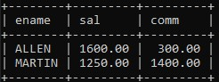

Query 12: Write a query to display the names of all employees where the third letter of their name is A.

# Solution

## SELECT ename FROM emp WHERE ename LIKE "__A%";

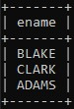

Query 13: Write a query to display the names of all employees that have two R's or A's in their name and are in department number 30 or their manager is 7788.

# Solution

## SELECT ename FROM emp WHERE ((ename LIKE "%A%A%" OR ename LIKE "%R%R%") AND deptno = 30) OR mgr = 7788;

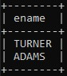

Query14. Write a query to display the name, job and salary of all employees whose job is clerk or analyst, and their salary are not equal to 1000, 3000 or 5000.

# Solution

## SELECT ename, job, sal FROM emp WHERE (job = "clerk" OR job = "analyst") AND (sal NOT IN (1000, 3000, 5000));

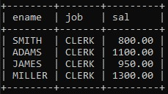

Query15. Write a query to display the name, salary and commission of all employees whose commission amount is greater than their salary increased by 5%.

# Solution

## SELECT ename, sal, comm FROM emp WHERE comm > sal * 1.05;

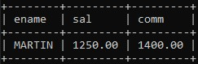

Query16. Write a query to display a current date.

**Solution**

## SELECT CURDATE();

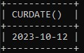

Query17. Write a query to display employee number, name, salary, salary increased by 15% expressed as a whole number.

# Solution

## SELECT empno, ename, sal, (sal * 1.15) AS aggr_sal FROM emp;

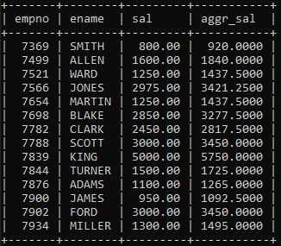

Query18. Write a query to display the employee number, name, salary, salary increased by 15% expressed as a whole number and increase in salary.

# Solution

## SELECT empno, ename, sal, (sal * 1.15) AS aggr_sal, ((sal * 1.15)-sal) AS incr_sal FROM emp;

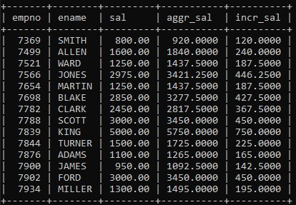

Query19.Write a query to display the following for each employee: -

<ename> earns <salary> monthly but wants <3 times salary>. Label the column as Dream Salary.

# Solution

## SELECT CONCAT(ename, " earns ", sal, " but wants ", 3 * sal) AS "Dream Salary" FROM emp;

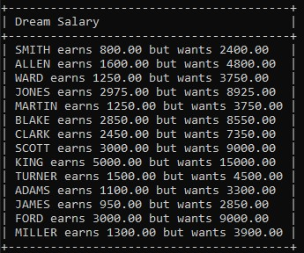

Query20.Write a query to display the employees name with the first letter capitalized and all other letters lower case and length of their name for all employees whose name start with J, A and M.

# Solution

## SELECT CONCAT(UPPER(SUBSTRING(ename, 1, 1)), LOWER(SUBSTRING(ename, 2))) AS "Employee Name" FROM emp WHERE (ename LIKE "J%" OR ename LIKE "A%" OR ename LIKE "R%");

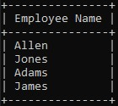

Query21. Write a query to display the name, department name, department number for all employees.

# Solution

## SELECT e.ename AS "Employee Name", d.dname AS "Department Name", d.deptno AS "Department Number" FROM emp e JOIN dept e ON e.deptno = d.deptno;

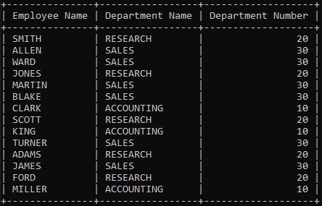

Query22. Write a query that displays the unique listing of all jobs that are in department 30.

# Solution

## SELECT DISTINCT job FROM emp WHERE deptno = 30;

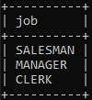

Query23. Write a query to display the employee name, department name and location for all employees who earn a commission.

# Solution

## SELECT e.ename AS "Employee Name", d.dname AS "Department Name", d.loc AS "Department Location" FROM emp e JOIN dept d ON e.deptno = d.deptno;

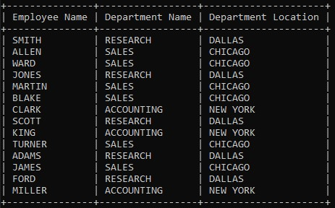

Query24. Write a query to display the employee name and department name for all employees who have 'A' in their name.

# Solution

## SELECT e.ename AS "Employee Name", d.dname AS "Department Name" FROM emp e JOIN dept d ON e.deptno = d.deptno WHERE e.ename LIKE "%A%";

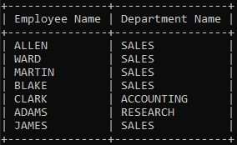

Query25. Write a query to display the name, job, department number and department name for all employees who work at location DALLAS.

# Solution

**SELECT e.ename AS "Employee Name", e.job AS "Job", d.deptno AS "Department Number", d.dname AS "Department Name" FROM emp e JOIN dept d ON e.deptno = d.deptno WHERE d.loc = "DALLAS";**

