CSE35101 Assignment 1 20211181 양성지

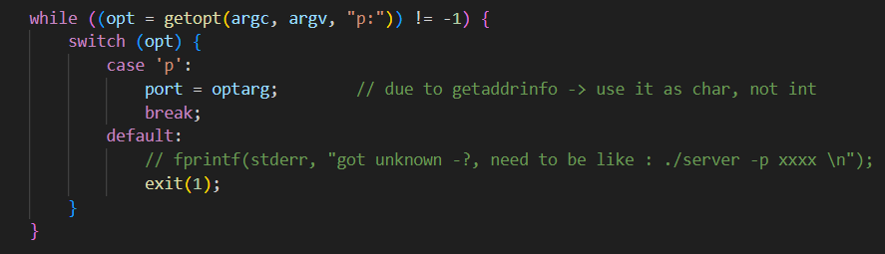
For easy parsing, used getopt()
Automatic htons() / htonl()
Set header + string (key + data) size to maximum 10MB
Exit the loop if EOF is met
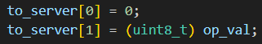
From Discussion, since actual op value takes 8 bit (1 byte), 8 bit is padding space.
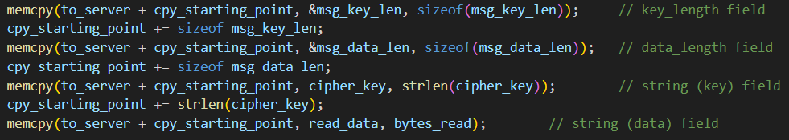
Make array to send the message
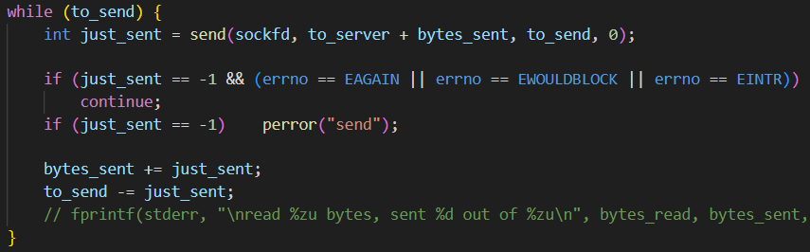
Loop in case it fails to send all the messages as planned. Also check if error was temporary or actual error.
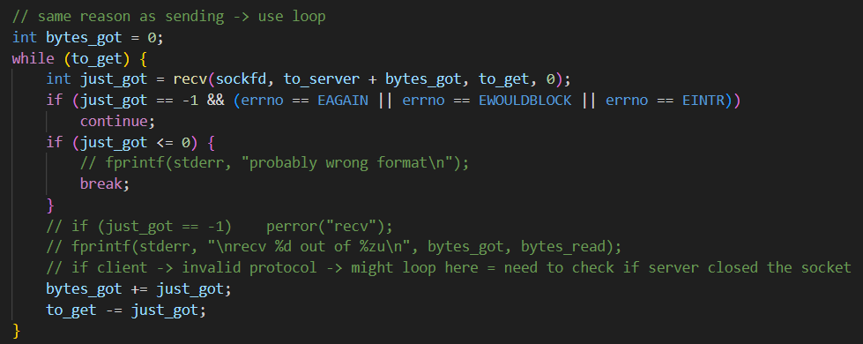
Same logic as send
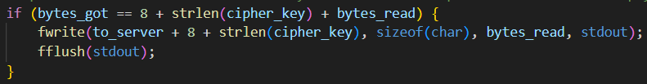
From Discussion, since the client doesn’t check the server’s response, and it already knows the length of the data, it just prints it out.
Events 51 since one server + maximum 50 clients
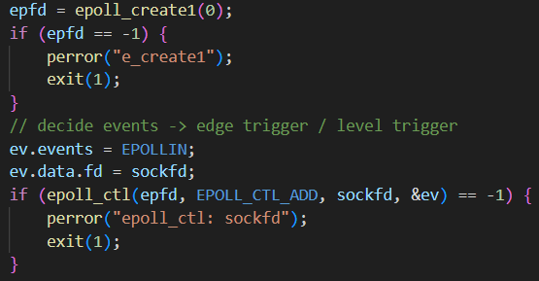
Make epoll, and add listening socket’s fd to epoll
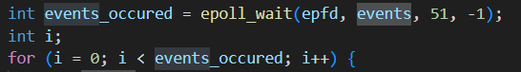
Loop all events made
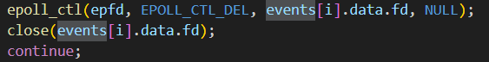
When terminating, remove from epoll, then close.
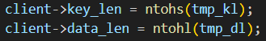
Change key_length, data_length from network order
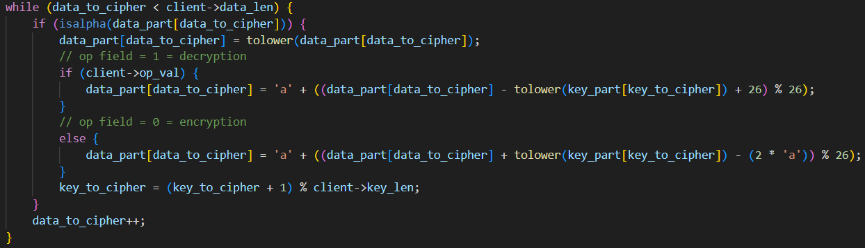
Cipher logic : check alphabet, then do encryption / decryption.

I Annotated all debugging codes (fprintf(stderr, ...) or perror())
With high probability, when the server already has 50 clients, and more clients wish to access the server, there would be “send: Connection reset by peer” error if it is printed with perror(), since the server denied the client from accessing.

references :
skeleton codes : https://beej.us/guide/bgnet/html/multi/index.html , https://gdngy.tistory.com/186
How to parse command line (getopt()) : https://man7.org/linux/man-pages/man3/getopt.3.html
error handling : https://sthyun.tistory.com/entry/EWOULDBLOCKEAGAIN , https://www.it-note.kr/125
socket : https://man7.org/linux/man-pages/man2/socket.2.html
epoll : https://eteo.tistory.com/903 , https://man7.org/linux/man-pages/man7/epoll.7.html , https://narakit.tistory.com/100 , https://stackoverflow.com/questions/73878961/setnonblocking-on-epoll-man-page

