CSE35101 Assignment 2 20211181 양성지
Used same method of starting the proxy server as in PA1’s server.

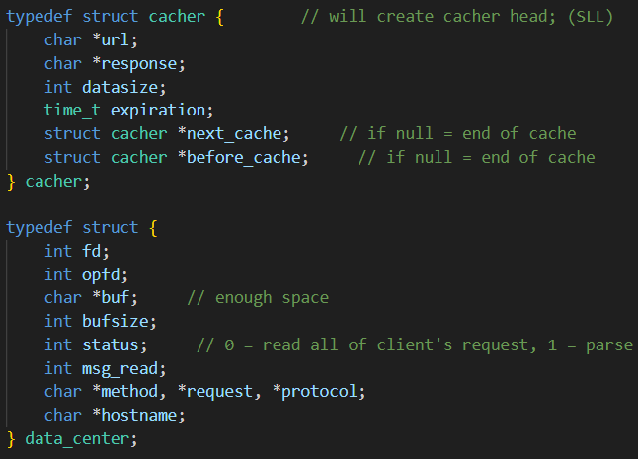
Structs used to save client’s request, server’s response.
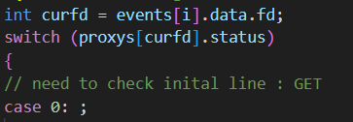
Used switch + case to clarify the proxy’s action.
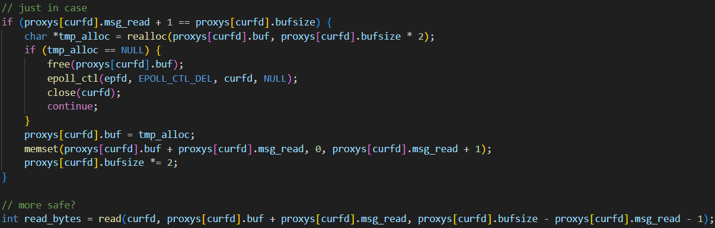
In case of longer request, check and realloc the buffer if needed (same method is used when getting the server’s response)
Check if header has all been written (being generous and support both \n and \r\n)
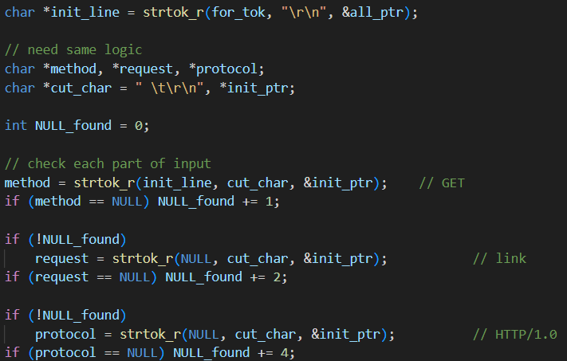
Extract method, URL, protocol by tokenizing the string. Same is applied with Host header as well.
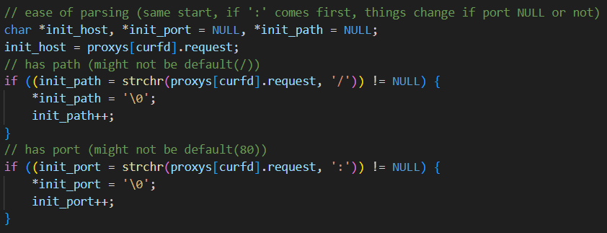
Extract actual host, port, path from URL.
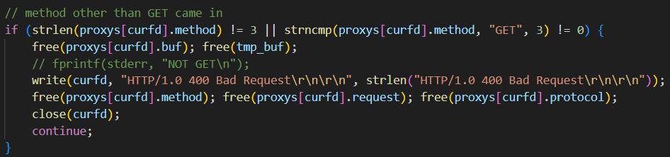
Error handling method, rest similar to this.
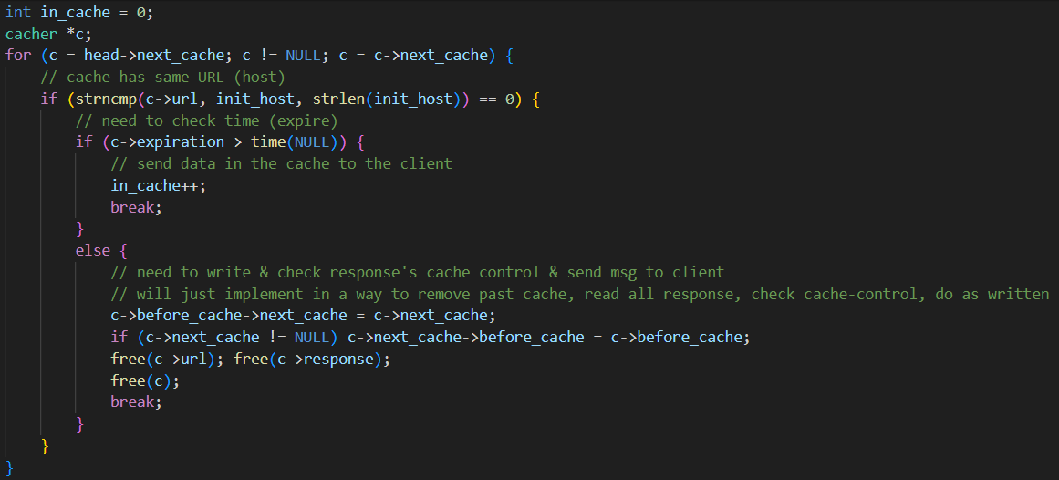
Check cache, if in the cache, proxy will be able to know with in_cache
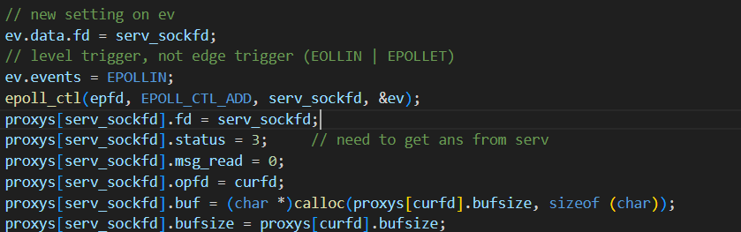
Create new fd to communicate with actual server.
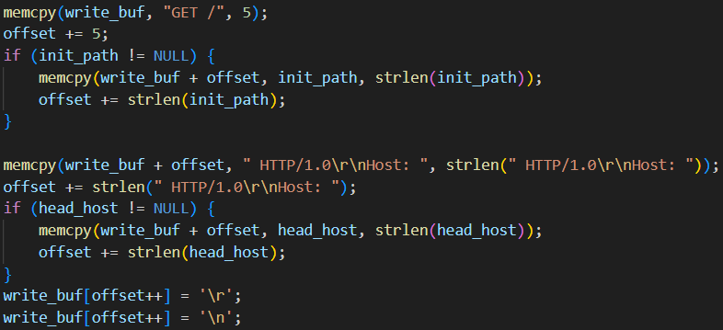
Organizing message to write to server.
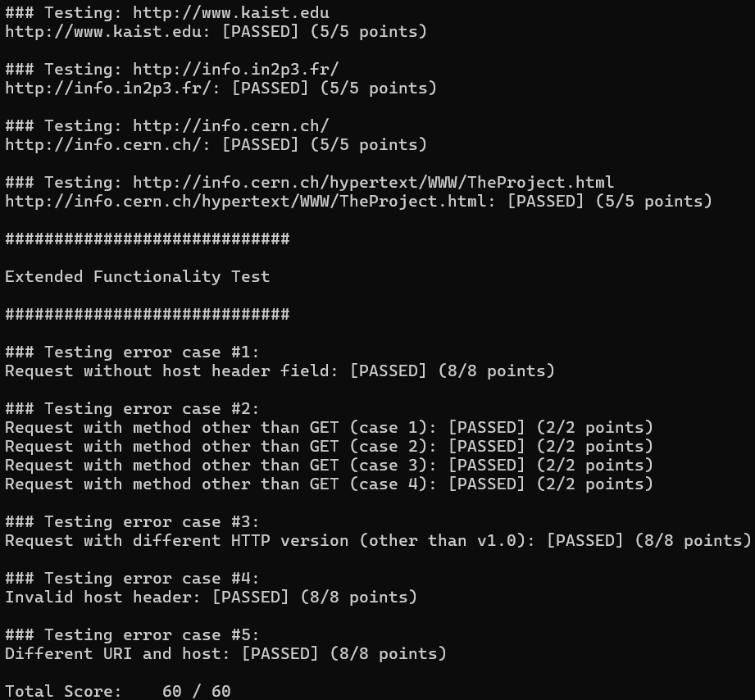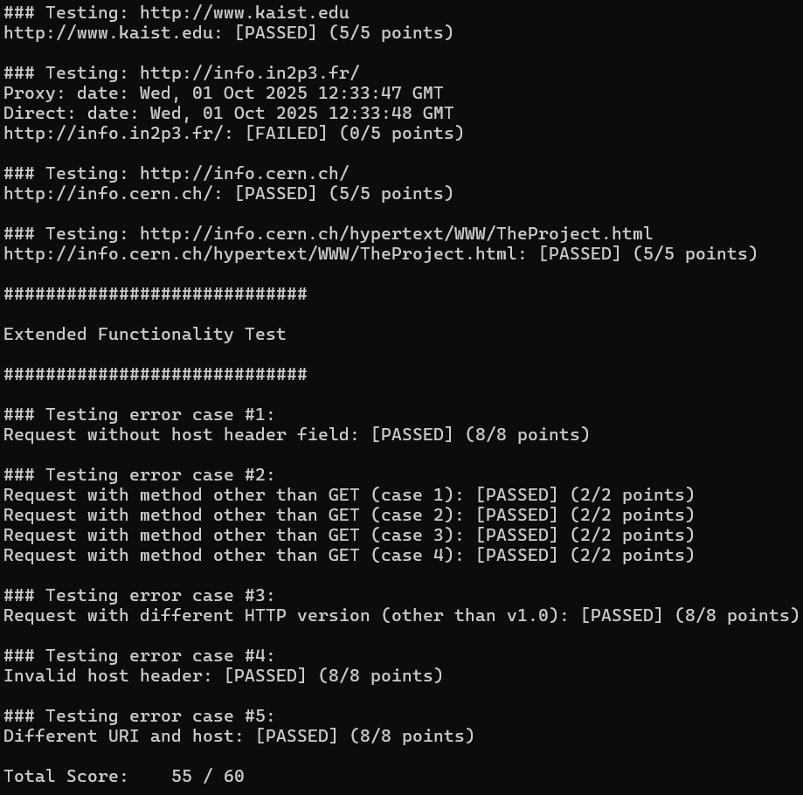
Like this, the second testcase’s result vary (same as last Q&A in Error Message Handling Issues)
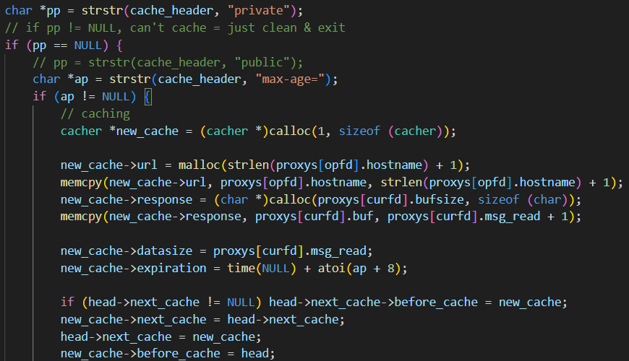
Verify and cache server’s response.
references :
https://www.ietf.org/rfc/rfc1945.txt
https://learn.microsoft.com/ko-kr/windows/win32/api/winsock2/nf-winsock2-listen
https://en.cppreference.com/w/c/string/byte.html
https://stackoverflow.com/questions/19338846/winsock2-getaddrinfo-to-resolve-a-hostname
https://developer.mozilla.org/en-US/docs/Learn_web_development/Howto/Web_mechanics/What_is_a_URL
https://developer.mozilla.org/en-US/docs/Web/HTTP/Guides/Messages

