CSE35101 Assignment 3 20211181 Seong-Ji Yang

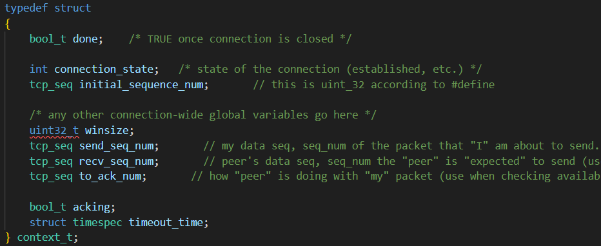
These are the required states, and Struct context_t, with added arguments for window size, my/peer’s sequence number, ack number, for delayed ack, and actual timeout time.
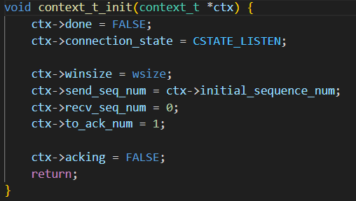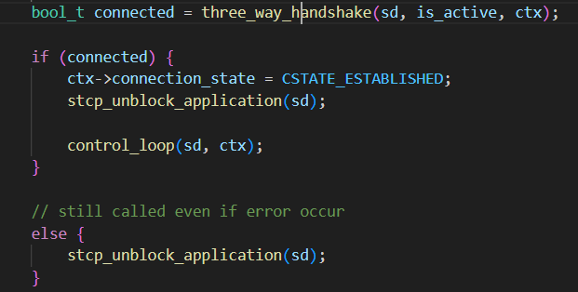
Additional function that initializes the context_t struct. And as written in the annotation, to check connection.
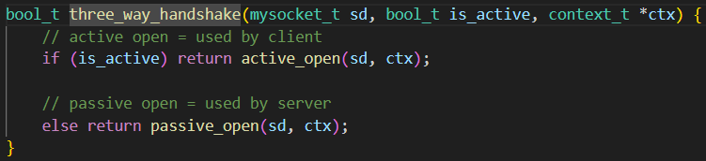
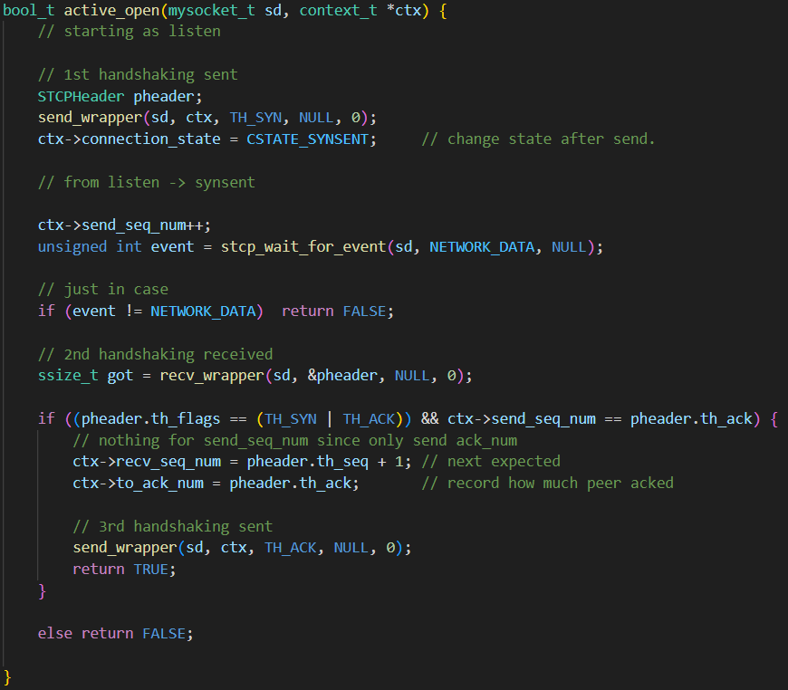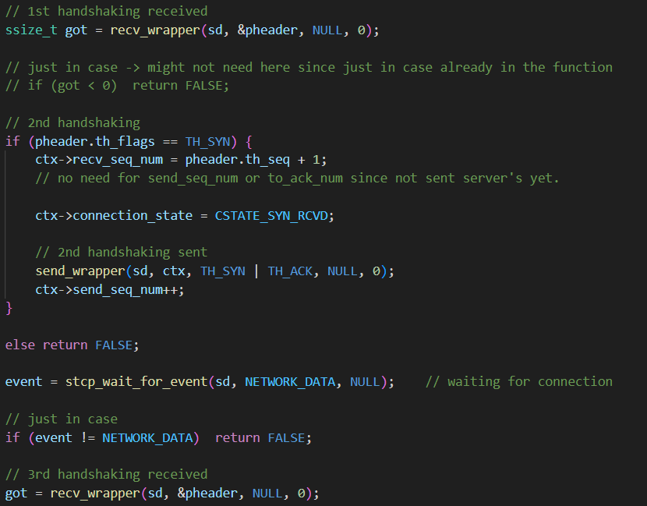
3-way handshaking function with active open and passive open.
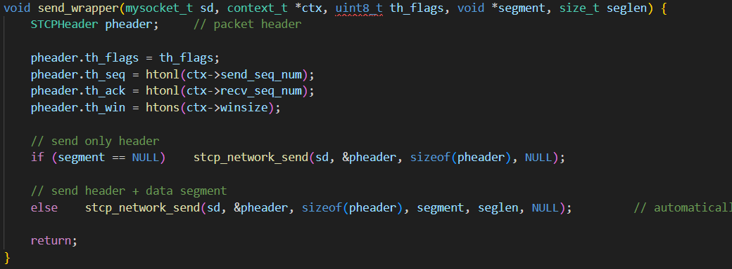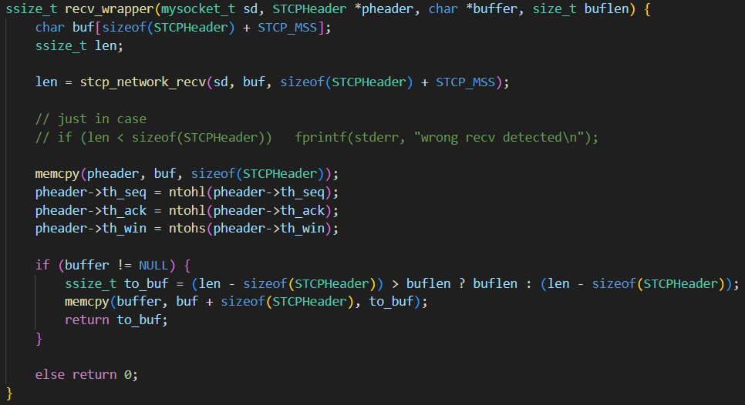
Wrapper functions for send and receive through network layer.
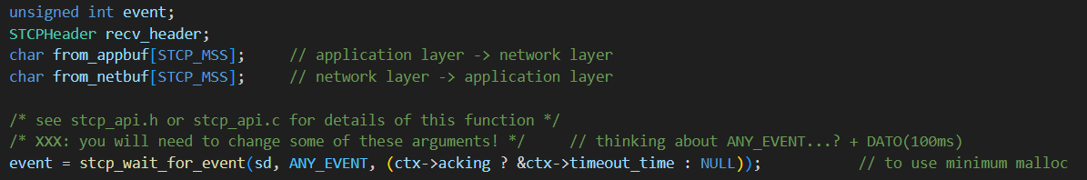
Control_loop, used ternary operator to not use malloc if possible. Also, two buffer to clarify received data and data to send.
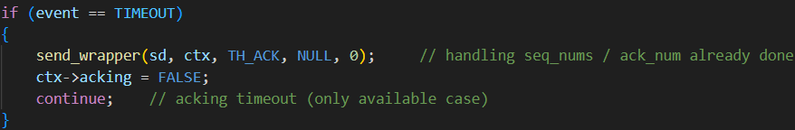
It used “==” since “&” means 0, which can’t go in the if statement.
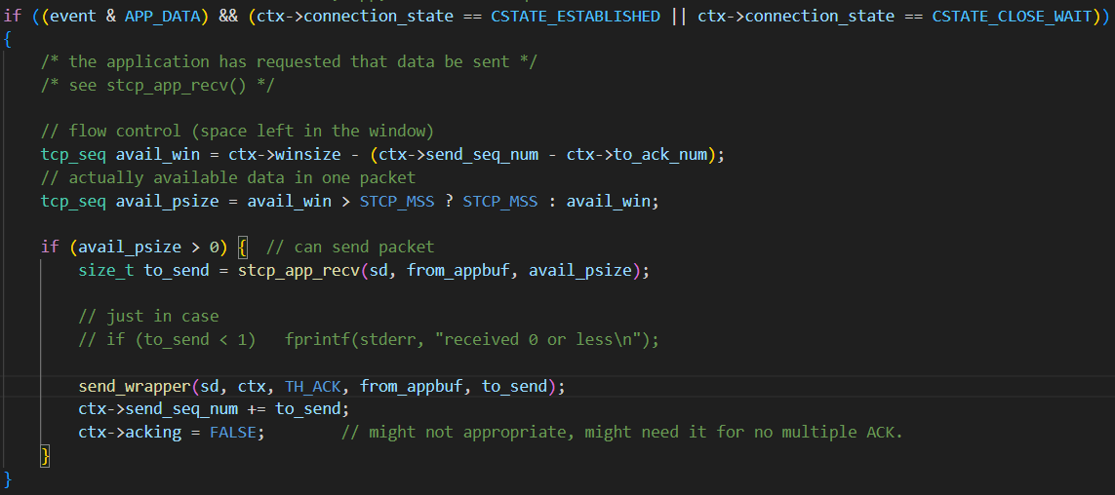
Logic to handle application layer signal. CLOSE_WAIT state can still send data
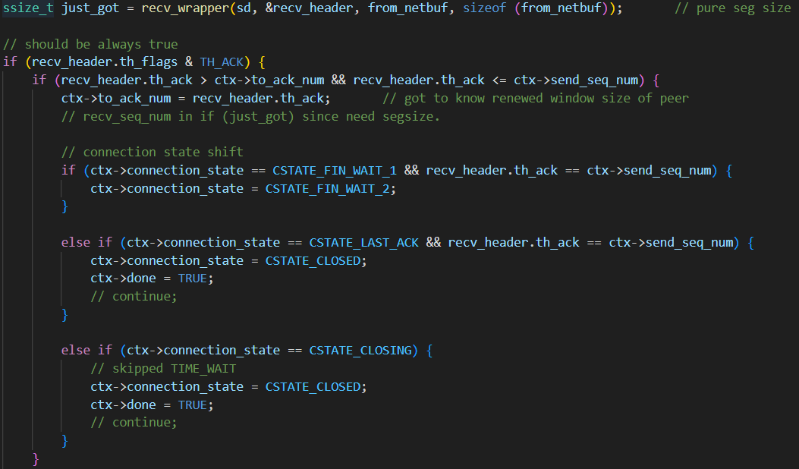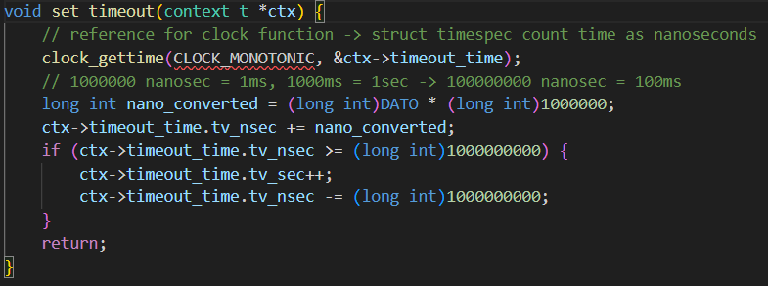
State change according to what state it is currently in, and function to set timeout time to be after 100ms.
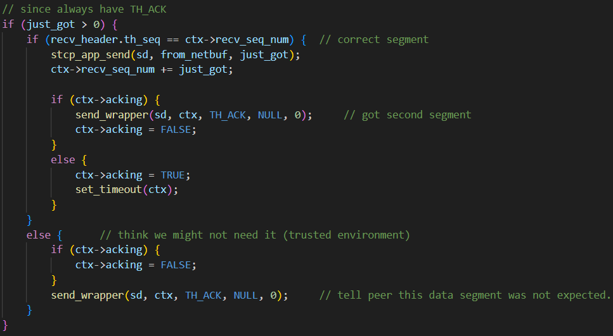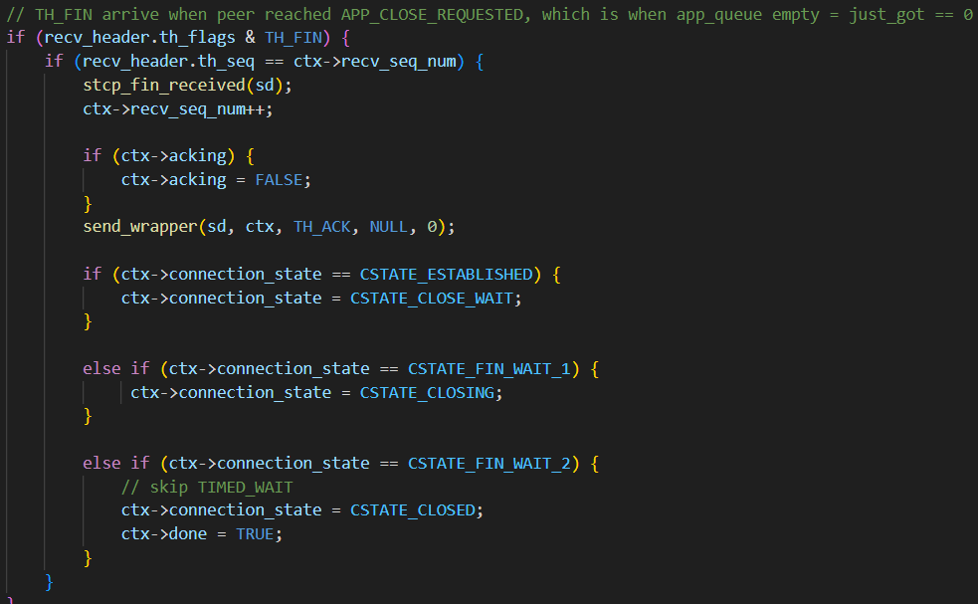
Since TH_FIN means queue is empty, so can send no data, so divided the action that takes when data is received, so only one out of these two will be done.
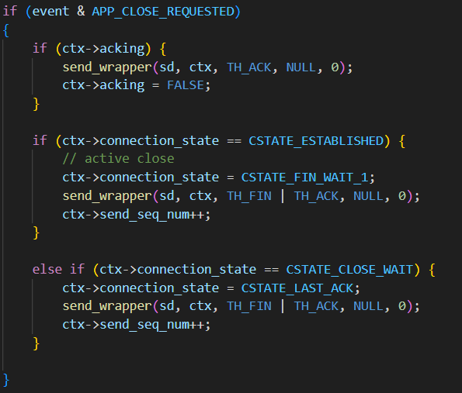
This means that 4-way handshake will be held, or being held.

No timed_wait state has been actually used (simplified to close right away, as written in the pdf).

References:
Timeout : https://exeter.tistory.com/1108
Handshaking & data transfer : https://tools.ietf.org/html/rfc793

