CSE35101 Assignment 4 20211181 Seong-Ji Yang

Proof of Forwarding and ARP
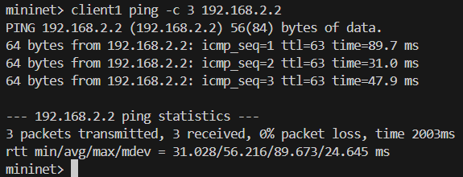
Echo reply
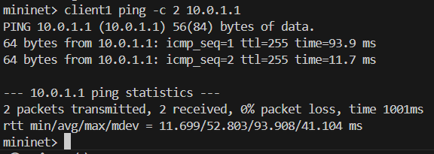
Destination Net Unreachable
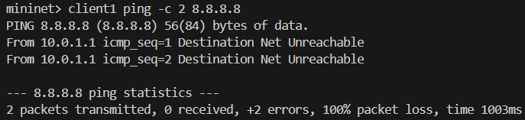
Destination Host Unreachable
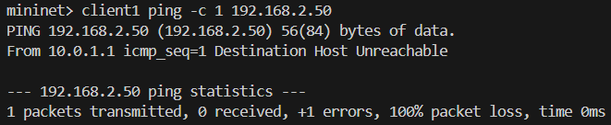
Port Unreachable
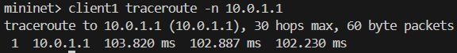
Time Exceeded
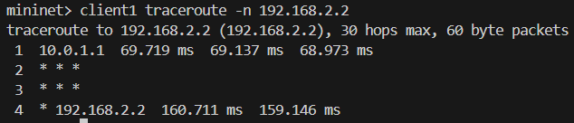
Firewall
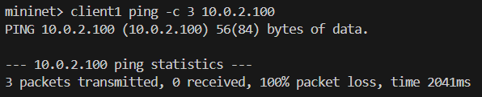
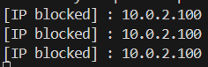

References :
https://www.scs.stanford.edu/09au-cs144/lab/router.html
https://datatracker.ietf.org/doc/html/rfc792
https://datatracker.ietf.org/doc/html/rfc826

