 | MINISTRY OF EDUCATION AND TRAINING

FPT UNIVERSITY

Capstone Project Document
[Subject]

[Title]

Unicorn
Group Members | Nguyen Tuan Minh – 01135  Nguyen Hong Nam – 00903  Nguyen Tien Huy – 01016  Nguyen Truong Hung – 00838  Nguyen Minh Hieu – 00684
Supervisor | Nguyen Tat Trung
Capstone Project code | E-learning-website

- Hanoi, 08/2012-

Installation Guide
  - System requirements

User Guide
  - Interface Walk-through
There is the public interface that is open to anyone who visits the web site, which can only be seen to those who have access.
Figure 2.1 shows Home page anyone who visits
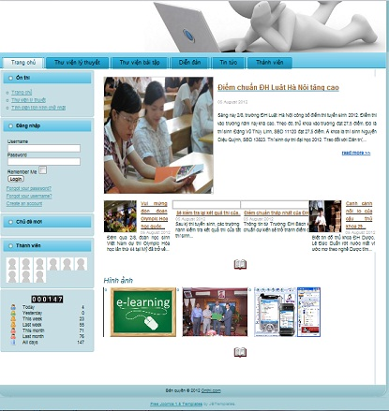
Figure 2.1: The public interface of “Onthi.com” allows a user to view theory and do question in tab”Thư viện lý thuyết”, go to forum when click tab “Diễn đàn”, do question to practice in tab ”Thư viện bài tập”, view news in tab ”Tin tức” and view members in tab “Thành viên”.
In this user guide part, you will be exploring the following sections of the interface:

¸ Homepage
¸ Tab ”Thư viện lý thuyết”
¸ Tab ”Thư viện Bài tập”
¸ Forum
¸ Tab “Tin tức”
¸ Tab “Thành viên”
¸ Tab “Đề thi”

  - Hompage
When user visit “Onthi” website, homepage will be displayed. As shown in Figure,
list of useful information of homepage.

[1] Click link “Trang chủ”: Go to Home page.
[2] Click link “Thư viện lý thuyết”: Go to theory library page to select theory want to read.
[3] Click link “Thư viện bài tập”: Go to exercise library page to select exercise in theory want to do.
[4] Click Link “Diễn đàn”: Go to forum.
[5] Click link “Tin tức”: Go to news page.
[6] Click link “Thành viên”: View member of site
[7] Left menu: to use functions of site.
[8] Login, log out: Login and log out site.
[9] ”Chủ đề mới” panel: show new thread create in forum
[10] “Thành viên” panel: Show number access this site, and member of site.
[11] Area show news: show news of site.
[12] Area “Hình ảnh”: user can view picture of Site
[13] Tab “Đề thi”: after Login site user can see tab “Đề thi”. You can do exam in it

