**Opening a pub in Central London**

**Anitya Vilekar**

**June 2020**

**1. Introduction –**

With a large number of sports bars and pubs, and an equally large number of frequenters, chains or individuals looking to open their own pubs face severe competition. Even though pricing, number screens, quality, etc. would be major influences in attracting customers, location and nearby competitors are equally important. New set ups would want to avoid areas with multiple, established pubs, in order to be able to build their reputation. A presence of public transport near the location would also improve the percentage of buyers, by removing the need of designated drivers within customer groups.

This project will work towards analyzing and selecting areas in London that would be strong contenders for opening a new pub.

**2. Data –**

The main dataset used was obtained from data.gov.uk, which was location based data for Public Transport access points in London. These locations were used to search for nearby venues with the FourSquare API. The resulting dataset had to be filtered, and only the data corresponding to pubs was retained. This new dataset in addition with the transport dataset was used to assess the problem.

**3. Exploratory Data Analysis –**

The dataset obtained from the FourSquare queries was used to generate a map highlighting the locations of pubs in London. The public transport database was then used to highlight the access points within the same map. These overlapping points on the map revealed regions of interest.

Clustering of the data within the pubs database was done using KMeans, and the resulting cluster plotted on the map. Finally, public transport access points with no pubs in a 500m radius were plotted against the cluster map, to reveal suitable spots for the new pub.

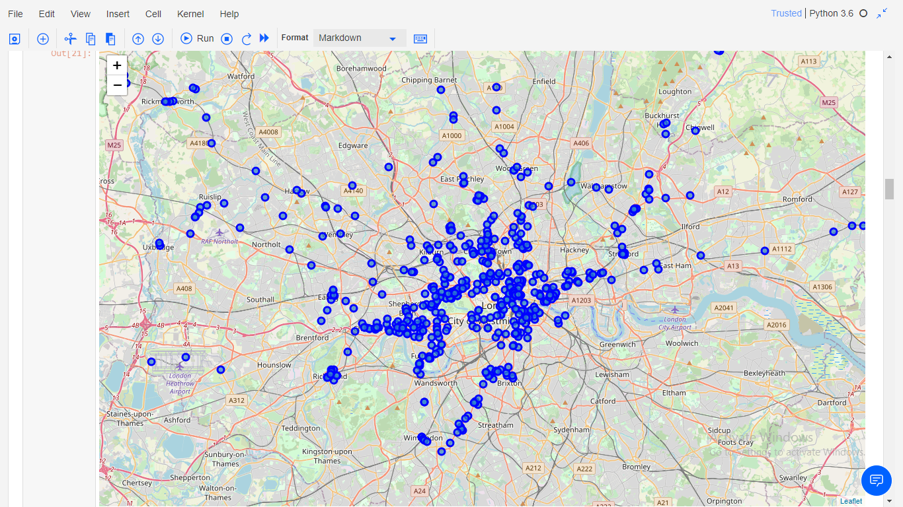

(Map showing all pubs within London)

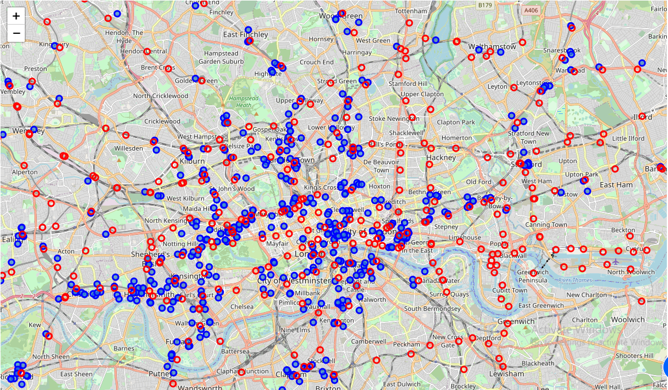

(Pubs in London superimposed with public transport access points)

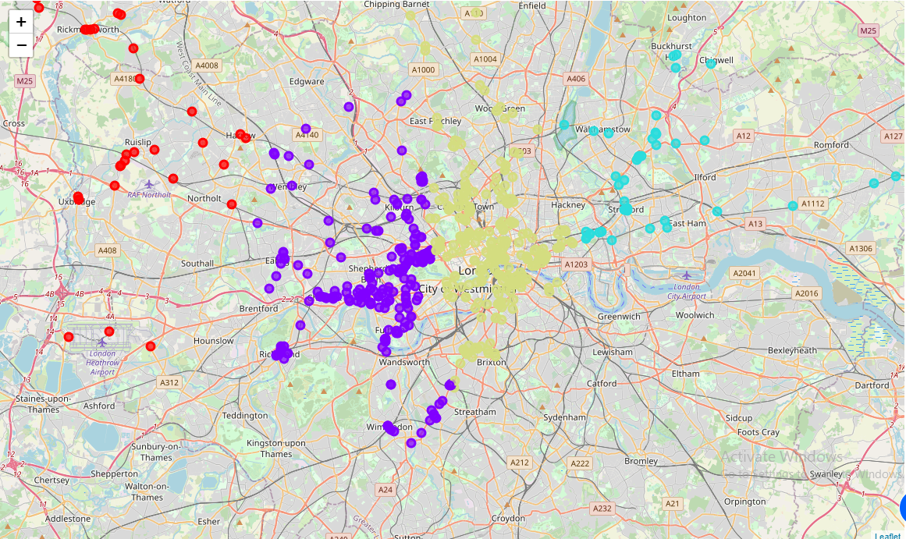

(Map highlighting pub clusters in London)

**4. Results –**

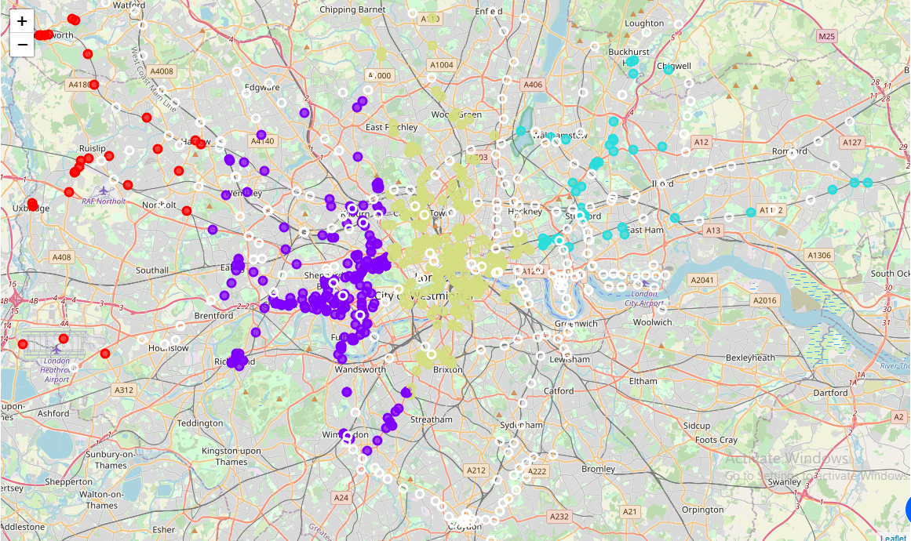The final map highlights 264 points where public transport can be accessed, with no existing pubs nearby. Although this contains many outlying points outside Central London that are irrelevant to the problem at and, the suitable points can be selected and explored using this map.

**5. Conclusion –**

From an analysis of the map it can be concluded that the areas of Chelsea, Mayfair, and Hackney are suitable spots for opening a new pub. These areas have easy access to public transport, and are densely populated due to their presence in the center of the city.