Exponential Function Simulation

Using the exponential function, let's examine the distribution of averages of multiple sets of 40 exponentials. The mean of an exponential function is 1/lambda and the standard deviation is also 1/lambda. For these simulations, lambda will be 0.2.

library(ggplot2) #load ggplot2 package  
set.seed(314) #set seed for reproducible results

Let's run 1000 simulations averaging 40 sample expontential samples.

nosim <- 1000  
n <- 40  
lambda <- 0.2

Set the mean of the 40 exponential samples as a function to be used to create a data frame of 1000 simulation values.

test <- function(n=n,lambda=lambda) mean(rexp(n, lambda))  
dat <- data.frame(x = c(apply(matrix(n,nosim), 1, test,lambda)))

Plotting a histogram of the results shows the distribution of average simulation values.

g <- ggplot(dat) + geom_histogram(aes(x=x,y=..density..), colour = "black", fill = "blue")   
g <- g + labs(title = "Histogram of 1000 means of 40 exponential samples")  
g <- g + labs(x = "Mean of 40 Samples of Exponential Distribution") + labs(y = "Density")  
g <- g + stat_function(fun = dnorm, size = 3, args = list(mean = 1/lambda, sd = 1/sqrt(n)/lambda))  
g <- g + geom_vline(xintercept = 1/lambda, colour = "black", size = 3)  
g <- g + geom_vline(xintercept = mean(dat$x), colour = "red", linetype = "longdash", size = 2)  
g <- g + annotate("text", x = 6.4, y = 0.55, label = "Expected Mean = 1/lambda = 5")  
g

## stat_bin: binwidth defaulted to range/30. Use 'binwidth = x' to adjust this.

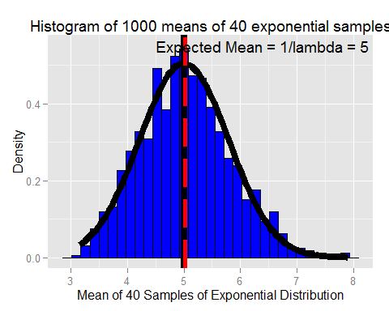

**1. Show where the distribution is centered at and compare it to the theoretical center of the distribution.**

The distribution mean (red dashed line) is centered near the theoretical mean (black line) near 5. The expected mean is 1/0.2 = 5. The calculated mean is 5.0233404.

**2. Show how variable it is and compare it to the theoretical variance of the distribution.**

The expected variance is calculated using 1/(n*lambda^2). The calculated variance is close and would be closer with more simulations.

exp_var <- round(1/(n*lambda^2),3)  
calc_var <- round((sd(dat$x))^2,3)  
print(c("Expected Variance =", exp_var))

## [1] "Expected Variance =" "0.625"

print(c("Calculated Variance =", calc_var))

## [1] "Calculated Variance =" "0.651"

**3. Show that the distribution is approximately normal.**

Plotted with the histogram is is a normal distribution with a mean of 1/0.2 =5 and a standard deviation of (1/sqrt(n)*lambda) = 1/(sqrt(40)*0.2) = 0.791, which matches the histogram well.