1) Write Java statements that accomplish each of the following tasks:

a) Display the message "Enter an integer:", leaving the cursor on the same line.

b) Assign the product of variables b and c to the int variable a

**int a = b * c;**

c) Use a comment to state that a program performs a sample payroll calculation.

2) What is a default constructor?

**A default constructor is a type of constructor that is automatically created by the Java compiler in the absence of any explicit constructor definitions in the class.**

How are an object’s instance variables initialized if a class has only a default constructor?

3) Explain what happens when a Java program attempts to divide one integer by another. What happens to the fractional part of the calculation?

**When we divide int by int value the output will be integer**

How can you avoid that outcome? **To avoid outcome we need to use for example double**

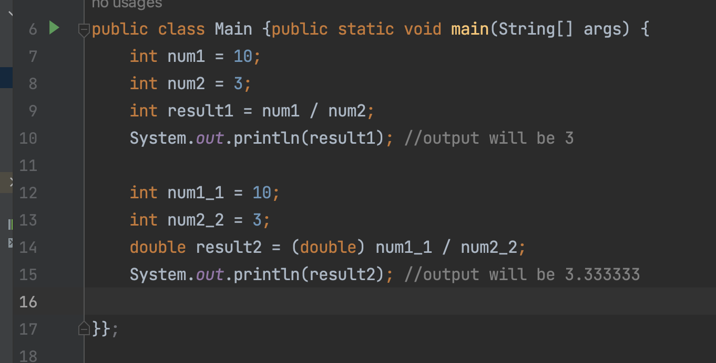

4) What is the value of x after each of the following statements is executed?

a. double x = Math.abs(7.5); **output 🡪 7.5**

b. double x = Math.floor(7.5); **output 🡪 7.0**

c. double x = Math.abs(0.0); **output 🡪 0.0**

d. double x = Math.ceil(0.0); **output 🡪 0.0**

e. double x = Math.abs(-6.4); **output 🡪 6.4**

f. double x = Math.ceil(-6.4); **output 🡪 -6.0**

g. double x = Math.ceil(-Math.abs(-8 + Math.floor(-5.5))); **output 🡪 -14.0**

5) Write statements that perform the following one-dimensional-array operations:

a. Set the 10 elements of integer array counts to zero.

b. Add one to each of the 15 elements of integer array bonus.

c. Display the five values of integer array bestScores in column format.

