#1

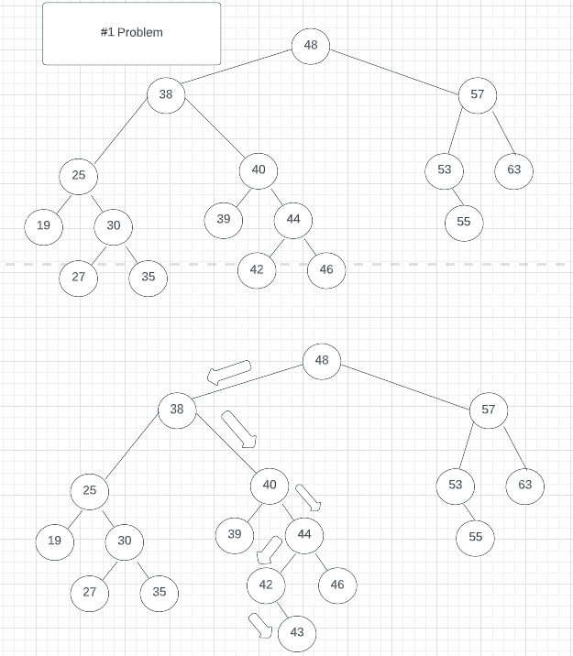

2#

#3.

#4

