#1. (((15 / (1*3)) + 9) – (3*(2+1)) = 5

#2. ((3*(16 / (8 - 6))) – (12 – (3+2))

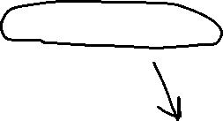

#3. a b d m g f h e j i k c l

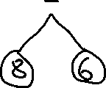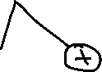

#4. m g d h f b j e c k l i a

#5. a b e i d f j k l m g h c

#6. j h f c i e g a d k b l

7#.

|  |  |  |  |  |  |  |  |  |  |  |  |  |  |  |
| --- | --- | --- | --- | --- | --- | --- | --- | --- | --- | --- | --- | --- | --- | --- |
| 0 | 1 | 2 | 3 | 4 | 5 | 6 | 7 | 8 | 9 | 10 | 11 | 12 | 13 | 14 |
| - | + | * | 2 | / | 3 | + |  |  | 15 | 5 |  |  | 2 | 1 |

8#. The maximum number nodes in a binary tree of height h is 2h+1 – 1.

Prove this property for any h ≥ 0 using mathematical induction.

**Base step**: h = 0

2K+1 – 1 = 21 -1 = 1 number of nodes 1

**Induction:** for, k, number of nodes = 2K+1 – 1

We will assume that for a height h that the statement is true. We must therefore show that a binary search tree of height

for, k+1, number of nodes = (2K+1 – 1) + (2k+1-1) + 1 =

= 2K+1 – 1 + 2K+1

= > 2K+2 – 1

The statement is true for h = 0 and the truth of the statement for and height h implies the truth of the statement for k + 1. Therefore, by the process of mathematical induction, the statement must be true for all h ≥ 0.