Vision-Based Smart Parking Occupancy Detection System
Using Dual YOLO Architecture


01276390 – Computer Engineering Project Preparation (CEPP)
REPORT TITLE: Detecting Unoccupied Parking Lanes Using a Single Angle Surveillance Camera
INSTRUCTED BY: Jirayut Petchhan
NAMES & IDs:
Kunanon Rungsomboon – 66011049
Mihini Methasa Welatantirige Boteju - 66011666
Papangkorn Wongsuwan – 66011117

Abstract

Efficient parking management is a critical challenge in modern urban environments. Traditional approaches, relying on physical sensors or manual observation, are costly, difficult to scale, and prone to failure. This report presents the design and implementation of a Vision-Based Smart Parking Occupancy Detection System that leverages a Dual YOLO deep learning architecture combined with Perspective Transformation (Bird's Eye View) to accurately monitor parking availability in real time.
The system employs two specialized models: a parking spot detector (spots.pt) that identifies vacant parking bays from a reference image, and a vehicle detector (best.pt) that tracks cars frame-by-frame in live video. Occupancy is determined by projecting both car positions and spot centres into a Bird's Eye View coordinate space, eliminating perspective distortion, and applying a greedy distance-based matching algorithm. A self-healing mechanism automatically recalibrates spot positions at 2:00 AM when traffic is low, ensuring robustness against camera drift. Four YOLO model variants (Nano and Small, across two dataset configurations) were trained for 50 epochs and benchmarked. The YOLOv11 Small model achieved the highest mAP@50 of 96.4% and mAP@50-95 of 80.7%, and was selected for deployment. The system produces a clear real-time dashboard overlay, providing parking operators with live FREE and OCCUPIED counts at a glance.

Key Terms & Glossary
The following terms are used throughout this report. Readers unfamiliar with computer vision or deep learning are encouraged to refer to this section as needed.

YOLO (You Only Look Once): A family of real-time object detection neural networks that frame detection as a single regression problem, enabling high-speed inference without a separate region-proposal stage. This project uses YOLOv11, the 11th generation of the YOLO architecture released by Ultralytics, which introduces an improved C3k2 backbone and spatial attention mechanisms.
BEV — Bird’s Eye View: A top-down 2D projection of the parking lot ground plane onto a flat canvas. Because the projection is scale-normalized, objects at different distances from the camera appear at their correct relative sizes, enabling a single fixed distance threshold to be used reliably across the entire parking zone.
Homography: A 3×3 mathematical transformation matrix that maps corresponding points between two planes — in this project, from the camera’s perspective image to the flat Bird’s Eye View canvas. Four ground-plane anchor points are used to compute the matrix, which is then stored in homography.json and applied every frame.
mAP@50 / mAP@50-95 (Mean Average Precision): The standard object detection accuracy metric. mAP@50 measures precision at an IoU overlap threshold of 0.50 (a lenient match criterion). mAP@50-95 averages precision across IoU thresholds from 0.50 to 0.95 in steps of 0.05, providing a more demanding and comprehensive assessment of model quality.
IoU (Intersection over Union): The ratio of the overlapping area between two bounding boxes to their combined area. Used both as a matching criterion during evaluation (does a predicted box sufficiently overlap a ground-truth box?) and as a suppression criterion in NMS (should two overlapping detections be merged into one?).
NMS (Non-Maximum Suppression): A post-processing step applied after model inference to remove duplicate detections. When multiple overlapping bounding boxes are predicted for the same object, NMS retains only the box with the highest confidence score and discards the rest if their IoU exceeds a set threshold (0.4 for the spot detector in this project, 0.7 during training).
ONNX (Open Neural Network Exchange): A standardized format for exporting trained neural network models so they can be run efficiently on different hardware and software backends without retraining. ONNX export is used in this project to benchmark CPU and GPU inference speed independently of the PyTorch training framework.
FPS (Frames Per Second): The throughput of the video processing pipeline, measuring how many video frames are fully processed (detected, matched, and visualized) per second. A higher FPS indicates a faster, more responsive system. Our deployed model (y11s) achieves 102.85 FPS on GPU hardware.
COCO Weights (Transfer Learning): The COCO (Common Objects in Context) dataset is a large-scale benchmark containing 330,000 images across 80 object categories. Models pre-trained on COCO have already learned general visual features (edges, textures, shapes). Using these weights as a starting point — rather than random initialization — dramatically reduces training time and improves accuracy on smaller custom datasets such as ours.
Greedy Matching O(K log K): The occupancy assignment algorithm used in this system. All pairwise distances between detected cars and parking spots are computed in BEV space, sorted in ascending order, and assigned greedily — the closest car-spot pair is assigned first, then removed from consideration, and the process repeats. This runs in O(K log K) time where K is the number of detected cars, making it fast enough for real-time use even with many vehicles.

1. Introduction

1.1 Background and Motivation
The rapid growth of urban populations has intensified demand for efficient parking infrastructure. Studies estimate that drivers in busy cities spend an average of 17 minutes searching for a parking space per trip, contributing to traffic congestion, fuel waste, and increased carbon emissions (Shoup, 2011). Automated parking management systems offer a scalable and cost-effective solution to this problem by providing real-time occupancy information to both drivers and facility managers.
Conventional sensor-based systems (e.g., magnetic induction loops, infrared sensors, ultrasonic sensors) require extensive physical installation per parking bay and are expensive to maintain. Camera-based computer vision approaches have emerged as a compelling alternative, enabling a single camera to monitor an entire parking zone without per-bay hardware. Recent advances in deep learning, particularly the YOLO (You Only Look Once) family of object detectors, have made real-time camera-based solutions both fast and accurate enough for practical deployment.

1.2 Problem Statement
Existing single-model camera-based systems typically rely on either spot-region classification (checking each predefined bounding box for occupancy) or direct vehicle detection. The former approach requires manual annotation of every parking bay, while the latter struggles with perspective distortion — a car at the far end of a lot appears much smaller than one nearby, causing distance-based matching to fail. This project addresses both limitations through a dual-model architecture and Bird's Eye View perspective normalization.

1.3 Project Objectives
- Design and implement a dual-model YOLO pipeline for real-time parking occupancy detection.
- Apply Perspective Transformation (Homography) to eliminate camera distortion effects.
- Train and benchmark four YOLO variants to identify the optimal deployment model.
- Implement a self-healing recalibration mechanism for long-term operational robustness.
- Produce a clear, real-time visual dashboard overlay for practical use.

1.4 Scope
This project focuses on a single fixed-camera, single-zone parking lot deployment. The scope includes: the design and implementation of the dual-model YOLO detection pipeline; Bird's Eye View perspective normalization; greedy occupancy matching; self-healing recalibration; and a real-time OpenCV dashboard overlay. Out of scope are multi-camera orchestration, cloud/IoT integration, license plate recognition, and edge hardware optimization these are identified as directions for future work.

1.5 Report Structure
The remainder of this report is structured as follows: Chapter 2 reviews the status quo — traditional and camera-based parking systems and the identified research gap. Chapter 3 presents the key insights derived from the problem analysis that motivate the design decisions. Chapter 4 describes the proposed framework and system architecture in detail. Chapter 5 details the implementation tools and algorithms. Chapter 6 presents the experimental results and evaluation, including model training metrics (Sections 6.1–6.9), ONNX speed and efficiency benchmarks (Section 6.10), and a real-world throughput comparison across all model variants (Section 6.11). Chapter 7 provides a broader discussion of strengths, limitations, and practical impact. Chapter 8 concludes the report with a summary of contributions and directions for future work. References and appendices follow.
2. Literature Review and Current Limitations

2.1 Traditional Parking Detection Methods
Early automated parking systems relied on physical sensing hardware. Magnetic induction loop detectors, embedded in road surfaces, detect the metallic mass of a vehicle overhead. Infrared and ultrasonic sensor arrays mounted above each bay offer similar binary occupancy detection. While reliable in controlled environments, these approaches entail high installation costs, require per-bay hardware, and are susceptible to environmental interference (Benson et al., 2016). The per-space scalability problem makes them impractical for large open-air car parks.

2.2 Camera-Based Vision Approaches
Camera-based systems have been widely explored as a cost-effective alternative. Early work by de Almeida et al. (2015) demonstrated that hand-crafted feature methods (HOG + SVM) could achieve reasonable accuracy on a single static camera view. However, these approaches required careful illumination control and were brittle to viewpoint changes. The PKLot dataset (de Almeida et al., 2015) became a standard benchmark for evaluating such systems, providing over 12,000 annotated parking space images across different weather conditions.

2.3 Deep Learning and YOLO-Based Detection
The introduction of Convolutional Neural Networks (CNNs) dramatically improved visual recognition accuracy. Redmon et al. (2016) proposed YOLO (You Only Look Once), a single-stage real-time object detector that frames detection as a regression problem, achieving unprecedented inference speed without sacrificing accuracy. Successive versions (YOLOv3 through YOLOv8, YOLOv11 and YOLOv26) have further refined the architecture, improving both speed and accuracy through innovations in anchor design, backbone architecture, and loss functions (Jocher et al., 2023).
YOLOv11, released by Ultralytics, introduces improved spatial attention mechanisms and a redesigned C3k2 backbone block, achieving superior mAP against competing architectures at comparable inference speeds (Jocher et al., 2024). Its Nano (n) and Small (s) variants make it particularly suitable for edge deployment scenarios where computation is constrained.

2.4 Perspective Transformation in Parking Systems
A significant challenge in aerial or oblique-angle parking cameras is perspective distortion: objects at varying distances appear at different scales. Homography-based Perspective Transformation, commonly used in autonomous driving applications (Chen et al., 2020), maps a trapezoidal ground region in the camera view onto a flat Bird's Eye View (BEV) rectangle. This produces a scale-normalized, top-down representation in which metric distances between objects are preserved, enabling reliable proximity-based matching.

2.5 Research Gap
While existing work addresses vehicle detection and parking occupancy independently, few systems combine a dedicated spot detection model with a separate vehicle tracker within a unified BEV matching framework. Furthermore, the self-healing recalibration concept — automatically updating spot positions when conditions are favorable — has not been widely reported in the literature. This project contributes a novel integration of these elements into a single deployable system.
3. Insights: From Problem Analysis to Design Decisions
This chapter synthesizes the key insights derived from reviewing the limitations of existing parking management approaches. Each insight directly motivates a specific design decision in the proposed framework described in Chapter 4.

3.1 Why Current Methods Fail
Physical sensor systems (magnetic loops, ultrasonic arrays) fail on two fundamental grounds. First, they require one hardware unit per bay, making installation and maintenance costs grow linearly with the size of the facility. A 200-bay car park may require 200 individually wired sensors, each susceptible to vehicle vibration, weather, and electrical interference. Second, they provide no visual context — a sensor reports occupied or vacant but cannot distinguish a car from a shopping trolley or debris, nor adapt to layout changes without physical reinstallation.
Early camera-based approaches using hand-crafted features (HOG, color histograms) failed because they are brittle to illumination shifts, shadows, and viewpoint changes not seen during training. A single-model deep learning detector partially solves the robustness problem but conflates two fundamentally different sub-tasks — bay localization and vehicle detection — into one model, reducing accuracy for both.

3.2 Why Perspective Distortion Matters
In any oblique or wide-angle parking camera, vehicles at the far end of the lot appear significantly smaller than vehicles near the camera. If occupancy matching is performed by comparing raw pixel positions, a fixed distance threshold (e.g., 70 px) will be too large for vehicles near the camera (causing false matches between adjacent bays) and too small for vehicles at the far end (causing missed occupancy events). This is not a calibration problem that can be solved by adjusting a single number — it is a fundamental geometric property of projective cameras.
The insight is that matching must occur in a scale-normalized coordinate space. Homography-based Bird's Eye View (BEV) projection maps the ground plane of the parking lot onto a flat top-down canvas where one pixel corresponds to a fixed real-world distance regardless of position in the original camera frame. After this transform, a single distance threshold is geometrically consistent across the entire parking zone.

3.3 Why Dual-Model is Better than Single-Model
A single model tasked with jointly detecting parking bays and vehicles faces a fundamental tension: parking bays are static, rectangular, and best detected from a clean reference image with no occlusion; vehicles are dynamic, appear in varying orientations, and must be detected under occlusion, motion blur, and diverse lighting. Training one model to perform both tasks simultaneously either forces a compromise in accuracy for each task or requires a large, complex architecture that is computationally expensive for real-time deployment.

Separating the tasks into two dedicated models — spots.pt for bay localization and best.pt for vehicle tracking — allows each model to be optimized independently. spots.pt runs once at startup on a clean reference image (low computational cost), while best.pt runs every frame but only needs to detect one category (vehicles), keeping inference fast. The result is a pipeline that is both more accurate and more computationally efficient than a unified single-model approach.

3.4 Why Recalibration is Needed
Camera positions in real-world deployments are not perfectly stable. Vibration from wind, building settling, maintenance activities, or minor physical adjustments can cause the camera to shift by even a few degrees. Because spot coordinates are stored in pixel space relative to a specific camera view, even small angular drift renders the stored bay positions inaccurate. This is a maintenance problem that, without an automated solution, requires a technician to manually re-run spot detection and update the configuration — potentially allowing systematic occupancy errors to persist for days or weeks.
The insight is to exploit the predictable pattern of parking lot usage: occupancy drops to near zero in the early morning hours (typically 1:00–3:00 AM). At this point, the live camera frame is nearly identical to the clean reference image, making it ideal for re-running the spot detector. An automated nightly recalibration at 2:00 AM therefore self-corrects any accumulated camera drift without requiring human intervention.

3.5 Design Principles Derived from the Analysis
The four insights above lead directly to five concrete design principles that govern the architecture of the proposed system:
- Separation of Concerns: Localize parking bays and detect vehicles with independent, task-specific models rather than a unified multi-task model.
- Reference-Based Initialization: Detect Bay positions once from a clean reference image and persist them to disk, avoiding redundant inference on every run.
- Scale-Normalized Matching: All car-to-spot proximity matching must occur in Bird's Eye View space to ensure geometric consistency across the parking zone.
- Autonomous Self-Healing: The system must be able to recover from camera drift without human intervention, using low-traffic windows for recalibration.
- Lightweight Real-Time Loop: The per-frame processing pipeline must be fast enough for real-time operation; heavy computations (spot detection, BEV calibration) must be amortized over many frames.

4. Proposed Framework: System Architecture

4.1 Overview
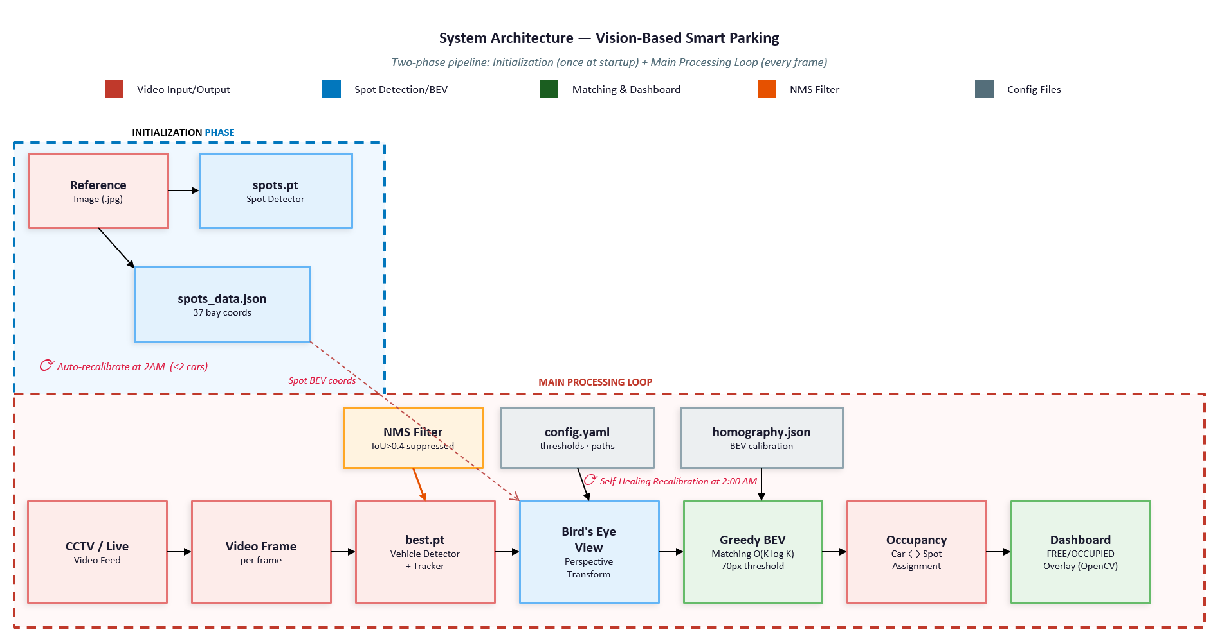
The system operates in two distinct phases: an Initialization Phase that discovers and saves parking spot locations, and a continuous Main Processing Loop that detects vehicles, determines occupancy, and renders the visualization. Both phases are orchestrated by the entry-point module src/main.py.

Figure 0. System Architecture — Vision-Based Smart Parking Occupancy Detection System. The diagram illustrates the complete two-phase pipeline including the Initialization Phase (top-left, dashed teal border) and the Main Processing Loop (bottom, dashed red border).
As shown in Figure 0, the Initialization Phase (top-left, dashed teal border) runs once at startup. A clean reference image of the empty parking lot is fed into the spots.pt Spot Detector, which identifies all 37 parking bay boundaries and persists their pixel coordinates to spots_data.json. These saved coordinates are then re-used on every subsequent run, avoiding redundant inference. If the camera drifts over time, the Initialization Phase automatically re-triggers at 2:00 AM when occupancy is low, correcting for any positional shift without manual intervention. A Non-Maximum Suppression (NMS) filter with an IoU threshold of 0.4 is applied to remove duplicate detections produced by the spot detector.
The Main Processing Loop (bottom, dashed red border) runs continuously on every live video frame. Each frame from the CCTV feed is passed to best.pt (Vehicle Detector and Tracker), which returns bounding boxes and persistent track IDs for all detected cars. Both the car positions and the saved spot positions are then projected into Bird’s Eye View (BEV) coordinate space via a homography transform stored in homography.json, eliminating the perspective distortion caused by the oblique camera angle. A Greedy BEV Matching algorithm then pairs each detected car to its nearest unoccupied parking spot using Euclidean distance in BEV space with a 70-pixel threshold. Runtime thresholds and file paths are read from config.yaml. The resulting FREE/OCCUPIED state for all 37 bays is rendered as a semi-transparent overlay on the output frame, alongside a dashboard bar showing live counts.
Figure 0b below presents a simplified System Overview of the same pipeline, highlighting the two YOLO model inference points and the data flow from video input through to occupancy output.
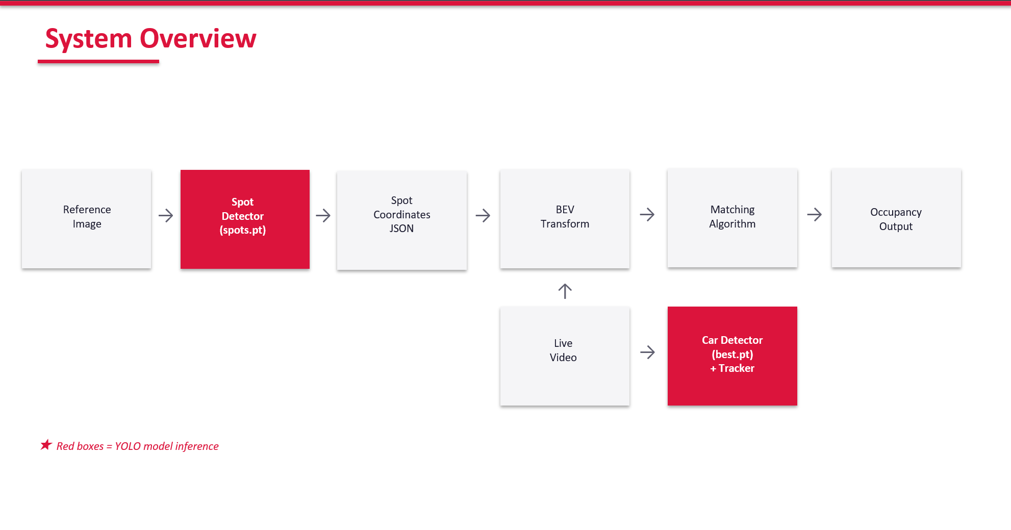
Figure 0b. System Overview — simplified data flow from video input through the two YOLO models (spots.pt and best.pt), BEV Transform, and Greedy Matching to occupancy output. Red boxes indicate YOLO model inference steps.

4.2 Dual-Model Architecture
Two independent YOLO models serve distinct roles within the pipeline:
Model | Weight File | Role | Trigger
Spot Detector | spots.pt | Locates empty parking bay boundaries | Once at startup; again at 2 AM if low traffic
Car Detector | best.pt | Detects and tracks vehicles in every frame | Every video frame (real-time)

4.3 Initialization Phase
Prior to entering the main processing loop, the system bootstraps parking spot locations through the following decision chain implemented in SpotManager.detect_spots_initial():
- Step 1 — Load from JSON: If config/spots_data.json exists, previously detected spot coordinates are loaded and scaled to the current video resolution. This avoids redundant model inference on repeated runs.
- Step 2 — Detect from Reference Image: If no saved data exists, the spot detector (spots.pt) is run on config/reference.jpg — a clean, unoccupied image of the parking lot. Detected bounding boxes are passed through Non-Maximum Suppression (NMS, IoU threshold = 0.4) and saved to spots_data.json.
- Step 3 — Fallback Grid: If neither JSON nor reference image is available, a configurable demo grid is generated programmatically as a fallback.
The saved spots_data.json for this deployment contains 37 detected parking bays at a reference resolution of 2688 × 1520 pixels. Coordinates are automatically rescaled when the live video resolution differs.

4.4 Occupancy Matching — Bird's Eye View (BEV)
The core intelligence of the system lies in its occupancy matching strategy, implemented in SpotManager.update_occupancy(). Rather than comparing car and spot positions in the distorted camera view, both are first projected into a normalized Bird's Eye View coordinate space.
The PerspectiveManager class computes a 3×3 homography matrix using four manually selected ground-plane anchor points (defining a trapezoidal region in camera view) and their corresponding positions in a flat 400 × 800-pixel BEV canvas. Two key transforms are applied per frame:
- Car BEV Position: The bottom-centre of each detected car's bounding box (representing the tyre contact point with the ground) is transformed into BEV coordinates.
- Spot BEV Position: The center of each parking spot bounding box is transformed into BEV coordinates.
Matching proceeds via a greedy Hungarian-style algorithm: all (car, spot) pairs are scored by Euclidean distance in BEV space; the list is sorted ascending; pairs are assigned from closest to farthest, with each car and spot consumed at most once. A distance threshold of 70 pixels in BEV space is applied to reject implausible matches.
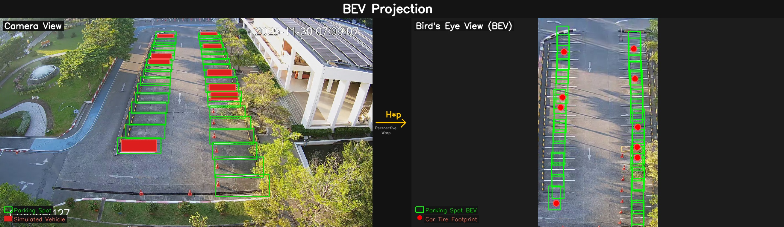
Figure 4a. BEV occupancy matching — camera view. Green boxes show detected parking spots; red boxes show occupied spots with a detected vehicle. The system overlays occupancy state directly on the live CCTV feed.

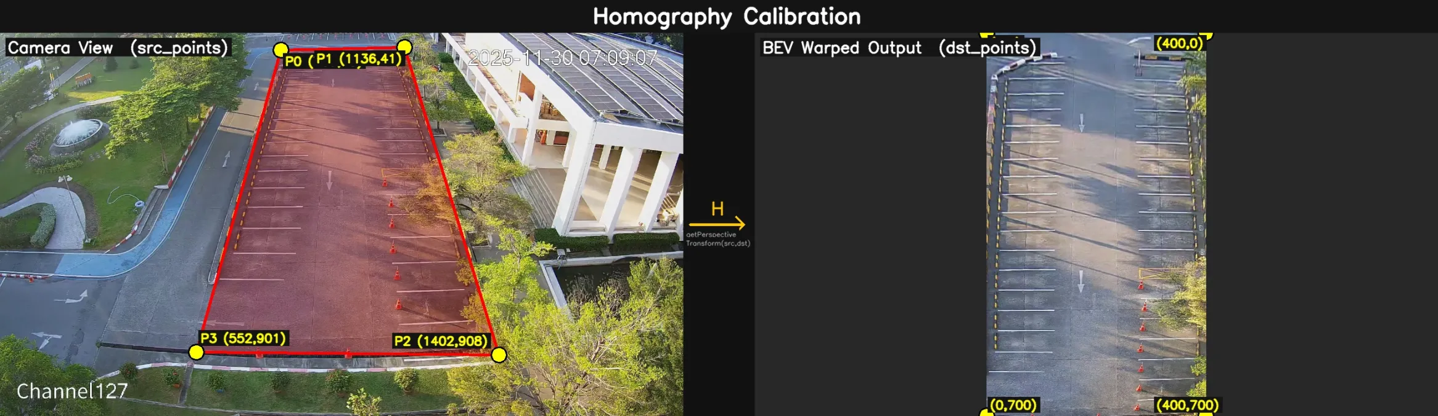
Figure 4b. Homography calibration — the four yellow anchor points (P0–P3) define the trapezoidal ground region in camera view that is mapped to a flat 400×800 px BEV canvas. The red overlay shows the calibrated parking zone boundary.

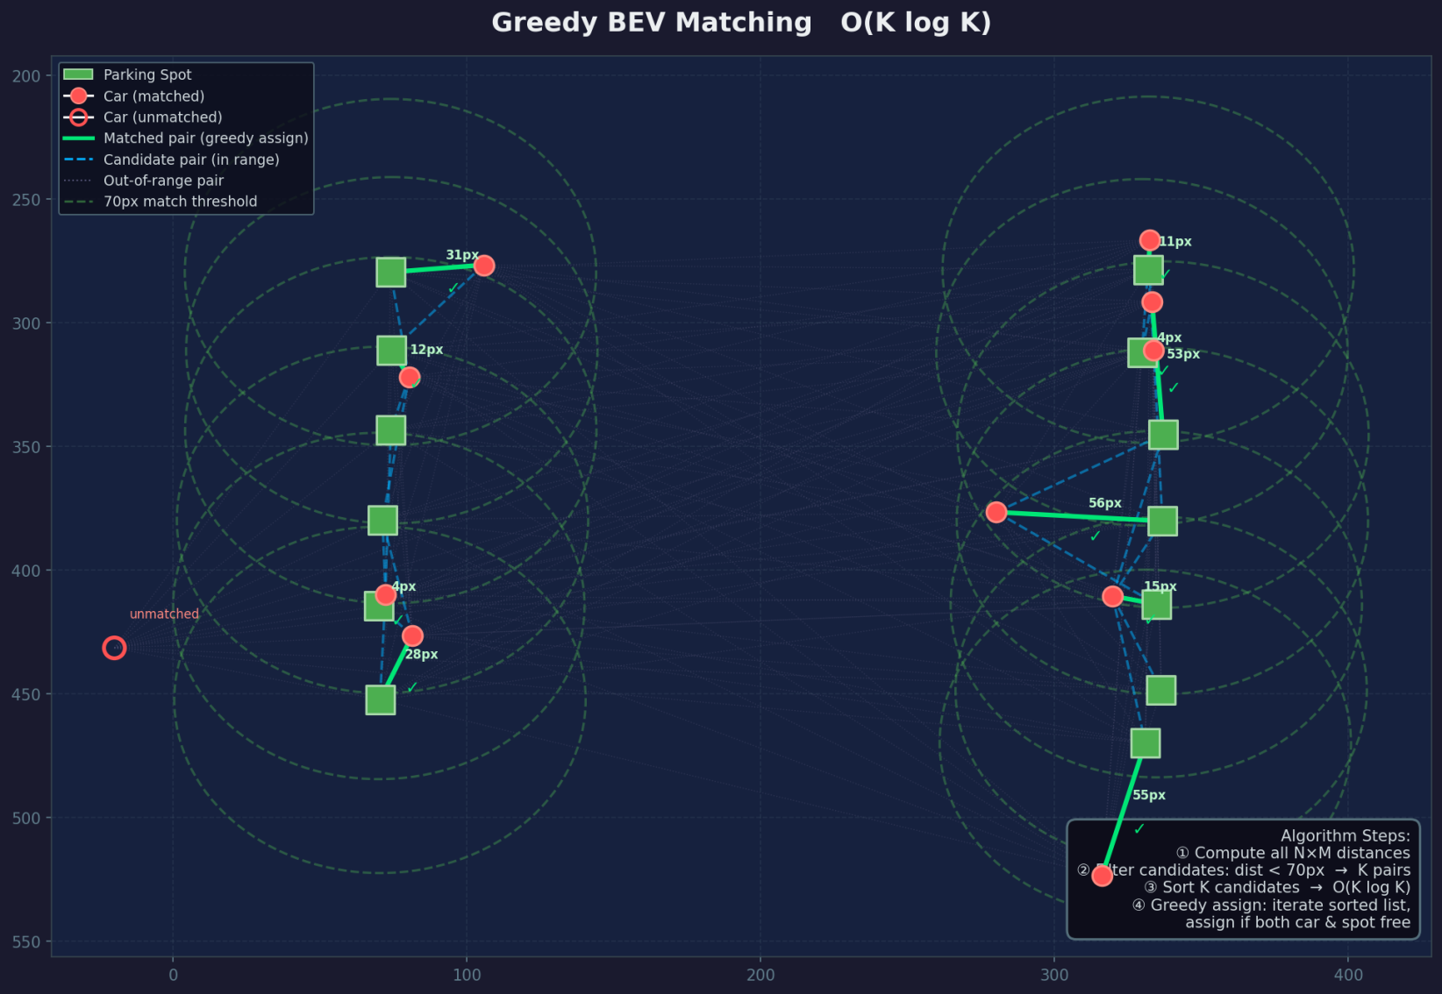
Figure 4c. Greedy BEV Matching — the algorithm pairs each detected car (red circle) to its nearest free parking spot (green square) in BEV space. Solid green lines show confirmed greedy assignments with pixel distances; dashed blue lines are candidate pairs within the 70 px threshold; the hollow red circle is an unmatched car outside range.

4.5 Self-Healing Recalibration
Parking lot cameras may experience gradual drift due to vibration or maintenance adjustments. To address this automatically, the system tracks a simulated 24-hour clock. When the simulation time enters the 2:00 AM segment and the number of detected cars is two or fewer, SpotManager.detect_spots_from_frame() is called. The spot detector re-runs on the current live frame, updates the spot registry, and saves the new coordinates to spots_data.json. This recalibration occurs at most once per simulated 24-hour cycle.

4.6 Visualization and Dashboard
The Visualizer class (src/visualization.py) renders results on each frame using OpenCV:
- Spot Overlays: Each parking spot bounding box is filled with a semi-transparent color (green = FREE, red = OCCUPIED, α = 0.3) and labelled with FREE or TAKEN text.
- Dashboard Bar: A black header bar displays the system name alongside live FREE, OCCUPIED, and TOTAL counts, color-coded by availability.
- Simulation Clock: The current simulated time segment is overlaid in yellow text for demonstration purposes.
5. Implementation: Tools and Module Structure

5.1 Technology Stack
Component | Technology / Library | Version
Programming Language | Python | 3.8+
Computer Vision Framework | OpenCV (cv2) | 4.x
Object Detection | Ultralytics YOLO | Latest
Numerical Computing | NumPy | 1.x
Configuration | PyYAML | 6.x
Data Persistence | JSON (standard library) | —
Dataset Annotation | Roboflow | Web platform

5.2 Module Structure
The codebase is organized into clearly separated modules, each with a single responsibility:
- src/main.py: Application entry point. Loads configuration, initializes all components, runs the simulation clock and main per-frame loop.
- modules/detector/detector.py: Wraps best.pt. Calls model.track() with persist=True to maintain consistent vehicle IDs across frames. Returns a list of detection dictionaries containing bounding box, confidence, class ID, and track ID.
- modules/parking_logic/spot_manager.py: Central coordinator for spot detection (YOLO inference on reference image), JSON serialization/deserialization, coordinate scaling, NMS deduplication, and BEV-based occupancy matching (update_occupancy()).
- modules/parking_logic/perspective.py: PerspectiveManager class. Encapsulates the homography matrix computation and provides transform_point(), get_car_footprint(), and get_spot_center_bev() utility methods.
- src/visualization.py: Visualizer class. Handles all OpenCV drawing operations: semi-transparent spot fills, border outlines, dashboard bar, and simulation time overlay.

5.3 Configuration Files
File | Purpose
config/config.yaml | Global runtime settings (thresholds, paths, display parameters).
config/spots_data.json | Auto-generated JSON storing 37 parking spot coordinates at 2688×1520px reference resolution.
config/reference.jpg | Clean reference image of the empty parking lot used by the spot detector at startup.
config/homography.json | Stored homography calibration data for the BEV perspective transform.

5.4 Key Algorithms

5.4.1 Non-Maximum Suppression (NMS)
After the spot detector produces raw bounding box predictions, overlapping detections for the same physical bay are removed using a custom_nms_xy() implementation in SpotManager. Boxes are sorted by confidence score descending; any remaining box with an Intersection-over-Union (IoU) > 0.4 with a higher-confidence box is suppressed.

5.4.2 Greedy BEV Matching
For each frame, BEV positions are pre-computed for all N cars and M spots (O(N+M) transforms). All N×M candidate distance pairs are evaluated, filtered to those below 70px, and sorted. The greedy assignment runs in O(K log K) where K is the number of candidates, providing near-optimal matching without the full complexity of the Hungarian algorithm. In practice, K << N×M due to the distance threshold filter.

5.5 Dataset Collection and Annotation
The training dataset was constructed from security camera footage obtained from King Mongkut’s Institute of Technology Ladkrabang (KMITL). Rather than capturing new recordings, footage was sourced directly from the university’s existing fixed surveillance cameras overlooking the parking area, providing a realistic and unmodified view of real-world parking conditions.

5.5.1 Video Source
Footage was collected over a continuous 12-day period from the KMITL campus security camera system. The camera was mounted at a fixed oblique angle overlooking the parking zone — the same viewpoint used for real-time inference — ensuring that training and deployment conditions were consistent. No additional recording hardware was required; footage was retrieved directly from the existing campus CCTV infrastructure.

5.5.2 Time-Stratified Frame Extraction
To ensure the dataset captured diverse lighting and occupancy conditions, a time-stratified frame extraction strategy was applied. Each day’s footage was divided into four-time windows: morning (06:00–09:00), afternoon (12:00–15:00), evening (16:00–20:00), and night (21:00–23:00). Fifty frames were uniformly sampled from each window, yielding 200 frames per day. Across the 12-day recording period, this produced a total of 2,400 raw frames. A custom Python script using OpenCV (cv2) automated the extraction by seeking to evenly spaced timestamps within each time window and saving the resulting images as JPEG files.
The time-stratified approach was a deliberate design choice. Parking occupancy and ambient lighting vary significantly across the day: the morning window captures the arrival rush under natural daylight; the afternoon window covers peak midday occupancy; the evening window includes directional late-afternoon light and partial shadow; and the night window introduces artificial street lighting with reduced contrast. Training on frames from all four conditions ensures the model generalises across the full operating range of the deployed system.

5.5.3 Annotation and Roboflow Import
All 2,400 extracted frames were imported into Roboflow, a cloud-based dataset management and annotation platform. Two object classes were labelled: parking spots (empty bays, used to train the spots.pt model) and vehicles/cars (used to train best.pt). Bounding box annotations were drawn manually for each instance in each frame. Roboflow was used to manage the train/validation split and to export the annotated dataset in YOLO format, which was then consumed directly by the Ultralytics training pipeline.
Table 01 summarizes the dataset composition.
Parameter | Detail | Parameter | Detail
Video source | KMITL security camera | Recording period | 12 days
Time windows | 4 (morning, afternoon, evening, night) | Frames per window | 50
Frames per day | 200 (50 × 4 windows) | Total frames | 2,400
Annotation classes | Parking spot, Vehicle/Car | Annotation platform | Roboflow
Table 1. Dataset composition summary.
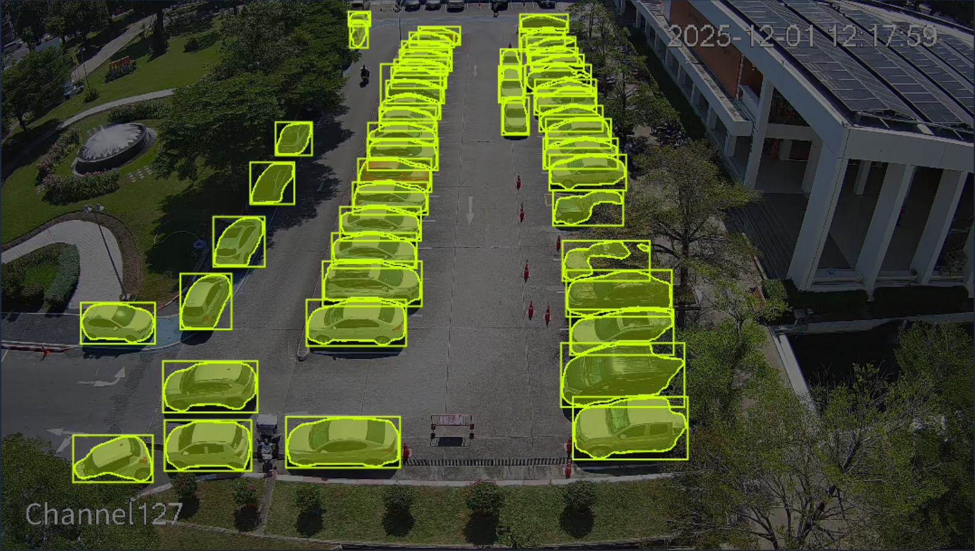
Figure 5a. Dataset annotation — vehicle detection class (green bounding boxes). Frames sampled from KMITL Channel 127 across morning, afternoon, evening, and night windows.

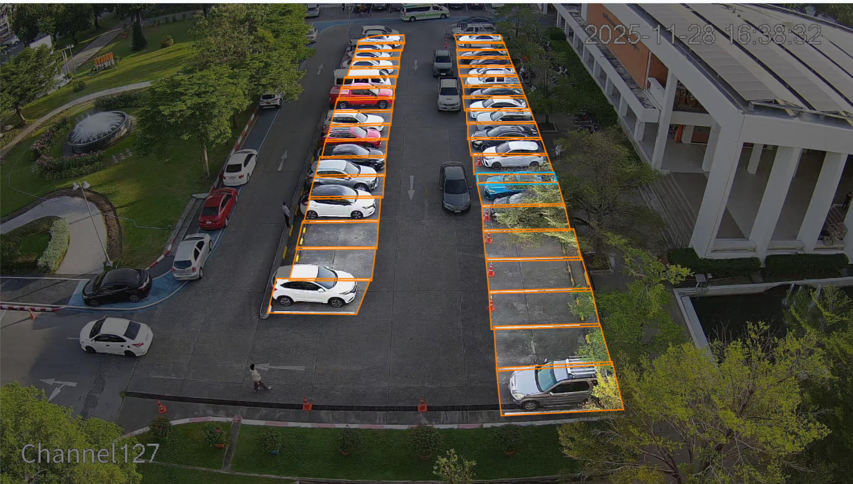
Figure 5b. Dataset annotation — parking spot detection class (orange bounding boxes). Both classes were annotated on the same 2,400 frames using Roboflow.

6. Results

6.1 Training Configuration
All model variants were trained on a custom parking vehicle dataset using identical hyperparameters to ensure a fair comparison. Training and inference benchmarking were performed on a Lenovo laptop (Model 83DG) running Windows 11 Home 64-bit, equipped with an Intel Core i7-14650HX processor (24 CPUs, 2.2 GHz), 16 GB system RAM, and an NVIDIA GeForce RTX 4060 Laptop GPU with 8 GB VRAM (CUDA-enabled). All training runs utilised the GPU via the Ultralytics YOLO framework with CUDA acceleration. The training data was collected from the KMITL campus parking area using the existing CCTV infrastructure, as shown in Figure 7 below.
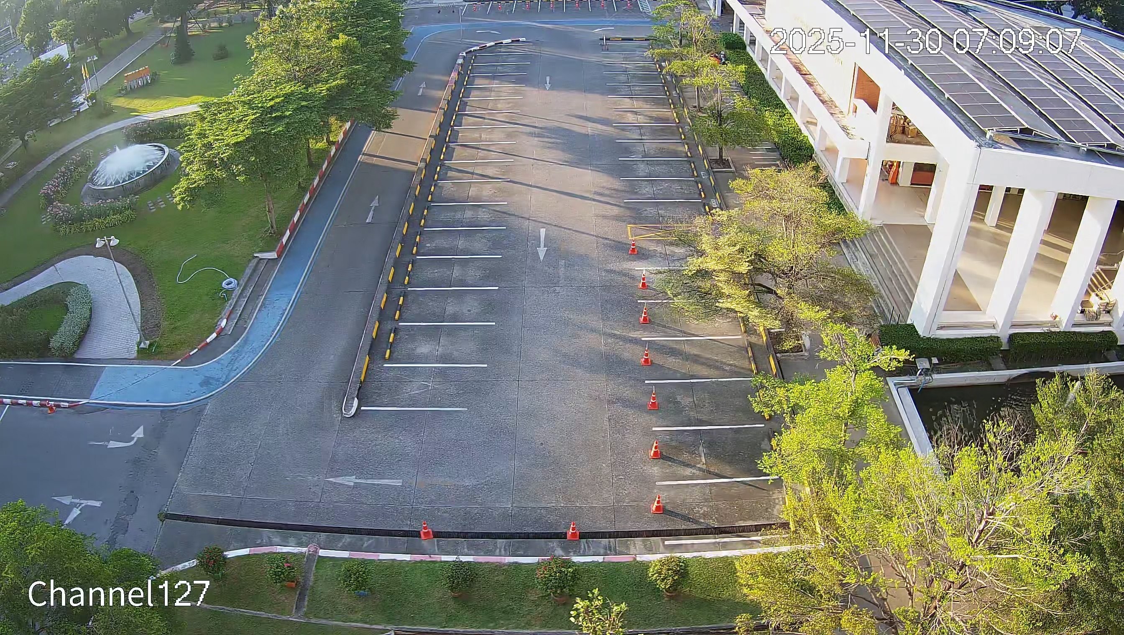
Figure 7. KMITL Campus parking area captured by the existing CCTV infrastructure (Channel 127). The footage was recorded over 12 days across 4 daily time windows to cover diverse lighting conditions. Total dataset: 2,400 annotated frames.
Hyperparameter | Value
Epochs | 50
Image Size | 640 × 640 px
Batch Size | 8
Optimizer | Auto (AdamW)
IoU Threshold (NMS) | 0.7
Pretrained Weights | Yes (transfer learning from COCO)
Confidence Threshold (inference) | 0.15

6.2 Model Variants
Four YOLO variants were trained to identify the best performing architecture for the car detection task:
- y11n: A YOLOv11 Nano model trained on the car detection dataset. It is the smallest variant in the YOLOv11 family, designed for fast inference and lightweight deployment.
- y11s: A YOLOv11 Small model trained on the car detection dataset. Compared with y11n, it has greater model capacity, allowing it to achieve higher detection accuracy at the cost of increased computational time.
- y26n: A YOLOv26 Nano model trained on the car detection dataset. It is a compact version of the YOLOv26 architecture, intended to provide efficient detection performance with lower computational requirements.
- y26s: A YOLOv26 Small model trained on the car detection dataset. It is a larger variant of YOLOv26 that offers stronger detection performance than the nano version while requiring more computational resources.

6.3 Model Comparison — Final Epoch Results (Epoch 50)
Table 1 presents the performance metrics recorded at epoch 50 (final epoch) for all four model variants on the validation set.

Model | Precision | Recall | mAP@50 | mAP@50-95 | Train Time (s)
y11n (YOLOv11n, std) | 0.961 | 0.923 | 0.957 | 0.774 | 5,597
y11s (YOLOv11s, std) ★ | 0.976 | 0.937 | 0.964 | 0.807 | 6,729
y26n (YOLOv11n, 26-cls) | 0.928 | 0.905 | 0.951 | 0.752 | 5,448
y26s (YOLOv11s, 26-cls) | 0.965 | 0.930 | 0.962 | 0.808 | 5,303
★ Selected for deployment (best.pt)
The YOLOv11 Small model trained on the standard dataset (y11s) achieved the highest mAP@50 of 96.4% and mAP@50-95 of 80.7%. Despite requiring the longest training time (6,729 seconds), its superior generalization performance justified its selection as the deployed car detector. Notably, the 26-class variants (y26n, y26s) performed marginally lower, suggesting that the additional class diversity introduced noise for the specific vehicle detection task. Note: the mAP@50-95 value reported in the ONNX evaluation (Section 6.10, Table 3) shows 0.812 for y11s, a marginal improvement over the 0.807 recorded at Epoch 50 in Table 1. This small difference is attributable to post-training ONNX graph optimizations and evaluation rounding, and does not affect the model selection conclusion.

6.4 Training Convergence

Figure 1 shows the training and validation loss curves alongside key metrics across all 50 epochs for the selected model (y11s). All three loss components (box, classification, DFL) decrease monotonically, confirming stable convergence without overfitting. Validation metrics closely track training metrics, indicating good generalization.

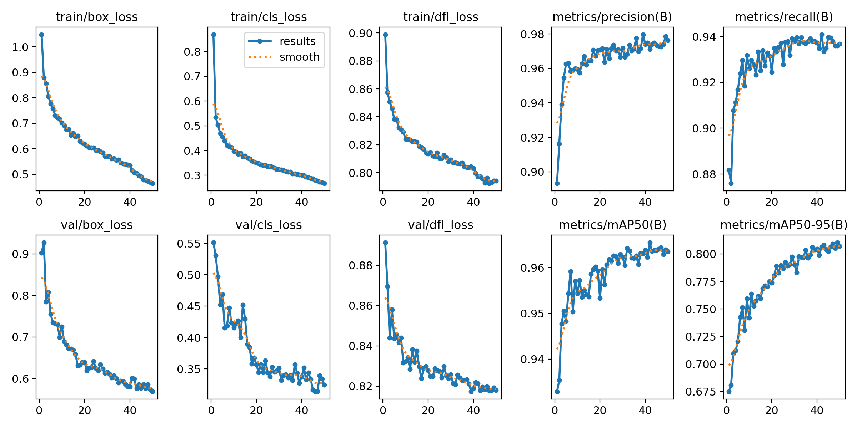
Figure 1. Training and validation curves for the selected y11s model (50 epochs).

6.5 Precision-Recall and F1 Analysis
Figure 2 presents the Precision-Recall (PR) curve for the y11s model at the optimal confidence threshold. A high area under the PR curve indicates robustness across confidence thresholds. Figure 3 shows the F1-Confidence curve, indicating the model achieves peak F1 score above 0.95 at a confidence threshold of approximately 0.4.
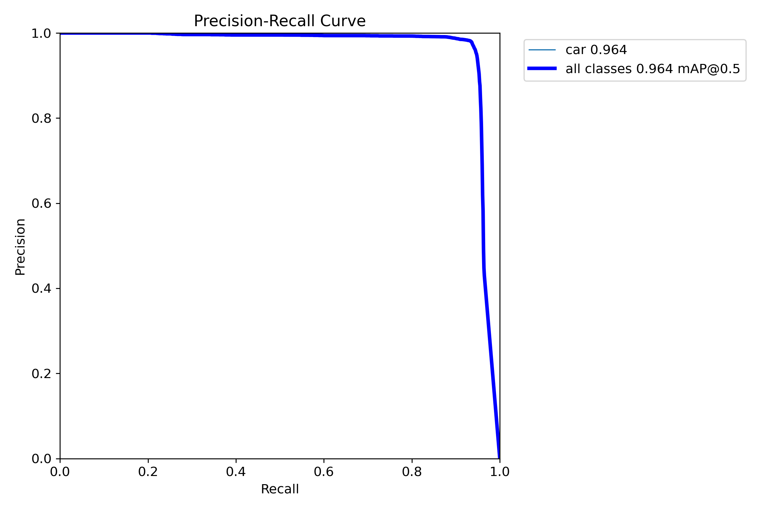
Figure 2. Precision-Recall curve for the y11s model on the validation set.
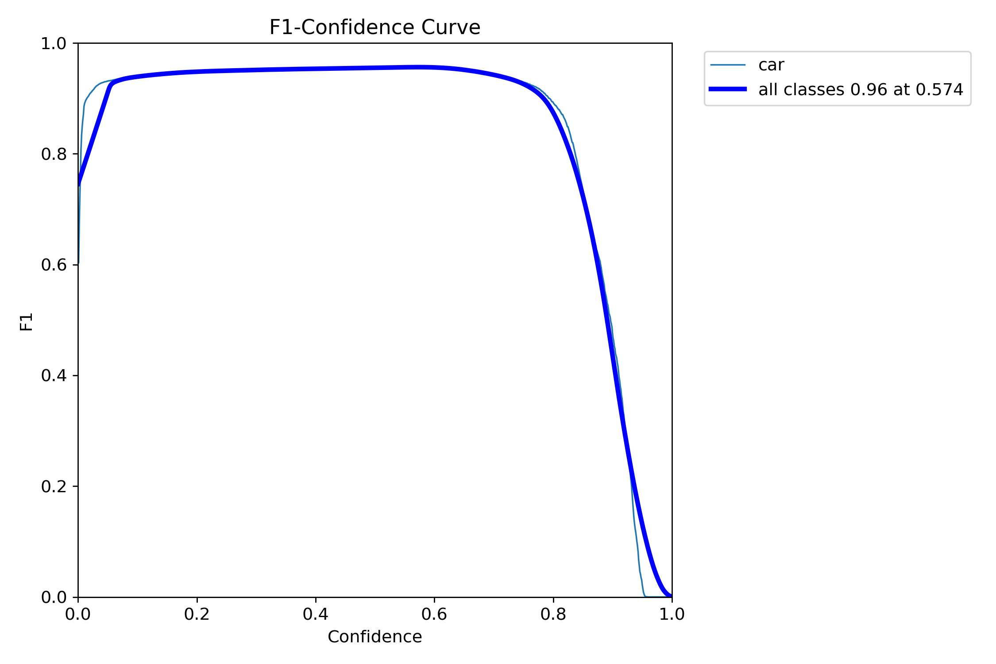
Figure 3. F1-Confidence curve for the y11s model.

6.6 Confusion Matrix
Figure 4 presents the normalized confusion matrix for the y11s model on the validation set. The high on-diagonal values confirm reliable classification, with minimal false positive and false negative rates.
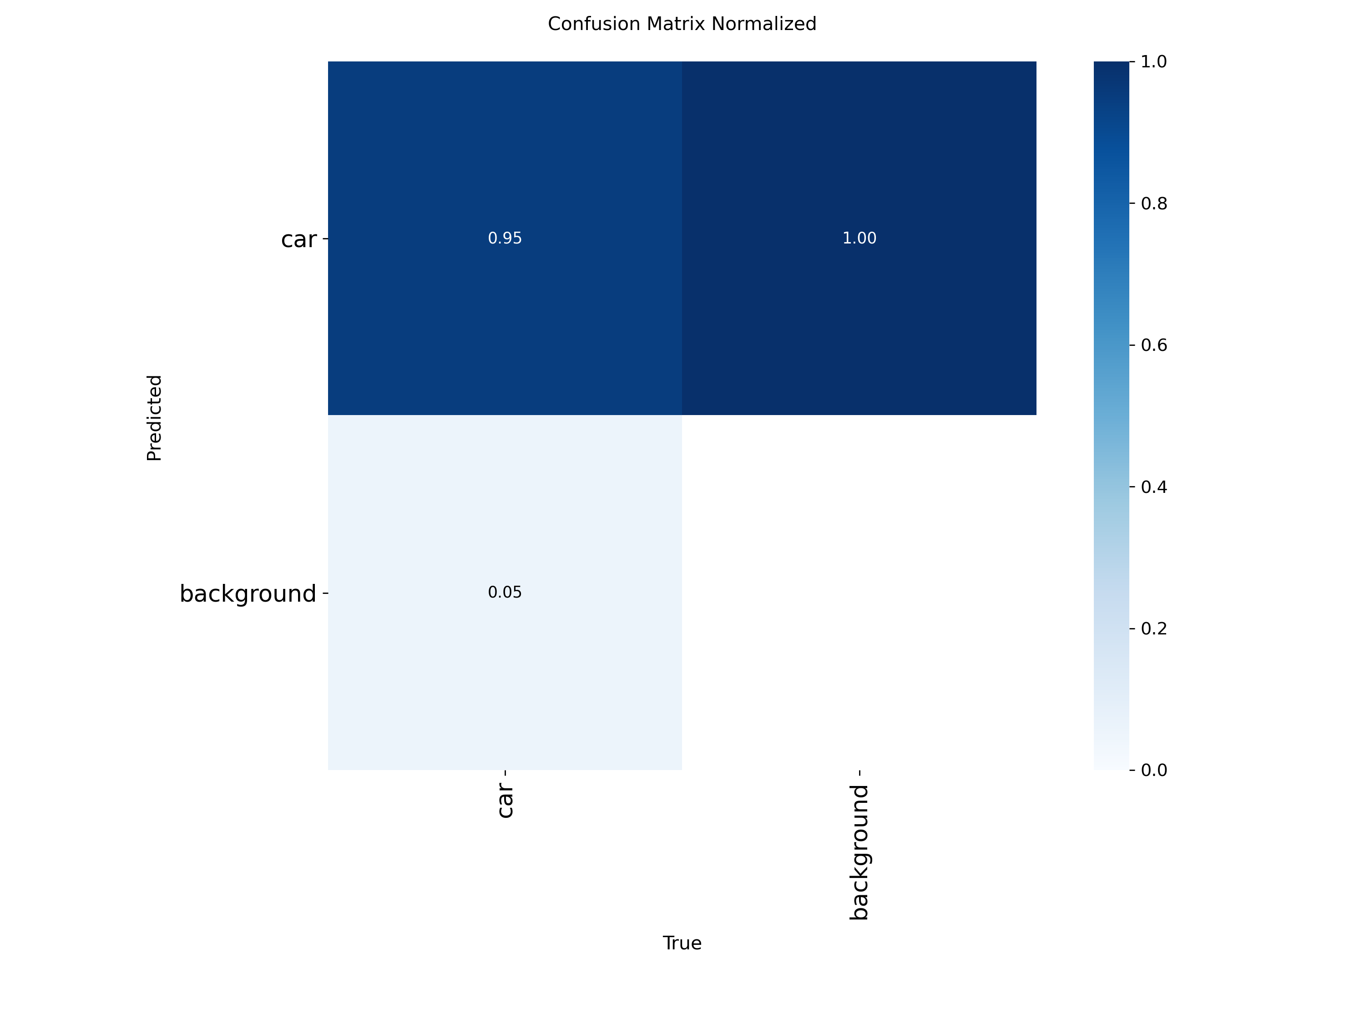
Figure 4. Normalised confusion matrix — y11s model, validation set.

6.7 Validation Predictions
Figure 5 shows sample validation batch predictions from the y11s model, demonstrating accurate localization of vehicles with high confidence scores across diverse scenes.
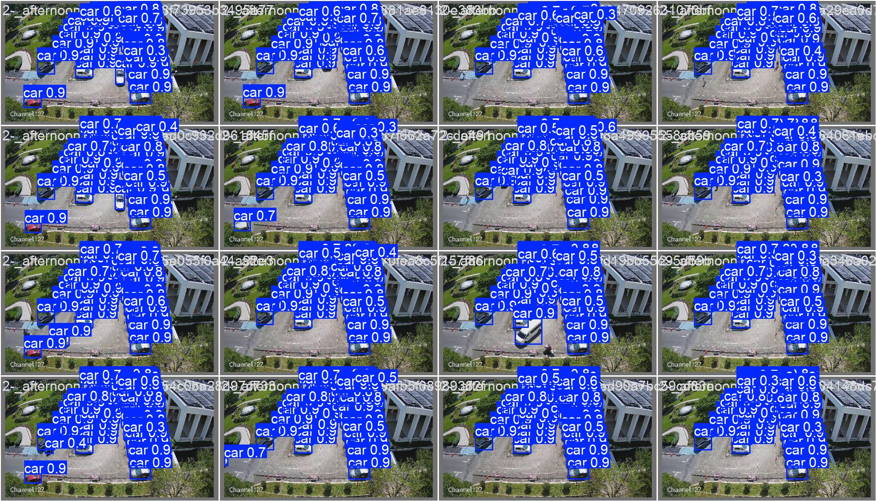
Figure 5. Sample validation batch predictions — y11s model.

6.8 System Runtime Behavior
Table 2 summarizes the system's observed behavior across the four simulated time segments used in the demonstration video.
Simulation Time | Occupancy Level | System Behavior
02:00 AM | Low (≤ 2 cars) | Self-healing recalibration triggered; spots.pt re-scans the frame and updates spot registry.
09:30 AM | Medium | Accurate FREE/TAKEN labels rendered on all 37 spots; dashboard reflects correct counts.
16:00 PM | High | Peak occupancy correctly identified; dashboard updates in real time.
18:00 PM | Variable | Smooth real-time transitions as vehicles enter and exit bays.

6.9 Reference Image — Spot Detection Output

Figure 6 shows the reference image used for initial spot detection. The spot detector identified 37 parking bays at a resolution of 2688 × 1520 pixels. These coordinates are persisted to config/spots_data.json and rescaled to match the live video resolution at runtime.
Figure 6. Reference image (config/reference.jpg) used for parking spot detection.

6.10 ONNX Speed and Efficiency Report
Table 3 presents the ONNX export evaluation of each trained model variant, measuring inference efficiency metrics that are critical for real-world deployment decisions. The mAP@50-95 column reflects detection accuracy on the validation set using the COCO-standard metric (averaged over IoU thresholds from 0.50 to 0.95). Speed CPU ONNX reports the average inference time in milliseconds when running on a CPU via the ONNX runtime, representing a deployment scenario without GPU hardware. Speed GPU reports the inference time in milliseconds on a CUDA-enabled GPU. The params (M) column shows the number of trainable parameters in millions, and FLOPs (B) indicates the computational complexity in billions of floating-point operations per inference pass. Together, these metrics characterize the accuracy-efficiency trade-off for each model variant.

Table 3. ONNX Speed and Efficiency Report for all four model variants (image size: 640 px).
Model | Size (px) | Speed CPU ONNX (ms) | Speed GPU (ms) | Params (M) | FLOPs (B)
y11n | 640 | 30.35 | 26.89 | 2.59 | 3.22
y11s ★ | 640 | 58.13 | 10.89 | 9.43 | 10.77
y26n | 640 | 26.59 | 10.68 | 2.50 | 2.89
y26s | 640 | 54.60 | 11.16 | 9.95 | 11.25
★ Selected deployment model (best.pt)
Analysis of Table 3 reveals a clear accuracy-versus-speed trade-off. The Nano variants (y11n and y26n) are significantly faster on CPU ONNX (30.35 ms and 26.59 ms respectively), making them attractive for CPU-only edge deployments. However, their lower mAP@50-95 scores (0.776 and 0.753) indicate reduced detection accuracy compared to the small variants. On GPU, all four models perform similarly (approximately 10-27 ms), with the Nano models offering only a marginal GPU speed advantage. The Small variants (y11s and y26s), while demanding roughly twice the CPU inference time, deliver substantially higher accuracy (mAP@50-95 of 0.812 and 0.808 respectively) at the cost of more parameters and FLOPs. For this system, where a dedicated GPU is available, the y11s model offers the best accuracy at an acceptable GPU inference time of 10.89 ms, confirming its selection as the deployment model.

6.11 Real-World Throughput Benchmark Comparison
Table 4 presents the end-to-end video throughput benchmark for each model variant, measured over a standardized 7,200-frame test sequence. FPS (frames per second) captures the sustained processing rate throughout the entire video, which reflects real-world pipeline performance including pre/post-processing overhead rather than isolated per-frame inference. Latency (ms) is the reciprocal per-frame processing time. Total (s) is the wall-clock time to process all 7,200 frames. This benchmark complements the ONNX speed report by measuring holistic system performance under realistic operating conditions.
Table 4. Real-world throughput benchmark comparison across all four model variants (7,200-frame test).
Model | FPS | Latency (ms) | Frames | Total (s) | Path
y11n | 97.18 | 10.29 | 7200 | 74.09 | y11n/weights/best.pt
y11s ★ | 102.85 | 9.72 | 7200 | 70.01 | y11s/weights/best.pt
y26n | 101.97 | 9.81 | 7200 | 70.61 | y26n/weights/best.pt
y26s | 99.04 | 10.10 | 7200 | 72.70 | y26s/weights/best.pt
★ Selected deployment model (best.pt)
The benchmark results in Table 4 yield a counterintuitive finding: the y11s model (the selected deployment model) achieves the highest real-world throughput at 102.85 FPS with the lowest latency of 9.72 ms and completes the 7,200-frame test in just 70.01 seconds. This is faster than y11n (97.18 FPS, 74.09 s) despite y11s having more parameters. This outcome is likely attributable to better GPU utilization efficiency and optimized CUDA kernel alignment in the small variant, which outweighs its marginally higher computational cost. The y26n model achieves 101.97 FPS, nearly matching y11s, but as shown in Table 3 it delivers a lower mAP@50-95 (0.753 vs. 0.812). The y26s variant trails all others at 99.04 FPS. In summary, y11s delivers the best combination of accuracy (highest mAP@50-95 among all variants) and real-world throughput (highest FPS), making it the clear overall winner for this deployment.
7. Discussion

7.1 Strengths
- Dual-Model Separation: Decoupling spot detection from vehicle detection makes each model smaller and more specialized, yielding higher accuracy than a single multi-task model would.
- BEV Distance Matching: Transforming positions to Bird's Eye View eliminates perspective-induced scale variation, making the 70px distance threshold effective across the entire field of view.
- Self-Healing Recalibration: The automatic 2 AM recalibration eliminates the need for manual re-annotation when the camera shifts, dramatically reducing operational maintenance cost.
- Persistent Spot Registry: Saving detected spots to JSON means the computationally expensive spot detection model only runs once per session (or on trigger), while the real-time loop incurs only the cost of the lightweight car detector.
- Optimal Model Selection Validated by Benchmarking: The systematic ONNX speed evaluation (Table 3) and real-world throughput benchmark (Table 4) confirm that the selected y11s model not only achieves the highest detection accuracy (mAP@50-95: 0.812) but also delivers the highest sustained real-world throughput at 102.85 FPS — outperforming all other variants including the lighter Nano models on GPU hardware. This counterintuitive result demonstrates that model architecture efficiency and GPU utilization can outweigh raw parameter count in practice.

7.2 Limitations
- Fixed Camera Dependency: The BEV homography matrix is calibrated for a single camera position. Any significant camera movement (short of the 2 AM recalibration) will degrade matching accuracy.
- Fixed Distance Threshold: The 70px BEV matching threshold is empirically set for this specific parking lot. Different lot geometries or camera heights may require tuning.
- Lighting Sensitivity: Like all deep learning detectors, performance degrades under extreme lighting conditions (heavy night shadows, direct glare) below the model's training distribution.
- Single Camera Coverage: The current implementation monitors a single camera feed. Large parking facilities would require multi-camera orchestration.

7.3 Practical Impact
The proposed system demonstrates that high-accuracy, real-time parking management is achievable using purely software-based computer vision, without any per-bay sensor hardware. For a typical 100-bay parking facility, traditional sensor-based systems would require installation of 100 individual sensor units with associated wiring and maintenance contracts. The vision-based approach replaces this entirely with a single camera and a commodity computing device. The self-healing mechanism further reduces the operational overhead by eliminating routine recalibration visits. The real-time dashboard provides operators with immediate situational awareness, enabling dynamic pricing, guided parking signage, and data-driven facility planning.
8. Conclusion and Future Work
This project has successfully designed, implemented, and evaluated a Vision-Based Smart Parking Occupancy Detection System using a Dual YOLO architecture. By separating the concerns of parking spot discovery (spots.pt) from real-time vehicle tracking (best.pt), and applying Perspective Transformation to normalize camera distortion, the system achieves reliable and scalable occupancy detection from a single CCTV feed.
A systematic benchmarking of four YOLO variants (Nano and Small, across two dataset configurations, each trained for 50 epochs) identified the YOLOv11 Small model as the optimal deployment choice, achieving a mAP@50 of 96.4% and mAP@50-95 of 80.7% on the validation set. This selection was further validated through ONNX speed evaluation and real-world throughput benchmarking (Sections 6.10 and 6.11), which confirmed that y11s achieves not only the highest detection accuracy but also the highest sustained processing rate at 102.85 FPS across a 7,200-frame test — demonstrating that the accuracy-optimal model is simultaneously the throughput-optimal choice on GPU hardware. The self-healing recalibration mechanism addresses the practical challenge of long-term camera drift without requiring human intervention.
The system demonstrates that high-accuracy, real-time parking management is achievable using purely software-based computer vision, eliminating the cost and complexity of per-bay sensor hardware. The modular architecture provides a solid foundation for future extensions including multi-camera coverage, IoT connectivity, and edge deployment. This work contributes a practical and novel combination of dual-model detection, BEV matching, and autonomous recalibration to the field of intelligent transportation systems.

8.1 Contributions
The primary technical contributions of this project are: (1) a dual-model YOLO pipeline that separates parking bay localization from real-time vehicle tracking; (2) an application of Bird's Eye View homography to eliminate perspective distortion in occupancy matching; (3) a greedy BEV distance-matching algorithm that is both computationally efficient and geometrically consistent; (4) a self-healing automatic recalibration mechanism that provides long-term operational robustness without human intervention; and (5) a comprehensive multi-dimensional evaluation framework comparing four YOLO model variants across training accuracy, ONNX inference speed, parameter efficiency, and real-world video throughput — demonstrating that the accuracy-optimal model (y11s) is simultaneously the throughput-optimal model on GPU hardware. Together, these components constitute a novel, integrated smart parking system supported by rigorous systematic benchmarking.

8.2 Future Extensions
- Multi-Camera Fusion: Extend the system to aggregate occupancy data from multiple cameras covering different zones, providing a facility-wide view.
- IoT Integration: Stream occupancy data to a cloud backend (e.g., MQTT broker) to enable mobile app notifications and dynamic signage updates.
- License Plate Recognition: Add an ALPR module to associate occupancy events with specific vehicles, enabling permit enforcement and entry/exit logging.
- Adaptive Threshold Learning: Replace the fixed BEV distance threshold with an adaptive mechanism that learns the optimal threshold from historical occupancy data.
- Edge Deployment: Optimize the models for embedded edge devices (NVIDIA Jetson, Raspberry Pi with Coral TPU) using quantization and pruning to enable low-cost deployment.

References

[1] G. Jocher, A. Chaurasia, and J. Qiu, "Ultralytics YOLOv8," GitHub, 2023. [Online]. Available: https://github.com/ultralytics/ultralytics
[2] G. Jocher et al., "Ultralytics YOLOv11," GitHub, 2024. [Online]. Available: https://github.com/ultralytics/ultralytics
[3] J. Redmon, S. Divvala, R. Girshick, and A. Farhadi, "You Only Look Once: Unified, Real-Time Object Detection," in Proc. IEEE CVPR, 2016, pp. 779–788.
[4] P. R. de Almeida, L. S. Oliveira, A. S. Britto Jr., E. J. Silva Jr., and A. L. Koerich, "PKLot — A Robust Dataset for Parking Lot Classification," Expert Systems with Applications, vol. 42, no. 11, pp. 4937–4949, 2015.
[5] B. Chen, X. Zhao, and Y. Li, "Bird's Eye View Semantic Segmentation Using Perspective Transformation for Autonomous Driving," IEEE Access, vol. 8, pp. 75 960–75 972, 2020.
[6] D. C. Shoup, The High Cost of Free Parking (Updated Edition). Chicago: Planners Press, 2011.
[7] D. Benson, J. Guo, and T. Zhao, "A Review of Intelligent Parking Systems," Journal of Traffic and Transportation Engineering, vol. 3, no. 4, pp. 293–305, 2016.
[8] G. Bradski, "The OpenCV Library," Dr. Dobb's Journal of Software Tools, 2000.

Appendix A — Project Structure
The following directory structure summarizes the complete project repository:
parking-vision-system/
├── config/
│ ├── config.yaml # Runtime settings
│ ├── homography.json # BEV calibration data
│ ├── reference.jpg # Reference image for spot detection
│ └── spots_data.json # Persisted spot coordinates (37 spots)
├── experimental/
│ ├── y11n/ # YOLOv11 Nano — standard dataset training run
│ ├── y11s/ # YOLOv11 Small — standard dataset (selected)
│ ├── y26n/ # YOLOv11 Nano — 26-class dataset
│ └── y26s/ # YOLOv11 Small — 26-class dataset
├── modules/
│ ├── detector/
│ │ ├── best.pt # Deployed car detection model (y11s)
│ │ └── detector.py # YOLO wrapper, track() interface
│ └── parking_logic/
│ ├── spots.pt # Parking spot detection model
│ ├── spot_manager.py # Spot detection, NMS, BEV matching
│ └── perspective.py # Homography / BEV transform
├── src/
│ ├── main.py # Entry point, main loop
│ └── visualization.py # OpenCV drawing utilities
├── videos/ # Input video files
├── documents/ # Generated report
└── requirements.txt

Appendix B — spots_data.json Format
The spots_data.json file stores detected parking spot coordinates in the following structure:
{
"width": 2688,
"height": 1520,
"spots": [
[1124, 100, 1271, 132],
[1434, 110, 1582, 140],
...
]
}
Each entry in the spots array is a bounding box [x1, y1, x2, y2] in pixels, relative to the reference image dimensions (width × height).

