# Install certificate

1. Check all of certificates

Start->mms->file->add/remove snap-in->choose “Certificate”-> add(current user)

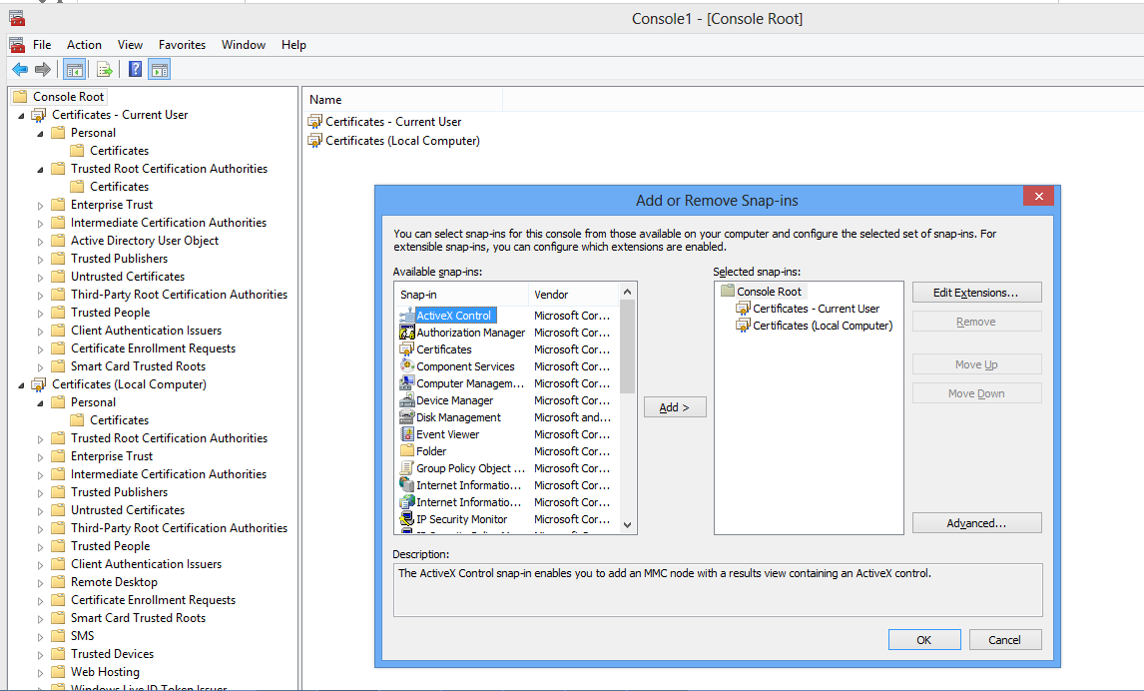

1. Install certificate

* In mms, just import the certificate.
* Use cmd example in tools\source\certMgr.