# Installation:

## TFPT 2010 Check-in Policy Pack

1. http://visualstudiogallery.msdn.microsoft.com/c255a1e4-04ba-4f68-8f4e-cd473d6b971f
2. Choose custom to make sure Check-in policy pack would be installed.

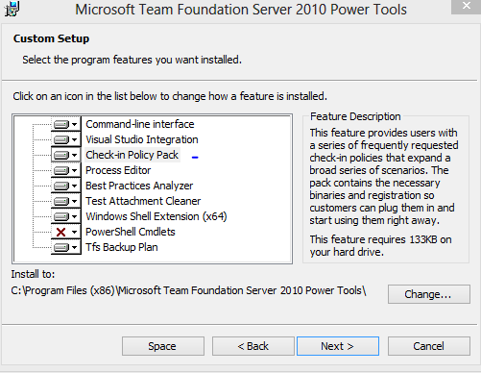

1. If there’s no Check-in Policy Pack maybe cause by didn’t install Visual Studio 2010/Team Explorer (\\sha-usp-04\Public\products\developers\Visual Studio 2010\Team Explorer)

## SSDT Update 1 for VS 2010

\\sha-usp-04\Public\products\developers\SQL Server Data Tools December 2012 for Visual Studio 2010

## SSDT Update 1 for VS 2012

\\sha-usp-04\Public\products\developers\SQL Server Data Tools December 2012 for Visual Studio 2012

# Command

## Build project

>msb /p:configuration=Debug;platform=X64

## Create solution & open in VS2012

slngen [/vs11]

## Unable to determine the workspace. You may be able to correct this by running 'tf workspaces /collection:TeamProjectCollectionUrl'.

tf workspaces /collection:http://sqlbuvsts01:8080/main