## 1) Create mLab Account on mlab.com

<https://mlab.com/signup>

1a) Verify your email to access account

## 2) Create Free Sandbox Deployment

2a) You should **NOT** need to provide any credit card or payment information!

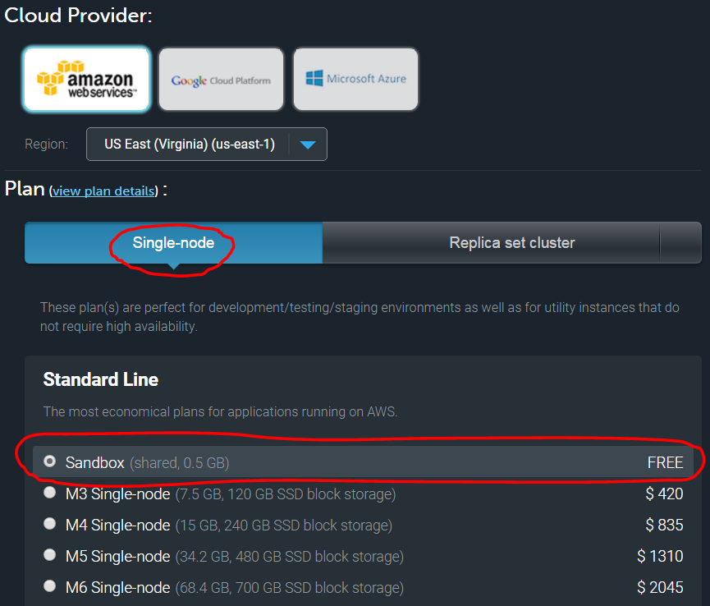

## 3) Create Database Name: emr

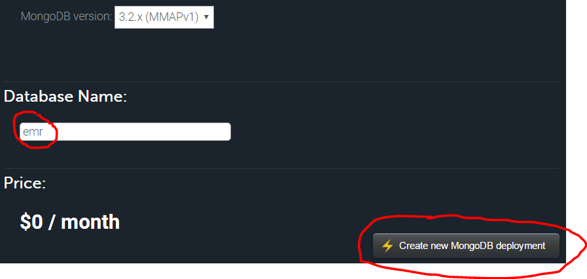

## 4) Create DB User

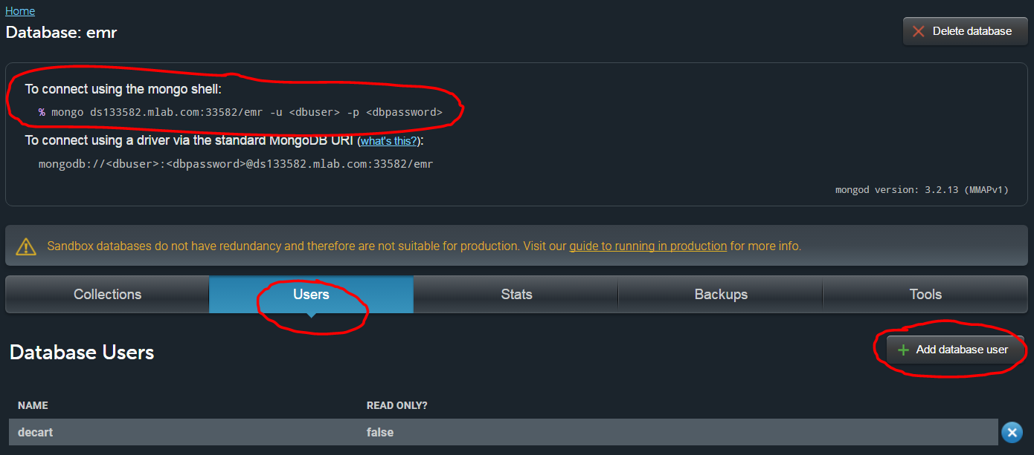

### 5) Connect to mLab with pymongo on JupyterHub

Login to <https://jupyterhub.med.utah.edu> with your github account credentials

Follow the instructions on this Jupyter Notebook file to practice working with mongoDB:

<https://github.com/UUDeCART/decart_nosql_resonant>

File Name: patientRegistration.ipynb

Steps Overview:

* 5a) Insert a few Patient Registration Documents
* 5b) Update your document
* 5c) Query to Verify Updated Document
* 5d) Run Aggregate Queries to Get Average Age of Patients
* 5e) Count Records
* 5f) Delete One Document
* 5g) List ALL Documents

### 6) Using MongoDB Compass to review your data

6a) Making a Connection

6b) Your connection info will be based on your Account Details. Your Port Number and Hostname will be different as well.

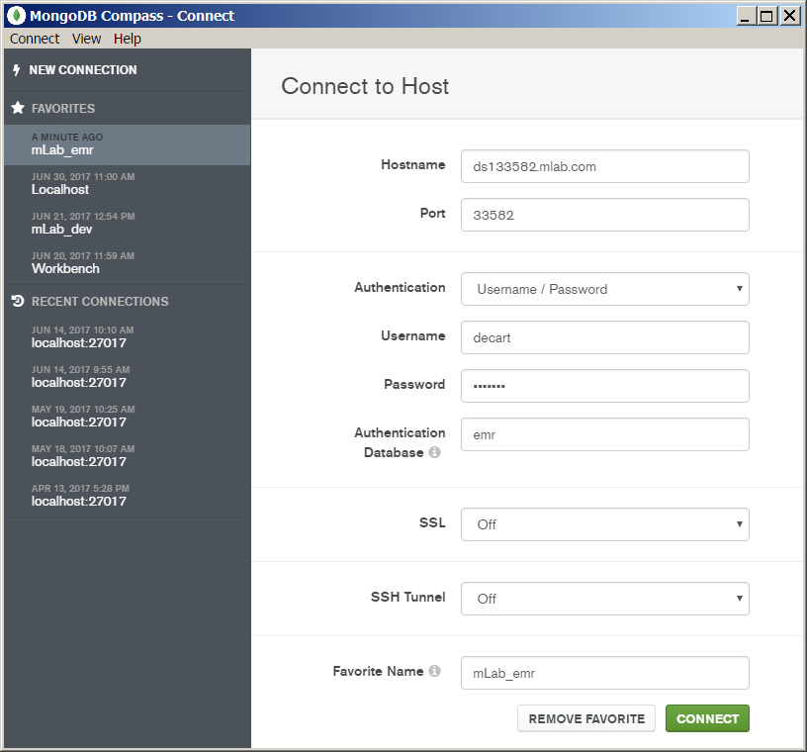

6b) Reviewing your Data with Compass

Use the Left Side to Navigate your Database & Collection

The Right Side "Documents" will list all your documents.

