ZEsarUX documentation - 24/05/2021

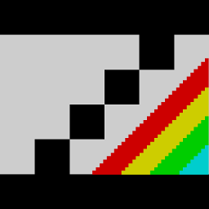

ZEsarUX ZX Second-Emulator And Released for UniX
Copyright (C) 2013 César Hernández Bañó

This file is part of ZEsarUX.

ZEsarUX is free software: you can redistribute it and/or modify it under the terms of the GNU General Public License as published by the Free Software Foundation, either version 3 of the License, or (at your option) any later version.

Index
Introduction 3
First steps 4
Sections in ZEsarUX window 5
Window actions 7
ZX Desktop 10

Introduction

This is not intended to be an exhaustive documentation for ZEsarUX emulator. Is just a brief description about how the emulator works, how the menus are structured, etc.
If you want to know all the features of the emulator you should:

- Read the FAQ
- Read the README
- Read the different documentation files in zesarux-extra package
- Use the included help (try pressing F1 on menu items!) and read the menu items tooltips
- Try all the menus, submenus and settings in ZEsarUX. There are a lot of hidden and amazing features not found on other emulators!

First steps

When you run ZEsarUX the first time you will get a window like this:

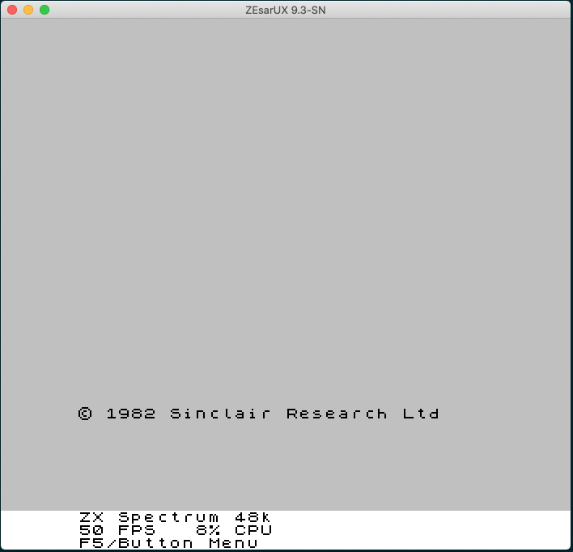
It doesn’t matter which operating system you use (Linux, Mac, Windows, etc), the emulator should look like exactly the same in all systems.
Everything in ZEsarUX runs in this window: emulated machine, menus, etc. So the first question people usually ask… Why are the menus different from my operating system? The answer is very simple: ZEsarUX manages its own windows, its own menus and I try not to be dependent from your operating system, so as I said first, it should look like the same on all systems.

Sections in ZEsarUX window

In the ZEsarUX window, we can see a different lower section:

This is called “Footer”. Some information is displayed there:
- The first line shows the emulated machine
- The second line shows the current FPS (Frames per Second, should be 50 FPS for best performance), the cpu usage (this is your machine cpu usage, higher values are not recommendable), cpu temperature (your physical cpu temperature)
- The third line is more dynamic, by default shows “F5/Button Menu”, it tells you must press F5 key or left mouse button to open the menu. It can show also a Real Tape loading, MMC card loading, etc

Pressing the F5 key or the left mouse button opens the main menu:

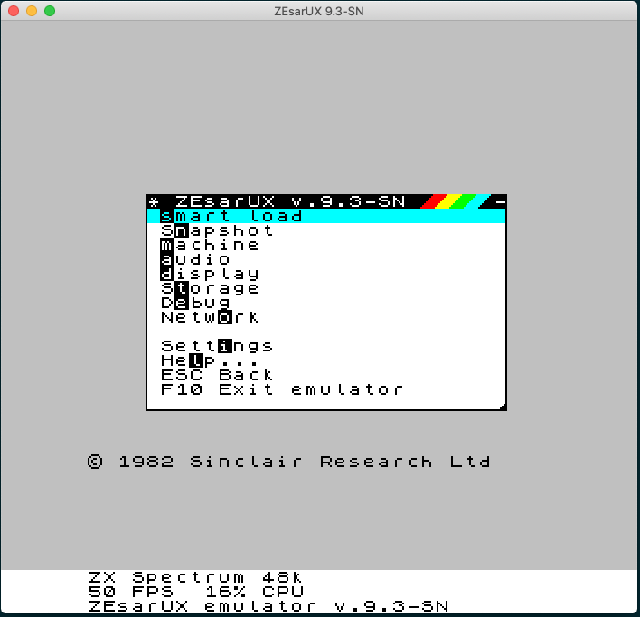
By default, the menu style is like the Spectrum 128 models, but it can be changed.
These menus are called “ZX Vision” menus, it’s a tribute to the “Turbo Vision” Borland menus, widely used in the 90’s.
When you open a ZEsarUX menu, by default it’s placed over the emulated machine display, the keyboard and mouse focus go to the opened menu, and not to the emulated machine. The emulated machine will continue running but won’t receive any keyboard key or mouse events.

What we call a window menu can include:
- Entries to other submenus (like this one shown on the main menu)
- A content window, for example the Audio Waveform window:
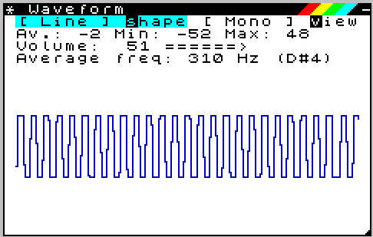
- Settings entries: like the different entries in Settings submenus:
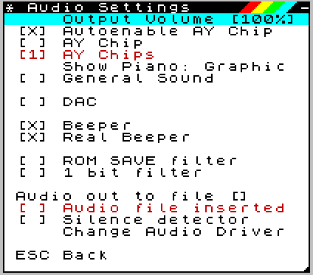

As a general rule, ZX Vision menus respond to the following keys or mouse actions:
- Esc/Right mouse button: closes the current menu and goes back to previous menu (if any)
- Cursor up, down, mouse movement: selects an item in the menu
- Cursor left, right, tab: selects an item on the left or right. Not
- Enter/Left mouse button: fires the action in the menu. It can open another menu, open a content window, or change a setting shown in this item.
- Space: some menu items (like breakpoints) can be enabled/disabled by pressing this key
- Letters from “a” to “z”: they can fire an item in the menu, most items have a “hotkey”, pressing that letter in a menu, it just fires that action (it’s equivalent to select that one and press Enter). Hotkey letters are shown in inverted text colour (and hidden the first seconds). For example:

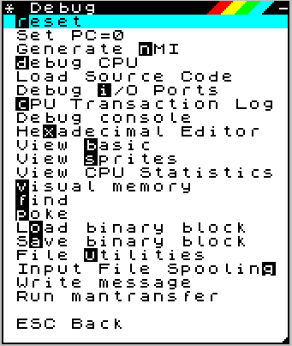
Pressing the “r” key in the menu Debug it just resets the machine.
These hotkeys are by default hidden when you enter a menu, but they are shown after a few seconds.

Window actions

Most ZX Vision windows respond to different events:

- Move window: you can move a window by keeping pressed the left mouse button on the window menu and moving the mouse. Remember I’m always referring to menus inside the ZEsarUX window, so for example:

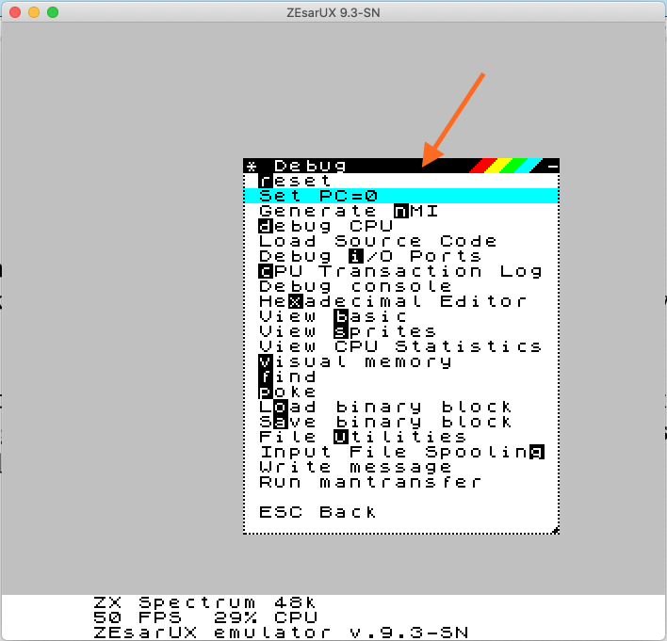
You must press the left button (and kept it pressed) where the arrow points at, and move the mouse. It’s like moving your operating system windows but in this case, this window is inside the ZEsarUX window.

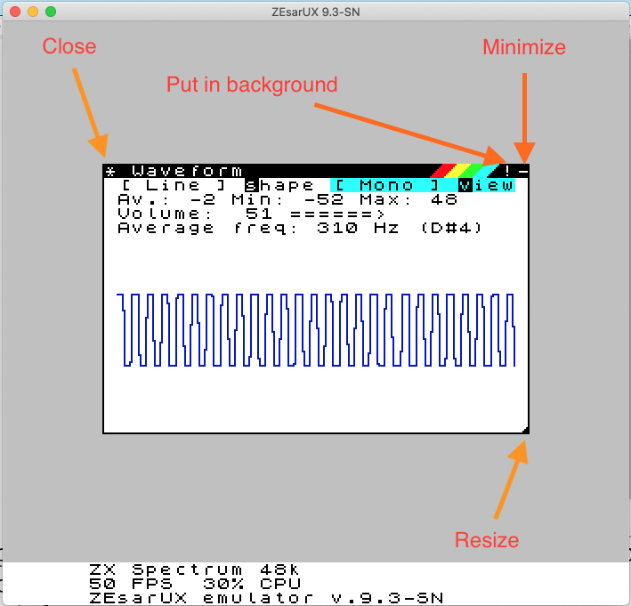

- Resize window: you can resize a window by keeping pressed the bottom-right section on the window menu and moving the mouse. Not all windows remembers the previous size: as a general rule, menu windows doesn’t remember the previous size, and many (but no all) content windows remember the previous size.
- Pressing the ‘*’ symbol, closes the window (just like pressing ESC key)
- Pressing the “-” symbol, minimizes the window
- Pressing the “!” symbol (or pressing F6 key) puts the window in the background. Not all windows allows this, usually many content windows can be put on the background (Note: background windows are by default not allowed, you must enable them in Settings→ GUI→ Window → Background Windows)
-Clicking (left mouse button) outsize a ZX Vision window will return keyboard focus to the emulated machine, but keeping the menu opened.

ZX Desktop

As we have seen in the previous chapter, the menu interface is placed by default over the emulated machine. But it can be changed, we can have a larger ZEsarUX interface window, so we can place menus on the right. We will have other advantages as we will see. This extra space is called “ZX Desktop”. To enable it, go to Settings→GUI→ ZX Desktop → Enable

Then the ZEsarUX window will be extended like this:
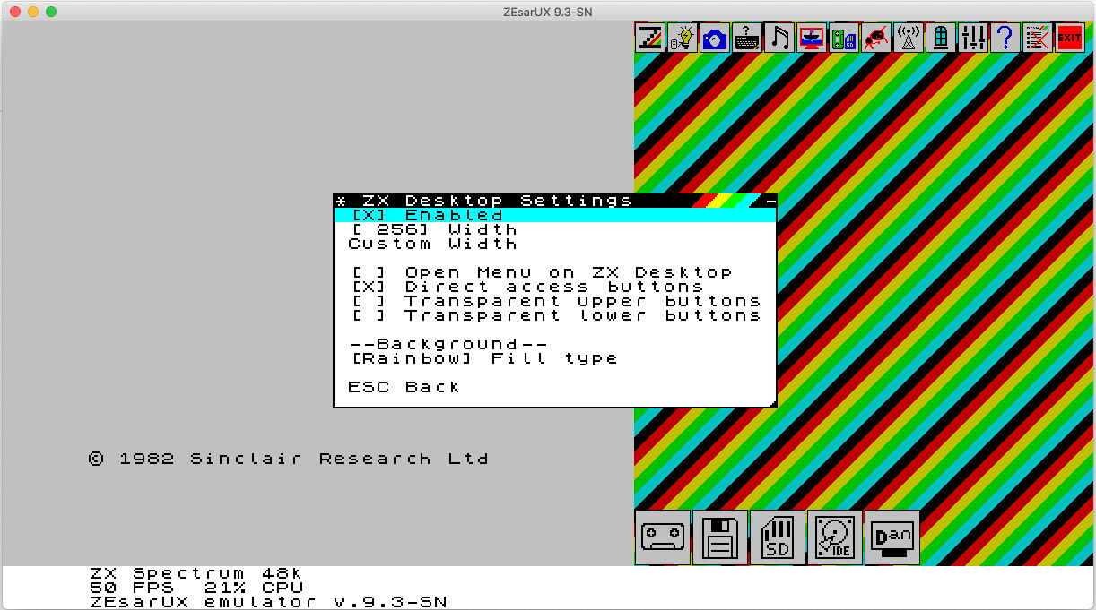
As we see, an extra space appears on the right, but also additional buttons:
- Buttons on the top access to main menu actions: ZEsarUX menu, Smartload menu, Snapshot menu, etc. There are two extra buttons on the right: Close all windows and Exit emulator
- Buttons on the bottom access to machine devices. By default, when no device is inserted, they will appear monochrome. But when inserted a device, they will get some colour to indicate a device is present.

As we see in this setting menu, we can:
- Change width: selecting this item the ZX Desktop will be bigger
- Custom width: just write an exact size
- Open menu on ZX Desktop: by default, menus will be centered horizontally on all the ZEsarUX window. Enabling this setting, will force windows to fit on the ZX Desktop space

You can play with all the other settings there.

TODO: Documentación con pie de pagina, logo ZEsarUX, etc

