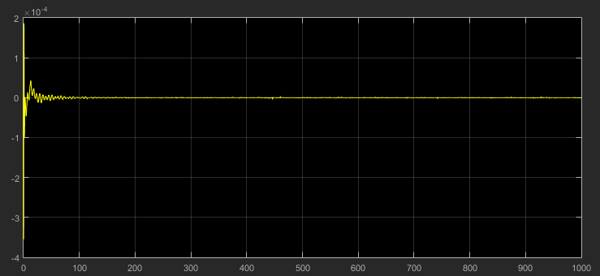

Error in x(t) for observable output x(t)

