Abstract

1. Introduction

Our approach takes advantage of…

1. Materials & Methods

2.1 Pre-processing

Our source input data includes cortical, subcortical, and DTI measurements totaling 66 features for 76 instances in the control group, 45 instances of untreated first episode schizophrenic patients, 20 instances of schizophrenic patients accepting medicine, and 35 instances of schizophrenic patients rejecting treatment. Two scaling techniques are tested – standardizing and principle component analysis (PCA).

2.2 Developing the model

Eight models are tested with five sets of input features. The eight models are linear regression, support vector machine (SVM) with a radial basis function (RBF) kernel, ridge regression, ElasticNet, Bayesian regression, Lasso, decision tree regression, and stochastic gradient descent.

2.3 Analysis

5-fold ross validation with random sampling from a shuffled dataset is used for model assessment. This cross validation is done 100 times on each model, with seeded random splits such that each model sees the same splits during training and fitting. For each cross validation, an average score is taken from the 5 configurations. Then, those averages are averaged after 100 iterations.

2.3.1 Brain age correlation

2.3.2 Body age correlation

1. Results

3.1 Brain age results

3.2 Body age results

1. Discussion

Ridge regression vastly outperforms ordinary least squares regression during cross validation, showing that there may be collinearity in the data. This can be expected, as the features represent brain regions which are close spatially. A reading for one area may be influenced by those around it. Ridge regression also shifts the coefficient weights toward 0, which can help stabilize them.

The Bayesian ridge inference model working better than ridge alone implies that there may be priors associated with the input data, which may be induced from the equipment that performed the brain scans to take this data, or the brain’s activity itself. Non-informed priors are used in this implementation of Bayesian ridge regression, assuming a Gaussian distribution around the feature vectors. The Bayesian inference model may also be performing better due to the smaller sample size, allowing for the priors to have significant impact on the resulting predicted age.

1. Conclusion

Results

We implement the methods using Python, scikit-learn, numPy, Pandas, and matplotlib.

A Bayesian ridge model performs best using the full feature vector (=0.883), showing the best ability to generalize over 100 iterations of 5-fold cross validation (=0.609). Other notable models using the full feature vector include SVM with RBF kernel (=0.536), ElasticNet (=0.593), and ridge (=0.516).

We also test subsets of the feature vectors of the cortical feature vector, subcortical feature vector, and DTI feature vector, the top 5 variables linearly correlated with brain age, and the top 20 variables linearly correlated with age. No other subset of data performs as well as the full feature vector with a Bayesian ridge regressor model.

Discussion

|  |  |  |  |
| --- | --- | --- | --- |
| **Feature** | **Linear** | **deg=2** | **deg=3** |
| superiorfrontal | 0.191806974 | 0.190957297 | 0.153828254 |
| GCC | 0.168573645 | 0.185481251 | 0.143588608 |
| parsopercularis | 0.162543893 | 0.148481573 | 0.107115252 |
| medialorbitofrontal | 0.156666067 | 0.144221257 | -0.102068301 |
| Thalamus | 0.151453842 | 0.154285246 | 0.126686093 |
| superiortemporal | 0.138638063 | 0.12829608 | 0.112861574 |
| rostralanteriorcingulate | 0.122889494 | 0.104477196 | 0.062824869 |
| CC | 0.109873238 | 0.11081502 | 0.085506722 |
| BCC | 0.105178546 | 0.099159928 | 0.059506878 |
| Left-Accumbens-area | 0.101227941 | 0.100850562 | -0.441981323 |
| FX | 0.084414875 | 0.075922113 | 0.042183436 |
| caudalmiddlefrontal | 0.078756231 | 0.033309392 | -0.097988119 |
| insula | 0.071186958 | 0.070307634 | 0.058560935 |
| supramarginal | 0.067991748 | 0.051994474 | -0.055696737 |
| frontalpole | 0.062361593 | 0.038629688 | -0.01095099 |
| rostralmiddlefrontal | 0.060488917 | 0.04040489 | -0.046457459 |
| parstriangularis | 0.059285932 | 0.062792963 | 0.027704727 |
| bankssts | 0.052170539 | 0.058758916 | -0.028086754 |
| CR | 0.022410172 | 0.01812194 | 0.010100561 |
| lateralorbitofrontal | 0.015881764 | -0.037889873 | -0.092436024 |

Figure: Top 20 variables linearly correlated with age using single variable linear/polynomial fitting

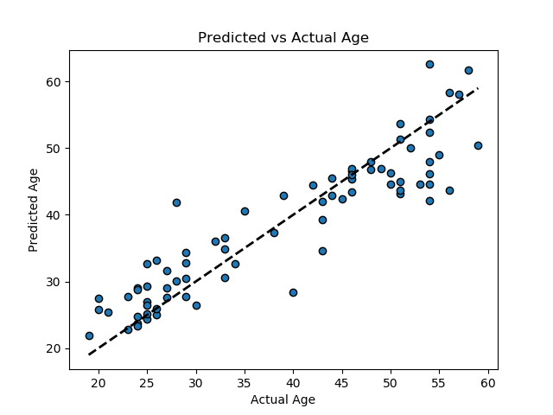

Figure: Predicted vs Actual Age for a Bayesian Ridge Regression model trained on all 76 samples using all 66 feature vectors (=0.883)

|  |  |
| --- | --- |
| Model |  |
| Bayesian Ridge | 0.609 |
| SVM - RBF | 0.536 |
| Linear Regression | -3.647 |
| Decision Tree | -0.37 |
| Ridge | 0.516 |
| Lasso | 0.383 |
| ElasticNet | 0.593 |
| SGD | 0.066 |

Figure: Model scores averaged over 100 iterations of 5-fold cross validation on the full feature vector

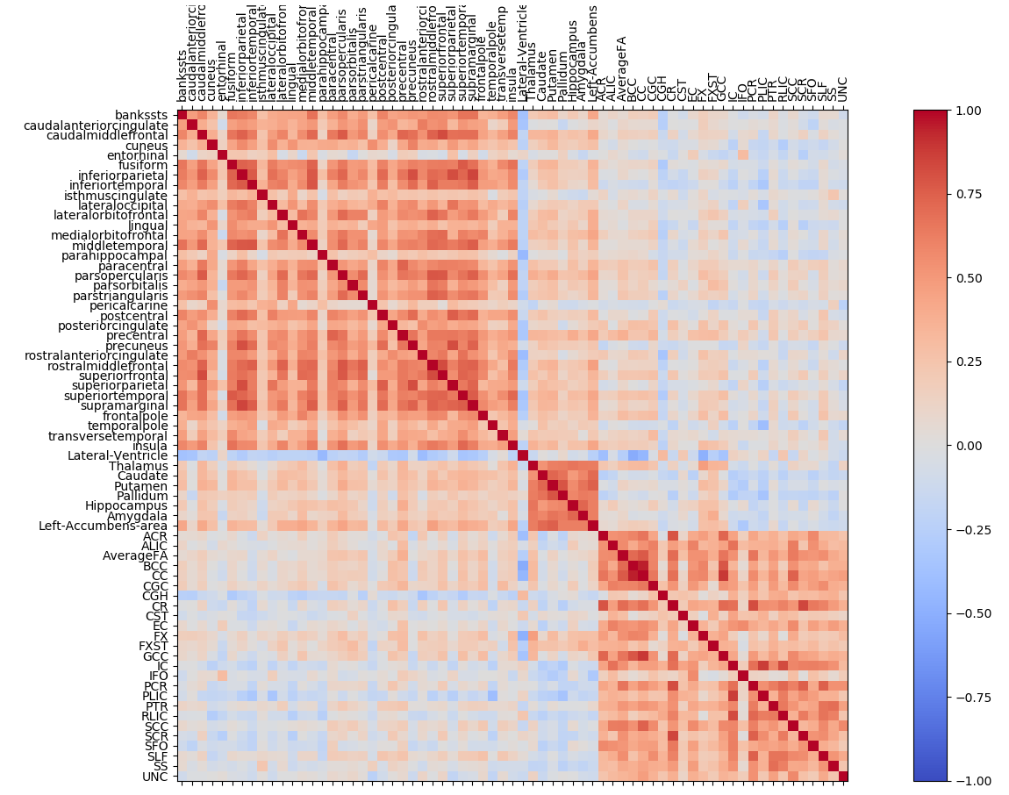



Figure: Covariance matrix of the 66 input features from the DTI, subcortical, and cortical datasets and all patient groups

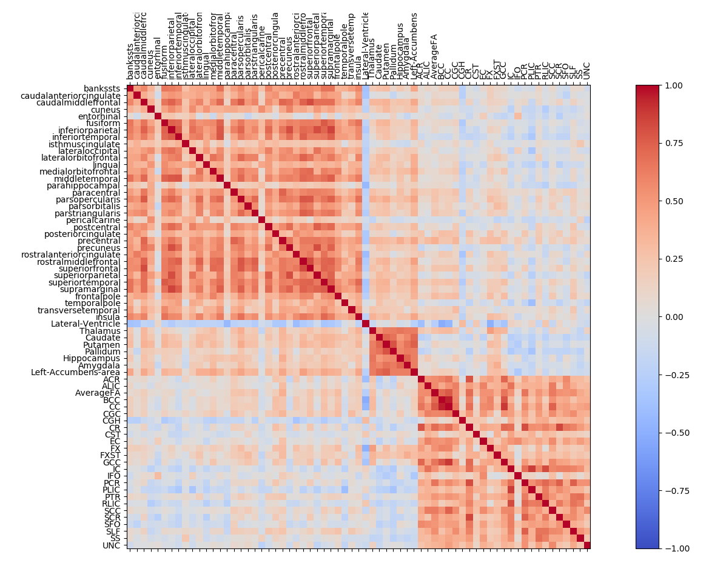

Figure: Covariance matrix of the 66 input features from the DTI, subcortical, and cortical datasets on only the control group