**A1 – Kimono**

**36°58'21.8"N 122°01'32.4"W**

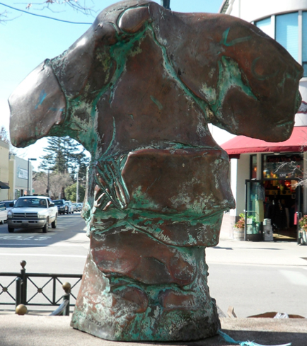

**A2 (original) – Vader Helmet**

**36°58'25.6"N 122°01'33.5"W**

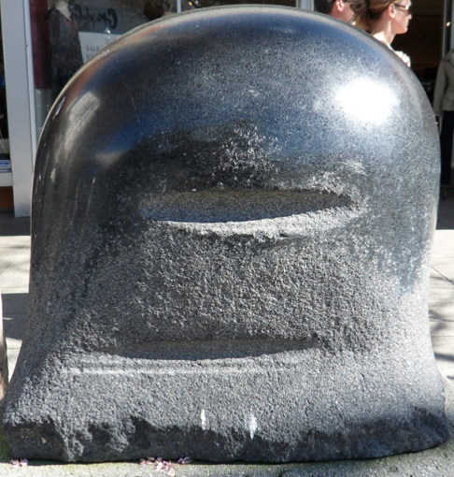

**A2 (replacement) – Pendulum**

**36°58'24.7"N 122°01'33.2"W**

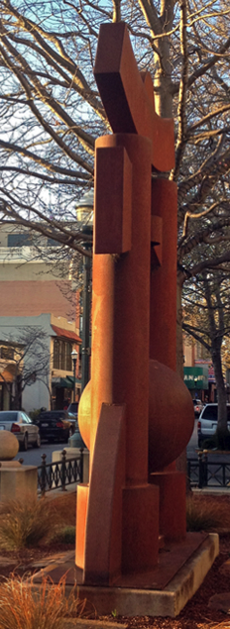

**A3 - Pi Signs**

**36°58'23.2"N 122°01'37.3"W**

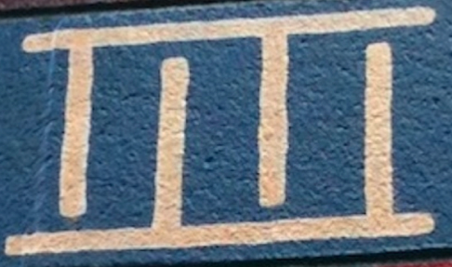

**A4 – Trumpet Bench**

**36°58'23.7"N 122°01'35.2"W**

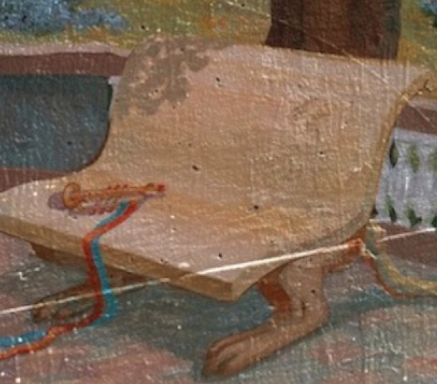

**A5 (original) – Emo Penguin**

**36°58'31.2"N 122°01'37.5"W**

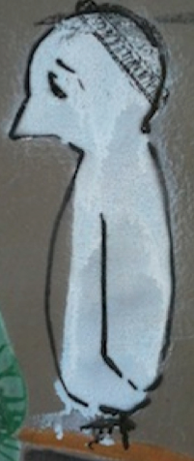

**A5 (replacement) – Phallic Thing**

**36°58'18.7"N 122°01'31.5"W**

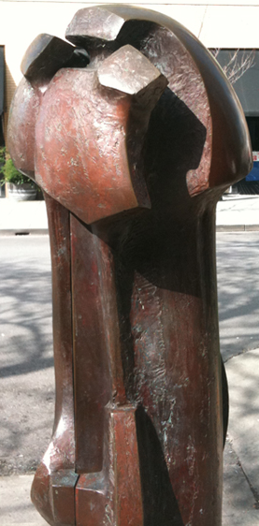

**B1 – Brass Slide**

**36°58'28.9"N 122°01'34.5"W**

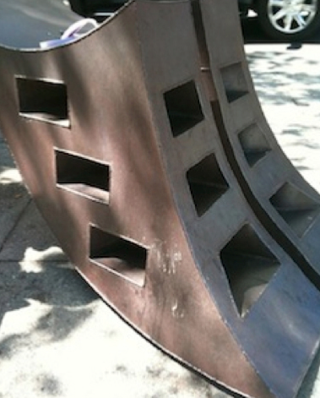

**B2 – Mosaic**

**36°58'22.5"N 122°01'35.0"W**

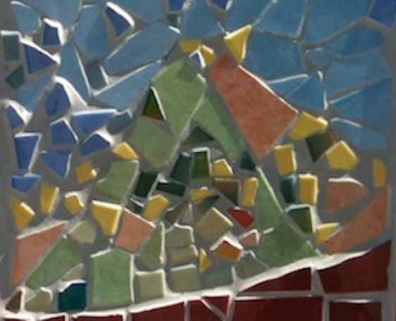

**B3 – Egg People**

**36°58'33.7"N 122°01'37.3"W**

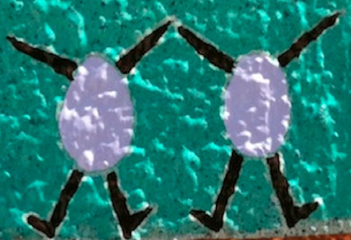

**B4 – Spiky Rocks**

**36°58'30.7"N 122°01'32.5"W**

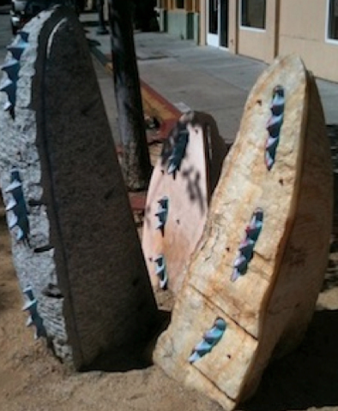

**B5 (original) – Curvy Vase**

**36°58'35.4"N 122°01'36.3"W**

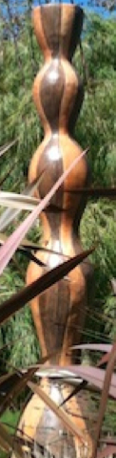

**B5 (replacement) – Silver Shapes**

**36°58'35.4"N 122°01'36.3"W**

