Lesson Plan
Title | Programming with Python
Time duration | 1 Hour
Review & Exercises | Review of concepts and exercises for practice

Lesson Review
- Write Python programs
  - How Python programs get executed:
    - The program gets executed line by line starting from the top.

print('Hello World!')
print('O----')
print(' ||||')
Outcome: Each print statement in the above sample code is printed one line at a time starting from top to bottom:
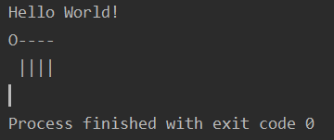
  - Programming Terms:
    - Data type: a set of values and a set of operations defined on those values. Python’s built-in data types include int (integers), float (floating-point numbers), str (strings), and bool (true or false values only).
    - String: a series of characters; strings are declared with quotations.
    - Operator: representation of a data-type operation, and include constructs which behave like functions (e.g., addition, subtraction, multiplication, division).
    - Operation precedence: precedence rules that specify the order in which operations in an expression should be applied.
    - Expression: a piece of code that produces a value.
      - Expressions can be passed as an argument to the print() function. The expression is executed before the print.

print('*' * 10)
Outcome: In this programming sample: the ‘*’ character is copied 10 times.
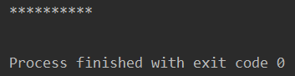
  - Using Variables:

    - Variable: variables are used to temporarily store data in a computer’s memory, which are accessible anywhere in the program by its label.
    - Execution: remember, statements are executed sequentially from top to bottom; variables assigned different values later will print the latest value assigned to them.
    - In addition to strings, variables can also be assigned integers, floats and Booleans.

# Variables Types
price = 10 # integer
rating = 4.9 # floating point number (float, real numbers)
first_name = 'John' # string
is_published = True # boolean
  - Getting Input:
    - Use the input() function to receive input from the user of the program. Like the print() function, the input() function is built into Python.

name = input('What is your name? ')
print('Hi ' + name)
Outcome: When the input() function is used, the program will pause, and the user will be prompted to enter a value before the program resumes. In this code sample, the user is prompted to enter their name, which gets printed to the console.
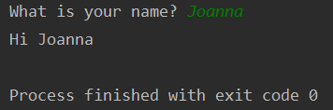
- Type Conversion: Type conversion is used to convert one data type to another data type in order to perform certain operations and function on that data. An example is converting a string to an integer. The number 10 can be represented as a string data type when enclosed in quotes – ‘10’ – and can also be represented as an integer data type when not enclosed in quotes. The string version of ‘10’ can be converted into an integer with type conversion.
  - A programming sample of type conversion is below. This program calculates the age of a person by subtracting the persons year of birth from the year 2020. The user is prompted for their birth year. The input() function returns this birth year as a string but it needs to be converted to an integer in order to perform the subtraction.

birth_year = input('Birth year: ')
age = 2020 - birth_year
print('Your age is: ' + age)

Output: the output below shows an error. This is because the birth_year is still a string since the input() function returns it as a string. It needs to be converted to an integer before the age is calculated.
An error message provides important information useful to debug the program, which includes (1) the line where the error occurred, (2) the statement that caused the error, and (3) the type of error thrown.
This error is thrown because Python is trying to execute a subtraction expression, but the operands don’t match! Why?
The value for age is an integer but the value for birth_year is a string and so at runtime the expression for age is:

2020 + ‘1985’

The above expression is invalid!

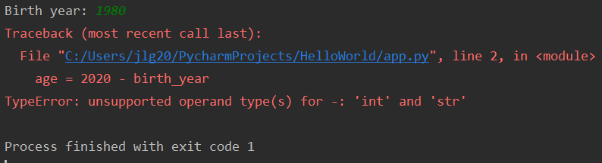
The problem with this is 2020 is an integer but 1985 is a string (notice the single quotes). Python doesn’t know how to evaluate this expression. It cannot subtract a string from an integer.

To fix this problem, the int() function is used to convert the birth_year string into an integer. The output now prompts the user for the birth year, and now correctly calculates and prints the age.

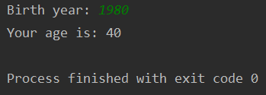
birth_year = input('Birth year: ')
age = 2020 - int(birth_year)
print('Your age is: ' + (str(age)))

  - There are several type conversion functions. These are Python built-in functions for converting values into different types.

- int() – converts a string into an integer
- float() – converts a string into a float
- bool() – converts a string into a boolean
- str() – converts the specified value into a string

  - It is possible to check the type of a variable with a special Python built-in function, called type(). Examples of showing the type of a variable using the type() function are displayed below.

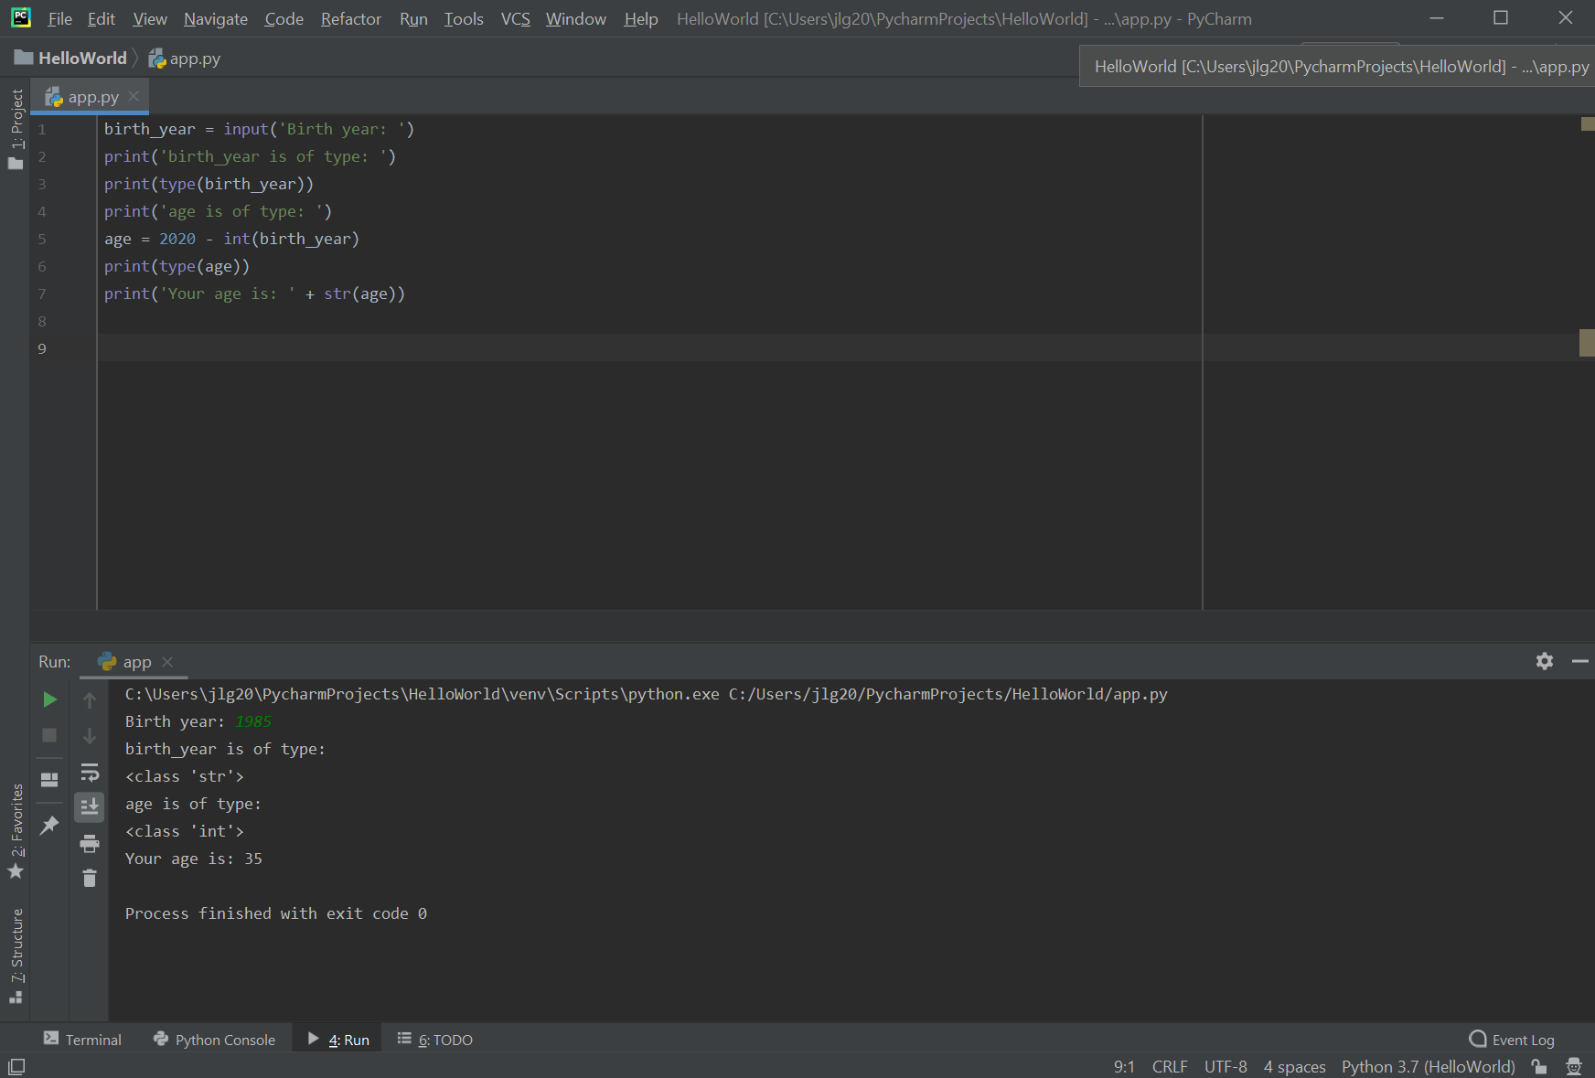
  - Key point: whenever you use the input() function you always get a string. If you are expecting a numerical value, you should always convert that string into either an integer or a float.

Practice Exercises

- We check in a patient named John Smith. He’s 20 years old and is a new patient. Assign three variables for: (1) his name, (2) his age, and (3) to determine if he is a new or existing patient. Print all three variables to the console.
- Ask two questions: the person’s name and favorite color. Print a message like “John likes the color blue!”
- Ask a user their weight (in pounds), convert it to kilograms and print to the console.
- Create a program that asks the user to enter their name and their age. Print out a message addressed to them that tells them the year that they will turn 100 years old.
- Suppose that a and b are integers. What does the following sequence of statements do?

t = a
b = t
a = b

