Lesson Plan
Title | Programming with Python
Time duration | 1 Hour
Review & Exercises | Review of concepts and exercises for practice

Lesson Review
- Data structures:
  - Lists
  - Lists: when print a subset of the list this does not overwrite the original list. Instead it creates a new list that gets printed.

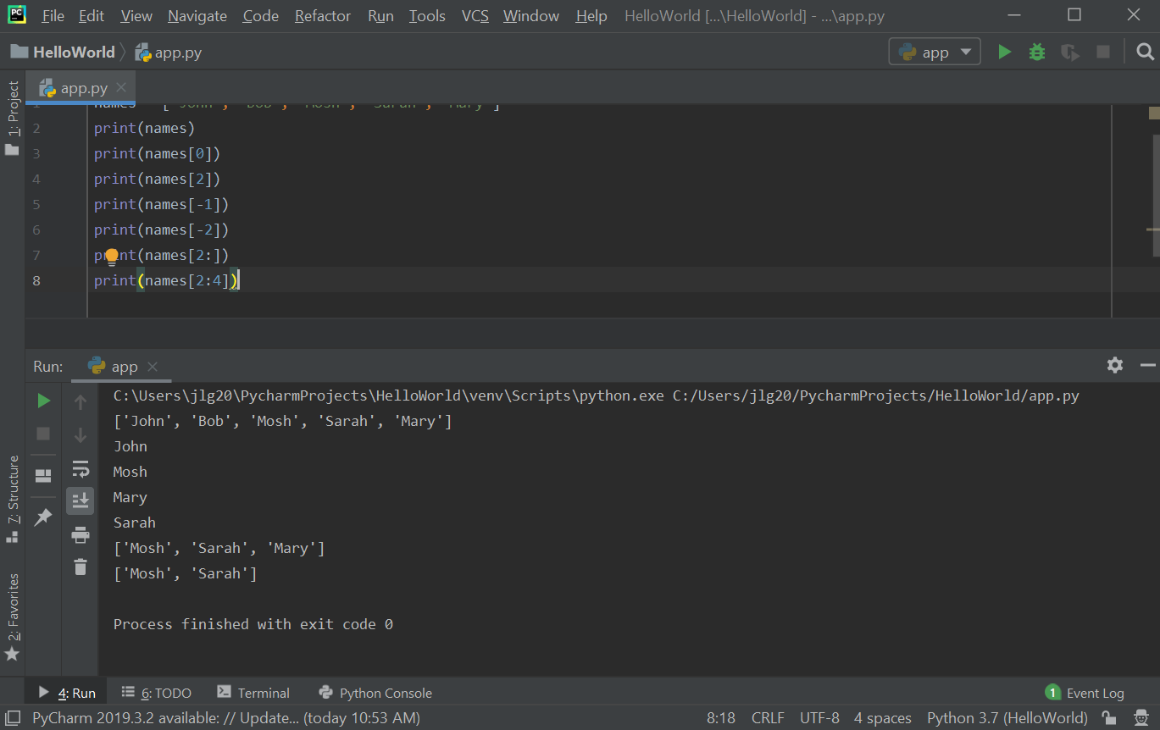

Values in the list can be modified using the index for that value.

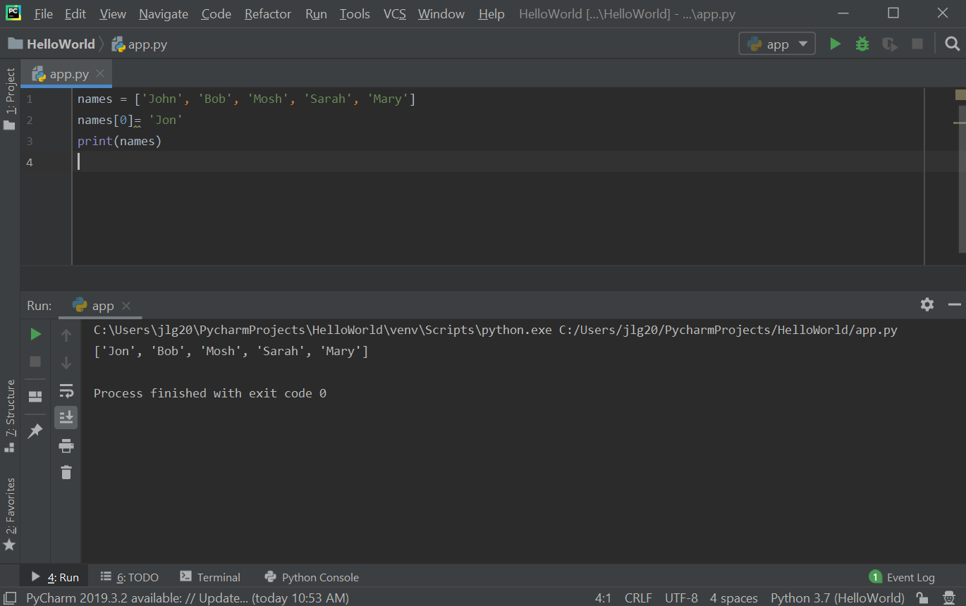

Exercise: write a program to find the largest number in a list.
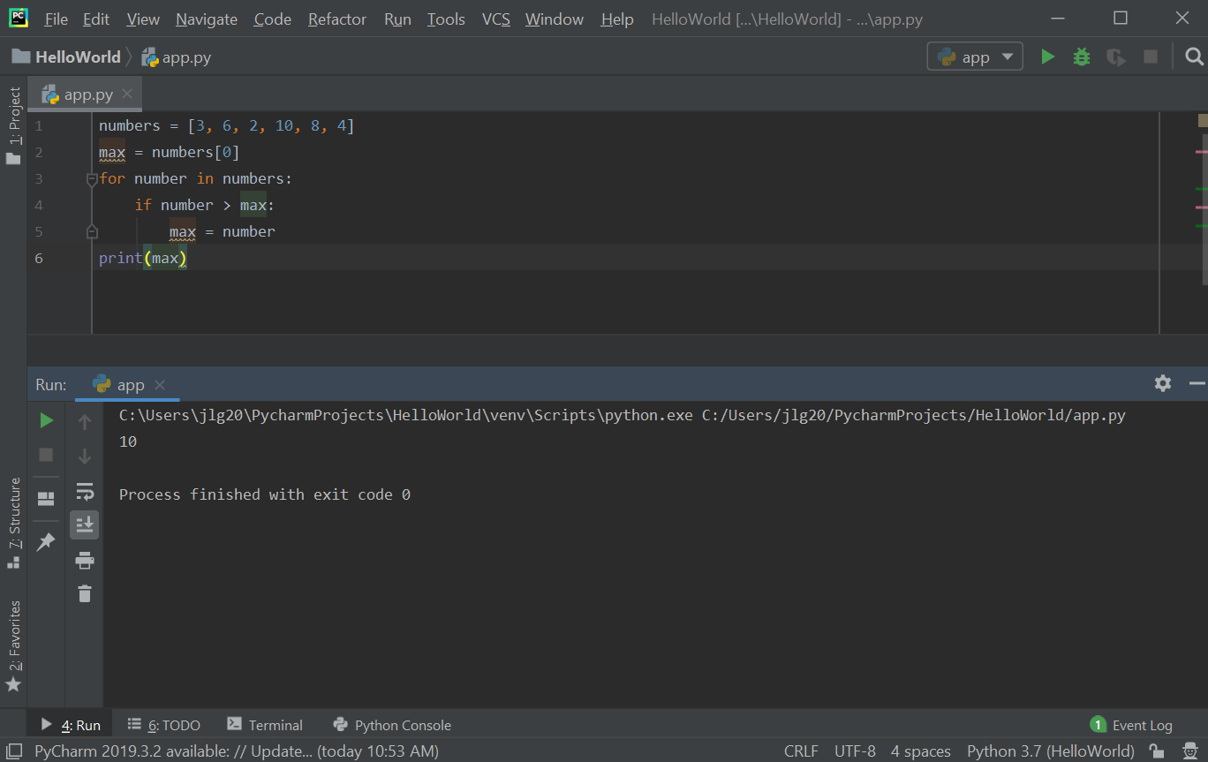

  - 2D Lists: 2D Lists: 2D lists have a lot of application in data science and machine learning. A 3-dimensional matrix (mathematics) can be represented in Python with a 2D list. 2D lists are where each item in that list is in another list. To access items in a 2D list, there is an outer list and then an inner list. The first [] refer to the outer list index and then the second [] refer to the inner list index. Nested loops can be used to iterate all the items in a 2D list.

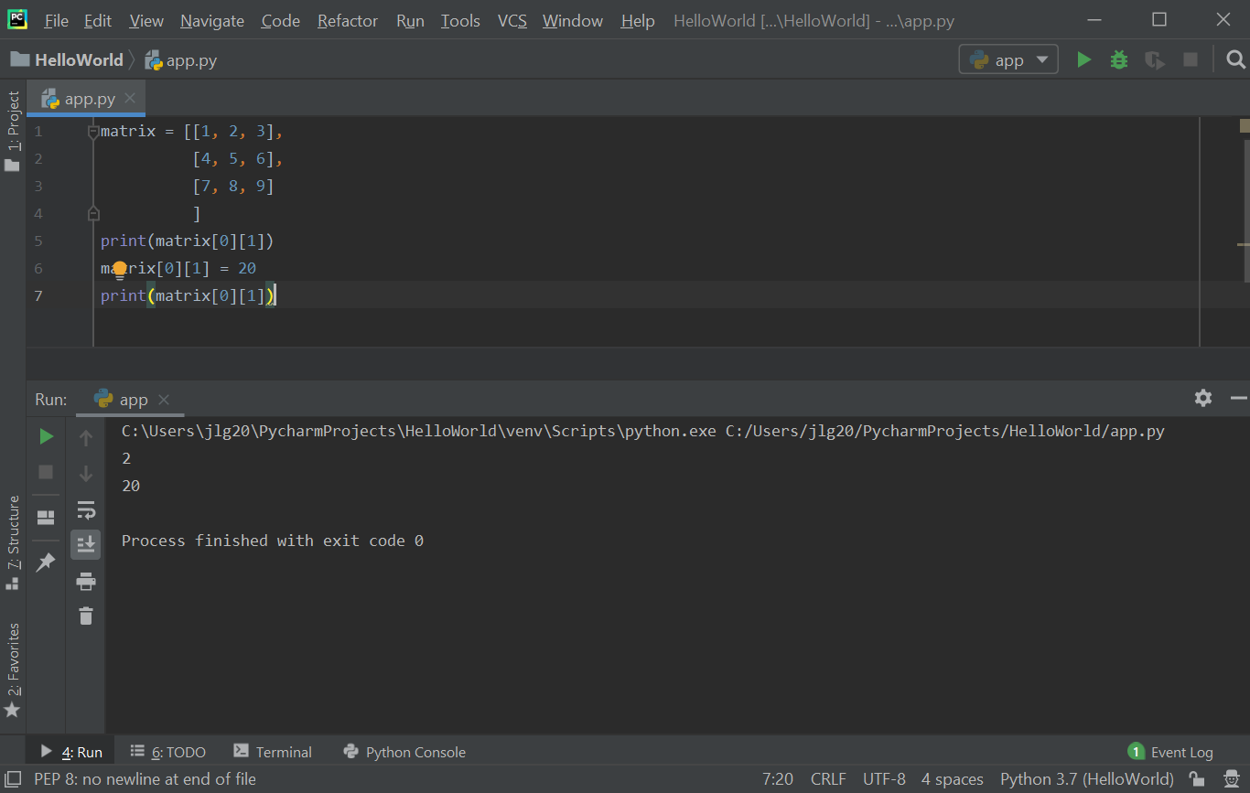

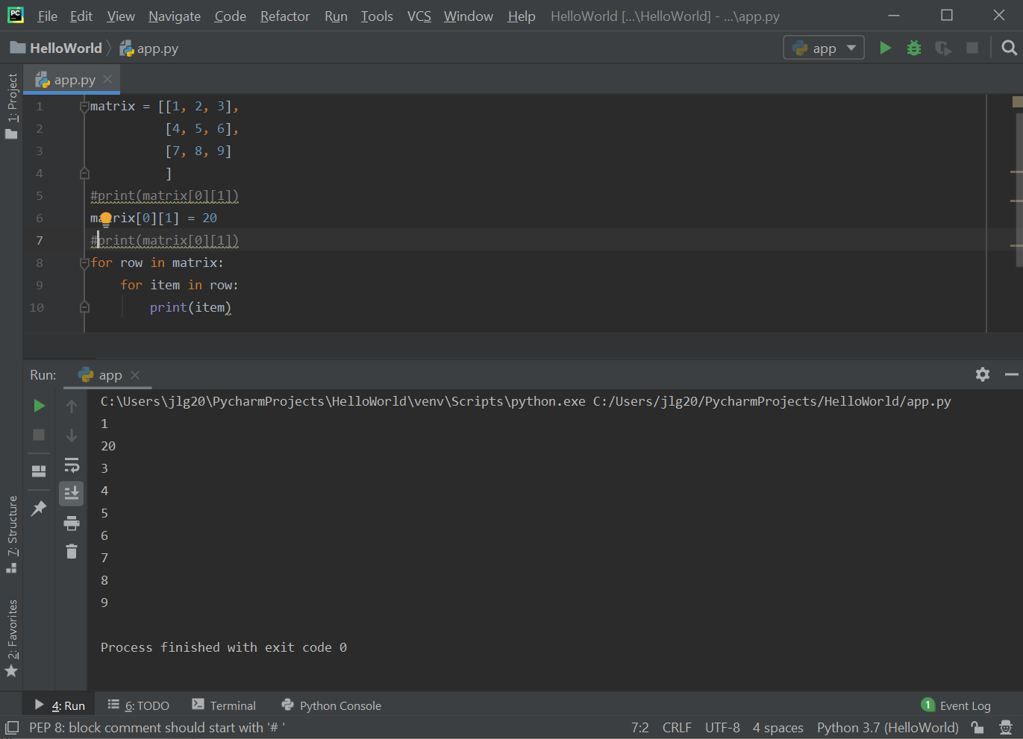

  - One example of an application of using two lists (arrays) is creating an array for suits and a second array of ranks to represent playing cards. These two arrays can then be used to create a deck of cards. The randrange() function can be used to randomly select a suit and a rank from the suits and ranks arrays, respectively.
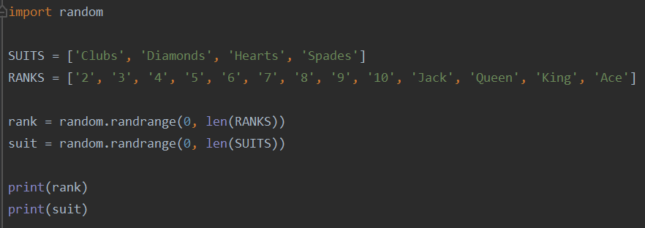

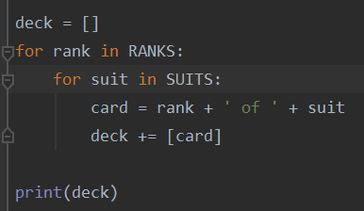
  - The deck array below is created by combining ranks and suits. The deck array will ultimately have length 52 to represent a full deck of playing cards.
Below is the output of the deck array, which show the entire deck of cards.

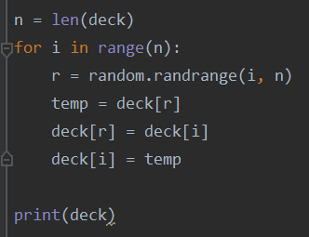
  - The code below shuffles the deck of cards by randomly selecting two cards from the existing decks array and swapping their positions. This is done n times, where n is defined as the size of the deck array.

Below is the output of the shuffling of the deck array. The cards are randomly positioned.

Practice Exercises
- Write a program that adds the elements of two 2-Dimensional arrays and puts the results in a third 2-Dimensional array (HINT: all of the arrays have to be the same length)(HINT: initialize the third resulting array with the proper dimensions before adding the elements from the first two arrays and placing the sum in the third array. For example, initialize the sum_matrix array (the third results array) with all zeros using the code: sum_matrix = [[0 for x in range(dim_col)] for i in range(dim_row)]). This will create the correct dimension for the sum_matrix. Use one set of nested for loops to iterate through both matrix and matrix1 to sum the elements and enter the sum into sum_matrix.
- Write a program that reverses the order of a 1D array. Do not use the reverse() array method (HINT: use the swap algorithm used to shuffle the deck array as a starting point).

