Lesson Plan
Title | Programming with Python
Time duration | 1 Hour
Review & Exercises | Review of concepts and exercises for practice

Lesson Review
- Data structures:
  - Lists
  - Lists: when print a subset of the list this does not overwrite the original list. Instead it creates a new list that gets printed.

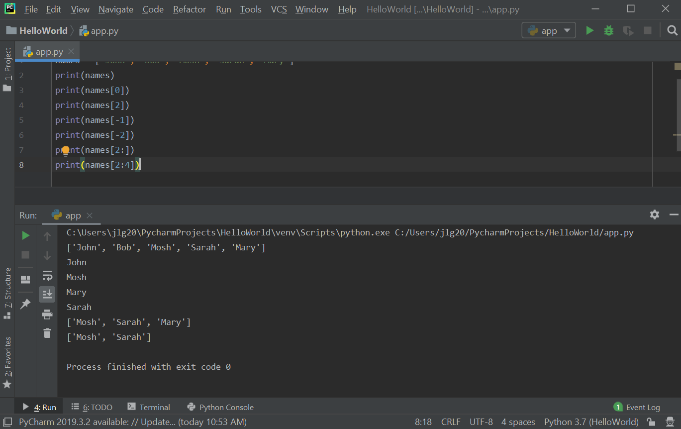

Values in the list can be modified using the index for that value.

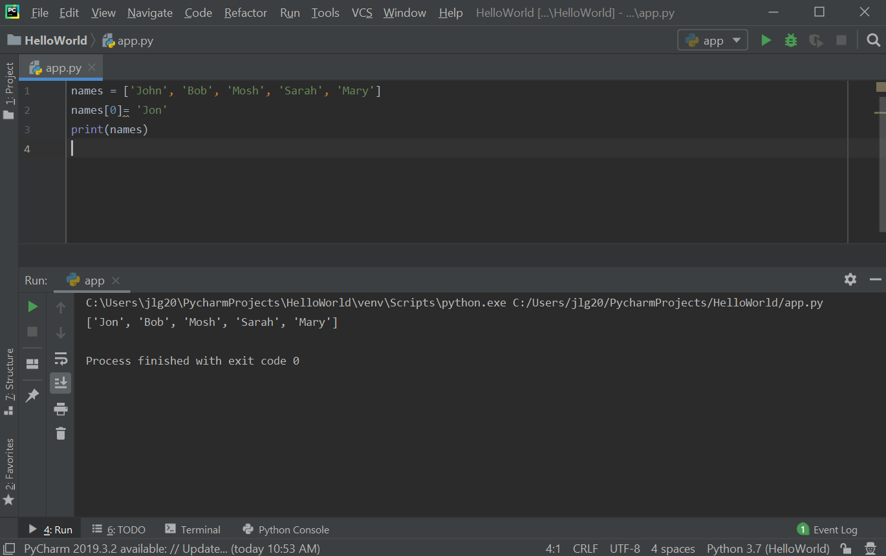

Exercise: write a program to find the largest number in a list.
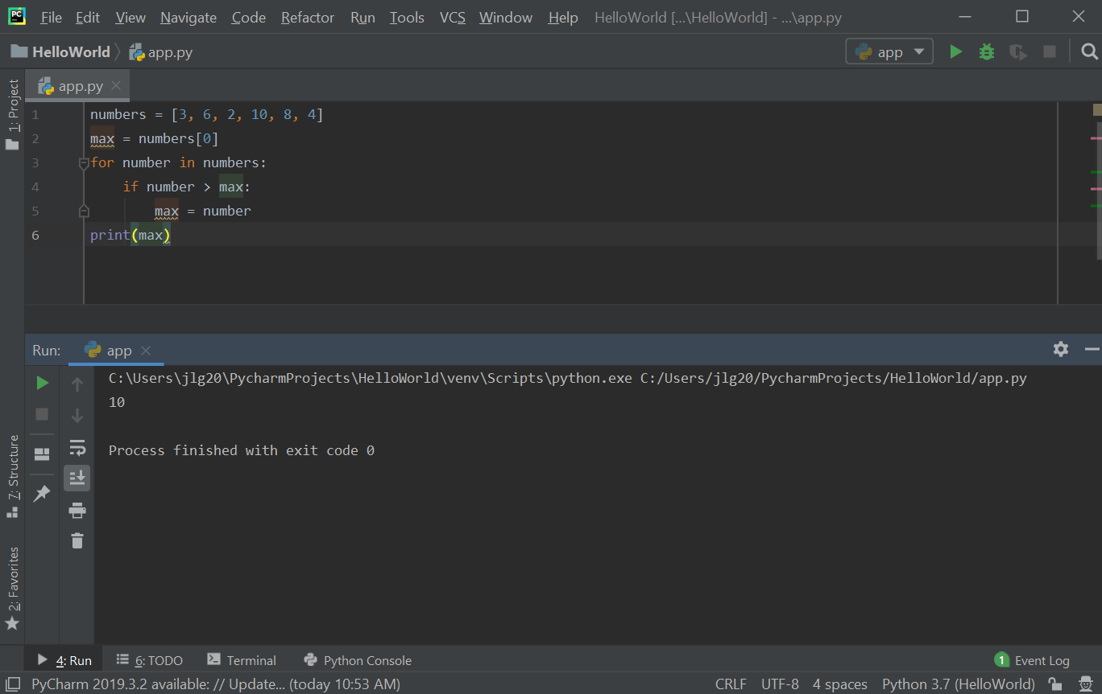

  - 2D Lists: 2D Lists: 2D lists have a lot of application in data science and machine learning. A 3-dimensional matrix (mathematics) can be represented in Python with a 2D list. 2D lists are where each item in that list is in another list. To access items in a 2D list, there is an outer list and then an inner list. The first [] refer to the outer list index and then the second [] refer to the inner list index. Nested loops can be used to iterate all the items in a 2D list.

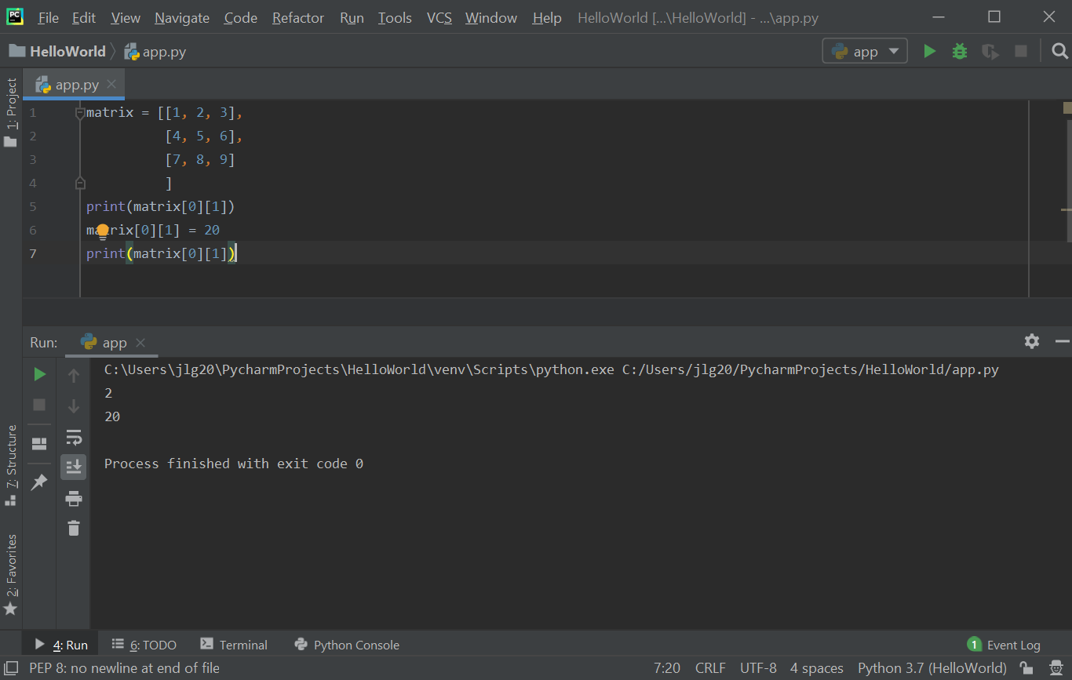

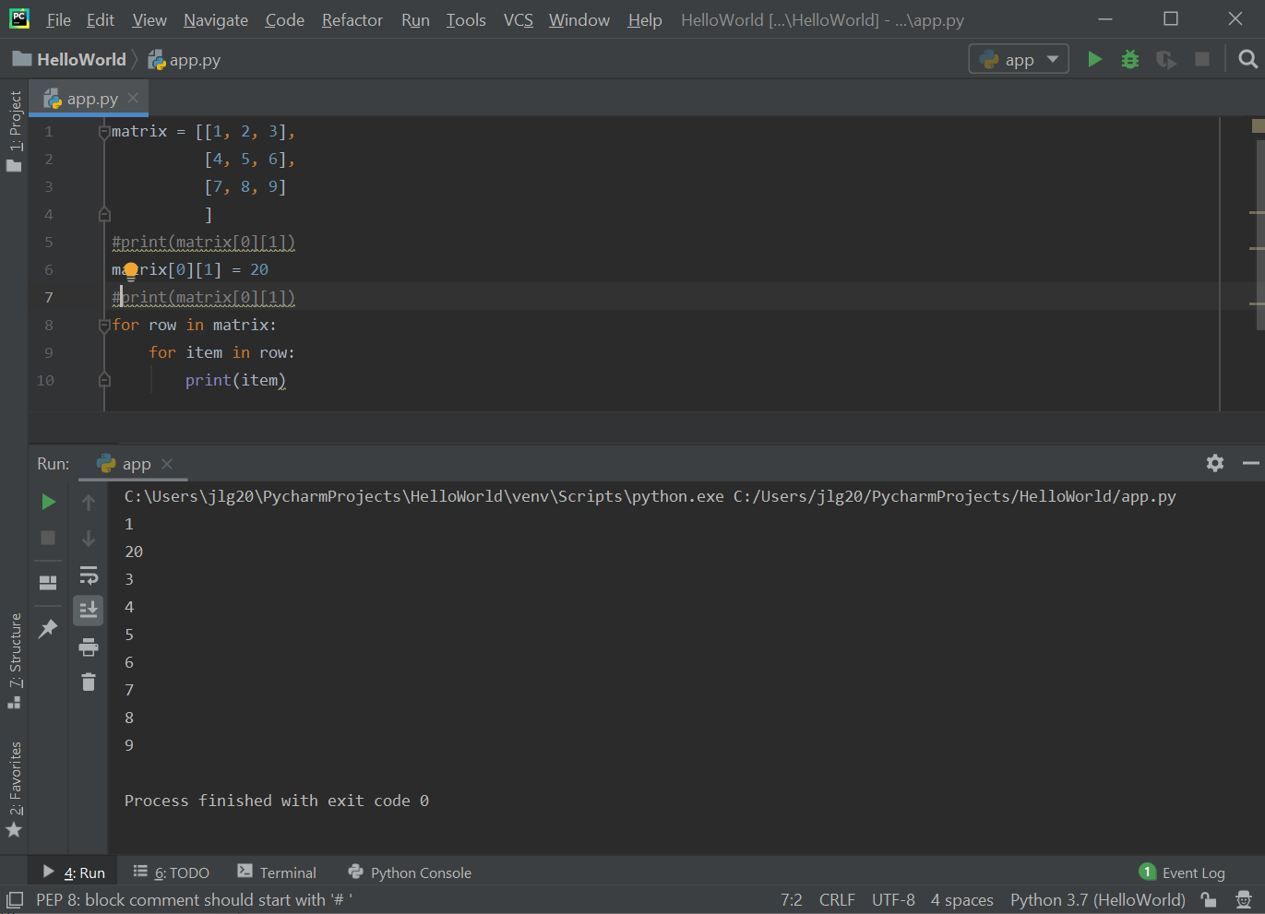

  - One example of an application of using two lists (arrays) is creating an array for suits and a second array of ranks to represent playing cards. These two arrays can then be used to create a deck of cards. The randrange() function can be used to randomly select a suit and a rank from the suits and ranks arrays, respectively.
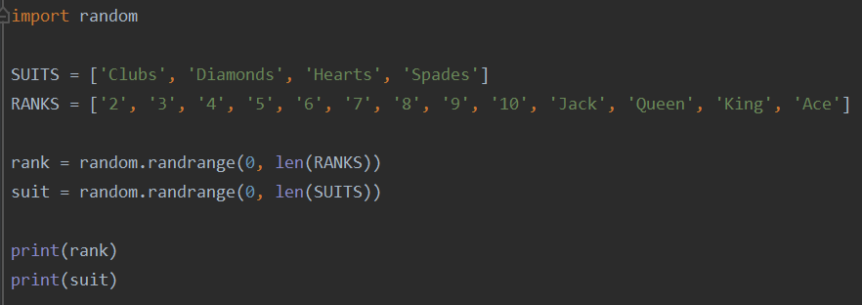

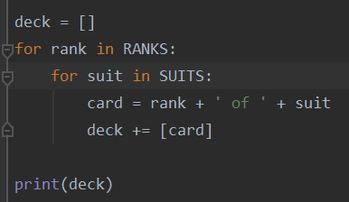
  - The deck array below is created by combining ranks and suits. The deck array will ultimately have length 52 to represent a full deck of playing cards.
Below is the output of the deck array, which show the entire deck of cards.

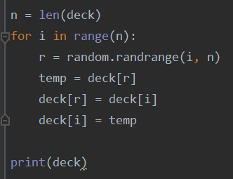
  - The code below shuffles the deck of cards by randomly selecting two cards from the existing decks array and swapping their positions. This is done n times, where n is defined as the size of the deck array.

Below is the output of the shuffling of the deck array. The cards are randomly positioned.

  - The next step is to distribute a shuffled deck of cards to players of a card game. In the code sample below, 5 cards will be distributed to each of the 3 players.

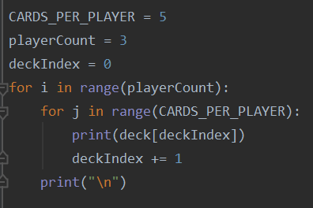

  - The shuffle algorithm used to shuffle the deck of cards above can also be applied to a 2D array. One example is to implement an in-array transpose of a 2D matrix. The code to do this is shown below.

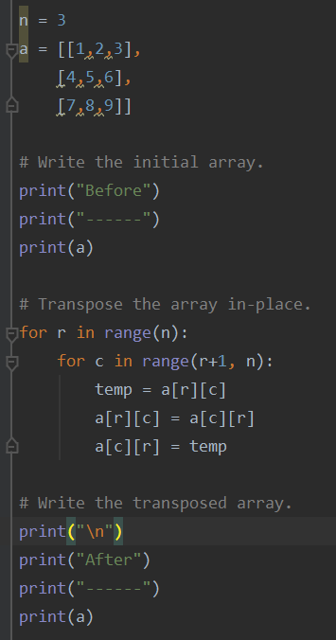

The output to the above code is shown below.

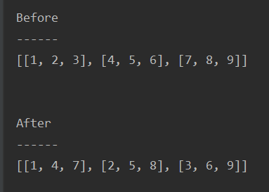
  - List Compression. Nested loops can be written in a single statement called list compression.
For example, the code shown below:

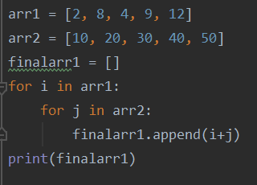

Can be rewritten as shown below. The syntax for the list compression sample below is:

new_array = [expression for item1 in iterable_array1 for item2 in iterable_array2]

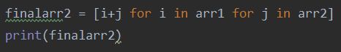

  - List compression is not limited to nested loops. You can also use conditional logic in list compression statements. For example, the code below shows the use of an if condition to test whether a number is an odd number.

The syntax for the list compression sample below is:

new_array = [expression for item in iterable_array if condition == True]

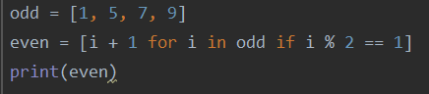

Practice Exercises

Note: these exercises focus on using both the traditional for loops and list compression syntax to iterate arrays. Please implement each exercise using both the traditional for loop syntax and using the list compression syntax.

- Write a program that removes all odd numbers from an array.
- Write a program to find all integers in an array between 1 and 1000 that are divisible by 5.
- Write a program to find all integers in an array between 1 and 1000 that has the digit 2 in that number.
- Write a program to find all integers in an array between 1 and 1000 and create a new list that contains the word “even” when encounter an even integer or “odd” when encounter an odd integer.

