Lesson Plan
Title | Programming with Python
Time duration | 1 Hour
Review & Exercises | Review of concepts and exercises for practice

Lesson Review
- Data structures:
  - Lists
  - Lists: when print a subset of the list this does not overwrite the original list. Instead it creates a new list that gets printed.

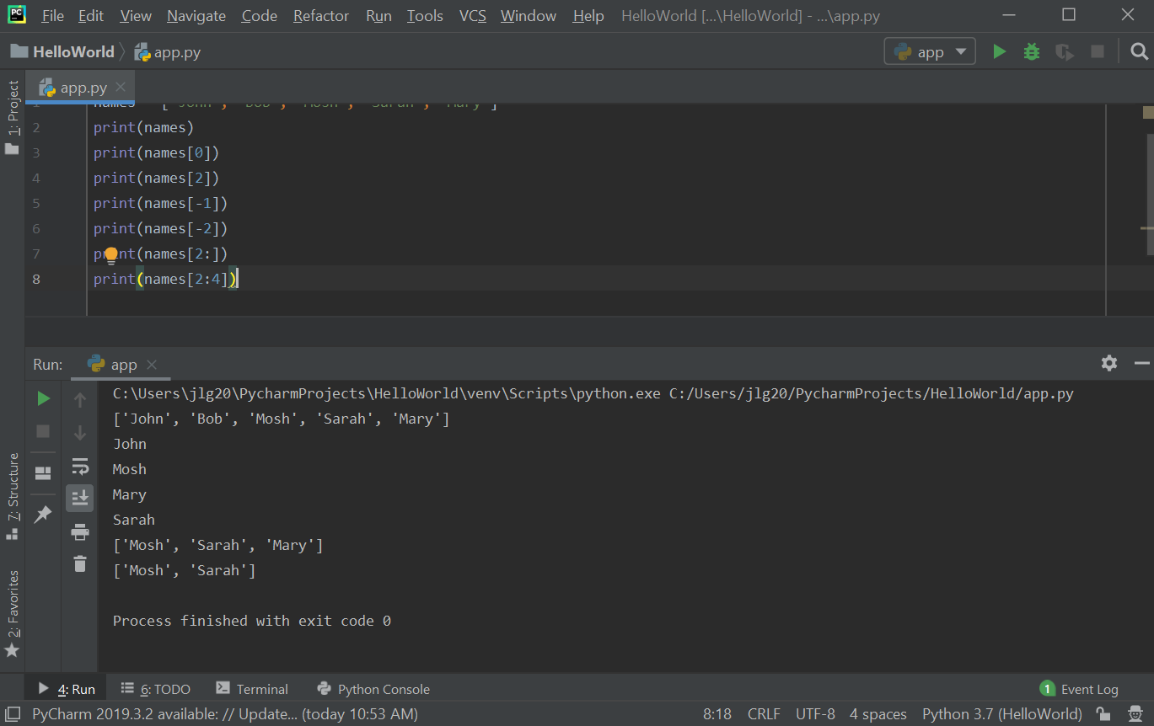

Values in the list can be modified using the index for that value.

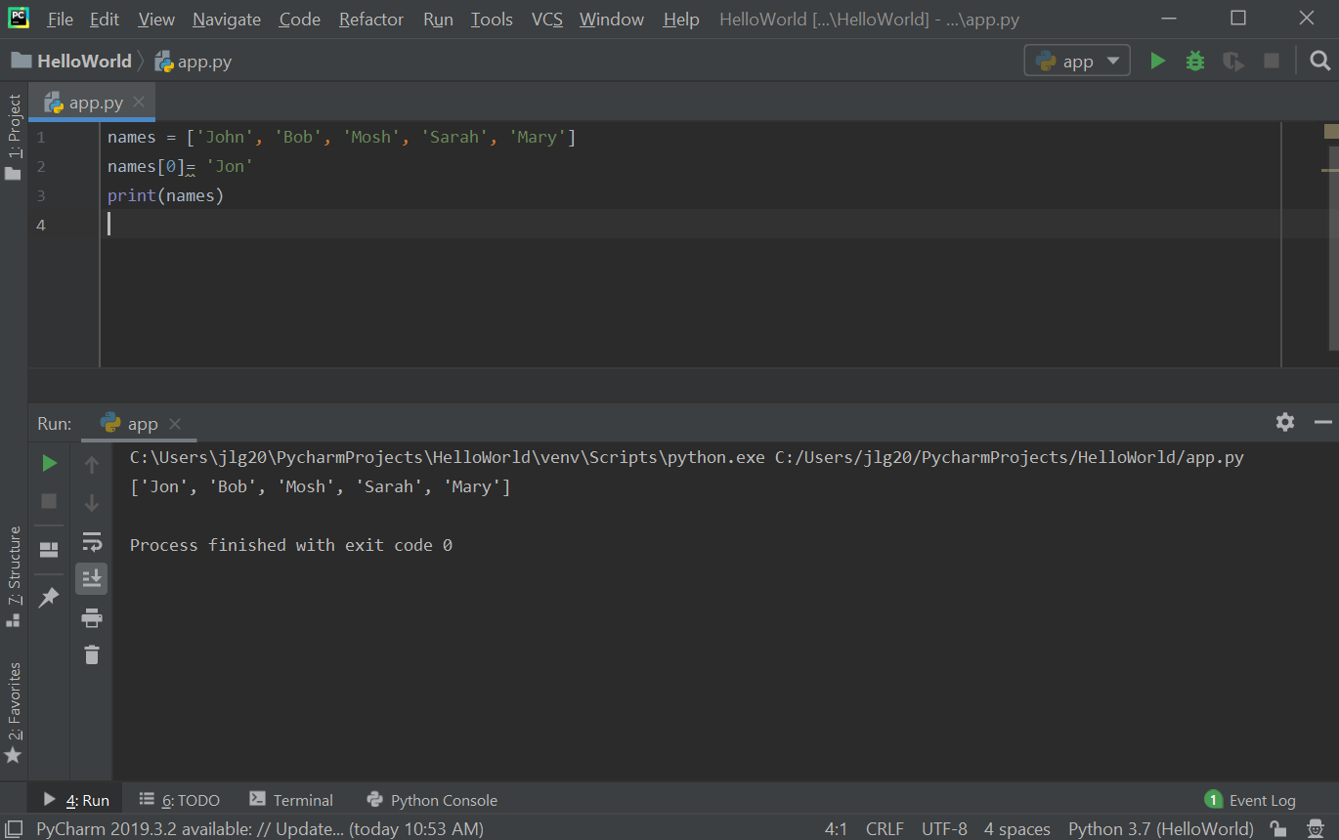

Exercise: write a program to find the largest number in a list.
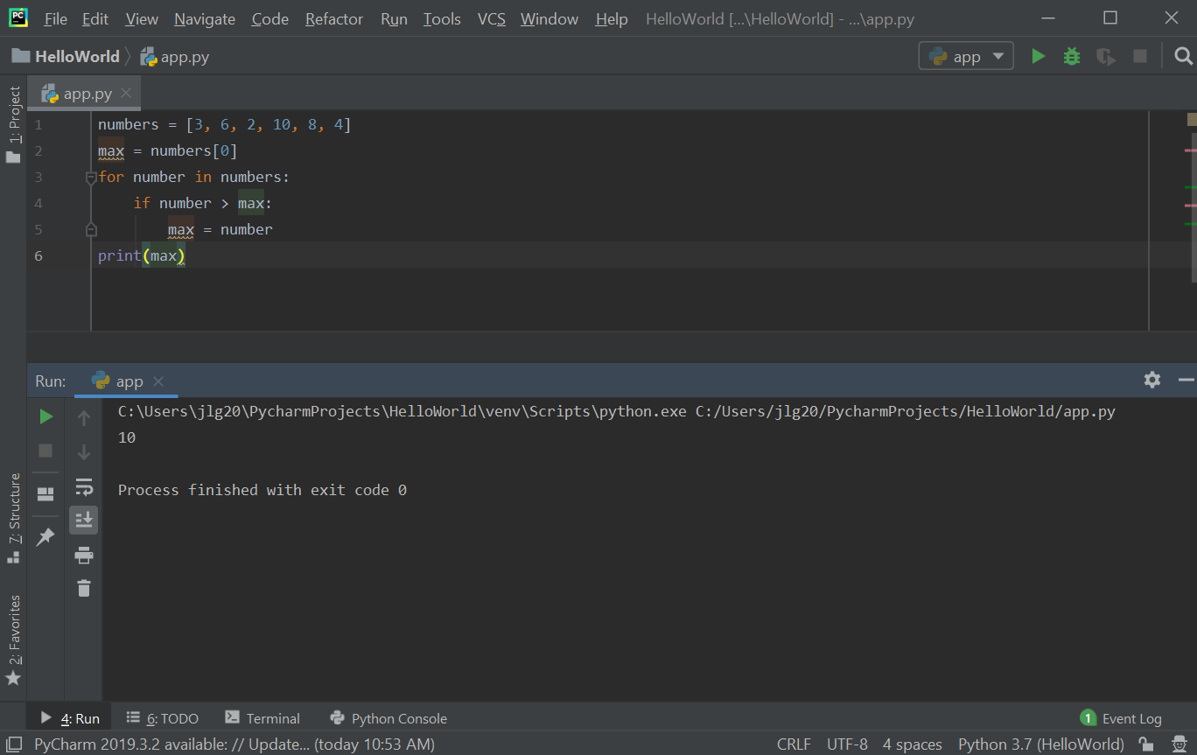

  - 2D Lists: 2D Lists: 2D lists have a lot of application in data science and machine learning. A 3-dimensional matrix (mathematics) can be represented in Python with a 2D list. 2D lists are where each item in that list is in another list. To access items in a 2D list, there is an outer list and then an inner list. The first [] refer to the outer list index and then the second [] refer to the inner list index. Nested loops can be used to iterate all the items in a 2D list.

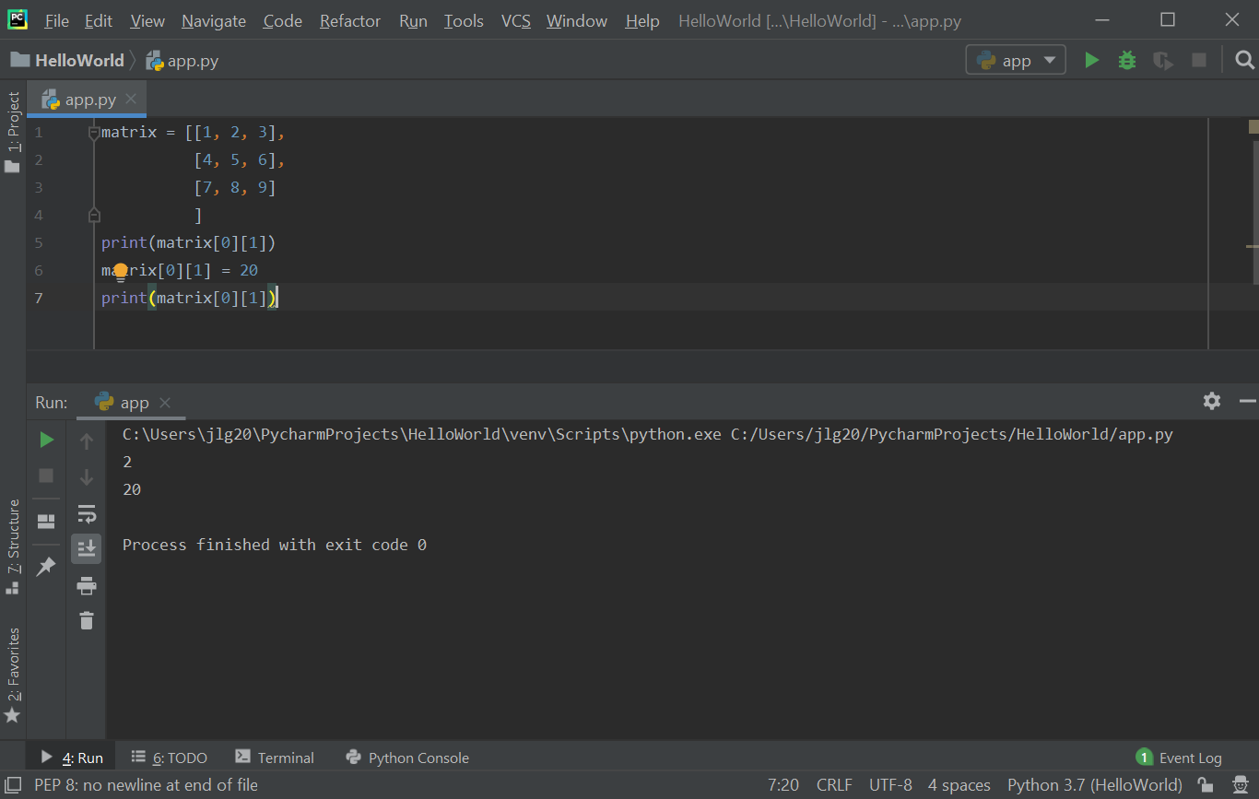

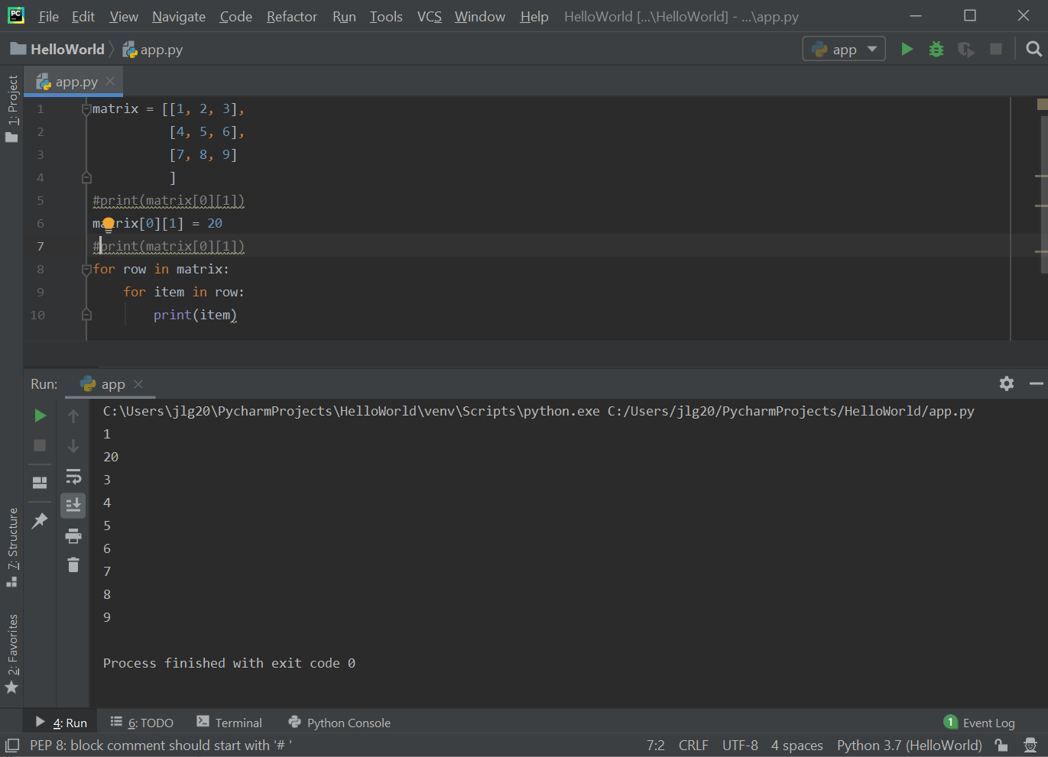

  - One example of an application of using two lists (arrays) is creating an array for suits and a second array of ranks to represent playing cards. These two arrays can then be used to create a deck of cards. The randrange() function can be used to randomly select a suit and a rank from the suits and ranks arrays, respectively.
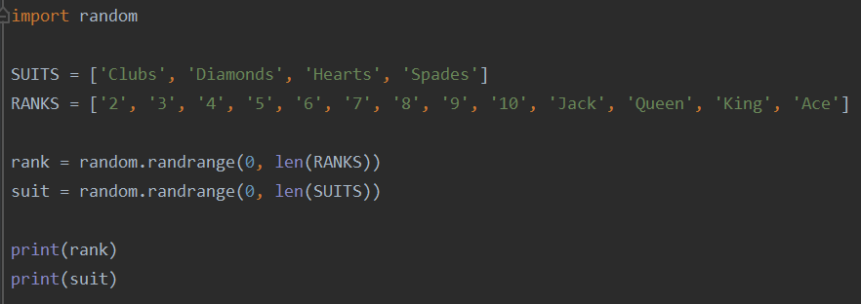

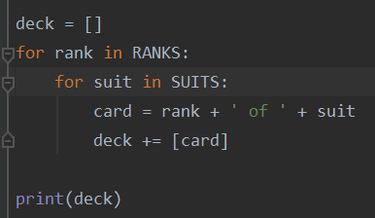
  - The deck array below is created by combining ranks and suits. The deck array will ultimately have length 52 to represent a full deck of playing cards.
Below is the output of the deck array, which show the entire deck of cards.

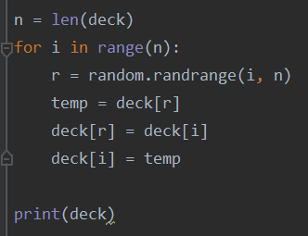
  - The code below shuffles the deck of cards by randomly selecting two cards from the existing decks array and swapping their positions. This is done n times, where n is defined as the size of the deck array.

Below is the output of the shuffling of the deck array. The cards are randomly positioned.

  - The next step is to distribute a shuffled deck of cards to players of a card game. In the code sample below, 5 cards will be distributed to each of the 3 players.

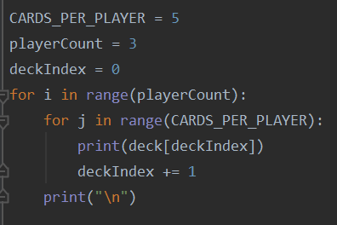

  - The shuffle algorithm used to shuffle the deck of cards above can also be applied to a 2D array. One example is to implement an in-array transpose of a 2D matrix. The code to do this is shown below.

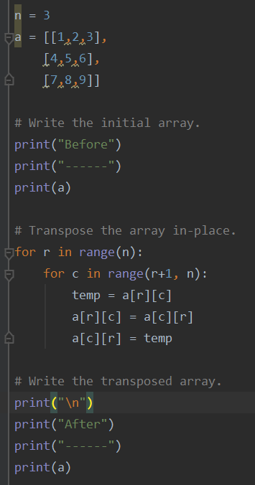

The output to the above code is shown below.

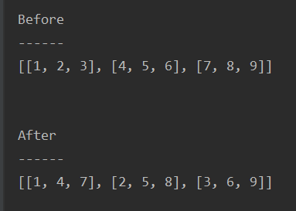
  - List Compression. Nested loops can be written in a single statement called list compression.
For example, the code shown below:

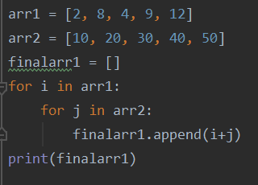

Can be rewritten as shown below. The syntax for the list compression sample below is:

new_array = [expression for item1 in iterable_array1 for item2 in iterable_array2]

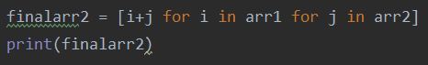

  - List compression is not limited to nested loops. You can also use conditional logic in list compression statements. For example, the code below shows the use of an if condition to test whether a number is an odd number.

The syntax for the list compression sample below is:

new_array = [expression for item in iterable_array if condition == True]

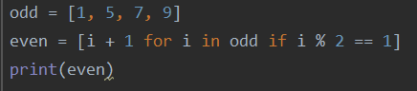

- Dicts (dictionaries): dictionaries are used to store information that come as key-value pairs.

Example: a customer has attributes: name, email, phone. Each of these attributes have a value. The keys in a dictionary must be unique. The values in a dictionary can be of any data type. To access the items in a dictionary, use "[]". Dictionaries are mutable and so key-value pairs can be added easily.
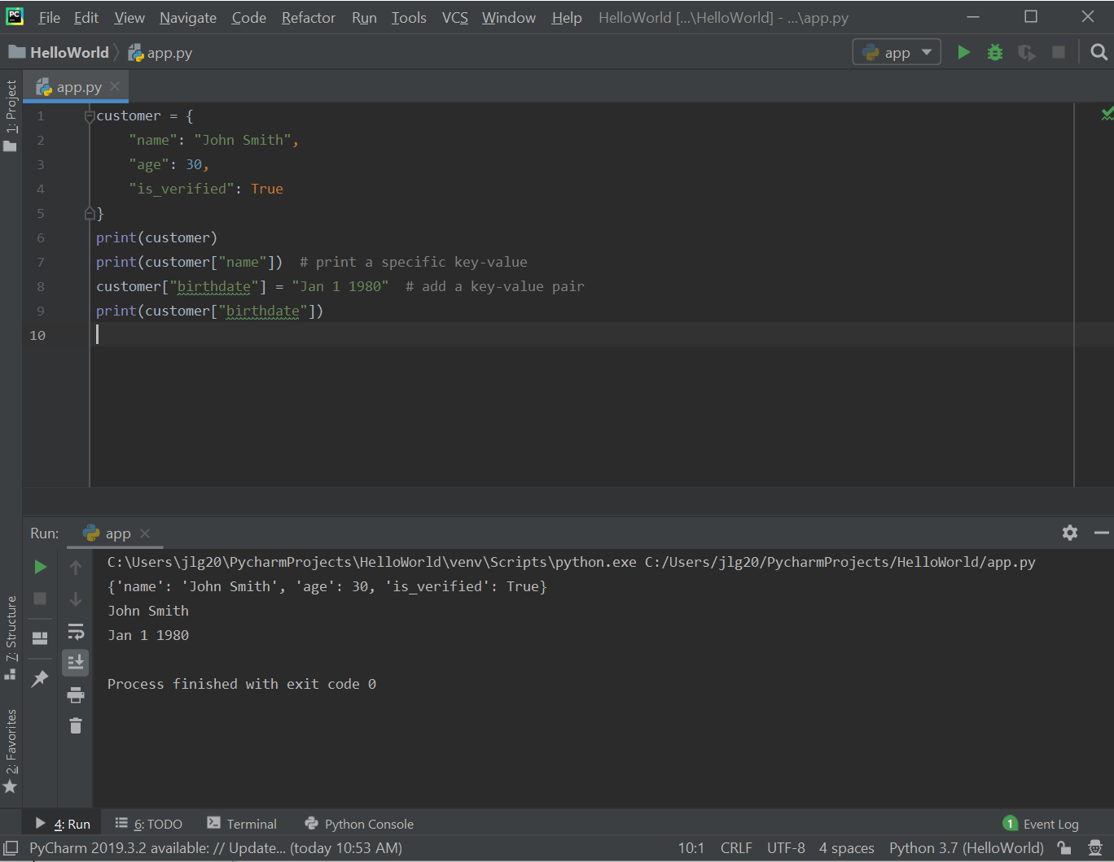

    - Emoji Converter: using dictionaries, can type messages followed by an emoji. Certain characters in the message will be converted to graphical emojis. For example, if the user enters the message “Good morning :)”, then the characters “:)” will be translated to 😊. To do this, we need to split the message using the split() method. What this does is go through the string and fines the character that is passed to the split() function and uses this character to split the string into multiple words and returns a list containing these multiple words. For example, in the below sample code, the split() method is passed the ‘ ‘ (blank character).
message = input(">")
words = message.split(' ')
print(words)
If a user enters “good morning sunshine”, this string will be split on the spaces and the following array will be created with three words:
>good morning sunshine
Array created: ['good', 'morning', 'sunshine']
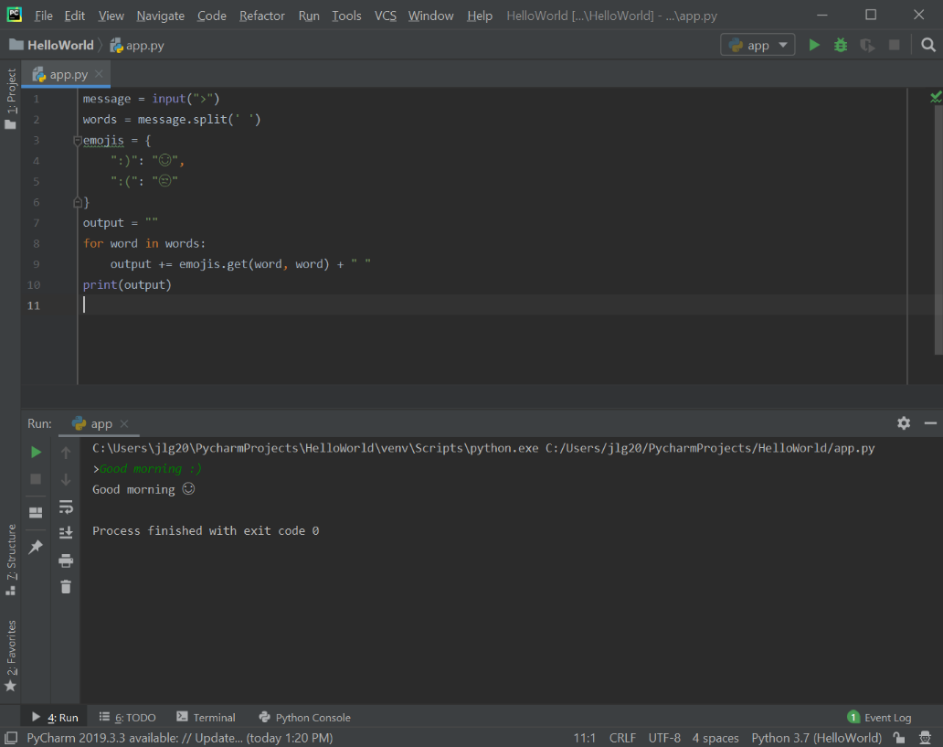
Below is the program that translates the characters “:)” to 😊.

- Writing functions:
  - Defining functions. Using functions provides a better way to organize code. We need to break up the code into smaller, more manageable, and more maintainable chunks – called functions. A function is a container for a few lines of code that perform a specific task. Examples that we have seen so far are the built-in functions print() and input(). These built-in functions perform a specific task. When building large, complex programs, we should break up our code into smaller reusable chunks, called functions, to better organize our code.
    - Defining a function. The “def” keyword is used to let the Python interpreter know that we are defining a function. The “def” keyword is followed by the function name, parentheses and a colon (the colon defines a block of code) (see code sample below).

def greet_user():
print('Hi there!')
print('Welcome aboard')
print("Start")
greet_user()
print("Finish")

- Execution flow: when the program is executed, the print statements inside the “greet_user()” function don’t get executed (printed to the terminal) because these two lines of code are inside of this function. So, these two lines will only get executed if we call this function. If we don’t call this function, then these two lines don’t get executed. So, the execution of the above program actually starts at the line “print(“Start”)”. After that, Python sees that you are calling the “greet_user()” function so it will jump to the function and execute the two print lines inside of the “greet_user()” function. Then it will jump out of the “greet_user()” function and continue normal execution of the program (the “print(“Finish”)” statement. This is how functions work (notice the order of the print statements in the output below).

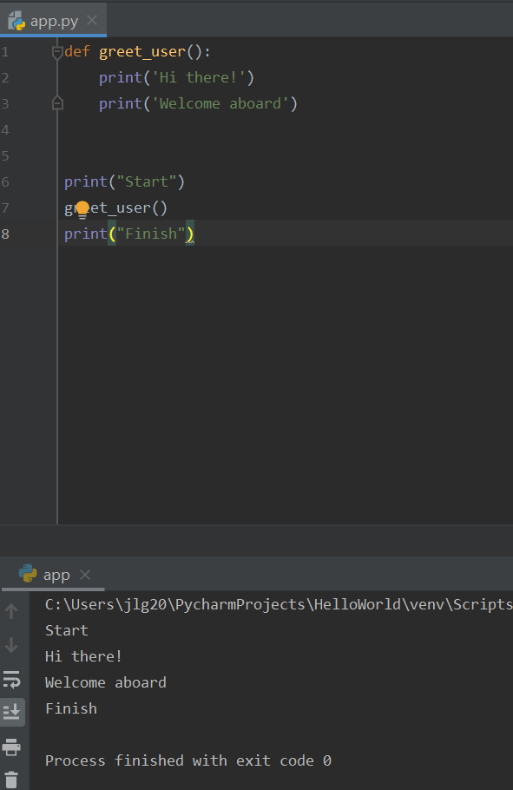

- Order of the code matters: here (above sample), we are calling the “greet_user()” function after the “greet_user()” function is defined. Notice the “greet_user()” function is called after it is defined. If you try to call the “greet_user()” function before it is defined, you will see an error. This means that Python doesn’t know what “greet_user()” is – it is not defined anywhere, and so we always define the function first and then call it. Below is an updated version of the program where the “greet_user()” function was modified to have a parameter.

  - Parameters. Parameters allow you to pass information to a function. In the function definition, parameters are added as placeholders for receiving information. For example, we can add a name parameter to our “greet_user()” function and pass the name of a user to the function when it is called. When the user’s name is passed as a value while the function is being called, the “name” parameter will be assigned that value. So, the name parameter will act as a local variable within that function. With this parameter, we can receive information in our functions.

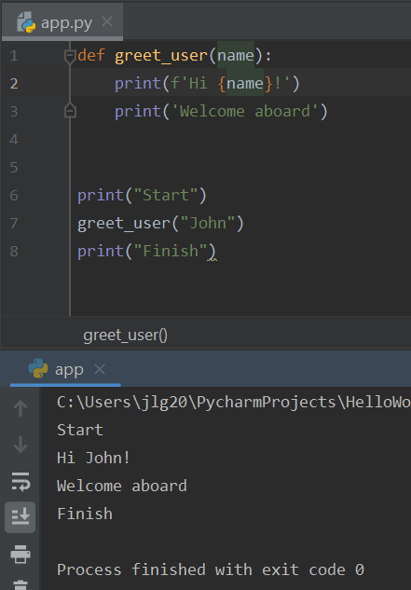

- In the sample below, we call the “greet_user()” function twice passing two different names. This shows reusing the function with a different value. If we didn’t have this function, then the code in the function would have to be written twice for the two different users’ names. This is the benefit of defining functions – we can take a few lines of code that have a specific purpose and put them inside a function.

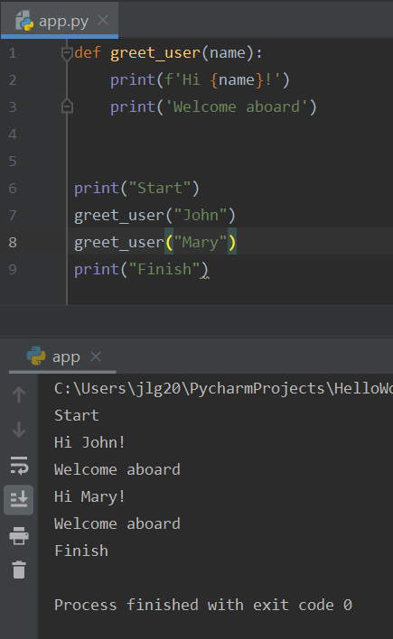

Note: if we have a parameter for a function, we are obligated to use that parameter. If you don’t pass a value for the parameter, you will get the below error. “Argument” is the value that is applied to a parameter of a function. In the above code sample, “John” and “Mary” are arguments passed as values to the “name” parameter when the “greet_user()” function is called. Parameters are placeholders for the variable that information will be passed through to the function, and arguments are the actual information being passed.
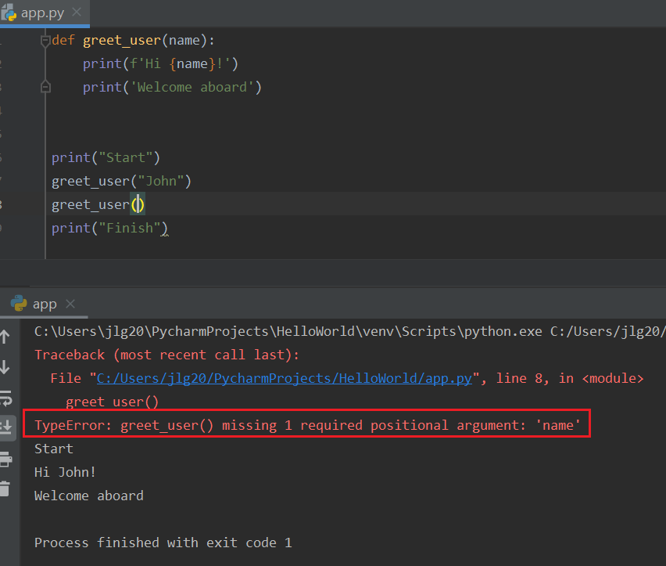
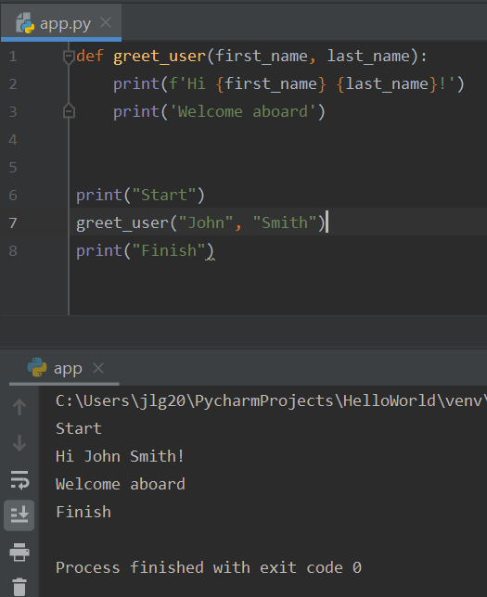
- Multiple parameters can be used with functions. The below sample is a modification of the “greet_user()” function with two parameters.

    - How to print functions that return values. This is useful when doing calculations and want to return the result using a function. Below is a sample function that returns a value:

def square(number):
return number * number
result = square(3)
print(result)

    - A call to the function can be directly made from the print() function:

def square(number):
return number * number
print(square(3))

Question: what will happen with the following code? Why?

def square(number):
print(number * number)
print(square(3))

    - Exercise: convert emoji code to use functions.

def emoji_converter(message):
words = message.split(" ")
emojis = {
":)": "😊",
":(": "😢"
}
output = ""
for word in words:
output += emojis.get(word, word) + " "
return output
message = input(">")
print(emoji_converter(message))

  - Function Recursion
    - Python supports function recursion which allows for a defined function toc all itself. Recursion should be used with caution as to avoid situations where writing a function which never terminates or one that uses excess amounts of memory or processor power.
    - An example of recursion is below.

def tri_recursion(k):
if(k > 0):
result = k + tri_recursion(k - 1)
print(result)
else:
result = 0
return result
print("\n\nRecursion Example Results")
tri_recursion(6)

Practice Exercises

Note: these exercises focus on using both the traditional for loops and list compression syntax to iterate arrays. Please implement each exercise using both the traditional for loop syntax and using the list compression syntax.

- Write program using both for loops and list compression that creates a list calculating the square of a list of integers.
- Write a program using both for loops and list compression that creates a list containing the first letter for each word in a list of words.
- Write a program using both for loops and list compression that uses the string method isdigit() to create a list of numbers from numbers identified in a list of strings.

Note: the exercises below focuses on using dictionaries.

- Write a program that adds a key/value pair to a dictionary.
- Write a program that checks if a key exists in a dictionary.

Note: these exercises focus on writing functions.
- Write a function called max_value() that takes three arguments (ints or floats) and returns the maximum value of the three values.

