Lesson Plan
Title | Programming with Python
Time duration | 1 Hour
Review & Exercises | Review of concepts and exercises for practice

Lesson Review
- Error Handling:
  - Try/Except/Finally.
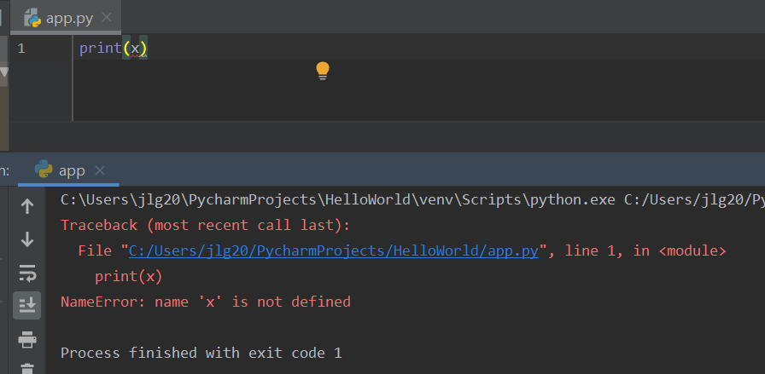
    - Python has built-in error handling; however, the programmer can add error handling to their code. When an error occurs, the program will stop executing and an error will be generated. A very simple example of Python’s error handling is trying to access a variable that was not defined. For example, just running the statement “print(x)” without first defining ‘x’:

Adding our own error handling to handle to the above example is demonstrated below. The “try” block lets you to test a block of code for errors. The “except” block lets you handle the error. The “try” statement is used to handle these exceptions. The “try” block raises the error and the “except” block will be executed. The “except” block must be included with a “try” block. If no “try/except” block is used, then the program will stop abruptly when an error occurs (as the above example demonstrates).

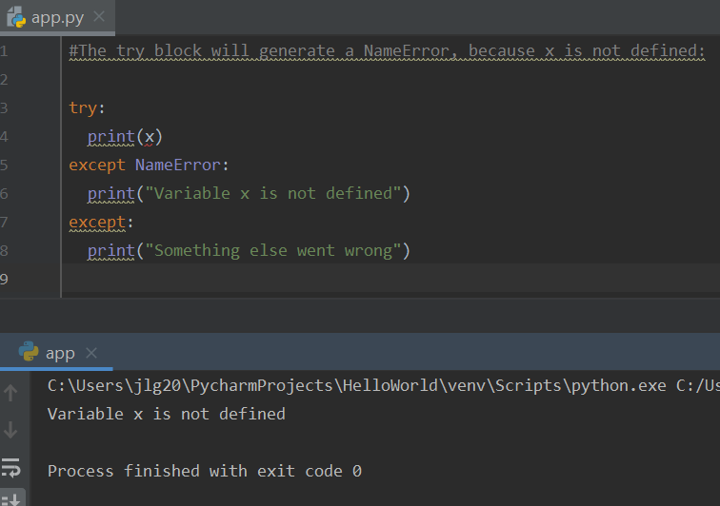
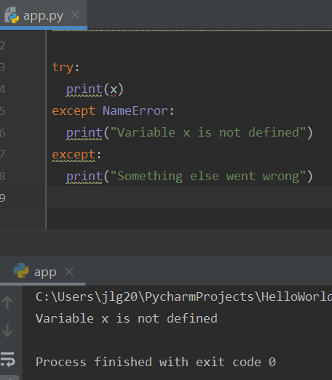
    - Error Handling Chains. The “try” block can be handled by several “except” blocks. There may be several different error types that a programmer might want to handle and so each “except” block can handle a different error type. Below is an example of an error handling chain.

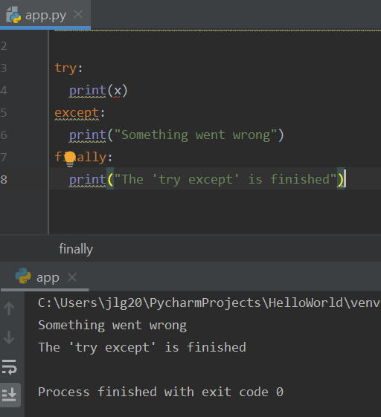
    - The “try/except” block can also be used with the “finally”. The “finally” block lets you execute code regardless of the result of the “try” or “except” blocks. As can be seen in the below example, the “finally” block gets executed regardless of whether an error is raised or not.

iv. Using “else” with “try”. In the below example, the print() statement is valid and no error is raised. Because no error is raised, the “else” block will get executed instead of the “except” block.

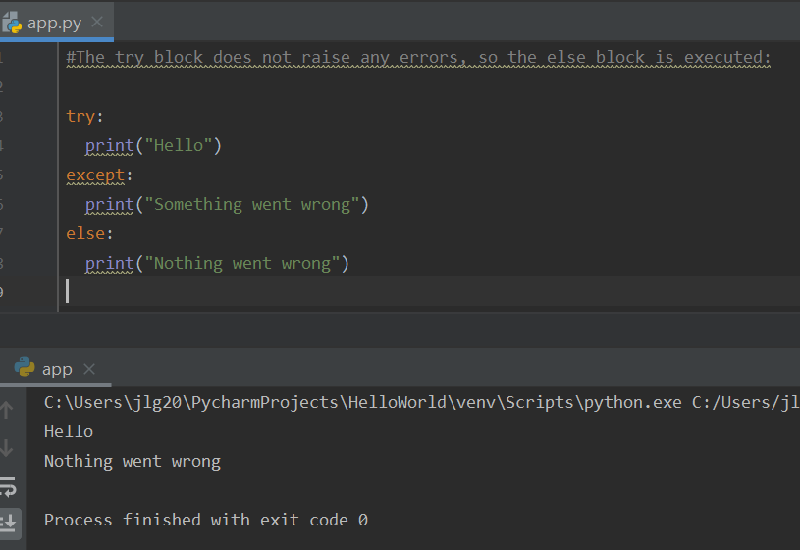

    - Handling ValueError types of errors:

try:
age = int(input('Age: '))
print(age)
except ValueError:
print('Invalid value')

try:
age = int(input('Age: '))
income = 2000
risk = income / age
print(age)
except ValueError:
print('Invalid value')

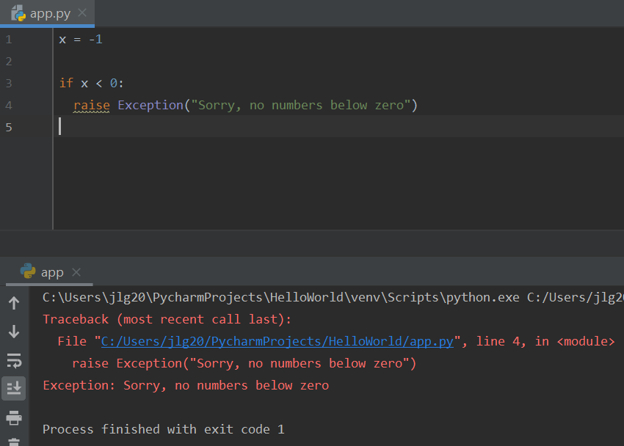
    - Raising an error. Programmers can also write code to throw an exception if some condition occurs. The “raise” keyword is used to throw an exception. Below is an example of how to raise an exception.

    - Defining the type of errors to raise. In the below example, “TypeError” is defined as the type of error to raise. Similar to using several “except” blocks, a programmer can define different types of errors to raise.

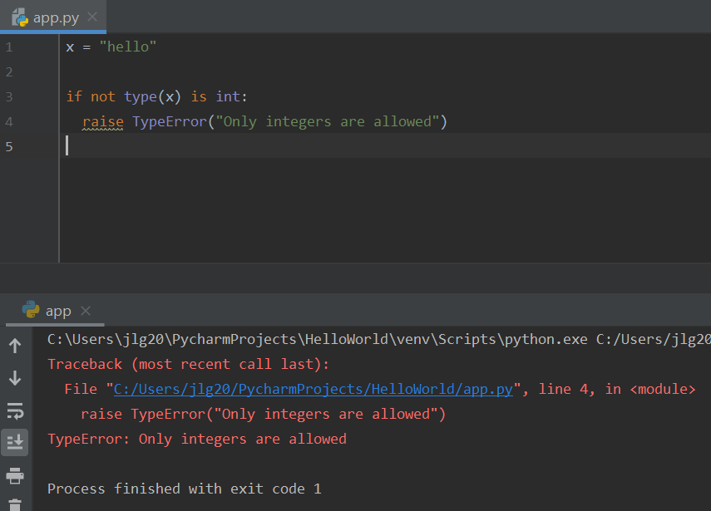

References:
- Python built-in exceptions: https://docs.python.org/3/library/exceptions.html

Practice Exercises
Note: these exercises focus on writing functions.
- Write a function called max_value() that takes three arguments (ints or floats) and returns the maximum value of the three values.
- Add error handling to your function you wrote above to check that all input are either ints or floats.

