Lesson Plan
Title | Programming with Python
Time duration | 1 Hour
Review & Exercises | Review of concepts and exercises for practice

Lesson Review
- Writing classes:
  - Classes. Python is an object-oriented programming language and almost everything in Python is an object with properties and methods for that object. Classes are object “blueprints” for creating objects. Below is an example of the most basic class in Python:

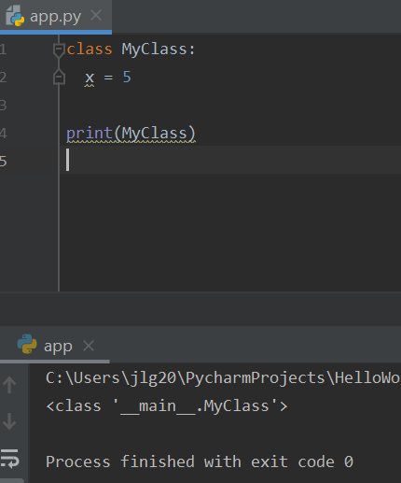

Below is an example of how to instantiate the above class:

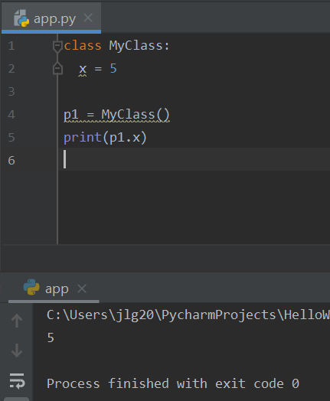

    - The __init__() function. The __init__() function is a Python built-in function all classes have. This function is always executed when a class is being instantiated. This function is used to assign values to object properties, or other operations that are necessary to be performed when the object is being created. Below is an example of how the __init__() function is used.

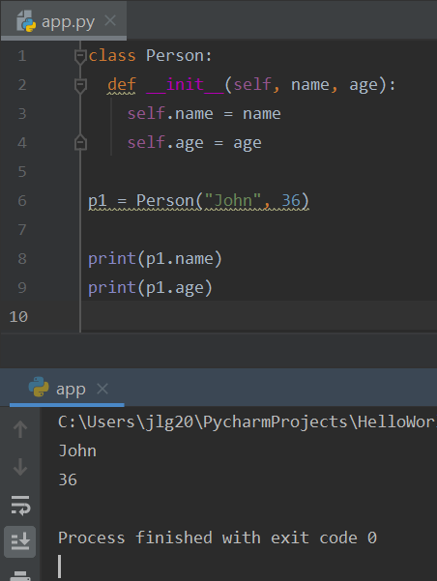

    - Class methods. Below is a sample class that has methods.

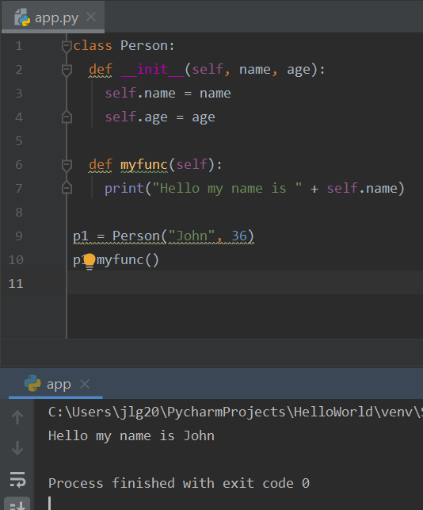

    - Class methods. Below is another sample class that has methods.
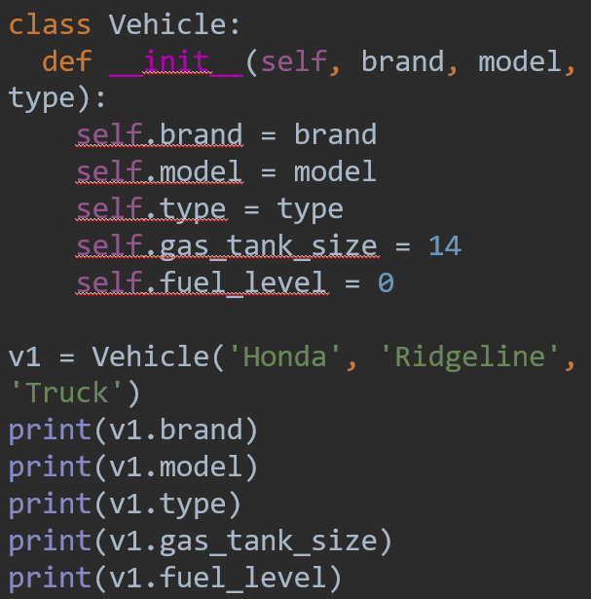

Practice Exercises
Note: these exercises focus on writing functions.
- Write a function called calc_mean() that takes an array of integers as an argument and calculates the mean from the integers in the array. The mean is the sum of the integers divided by the total number of integers in the array. Be sure to use the return feature to return the calculated mean.
- Write a function called swap() that takes three arguments: an array of integers, an index, i, and another index, j. The function should swap the integer located in the array at index i with the integer located in the array at index j. Return the array with the swapped integers.

