Lesson Plan

Title | Programming with Python
Time duration | 1 Hour
Review & Exercises | Review of concepts and exercises for practice

Lesson Review
- Writing classes:
  - Classes. Python is an object-oriented programming language and almost everything in Python is an object with properties and methods for that object. Classes are object “blueprints” for creating objects. Below is an example of the most basic class in Python:

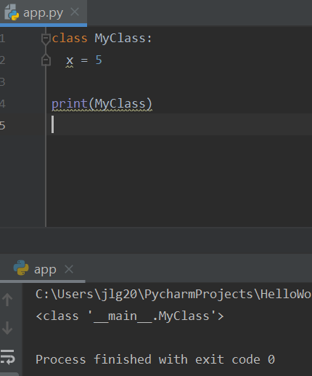

Below is an example of how to instantiate the above class:

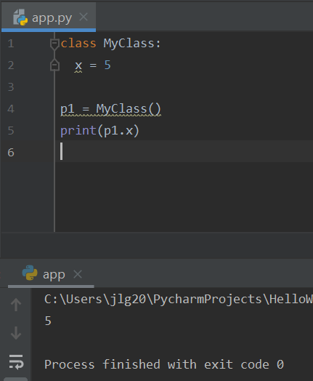

    - The init () function. The init () function is a Python built-in function all classes have. This function is always executed when a class is being instantiated. This function is used to assign values to object properties, or other operations that are necessary to be performed when the object is being created. Below is an example of how the init () function is used.

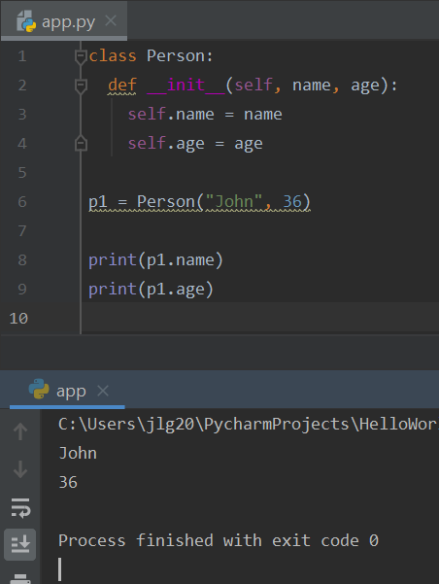

    - Class methods. Below is a sample class that has methods.

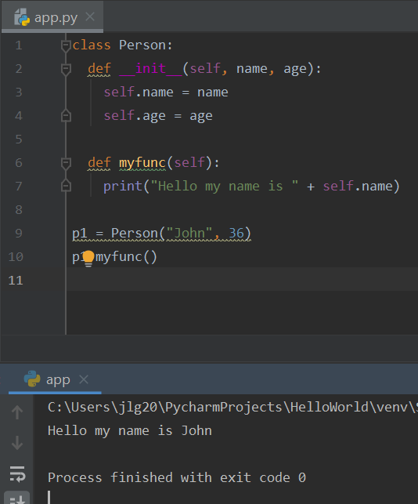

    - Class methods. Below is another sample class that has methods.
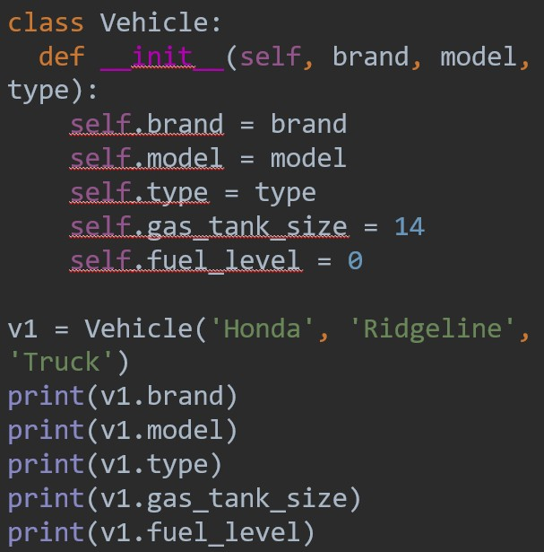

    - Methods could be added to classes to perform certain tasks on the objects of that class:
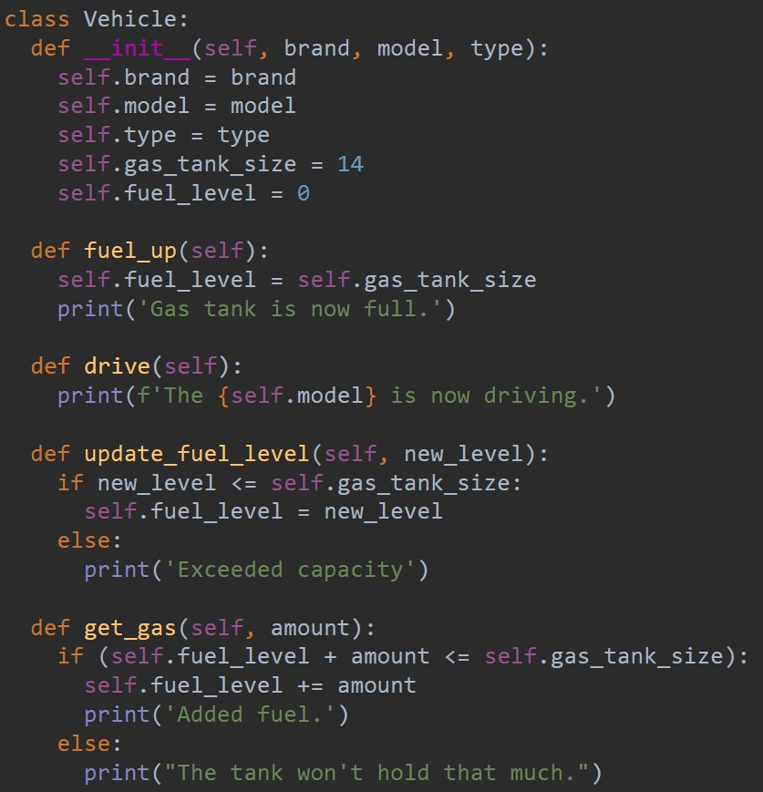

    - Class inheritance allows you to extend a class by inheriting attributes and methods from the parent class. Through inheritance, the child class automatically has access to all of the attributes and methods of the parent class. In the child class, you can declare new attributes and methods that are not accessible in the parent class. These added attributes and methods make a child class more specific.

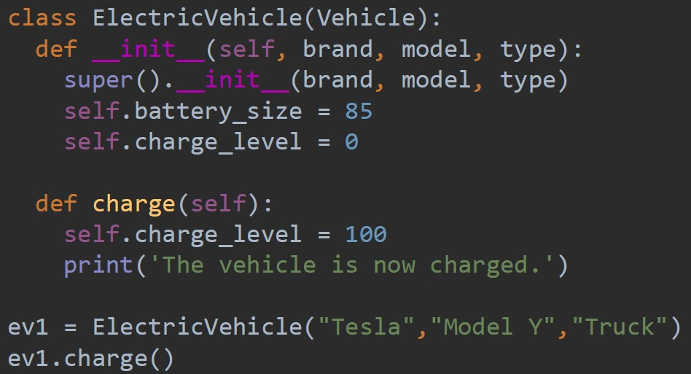

Practice Exercises
Note: these exercises focus on writing functions.
- Write a function called majority_odd_bools() with three bool parameters. The function should return True if at least two of the bool arguments are True, otherwise it should return False.
- Write a function called lg() with one integer parameter. The function should calculate the base-2 logarithm of that integer. Hint: use the math module.
- Write a function called signum() with one float parameter. The function should return -1 if the float is less than 0, return 0 if the float is equal to 0, or return +1 if the float is greater than 0.
- Write a function called scaled_array() with one array parameter of strictly positive floats (all floats must be greater than zero). The function should rescale each float element in the array to between 0 and 1. To rescale each float element, subtract each element by the minimum element in the array followed by dividing each element in the array with the difference between the minimum and maximum values. Hint: use the Python built-in min() and max() array functions to get the minimum and maximum values from the array.

