Lesson Plan
Title | Programming with Python
Time duration | 1 Hour
Review & Exercises | Review of concepts and exercises for practice

Lesson Review
- Writing classes:
  - Classes. Python is an object-oriented programming language and almost everything in Python is an object with properties and methods for that object. Classes are object “blueprints” for creating objects. Below is an example of the most basic class in Python:

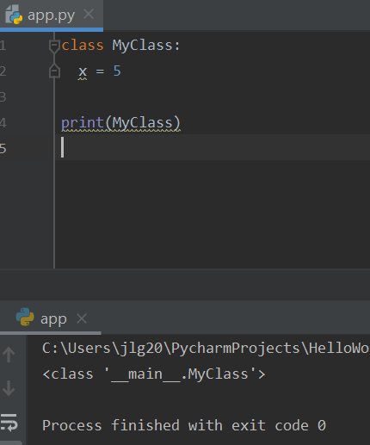

Below is an example of how to instantiate the above class:

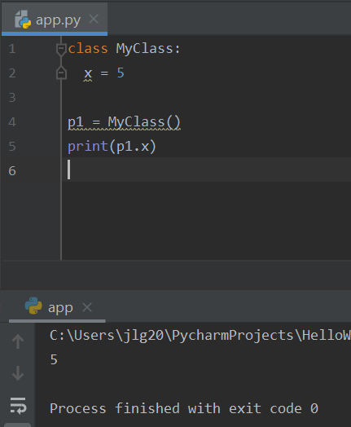

    - The __init__() function. The __init__() function is a Python built-in function all classes have. This function is always executed when a class is being instantiated. This function is used to assign values to object properties, or other operations that are necessary to be performed when the object is being created. Below is an example of how the __init__() function is used.

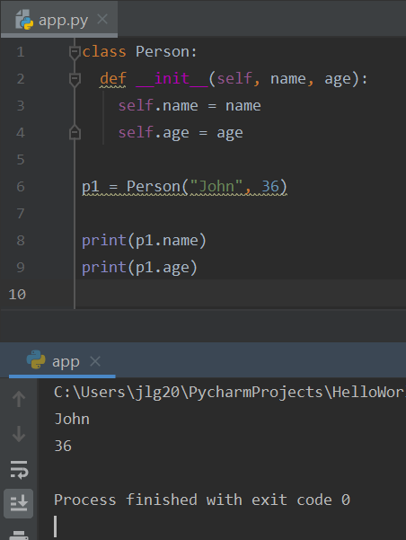

    - Class methods. Below is a sample class that has methods.

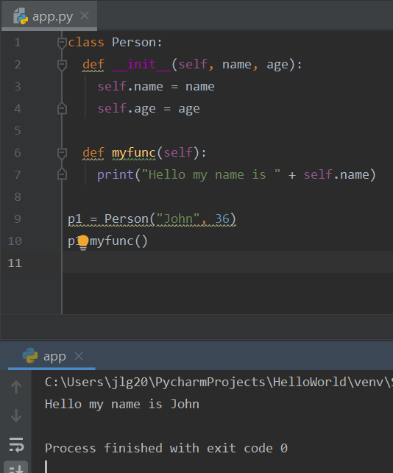

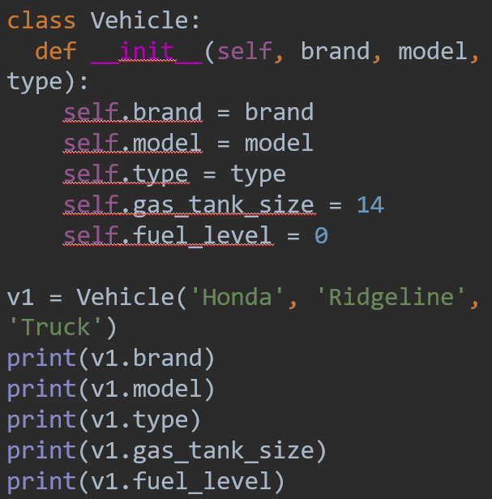
    - Class methods. Below is another sample class that has methods.

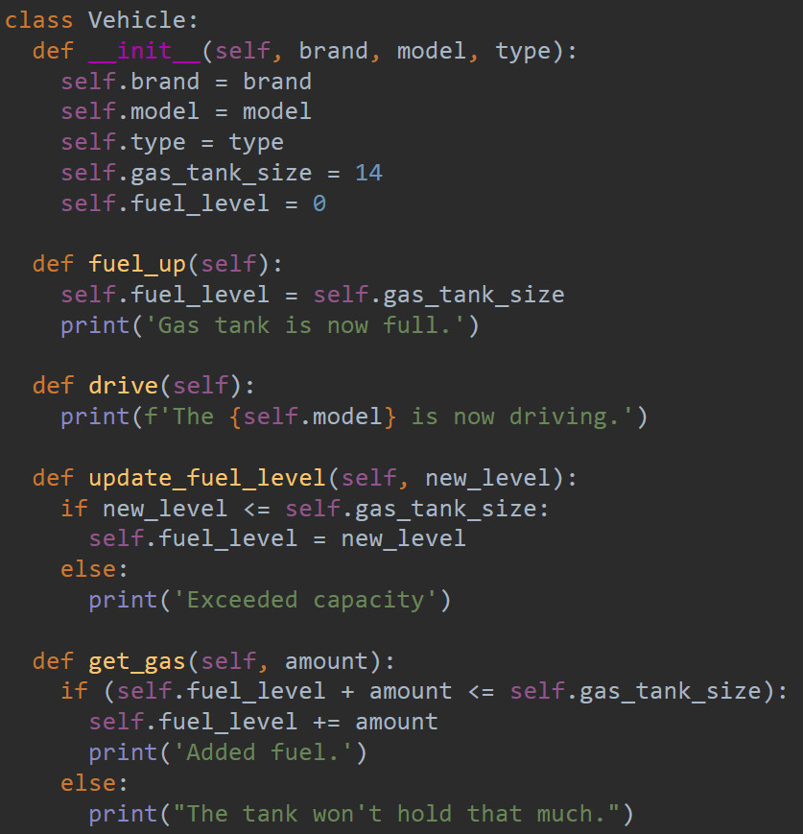
    - Methods could be added to classes to perform certain tasks on the objects of that class:

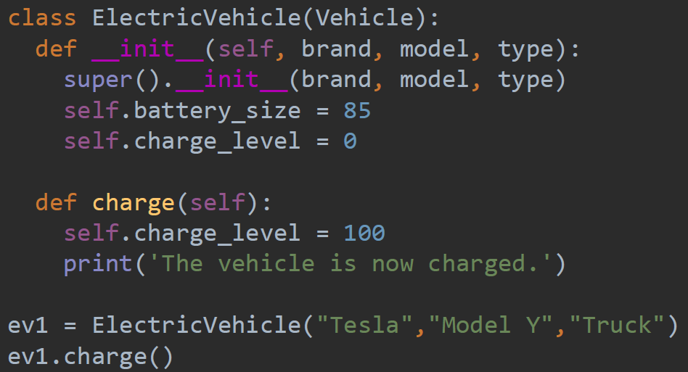
    - Class inheritance allows you to extend a class by inheriting attributes and methods from the parent class. Through inheritance, the child class automatically has access to all of the attributes and methods of the parent class. In the child class, you can declare new attributes and methods that are not accessible in the parent class. These added attributes and methods make a child class more specific.

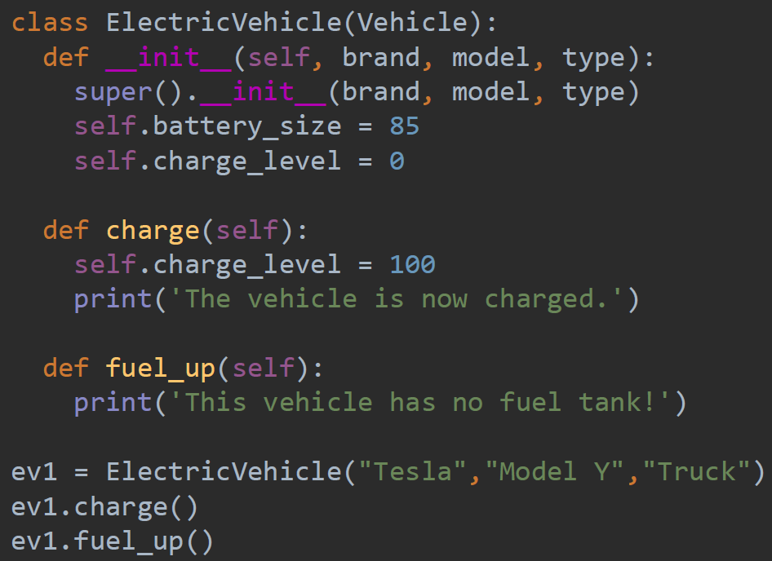
    - Overriding is when a child class can override a method it inherits from a parent class. Since child classes are more specific, the behavior of the overriding method will be different in the child class from the parent class.

    - Instances as Attributes. Instances of a class can be stored as an attribute in another class. Attributes like these allow for classes to be used to model complex situations. In the example code below, the Battery class is an attribute in the ElectricVehicle class.
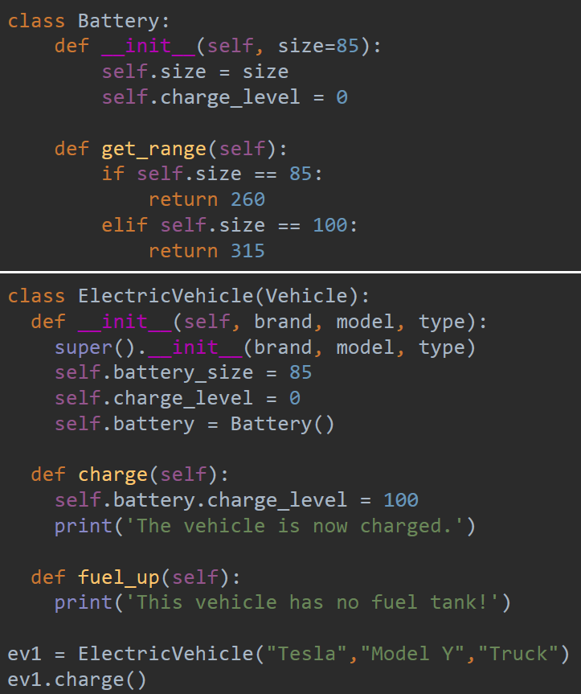

Practice Exercises
Note: this exercise focuses on writing classes.

- Create the following seven classes: the Monster, Gremlin, Vampire, Werewolf, Zombie, GiantSnake and PoisonousGiantSnake classes. The Monster class is the parent class to the Gremlin, Vampire, Werewolf, Zombie and GiantSnake classes. The GiantSnake class is a parent class to the PoisonousGiantSnake class. Below is a diagram that shows the class hierarchy and relationships between these classes four classes.

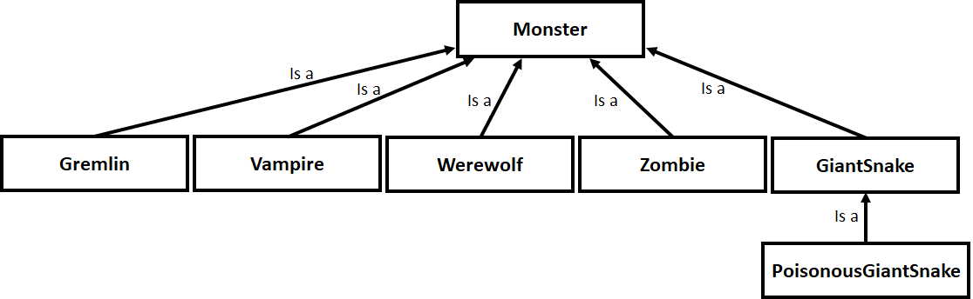

All classes should have properties name and weight, and so think about how all child classes will inherit these properties. Hint: the PoisonousGiantSnake, even though it is a child class of GiantSnake, it should also inherit the name and weight properties from the Monster class. The Monster class should also have the property numberOfMonsters.

Each child class should also have its own properties. For example, the Gremlin class should have the property fluffy and numberOfGremlins. The Vampire class should have properties vampireAge and numberOfVampires. The Werewolf class should have properties humanForm and numberOfWerewolves. The Zombie should have the property numberOfZombies plus other properties that you should come up with. The GiantSnake class should have the property numberOfGiantSnakes and other properties that you should come up with. Finally, the PoisonousGiantSnake class should have the property numberOfPoisonousGiantSnakes and other properties that you should come up with.

Below is the code for the Monster class. This is the complete implementation of the Monster class and so you don’t have to add any code here. You will add code to the subclasses below. Study the Monster class carefully so you understand how the class is implemented. In particular, identify the constructor (the __init__() method). This method is called to initialize the attributes. Identify the attributes for the Monster class (hint: they are in the constructor). Identify all the methods in the Monster class. Write code to instantiate the Monster class and call some of the Monster class methods to test the class.

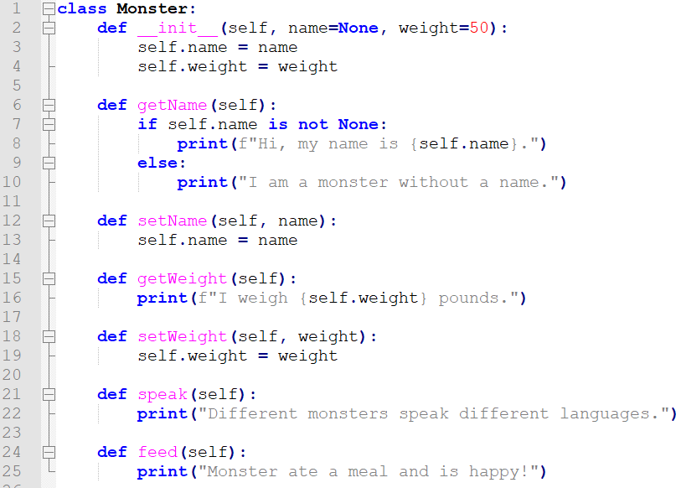

Below is the template for the Gremlin class. Gremlins are monsters and so the Gremlin class should be a child class of Monster and inherit the attributes and methods from the Monster class.
- In the Gremlin template below, how would you make the Gremlin class extend the Monster class (it should go in the first red box)?

- You want to know if the Gremlin is fluffy. How do you write an “if” condition to test that the Gremlin is fluffy (hint: you will need to test the value of the attribute self.fluffy)? Write your code in the red box inside the method “isFluffy()”.
- Finally, the gremlin wants to eat. If the gremlin is fluffy, the gremlin will turn to not being fluffy if the gremlin eats after midnight but before sunrise. If the gremlin eats any other time, then the gremlin will remain fluffy. To implement the feed() method, you need to first get the weight of the gremlin and add the weight of the food. This will set the new weight for the gremlin because he is going to increase in weight after eating. The weight attribute is inherited from the Monster class and so you will need to use super() to access the setWeight() method from the parent class. What would this statement look like? You should put this as the first statement in the red box inside the feed() method below.

Next, you should check if the gremlin is eating after midnight and before sunrise. You have two attributes (self.sunrise and self.midnight) in the Gremlin class that are not part of the Monster class. Why? What does this mean? You should use these two attributes to check if the gremlin is eating after midnight and before sunrise. This will be an “if” condition with two expressions in this “if” condition joined by “and” because you want each: time is later than self.midnight and time is before self.sunrise to be true. If both are true, then you want to change fluffy to false. You will need to call the setFluffy method. This code also goes in the red box in the feed() method.
- Write code to test your Gremlin class by instantiating it and calling its methods. Be sure to include code that checks whether the Gremlin class does inherit the attributes from the Monster class.

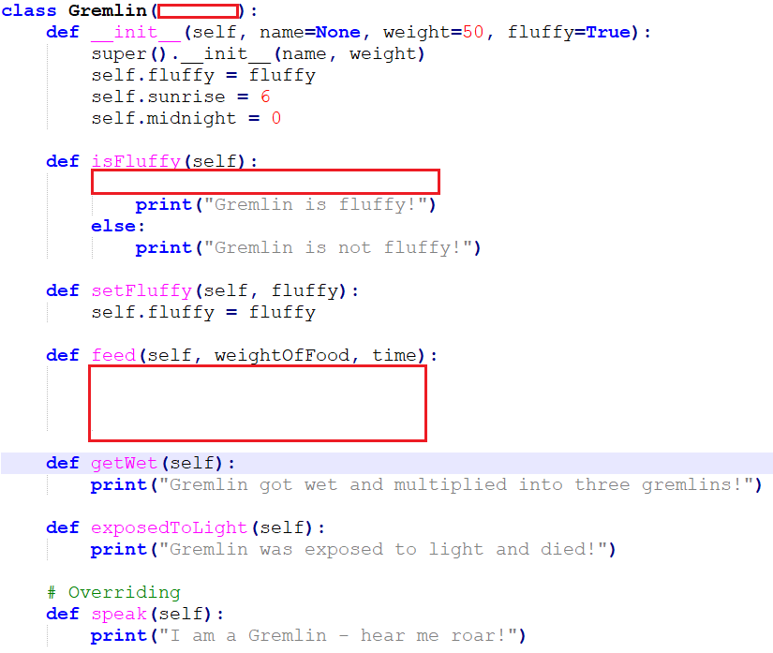

Below is the template for the Vampire class. Vampires are also monsters and so the Vampire class should also be a child class of Monster and inherit the attributes and methods from the Monster class.

- First, you will need to complete the Vampire class. First, you need to specify how it would extend the Monster class (put your answer in the first red box).
- You will need to add two new attributes that are specific to the Vampire. These two attributes are self.sunUp and self.sunDown. Initialize self.sunUp to 6.5 and self.sunDown to 19.0. How would you add these attributes? Add these to the red box in the constructor.
- Finally, the Vampire class should also include a speak() method that overrides the speak() method in the Monster class. In the Vampire class template below, in the third red box, implement the speak() method and mention that the vampire says: “I am a vampire – mwahaha!”.
- Write code to test your Vampire class by instantiating it and calling its methods. Be sure to include code that checks whether the Vampire class does inherit the attributes from the Monster class.

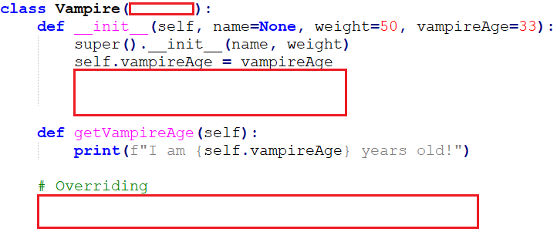

Below is the template for the Werewolf class. Werewolfs are also monsters and so the Werewolf class should also be a child class of Monster and inherit the attributes and methods from the Monster class.

- First, add the code, in the first red box, to extend the Werewolf class from the Monster class.
- Recall, the name and weight are attributes in the Monster class. All child classes, including the Werewolf class, inherit name and weight from the Monster class because they are all monsters. In the second red box, set the name and weight for the Werewolf by adding a line of code that calls the Monster class constructor using the super() method. Also, in the second red box, add two new attributes for the Werewolf. These new attributes should be nightTime and humanForm. Initialize nightTime to 21 and humanForm to false.
- Notice, in the Werewolf class there is a method called transform(). This method transforms the werewolf to and from human form. It first checks if the werewolf is in human form and if so then transform the werewolf to not be in human form and vice versa. Notice the “if” conditions that do this. In the method below transform(), called the isHumanForm() method checks if the werewolf is in human form. You need to implement this method by putting your code in the third red box. You first need to use an “if” condition to test if the werewolf is currently in human form. If so, print “I am a werewolf that is in human form”. If the werewolf is not in human form then print “I am a werewolf that is not in human form.”
- Write code to test your Werewolf class by instantiating it and calling its methods. Be sure to include code that checks whether the Werewolf class does inherit the attributes from the Monster class.

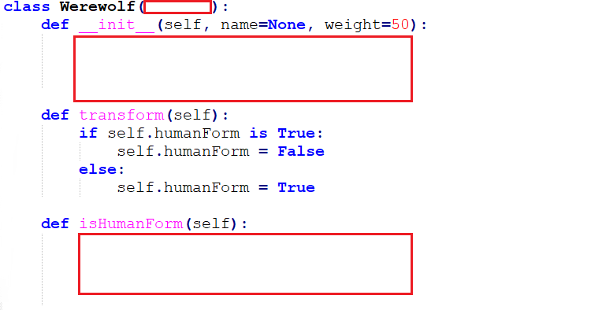
Below are templates for the Zombie, GiantSnake and PoisonousGiantSnake classes. Both Zombie and GiantSnake are monsters and so the Zombie and GiantSnake classes should also be a child class of Monster and inherit the attributes and methods from the Monster class. PoisonousGiantSnake is a Monster but it is also a GiantSnake. The PoisonousGiantSnake class should be a child class of GiantSnake. It will inherit attributes from both Monster and GiantSnake.
- Add code to extend Zombie and GiantSnake from the Monster class.
- Add cod to extend PoisonousGiantSnake from the GiantSnake class.
- Add attributes to Zombie and GiantSnake that are not in Monster.
- Add attributes to PoisonousGiantSnake that is not in GiantSnake and not in Monster.
- Extend Zombie, GiantSnake and PoisonousGiantSnake to add methods to do neat things. Use your imagination on this part.
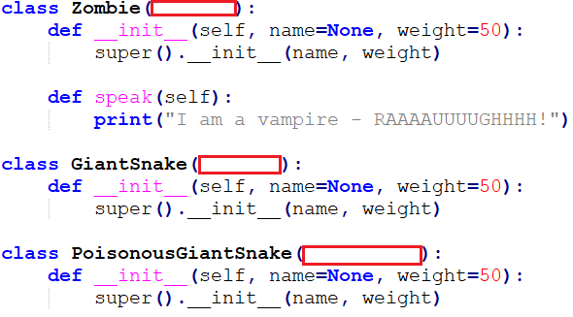
- Write code to test your Zombie, GiantSnake and PoisonousGiantSnake classes by instantiating them and calling their methods. Be sure to include code that checks whether the Zombie, GiantSnake and PoisonousGiantSnake classes do inherit the attributes from the Monster class. Also, write code that checks that the PoisonousGiantSnake class inherits attributes from the GiantSnake class.

