Lesson Plan
Title | Programming with Python
Time duration | 1 Hour
Review & Exercises | Review of concepts and exercises for practice

Lesson Review
- Declaring Strings:
  - Double quotes or single quotes can be used for strings, but there are times when double quotes should be used instead of single quotes and vice versa.
    - If a single quote (e.g., an apostrophe) is being used as part of the string value, then the entire string should be encapsulated in double quotes.

course = 'Python for Beginners' # using single quotes, but can also use double quotes
course = 'Python's course for beginners' # there is a problem here
course "Python's course for Beginners"
    - If a word in the string value is being emphasized using double quotes, then the entire string should be encapsulated in single quotes.

course = "Python for "Beginners"" # there is a problem here
course = 'Python for "Beginners"'
  - Handling very long strings - using triple quotes allows for very long strings that span across multiple lines.
    - In this code sample, an email message is a string with multiple lines. Notice the triple quotes at the begging and end of this string.

email_msg = '''
Hi John,
Here is our first email to you.
Thank you,
The programming team
'''

- Indexing Strings: strings are objects that are arrays of characters. Because of this, individual characters could be accessed within a string using indexing.
  - Indexes start from 0 and so the first character of a string has index 0. Below is a small graphic that shows the string “Python” being viewed as an array of characters. The first character, which is the letter ‘P’ is indexed at 0. Array elements always start at position 0, not position 1.
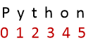
  - This code sample applies various index examples to access different characters within a string.

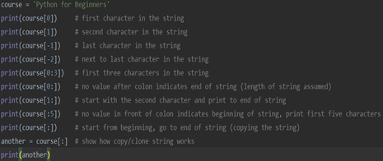
  - Question: what does the following code do?
name = ‘Jennifer’
print(name[1:-1])
- Working with Formatted Strings: formatted strings are useful for dynamically generating text for string variables.
  - In this code sample:
    - The variable “message” is not a formatted string and is code that is difficult to understand and maintain. This method uses string concatenation.
    - The variable “msg” is a formatted string indicated by the ‘f’ prepending the single quotes at the beginning of the string. The ‘{}’ are placeholders that will substitute the assigned value for the variables encapsulated in the ‘{}’ at runtime.
    - Notice the string printout is identical for both methods, but the second method is much more understandable and easier to maintain.

first_name = 'John'
last_name = 'Smith'
message = first_name + ' [' + last_name + '] is a coder' # this is not an ideal approach because difficult to maintain
print(message)
better_message = f'{first_name} [{last_name}] is a coder' # this is a formatted string
print(better_message)
The output is exactly the same in both instances. The unformatted string using concatenation is the first print statement below, and the formatted string is the second print statement.
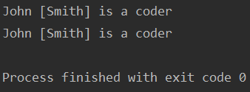
- Using string methods: there are several methods that are built into Python available to perform various functions on strings.
  - The len() method is used to print the length of the string. Recall that the string is an array of characters and so the length of the string is equal to the number of elements in this array.

course = "Python for beginners"
print(len(course))

    - Using the len() function is particularly useful when getting input from the user. Each input field would likely have a limit. For example, a 50-character limit for the user’s name. So, using the len() function we can enforce a limit on the number of characters for an input field. If a user types in more characters than we allow them then we can display an error.
    - Len() is a general-purpose function built into python and so it is not limited to just getting the length of a string. When we look at lists, we can use the len() function and count the number of items in a list.
    - Other functions specific to strings. Can convert string characters to upper case, for example.
  - Below shows the upper() function used to convert all the characters of a string to upper case.

course = "Python for beginners"
print(course.upper())

  - The upper() function is accessible by adding a ‘.’ At the end of the variable name. This shows a list of other functions specific to strings.

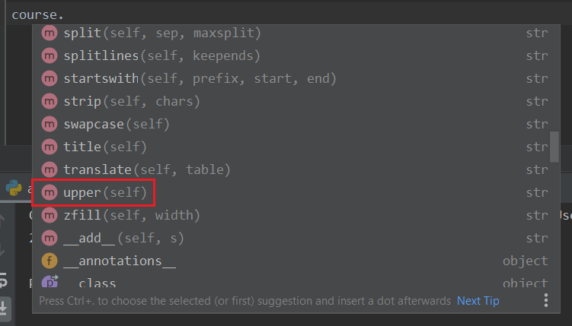
NOTE: in Object-Oriented Programming, functions are really called methods. The function upper() is a function, but if referred to an object, such as the string, then it is a method. In contrast print() and len() are general-purpose functions that don’t belong to any specific objects like strings or integers and so these are not methods. This is the difference between a function and a method.
    - The upper() method does not change the string value to the course variable. Instead, it creates a new string with all characters converted to upper case. If you print the original string after applying the upper() method, you will get the original string.
    - Similarly, there is the lower() method that converts all characters in a string to lower case.
    - The find() method finds the index of the first instance of a character in a string and is case-sensitive. The first screenshot shows that the first instance of lower-case 'o' is found as the fifth character in the string (index = 4), but in the second screenshot the upper-case 'O' doesn't exist in this string, and so a -1 is returned.

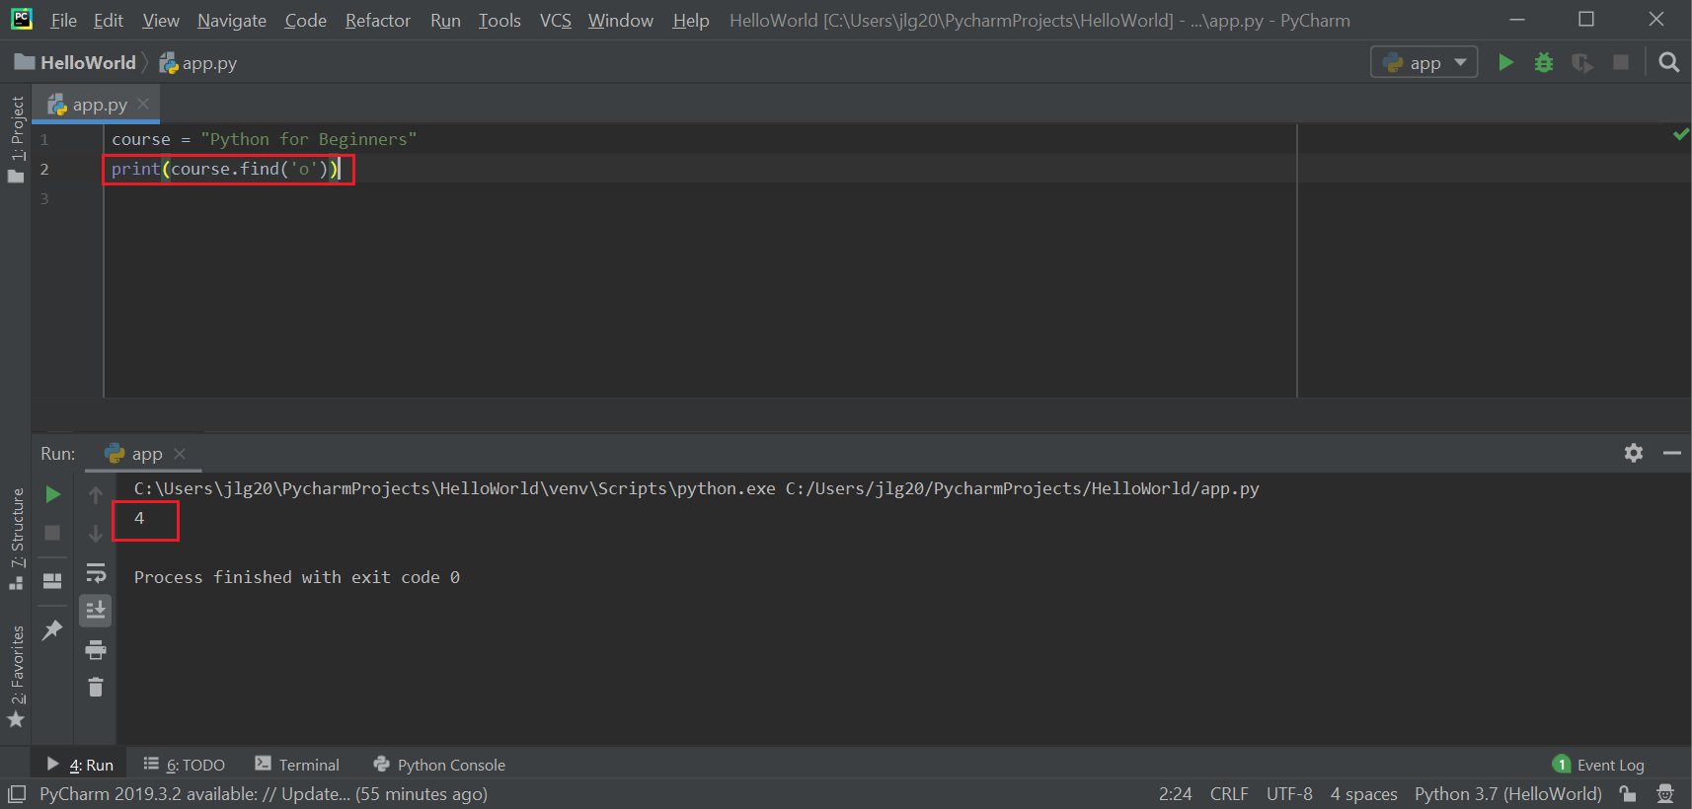

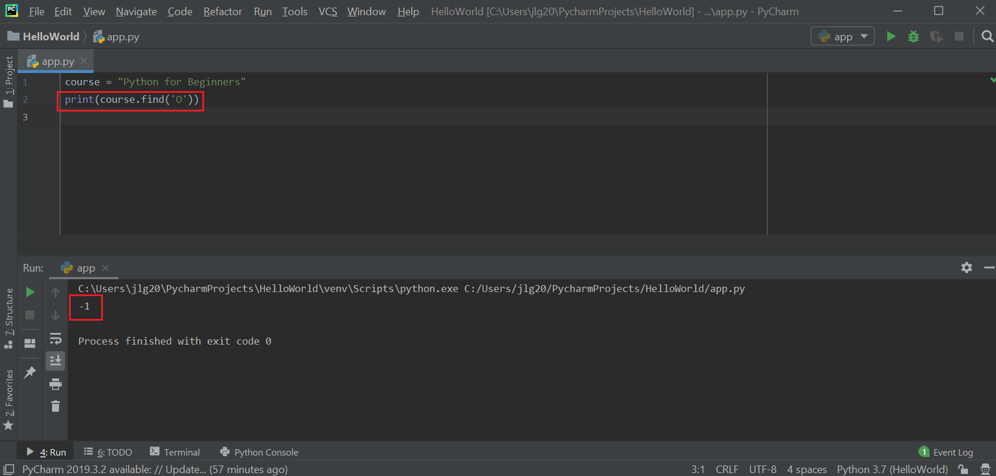

    - A sequence of characters can also be sent to the find method. If you pass the string "Beginners" (see screenshot below) then the find method will return 11 indicating that the word "Beginner" begins at index 11.

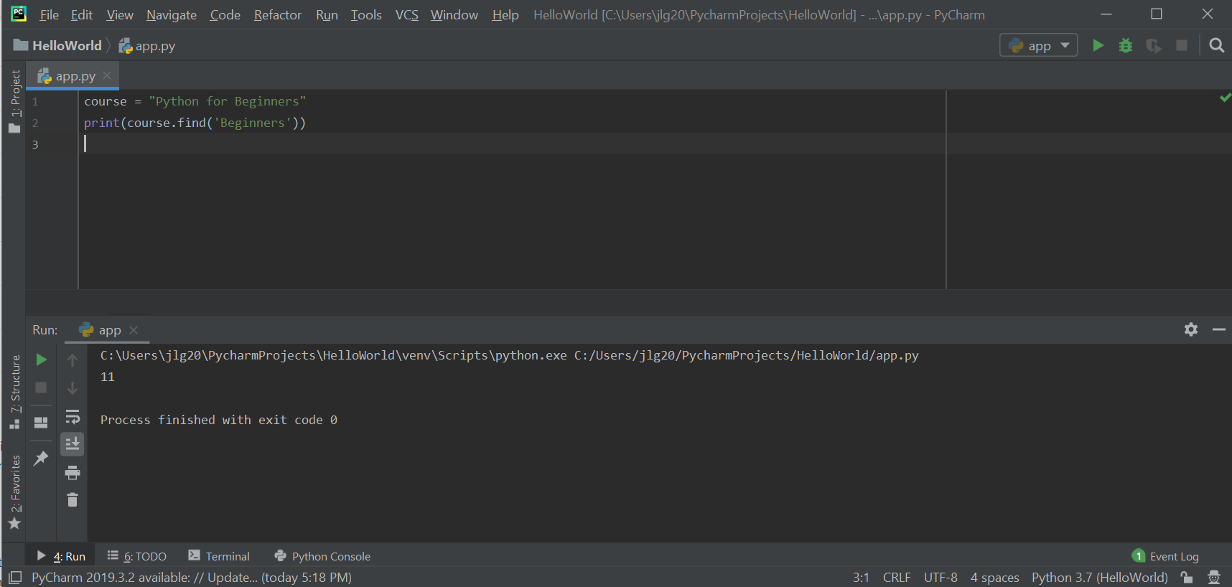

    - The method for replacing a character or sequence of characters is the replace() method. This method is case-sensitive. This is really a find and replace method in the sense where it finds the character or string of characters (the first parameter) and replaces it with the character or string of characters (the second parameter).

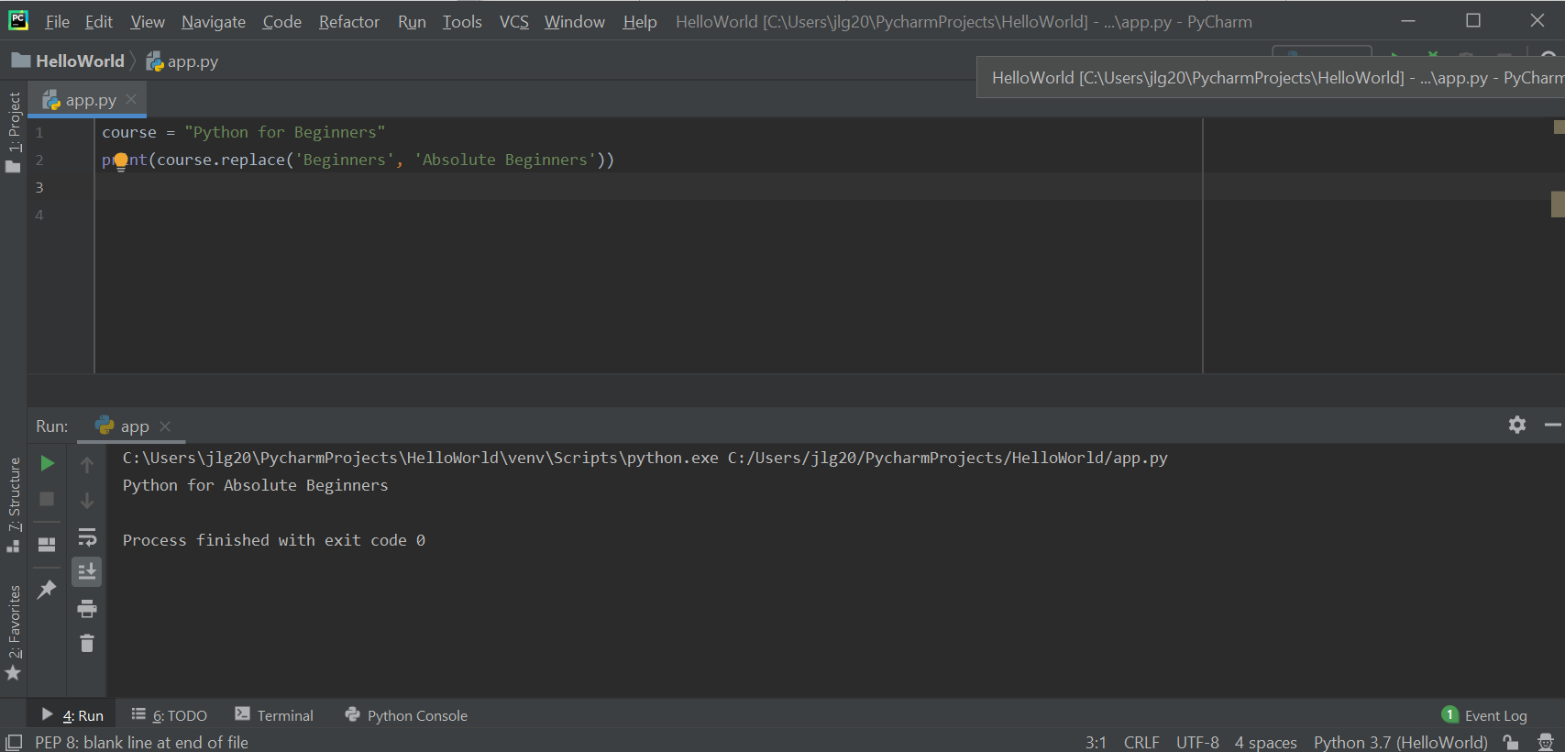

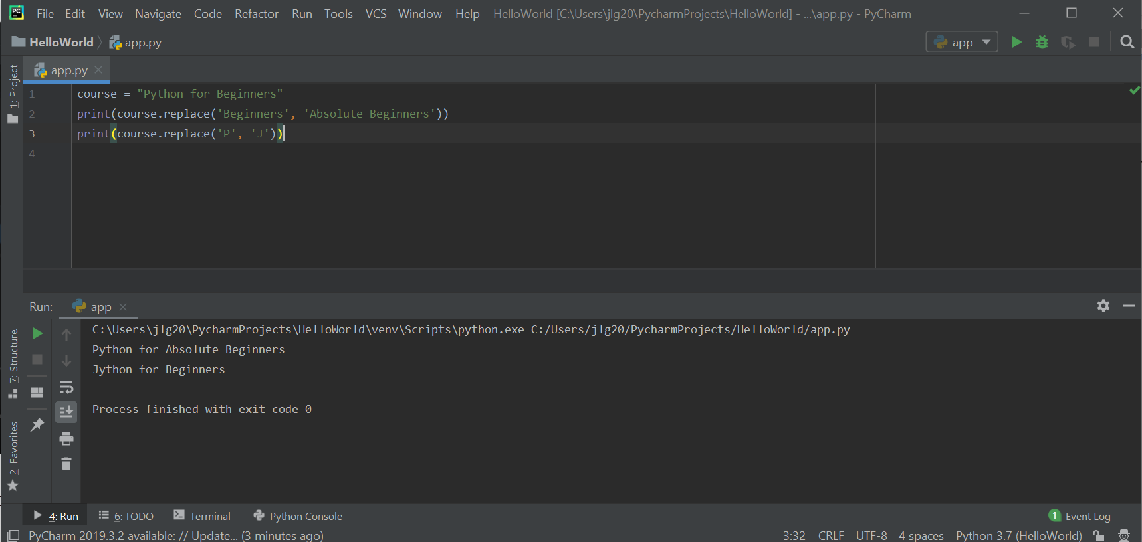

    - To check the existence of a character or a sequence of characters in the string, use the 'in' operator. In the sample below, we want to know if the string contains the word 'Python'. This is a Boolean expression that returns true or false. The first sample (below) returns true because 'Python' is found but the second one returns false because the word 'python' is not found since this is case sensitive. The 'in' operator is different from the find() method because the find() method returns the index to the first instance of the character or string to find whereas the 'in' operator is used in a Boolean expression and returns true or false.

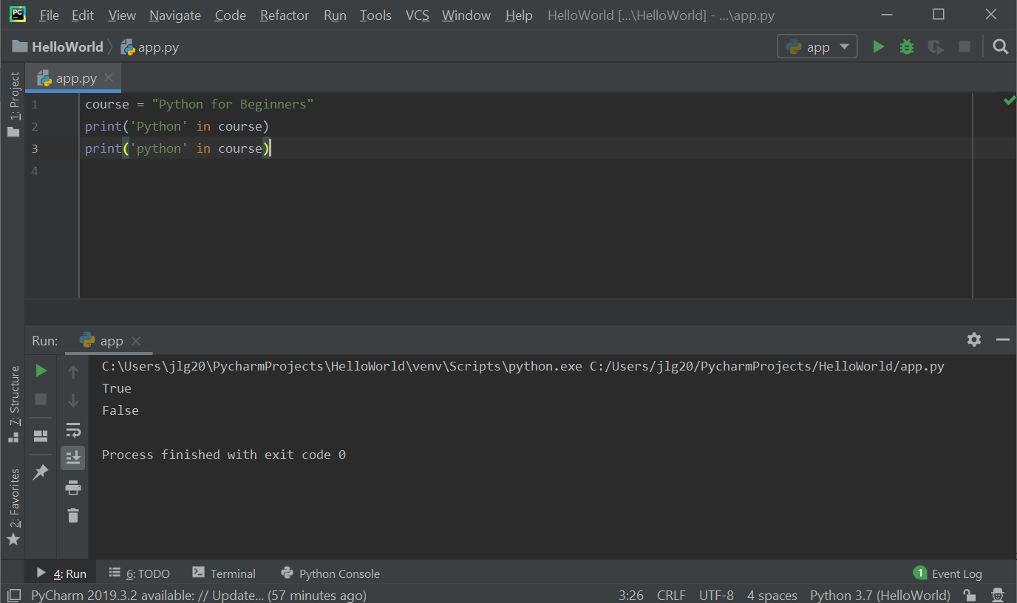

  - Below is a summary of string functions/methods that we learned:
- len()
- upper()
- lower()
- title()
- find()
- replace()

Resources
- Python documentation – Python Standard Library: https://docs.python.org/3/library/index.html
- Python documentation – order precedence rules: https://docs.python.org/3/reference/expressions.html
- Python documentation – string methods: https://docs.python.org/3/library/stdtypes.html?highlight=upper#str.upper

Practice Exercises
- Write a Python program to print the following string in a specific format (see the output).
Sample String : "Twinkle, twinkle, little star, How I wonder what you are! Up above the world so high, Like a diamond in the sky. Twinkle, twinkle, little star, How I wonder what you are" Output:

Twinkle, twinkle, little star,
How I wonder what you are!
Up above the world so high,
Like a diamond in the sky.
Twinkle, twinkle, little star,
How I wonder what you are

  - Write a Python program to calculate the length of a string.
  - Python program to count the number of characters (character frequency) in a string.
  - Write a Python program to get a string made of the first 2 and the last 2 chars from a given a string. If the string length is less than 2, return instead of the empty string.
Sample execution of the program:
Sample String : 'w3resource'
Expected Result : 'w3ce'
Sample String : 'w3'
Expected Result : 'w3w3'
Sample String : ' w'
Expected Result : Empty String

  - Write a Python program to add 'ing' at the end of a given string (length should be at least 3). If the given string already ends with 'ing' then add 'ly' instead. If the string length of the given string is less than 3, leave it unchanged.
Sample execution of the program:
Sample String : 'abc'
Expected Result : 'abcing'
Sample String : 'string'
Expected Result : 'stringly'

  - Write a Python program to find the first appearance of the substring 'not' and 'poor' from a given string, if 'not' follows the 'poor', replace the whole 'not'...'poor' substring with 'good'. Return the resulting string.
Sample execution of the program:
Sample String : 'The lyrics is not that poor!'
'The lyrics is poor!'
Expected Result : 'The lyrics is good!'
'The lyrics is poor!'

  - Write a Python program to remove the nth index character from a nonempty string.

