Lesson Plan
Title | Programming with Python
Time duration | 1 Hour
Review & Exercises | Review of concepts and exercises for practice

Lesson Review
- Using arithmetic operations: in Python there are two types of numbers: (1) integers, which are whole numbers that do not have decimal points; and (2) floats, which are numbers with decimal points.
  - There are operations, methods and functions built into Python that can be used on numbers.
    - An example of an operation is adding (‘+’) two integers. There are also the subtraction (‘-‘) and multiplication (‘*’) operations.

print(10 + 3)
    - There are a few types of division operations to make note of:
      - (‘/’) – this is the standard division operation that returns a float.
      - (‘//’) – using double ‘/’, this is modular – division that returns an integer.
      - (‘%’) – this returns the remainder of the division.
      - (‘**’) – this is exponent that returns the power, e.g., it returns 10 to the power of 3.

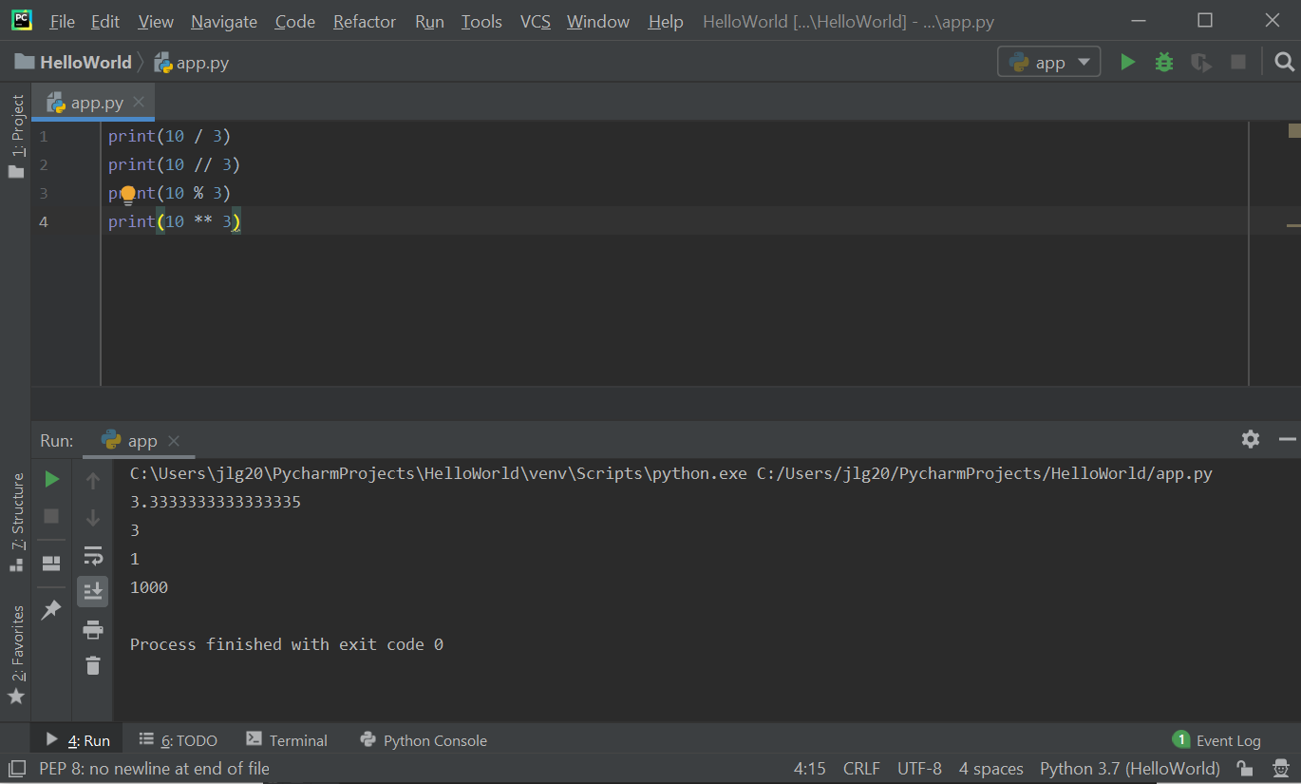
    - For all of the arithmetic operators above, there are augmented assignment operators. Augmented assignment operators are operators that act as short-hand notation when performing the above operators where the operator takes a variable as one of its arguments and then assigns the result back to that same variable. For example, adding X = X + 3, the augmented assignment operator would be X += 3.

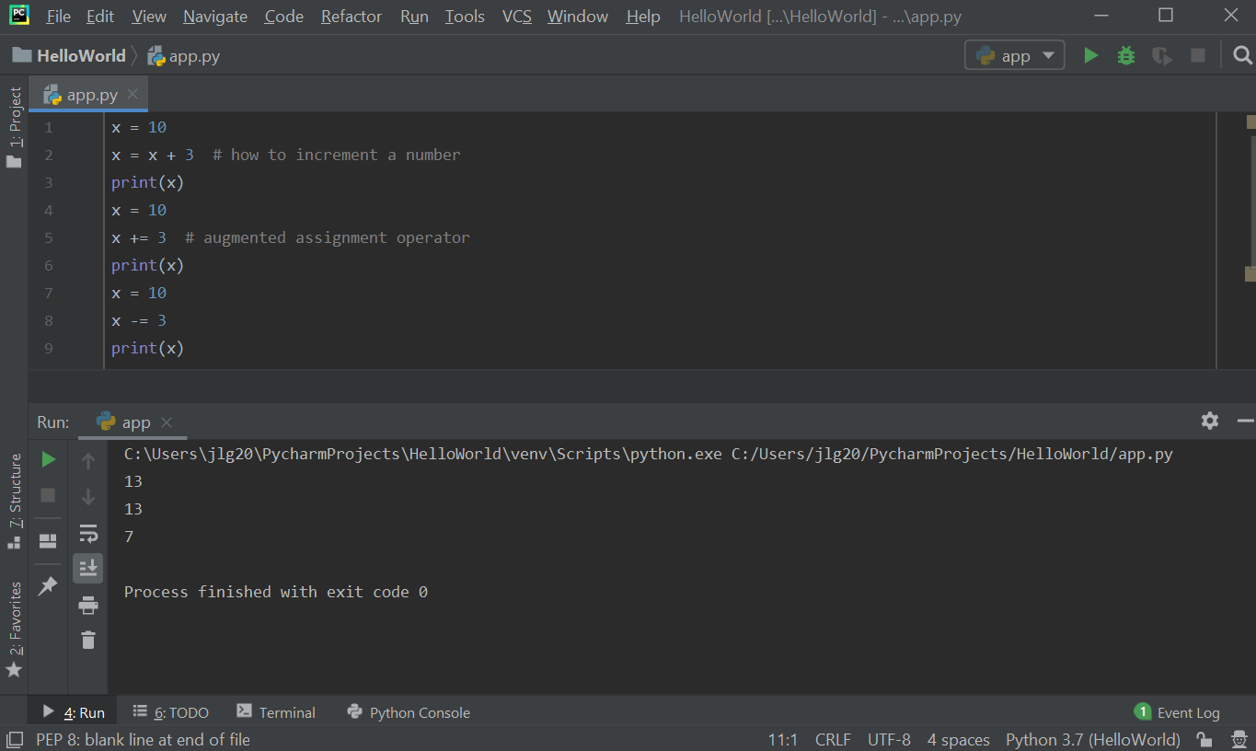
    - Order precedence. If there is more than one arithmetic operator in a statement, they must follow order of precedence rules. The order is as follows: exponentiation is performed first. Multiplication or division would be performed second. Addition or subtraction would be performed third.
      - In the first sample, the multiplication will be executed before the addition based on the operator precedence rules.
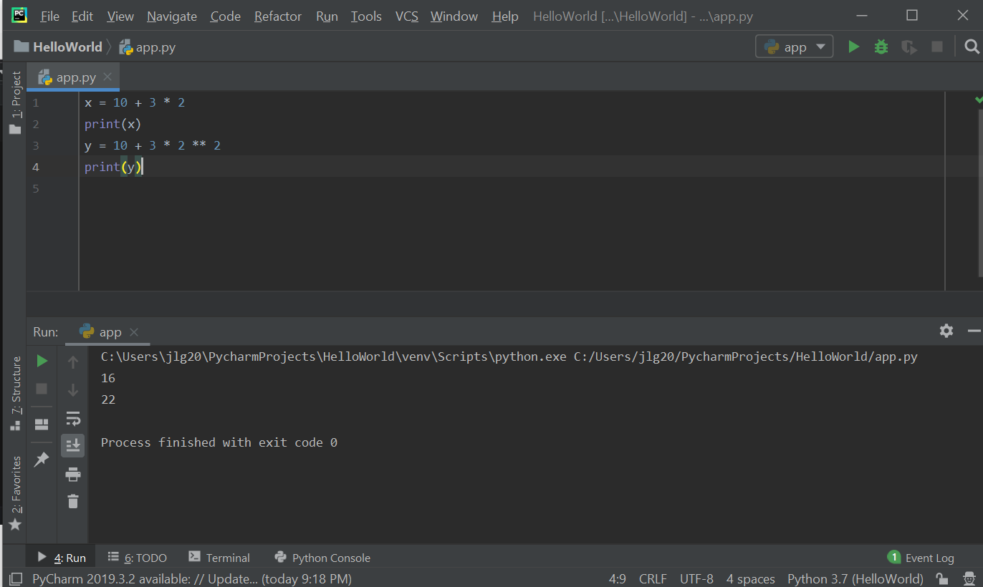

    - Parentheses can be used to change the order of operation. Parentheses always takes priority as shown in the below example.

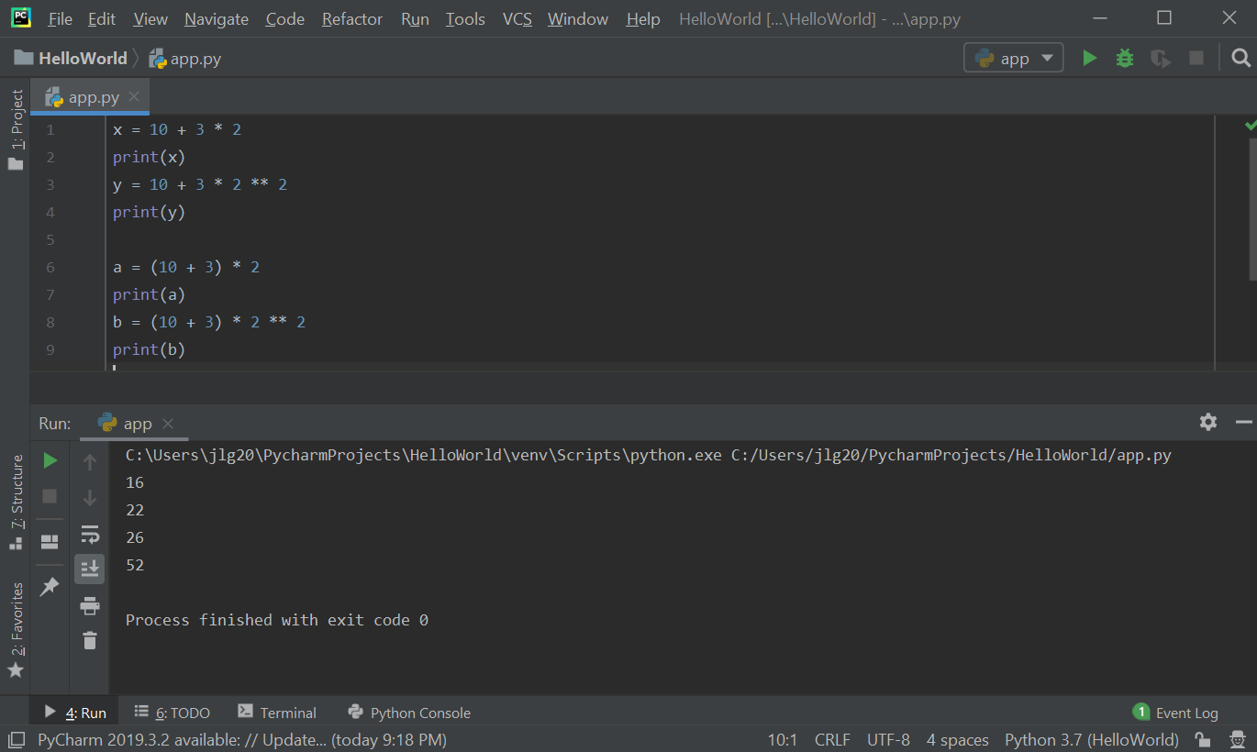

- Math functions, and importing the math module for additional functions:
  - Examples of math functions built into Python are round() – to round a number, and the abs() – that takes the absolute value of a number and always returns a positive number.
  - Python has a handful of built-in mathematical functions, but if you want to write programs that involve complex calculations you need to import the math module. A module in Python is a separate file of some reusable code and we use these modules to organize our code into different files. This math module includes a bunch of reusable functions that perform mathematical calculations.
  - How to use the math module: at the top of the .py file, type "import math". Now 'math' is an object, like a string, so we can access its functions. More accurately, they are methods with the '.' operator: "math." shows all the mathematical functions/methods available in this module.

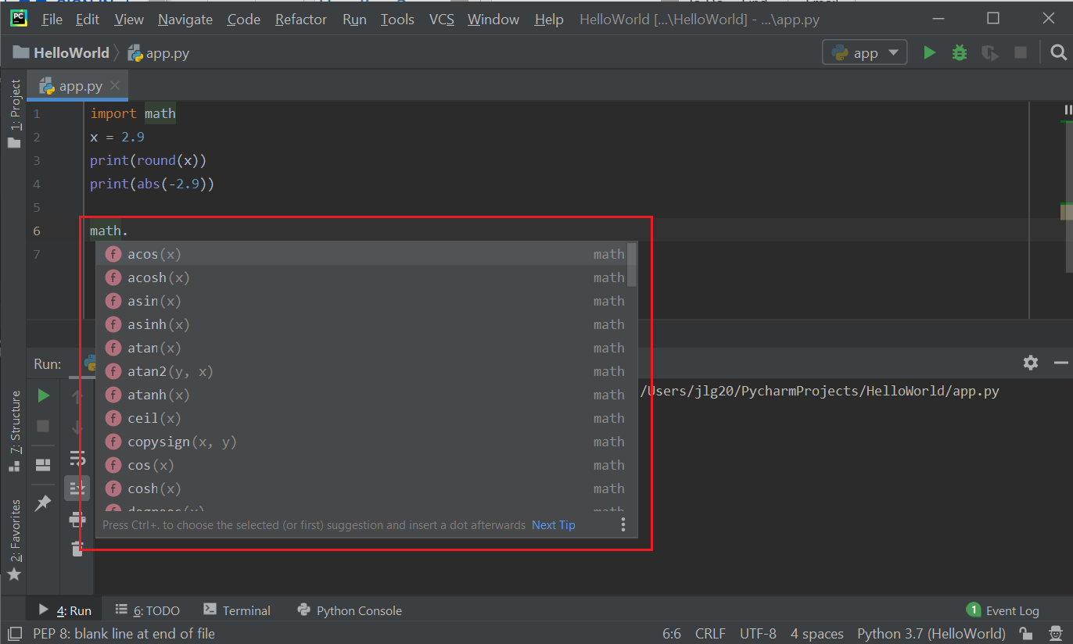
    - The math.ceil() function is included in the math module. Below is code using the math.ceil() function on the float 2.9.

print(math.ceil(2.9))
Output:
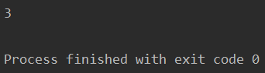
    - The math.floor() function is also included in the math module. Below is code using the math.floor() function on the same number.

print(math.floor(2.9))
Output:
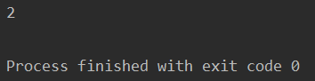

  - To learn about the math module in Python, in a browser search for "python 3 math module". Be sure to type the version of python used. The math module can be found at: https://docs.python.org/3/library/math.html. This documentation will show the functions available in the math module as well as a description explaining how to use them. To access the Python standard library including all modules available in Python go to: https://docs.python.org/3/library/index.html. Below is a screenshot of online documentation of the math module.

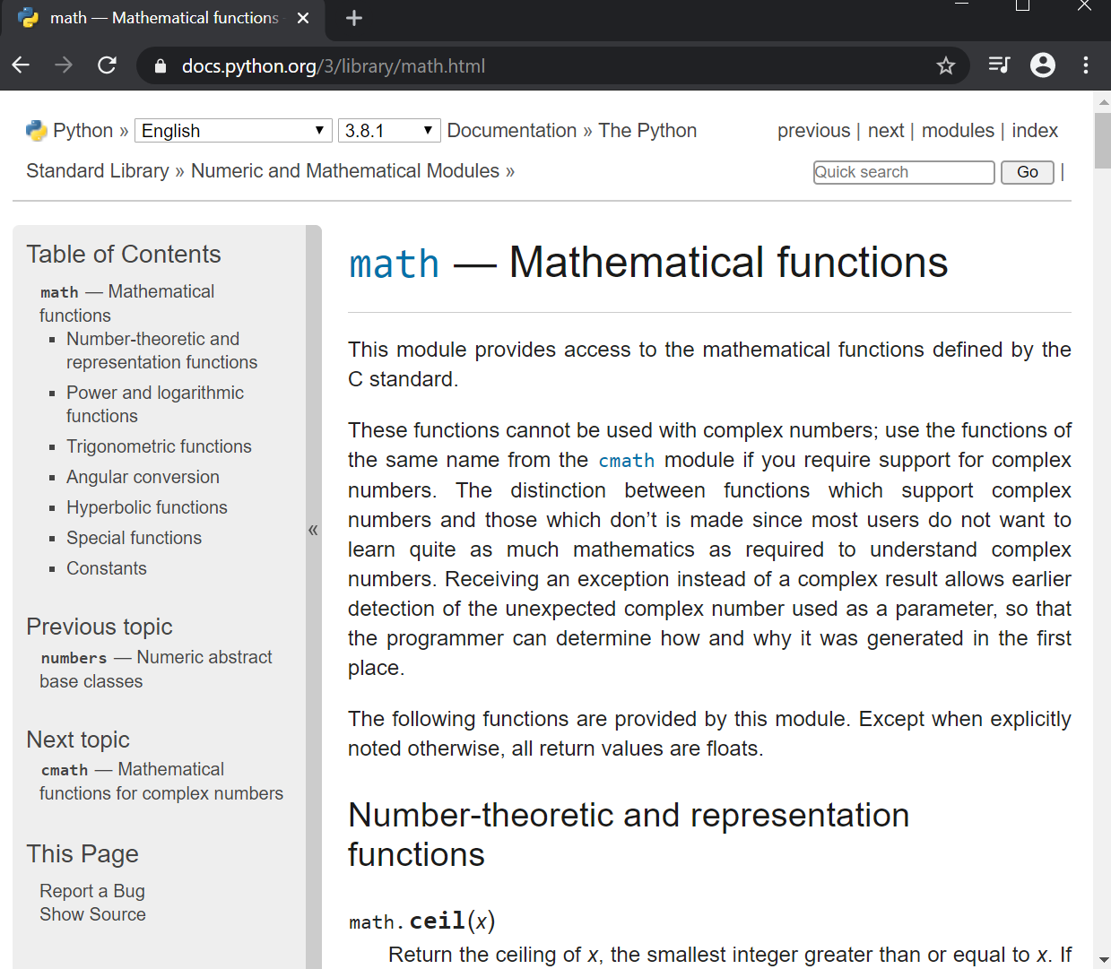

- Conditional Statements:
  - If, Else and shorthand for If/Else, Elif
    - If Statements: If statements are important in programming and allow us to build programs that can make decisions based on some conditions. If some condition is true you are going to do certain things otherwise, we are going to do other things.
      - Example: implement the following logic:

If it's hot
It's a hot day
Drink plenty of water
Otherwise if it's cold
It's a cold day
Wear warm clothes
Otherwise
It's a lovely day

To write this program:
    - set a Boolean variable is_hot = True,
    - add an if condition using the is_hot Boolean variable. If this turns out to be true then going to do certain things - in this case, tell the user it is a hot day and drink plenty of water,
    - at the end of the condition statement, put a ':' and when click "Enter" this will automatically indent the code following it and any code listed under this indentation will be executed if the condition is true otherwise it will be ignored,
    - after adding codes in the if-condition block, use shift-tab to place the cursor back,
    - add another print statement outside of the if-condition block (see sample program below). The first print statement gets executed because is_hot is True, and the second print gets executed, even though outside of the if-condition block, it follows the if-condition and so execution from top to bottom still applies.

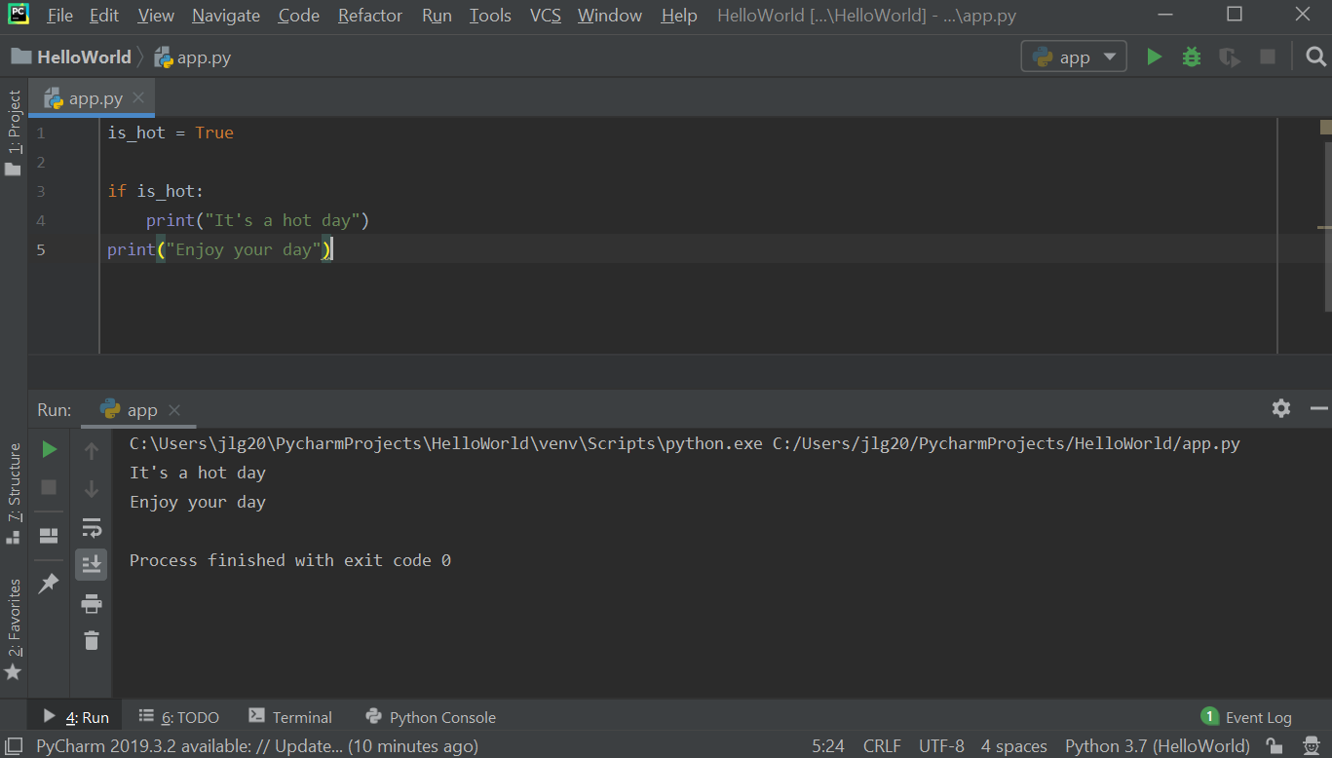
If change the is_hot variable to False, then only the second print statement gets executed.

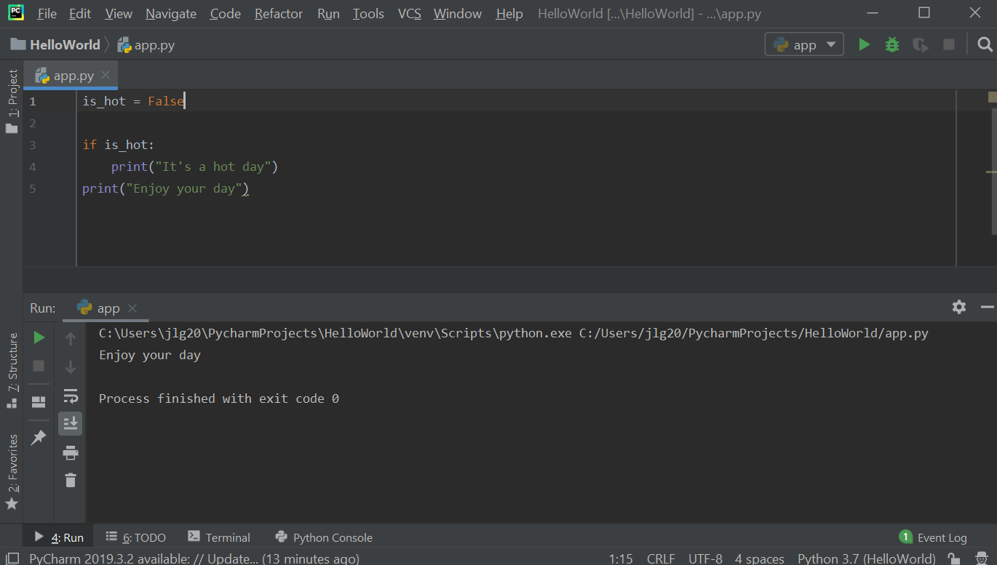

Adding another print statement to the if-condition block shows that all statements within that block will be executed if is_hot is True:

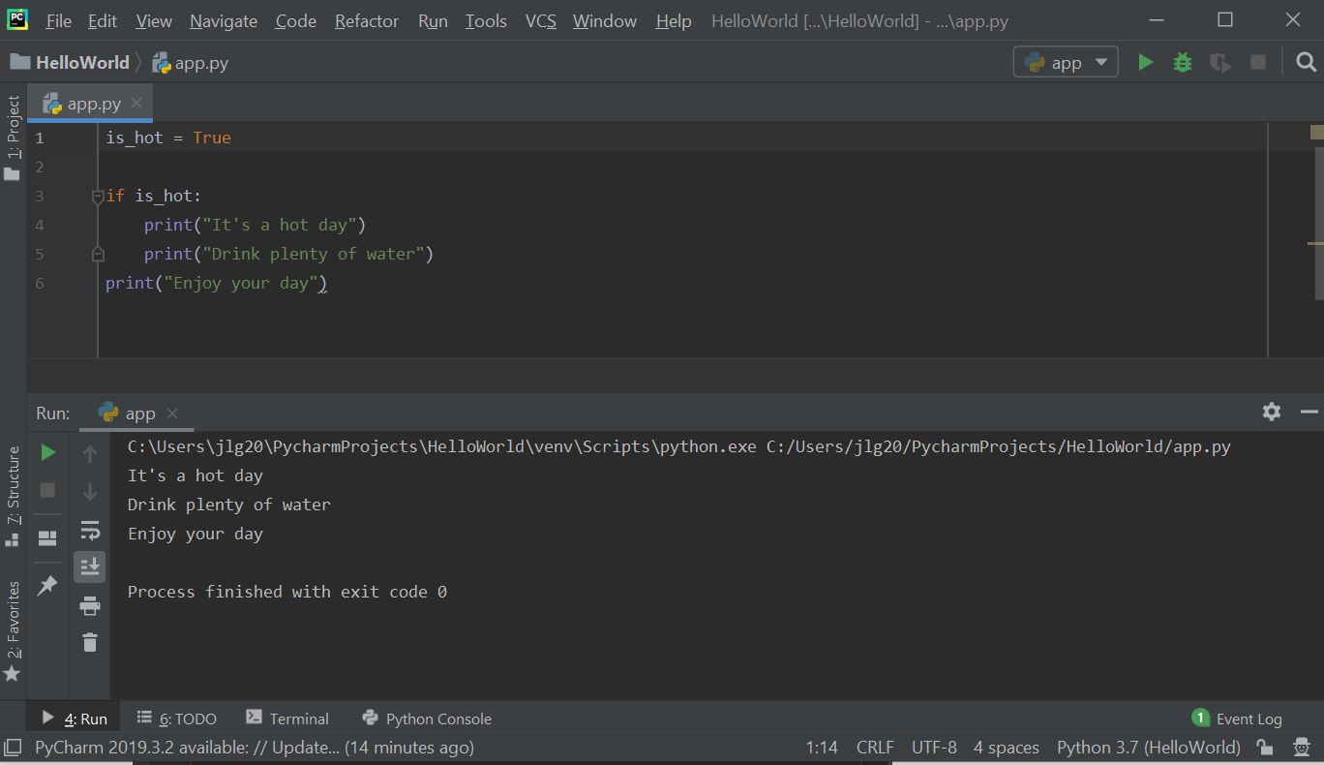

    - Using If-Else: expanding the example above, adding an else statement will cause another indentation. All the statements that are within the indentation following the else are part of the else-block and will be executed when is_hot is False.

In the below sample, is_hot is set to True and so you won't see any of the print statements relating to a cold day.

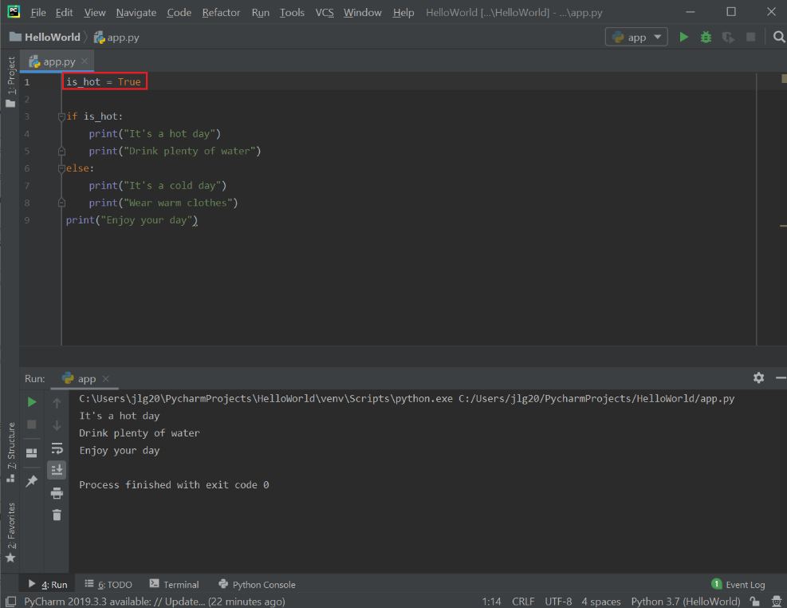

In the below sample, is_hot is set to False and so you won't see any print statements relating to a hot day. Instead, you will see print statements relating to a cold day.

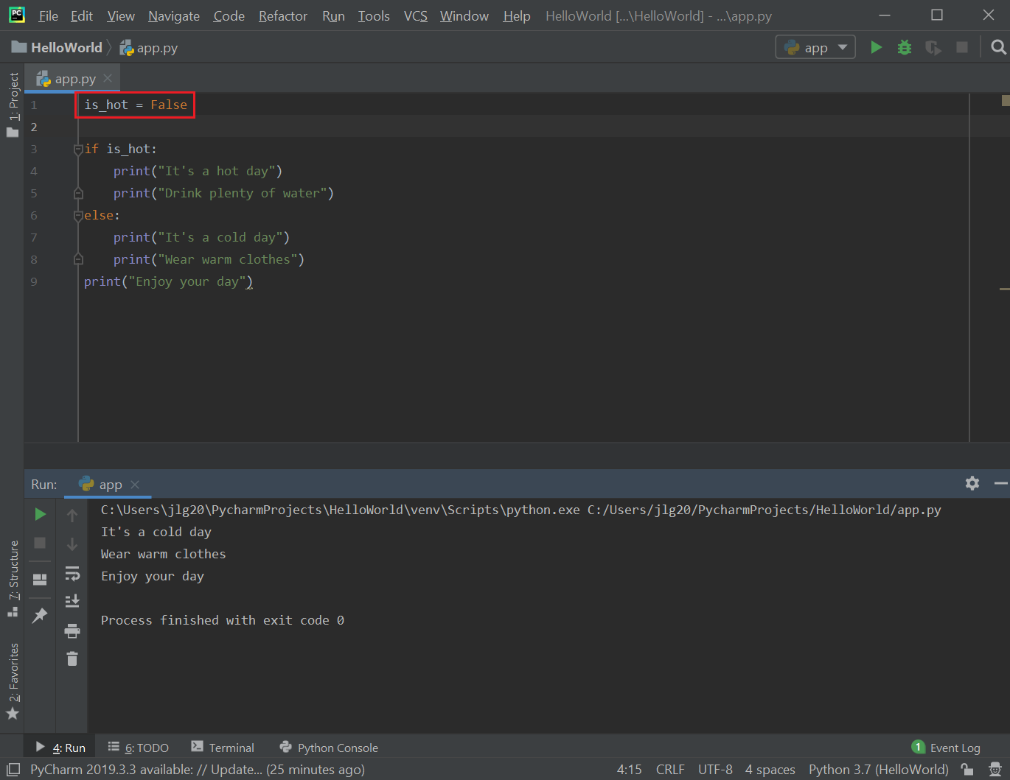

There is a problem with the logic in the above sample. If it is not a hot day it doesn’t mean it is a cold day either. It can also be a pleasant day. The logic should be if hot, print hot day messages, else if cold, print cold day messages, otherwise it is a pleasant day. To fix this logical error, add the following:

- add another Boolean is_cold and set to True (currently, is_hot = False),
- add a second condition following the if is_hot condition, and use elif (e.g., "else if") to do this:

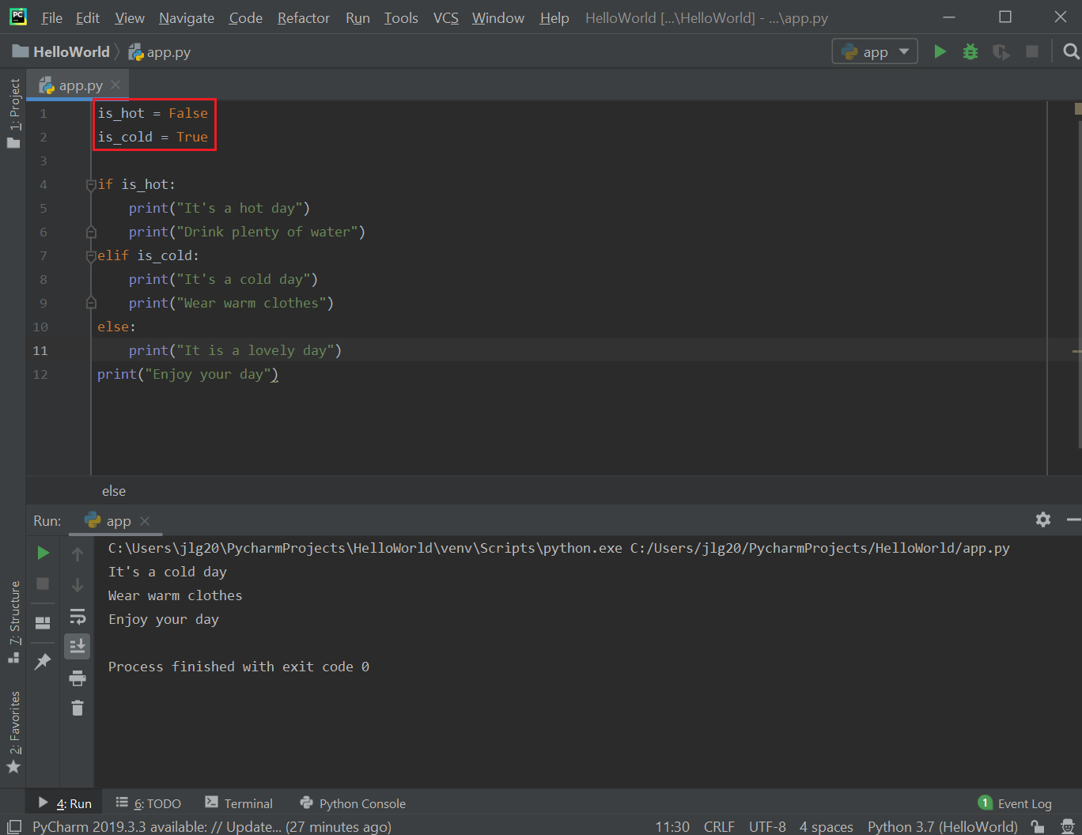

If both is_hot and is_cold is both False, then can print a different message. The execution works as follows: it executes and evaluates the is_hot if statement, and because is_hot is false, the print statements in this if-condition block are ignored. It then executes and evaluates the is_cold if statement (elif), and because is_cold is false, the print statements in this elif-condition block are ignored. It then executes the else statement and prints the statements in the else block because the other two conditions were false. Finally, it executes any statements after these condition blocks that are not part of any of those condition blocks (e.g., the very last print statement). Note, if one of the other conditions are true (e.g., "if is_hot" or "elif is_cold") then the else block gets ignored.

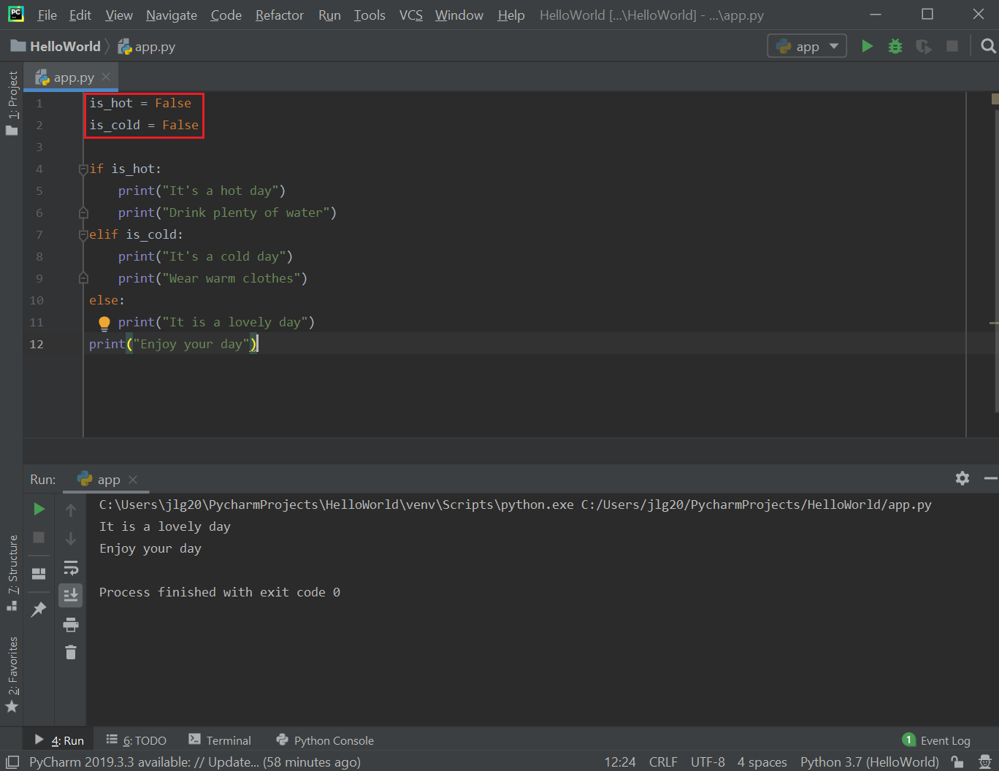

    - Exercise: implement the following logic:

The price of a house is $1M.
If buyer has good credit,
They need to put down 10%
Otherwise
They need to put down 20%
Print the down payment

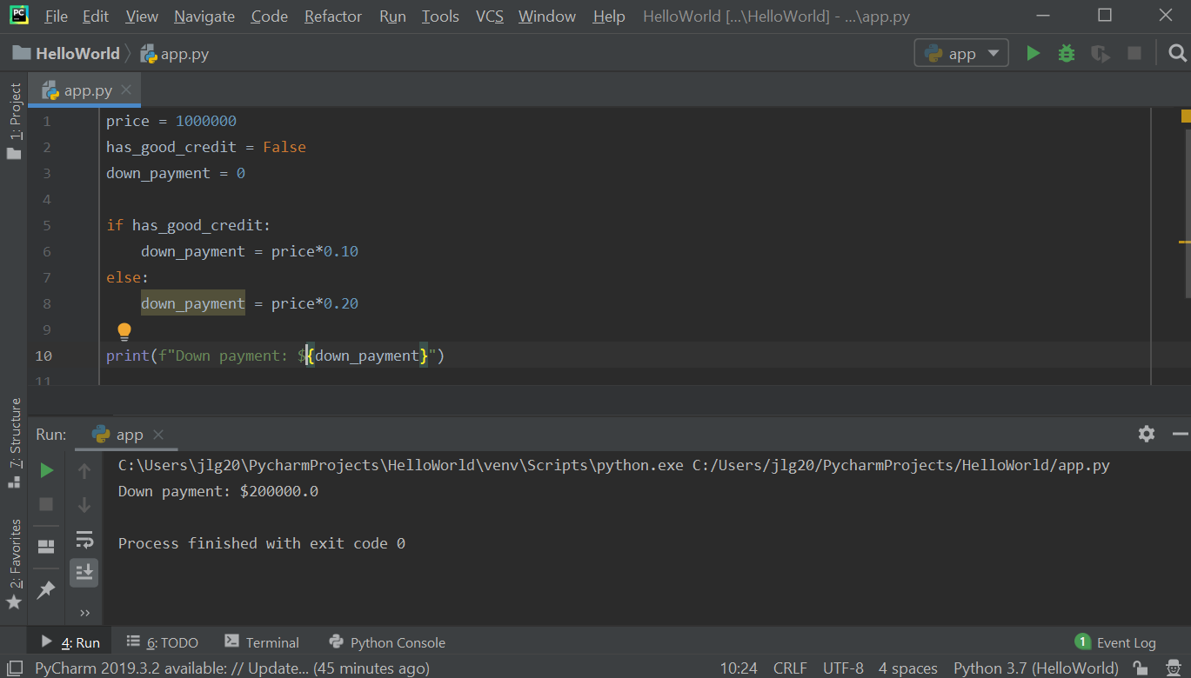

Resources
- Python documentation – Python Standard Library: https://docs.python.org/3/library/index.html
- Python documentation – Math module: https://docs.python.org/3/library/math.html
- Python documentation – String methods: https://docs.python.org/3/library/stdtypes.html?highlight=upper#str.upper

Practice Exercises
- Exercises using arithmetic operations and math functions (hint: you may have to use functions from the math module for some questions):
  - Write a Python program to convert degree to radian. Note : The radian is the standard unit of angular measure, used in many areas of mathematics. An angle's measurement in radians is numerically equal to the length of a corresponding arc of a unit circle; one radian is just under 57.3 degrees (when the arc length is equal to the radius).

Test Data:
Degree : 15
Expected Result in radians: 0.2619047619047619

  - Write a Python program to convert radian to degree.

Test Data:
Radian : .52
Expected Result : 29.781818181818185

  - Write a Python program to calculate the area of a trapezoid. Note : A trapezoid is a quadrilateral with two sides parallel. An isosceles trapezoid is a trapezoid in which the base angles are equal. The formula to calculate the area of a trapezoid is:

A = $\frac{1}{2}h(b1+b2)$
where h is the height of the trapezoid, and
b1 and b2 are the base lengths of the trapezoid

Example output:
Test Data:
Height : 5
Base, first value : 5
Base, second value : 6
Expected Output: Area is : 27.5

  - Write a Python program to calculate surface volume and area of a cylinder. Note: A cylinder is one of the most basic curvilinear geometric shapes, the surface formed by the points at a fixed distance from a given straight line, the axis of the cylinder.

The formula to calculate the volume of a cylinder is:
V = $πr^{2}h$
where r is the radius, and h is the height of the cylinder

The formula to calculate the area of a cylinder is:

A = $2πr^{2}+h(2πr)$
where r is the radius, and h is the height of the cylinder

Example output:
Test Data:
volume : Height (4), Radius(6)
Expected Output:
Volume is : 452.57142857142856
Surface Area is : 377.1428571428571

