Lesson Plan
Title | Programming with Python
Time duration | 1 Hour
Review & Exercises | Review of concepts and exercises for practice

Lesson Review
- Conditional Statements:
  - If, Else and shorthand for If/Else, Elif
    - If Statements: If statements are important in programming and allow us to build programs that can make decisions based on some conditions. If some condition is true you are going to do certain things otherwise, we are going to do other things.
      - Example: implement the following logic:

If it's hot
It's a hot day
Drink plenty of water
Otherwise if it's cold
It's a cold day
Wear warm clothes
Otherwise
It's a lovely day

To write this program:
    - set a Boolean variable is_hot = True,
    - add an if condition using the is_hot Boolean variable. If this turns out to be true then going to do certain things - in this case, tell the user it is a hot day and drink plenty of water,
    - at the end of the condition statement, put a ':' and when click "Enter" this will automatically indent the code following it and any code listed under this indentation will be executed if the condition is true otherwise it will be ignored,
    - after adding codes in the if-condition block, use shift-tab to place the cursor back,
    - add another print statement outside of the if-condition block (see sample program below). The first print statement gets executed because is_hot is True, and the second print gets executed, even though outside of the if-condition block, it follows the if-condition and so execution from top to bottom still applies.

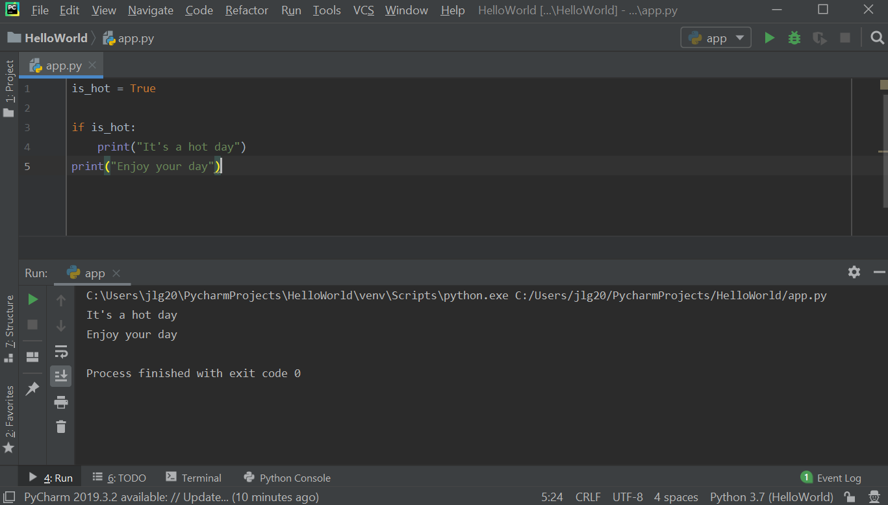
If change the is_hot variable to False, then only the second print statement gets executed.

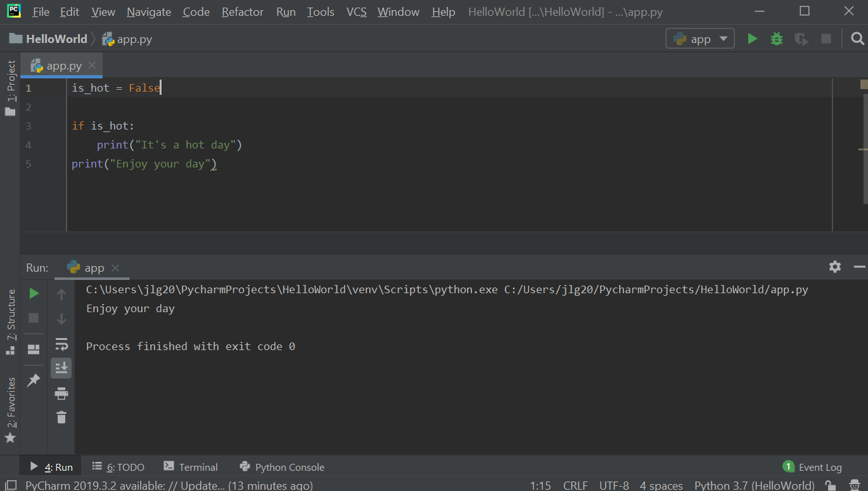

Adding another print statement to the if-condition block shows that all statements within that block will be executed if is_hot is True:

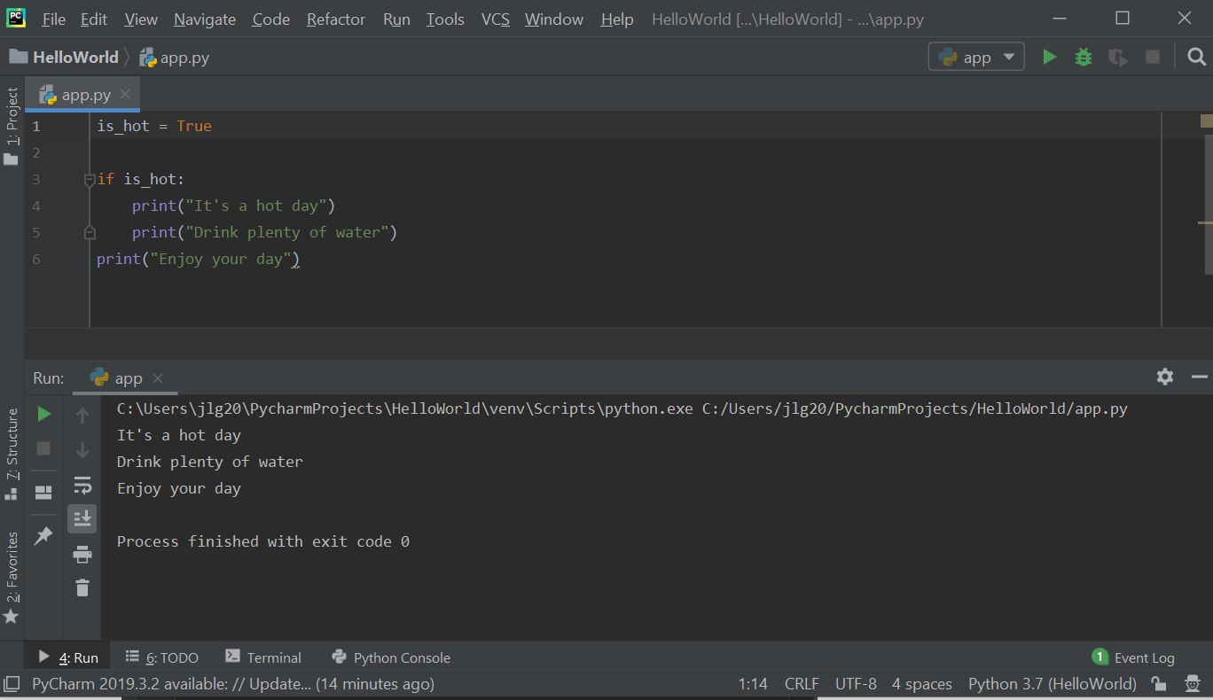

    - Using If-Else: expanding the example above, adding an else statement will cause another indentation. All the statements that are within the indentation following the else are part of the else-block and will be executed when is_hot is False.

In the below sample, is_hot is set to True and so you won't see any of the print statements relating to a cold day.

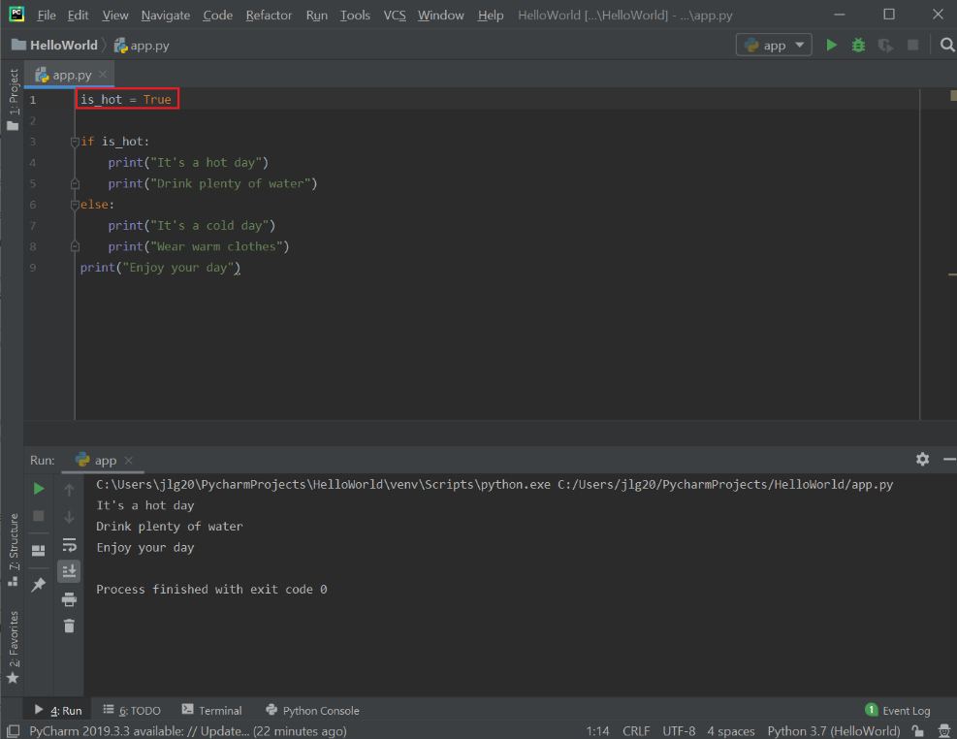

In the below sample, is_hot is set to False and so you won't see any print statements relating to a hot day. Instead, you will see print statements relating to a cold day.

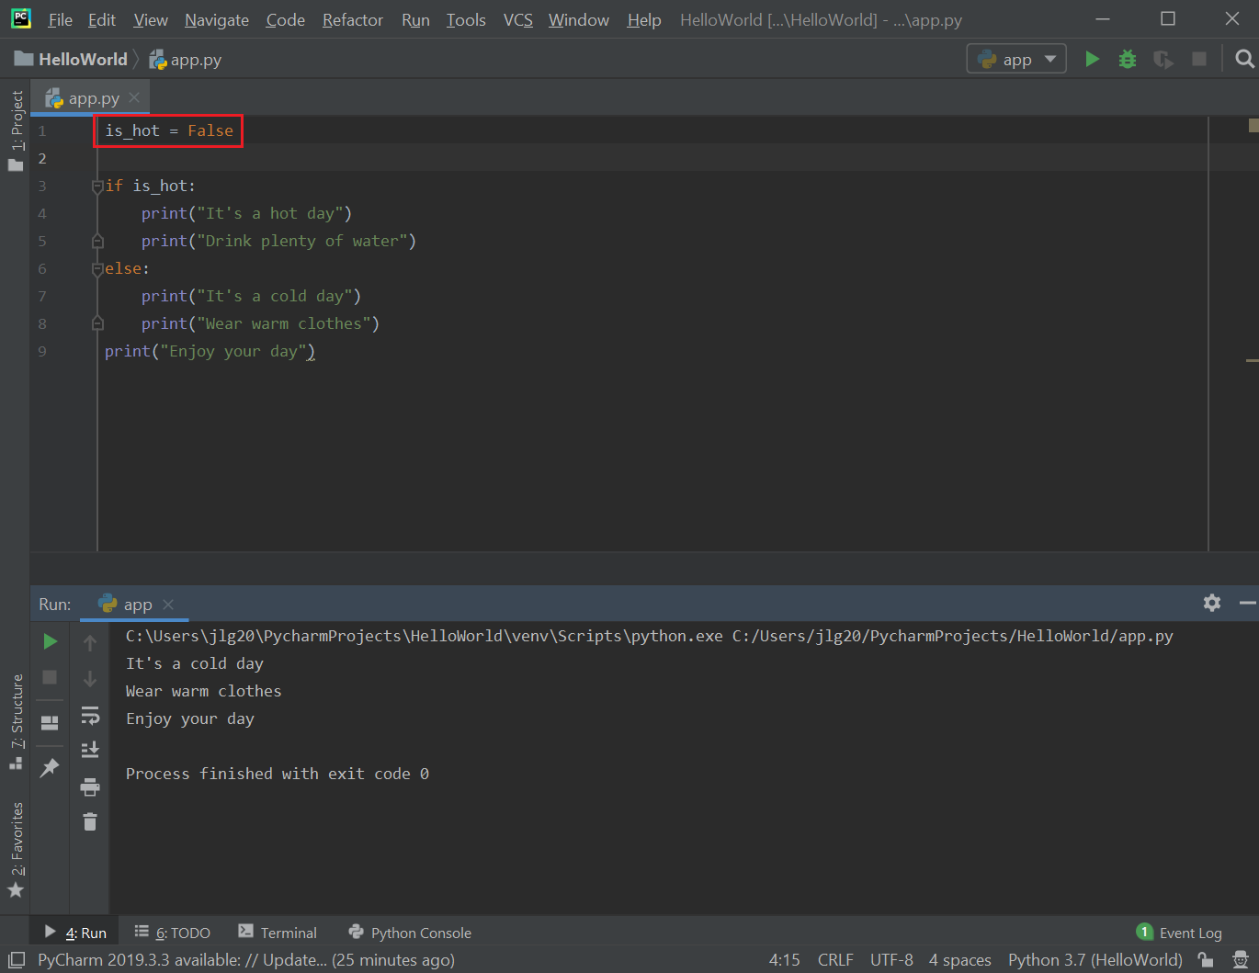

There is a problem with the logic in the above sample. If it is not a hot day it doesn’t mean it is a cold day either. It can also be a pleasant day. The logic should be if hot, print hot day messages, else if cold, print cold day messages, otherwise it is a pleasant day. To fix this logical error, add the following:

- add another Boolean is_cold and set to True (currently, is_hot = False),
- add a second condition following the if is_hot condition, and use elif (e.g., "else if") to do this:

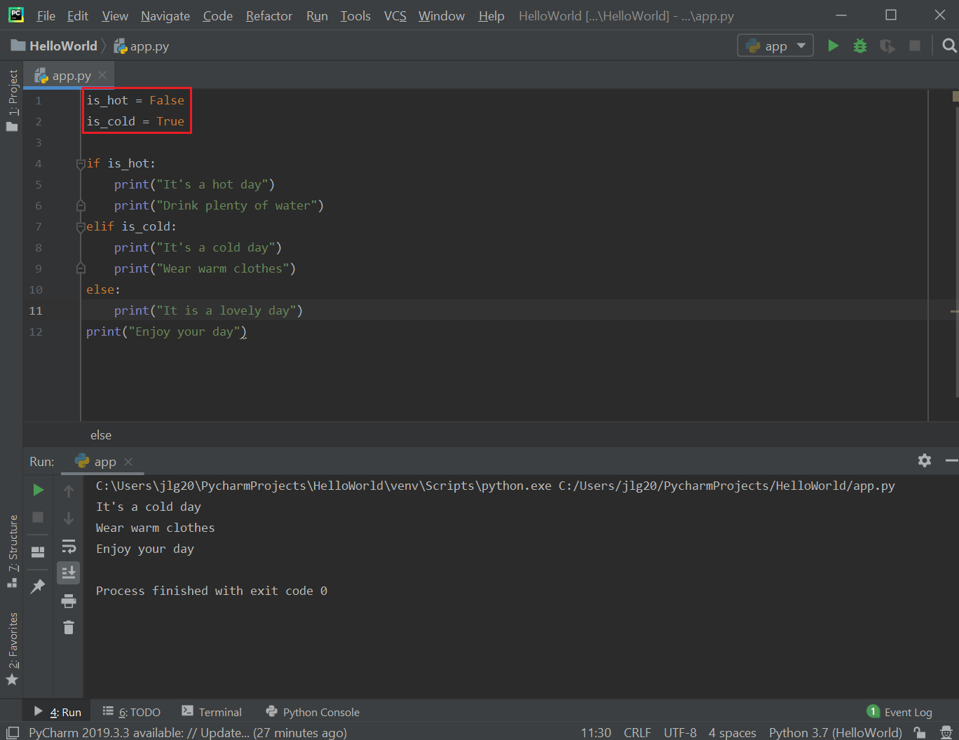

If both is_hot and is_cold is both False, then can print a different message. The execution works as follows: it executes and evaluates the is_hot if statement, and because is_hot is false, the print statements in this if-condition block are ignored. It then executes and evaluates the is_cold if statement (elif), and because is_cold is false, the print statements in this elif-condition block are ignored. It then executes the else statement and prints the statements in the else block because the other two conditions were false. Finally, it executes any statements after these condition blocks that are not part of any of those condition blocks (e.g., the very last print statement). Note, if one of the other conditions are true (e.g., "if is_hot" or "elif is_cold") then the else block gets ignored.

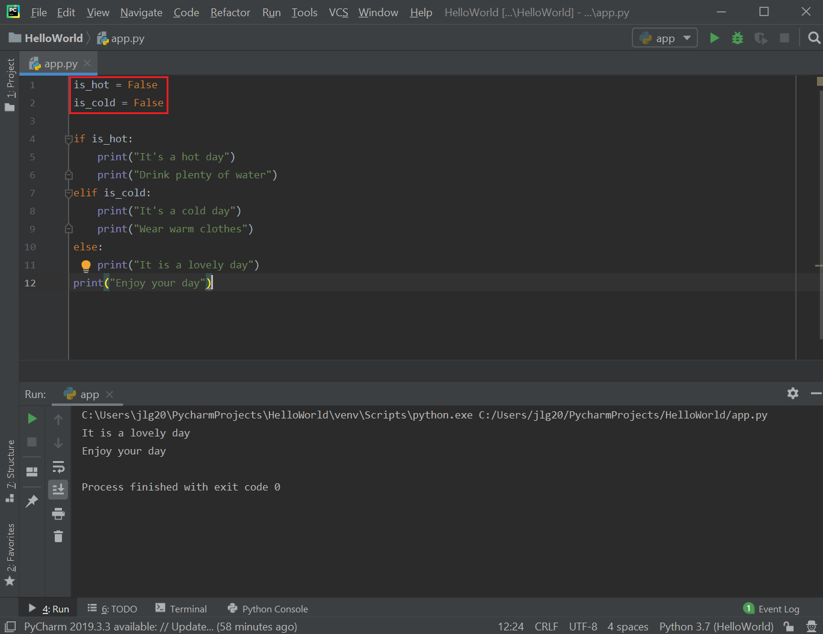

  - Using logical conditions: Equals, Not Equals, Less than, Less than or equal to, Greater than, and Greater than or equal to: logical operators are used when have multiple conditions.
    - Logical AND: both conditions must be true when using logical AND.
      - Example: in the below example, there are two conditions: (1) having high income and (2) having good credit. If both of these conditions are true, then the application is eligible for a loan. The logical AND operator is used to combine two conditions (any programming language that supports if statements also support logical operators).

If applicant has high income AND good credit
Eligible for loan

If both conditions are true, then the print statement is printed. If one is false, then the print statement is not printed.

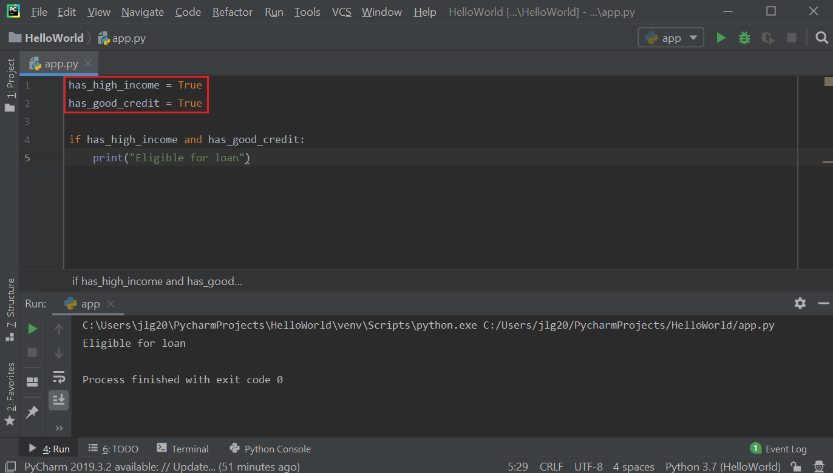

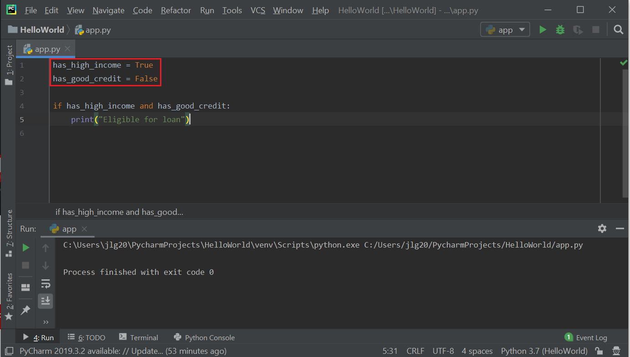

    - Exercise: implement the following logic:

The price of a house is $1M.
If buyer has good credit,
They need to put down 10%
Otherwise
They need to put down 20%
Print the down payment

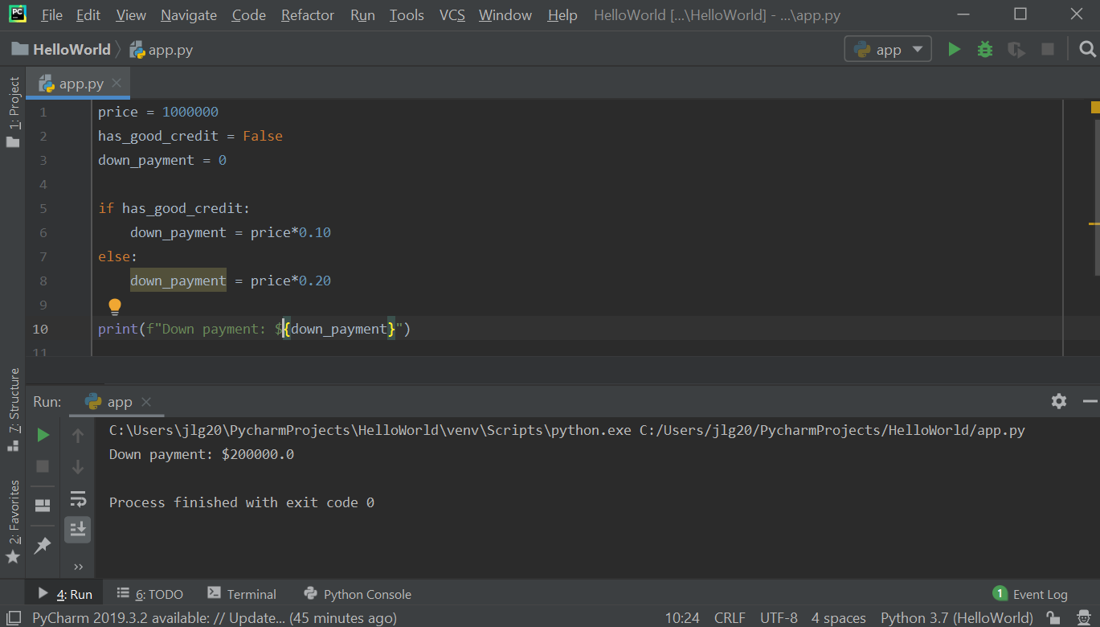

    - Exercise: implement the following logic:

Assuming the home buyer has a high income:
The loan amount for a house is $1M.
If buyer has good credit,
They need to put down 10%
Otherwise
They need to put down 20%
Print the down payment

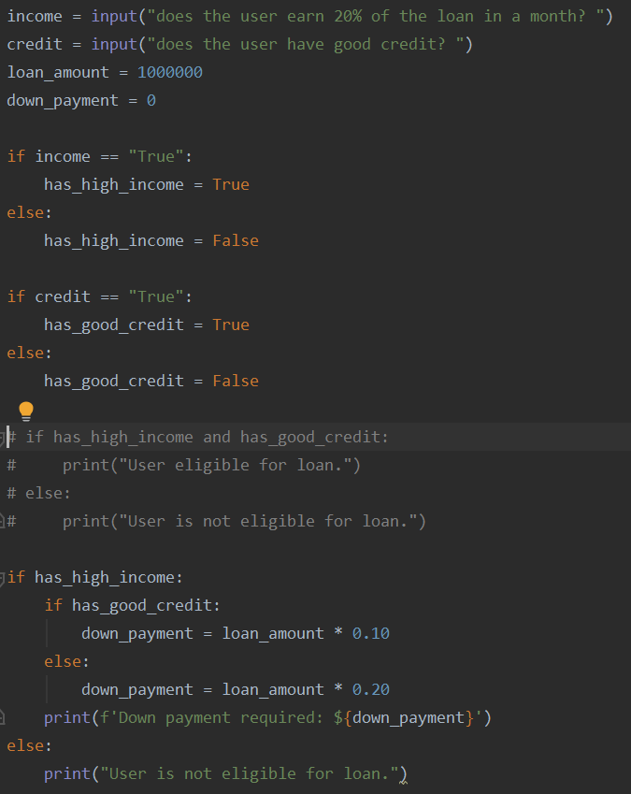

Resources
- Logical AND and OR Truth Tables: https://byjus.com/maths/truth-table/

Practice Exercises
- Using nested if-else statements can be very confusing to read and error-prone as indicated in the code below. Rewrite the below program using if-elif-else that eliminates all nested if-else statements.

