Lesson Plan
Title | Programming with Python
Time duration | 1 Hour
Review & Exercises | Review of concepts and exercises for practice

Lesson Review
- Conditional Statements:
  - Using logical conditions: Equals, Not Equals, Less than, Less than or equal to, Greater than, and Greater than or equal to: logical operators are used when have multiple conditions.
    - Logical AND: both conditions must be true when using logical AND.
      - Example: in the below example, there are two conditions: (1) having high income and (2) having good credit. If both of these conditions are true, then the application is eligible for a loan. The logical AND operator is used to combine two conditions (any programming language that supports if statements also support logical operators).

If applicant has high income AND good credit
Eligible for loan

If both conditions are true, then the print statement is printed. If one is false, then the print statement is not printed.

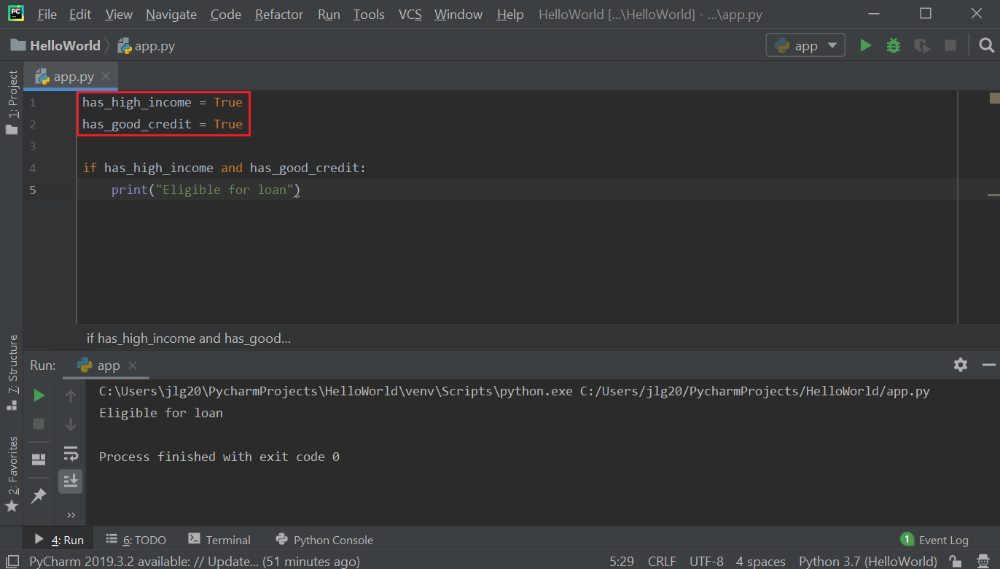

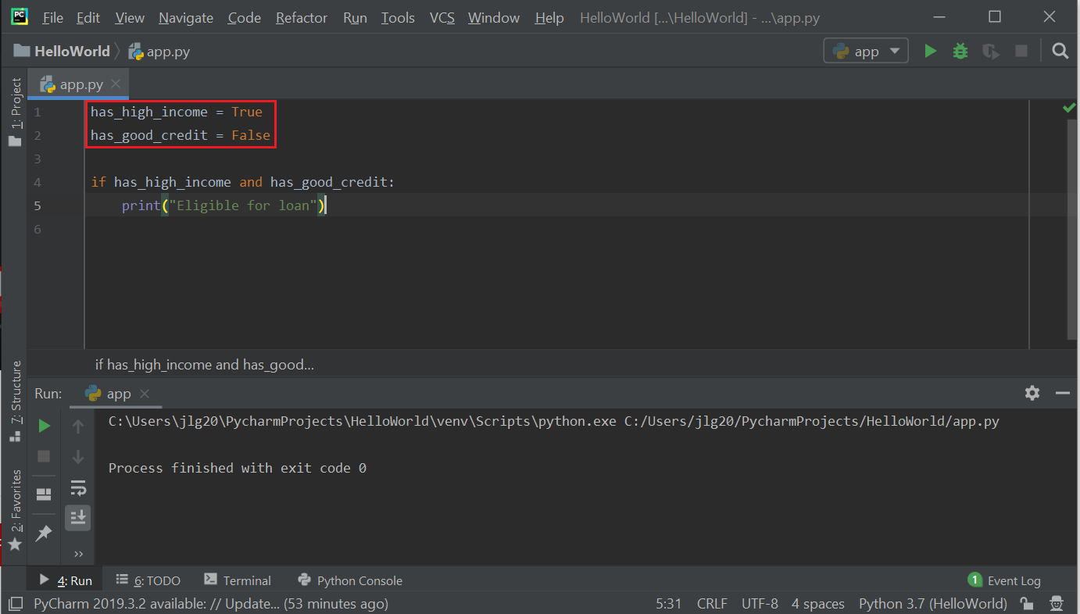

    - Logical OR: use logical OR in situations where at least one of the conditions is true.
      - Example: in the below example, there are two conditions: (1) having high income or (2) having good credit. If both of these conditions are true, then the application is eligible for a loan. The logical AND operator is used to combine two conditions (any programming language that supports if statements also support logical operators).

If applicant has high income OR good credit
Eligible for loan
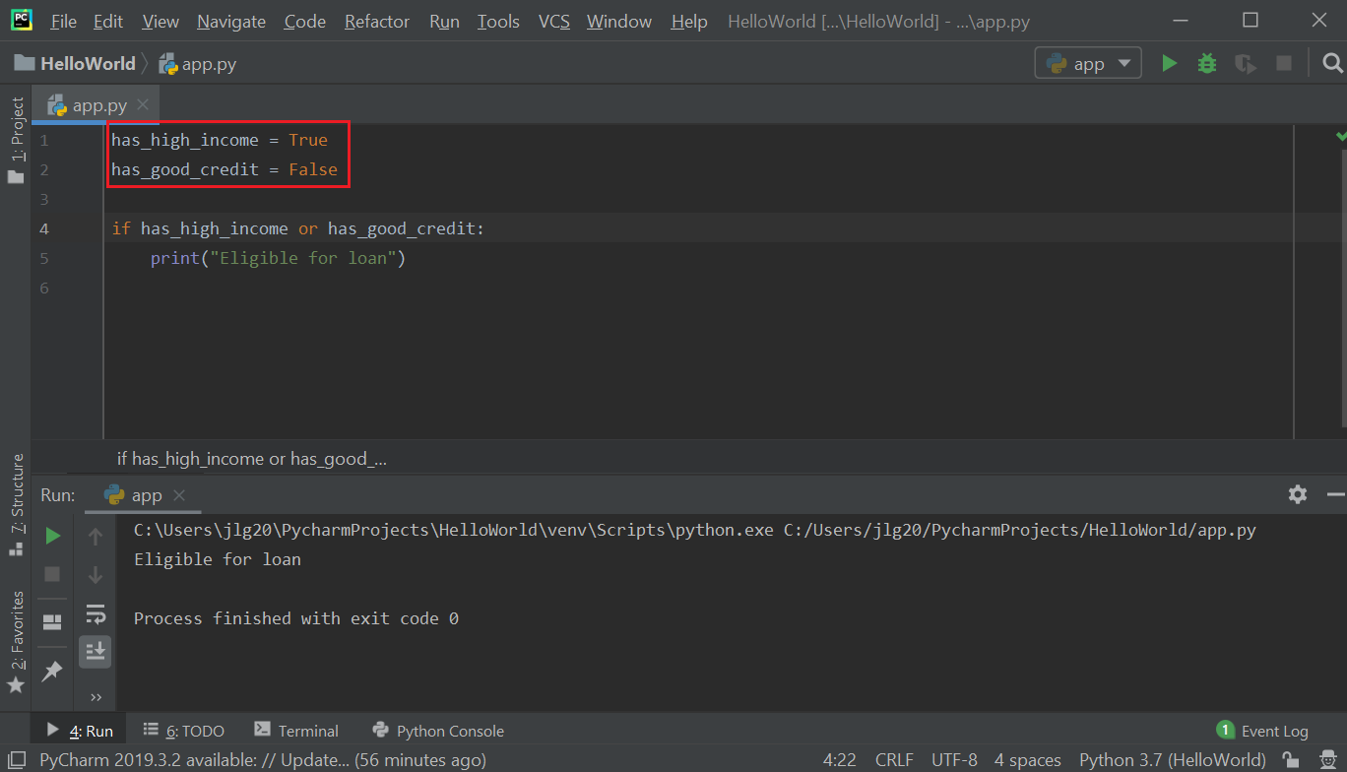

If both conditions are false, then the print statement will not be executed.

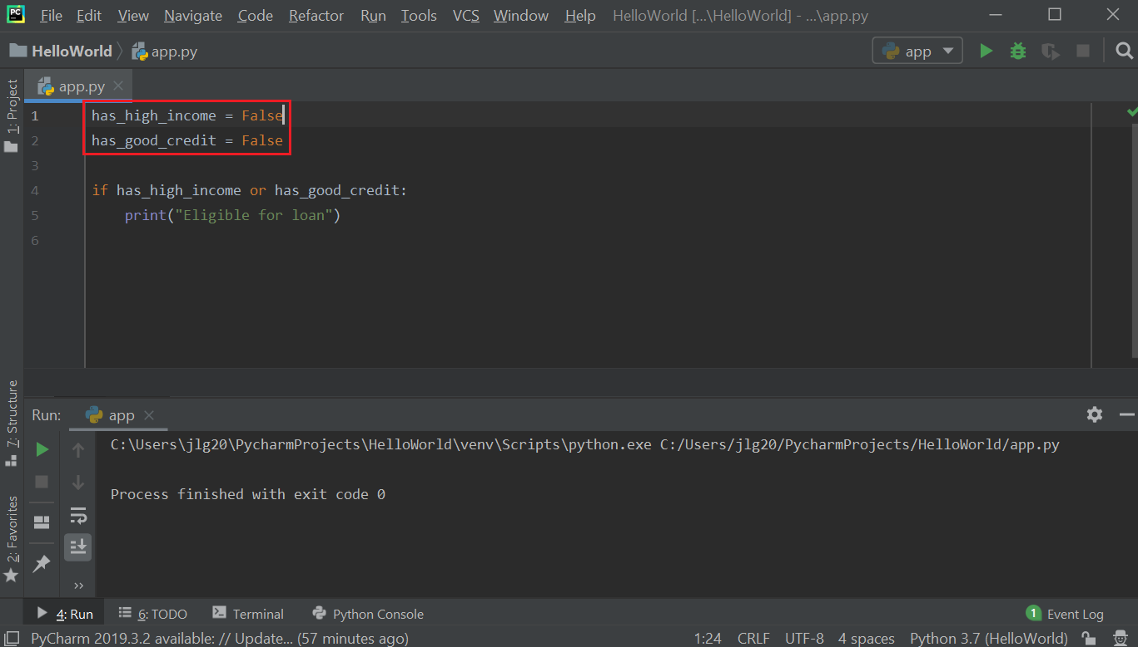

Comparing the AND and OR operators:

AND: both conditions must be true
OR: at least one condition is true

  - Other logical operators: Not: Logical NOT: inverses the Boolean value. If given a True Boolean value, then NOT converts it to False, and vice versa.
    - Example: implement the following logic:

If applicant has good credit AND doesn't have a criminal record
Eligible for loan

In the below example, the NOT operator is being used in the condition with the AND operator. The Boolean has_criminal_record is set to False, and using the NOT operator with the AND operator converts this to True and so have two TRUE conditions in this if condition (recall, for the AND operator, both conditions must be True), thus the print statement will be executed then the application is eligible for a loan.

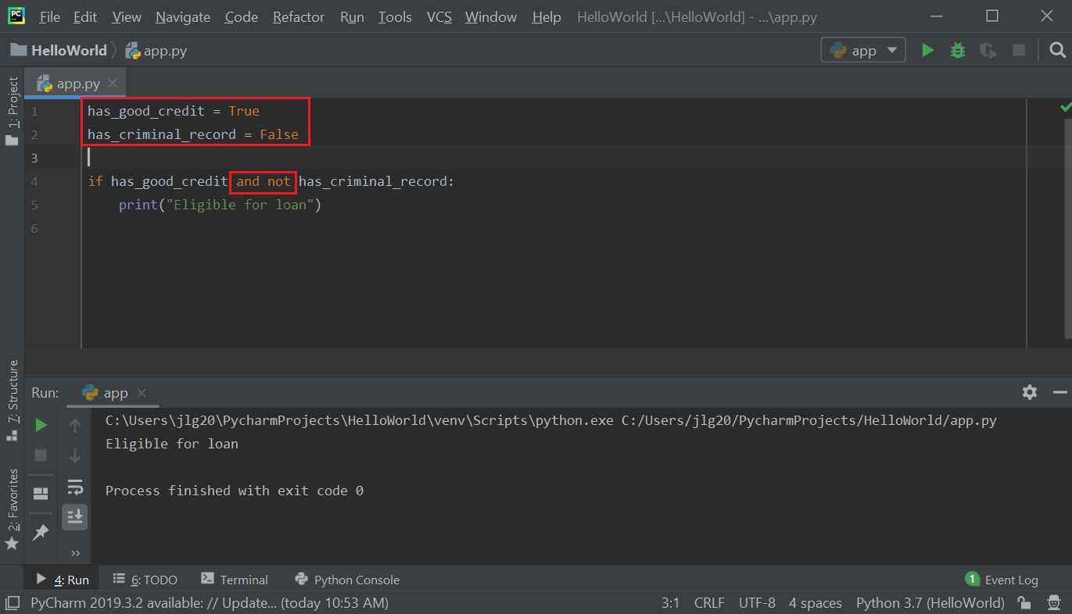

    - If we change has_criminal_record to True, and apply the NOT operator to this variable, then it is converted to False. This causes one of the if-conditions to be false and so the print statement will not be executed.

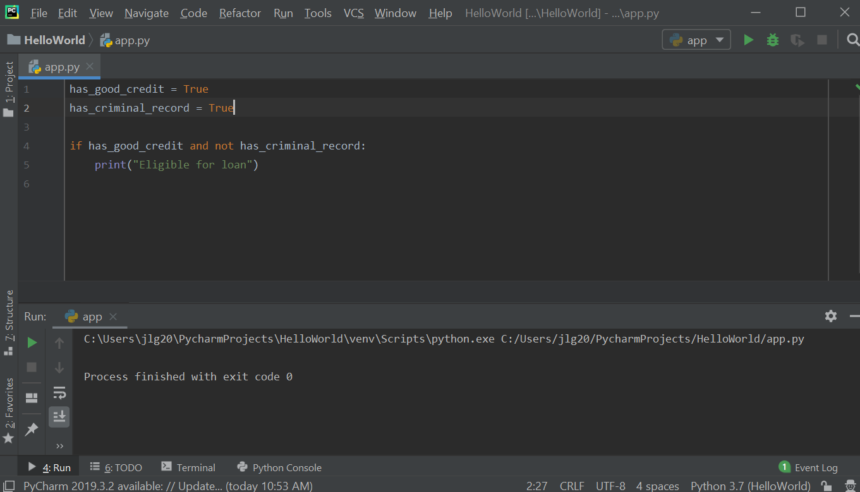

Resources
- Logical AND and OR Truth Tables: https://byjus.com/maths/truth-table/

Practice Exercises
- Implement a program that takes three integers as input and prints 'equal' if all three are equal, and 'not equal' otherwise.
- Write a program that takes two floats as input and prints True if both are strictly between 0 and 1 and False otherwise.
- Create a program, powers of two that uses two variables — one as an index that controls a while loop and the other to accumulate a computational result calculating the power of two.

