Lesson Plan
Title | Programming with Python
Time duration | 1 Hour
Review & Exercises | Review of concepts and exercises for practice

Lesson Review
- Control Statements:
- While loops: while loops are used to execute code multiple times and they are often useful in building interactive programs and games. The structure of a while loop is "while condition:" and if the condition is true, the statements in the block will continue to execute.
    - Below is a basic while loop. The variable 'i' is initialized to 1. The while condition tests whether the 'i' variable is less than 5, and if so, print the current value for 'i'. In this while-loop block of code, 'i' is being incremented. This prevents infinite loops. Each time 'i' is incremented but less than 5 the print 'i' statement will be executed. Once 'i' reaches 5 the while-loop block breaks and the last print statement (prints "Done") gets executed.

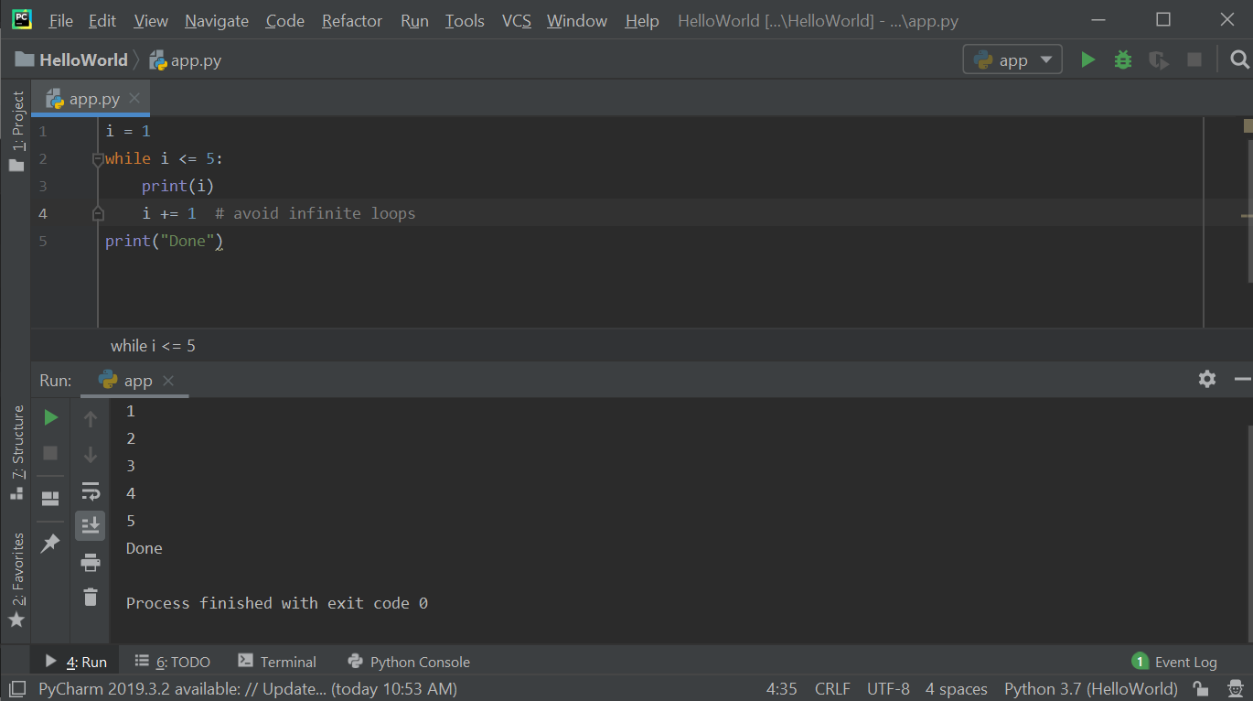

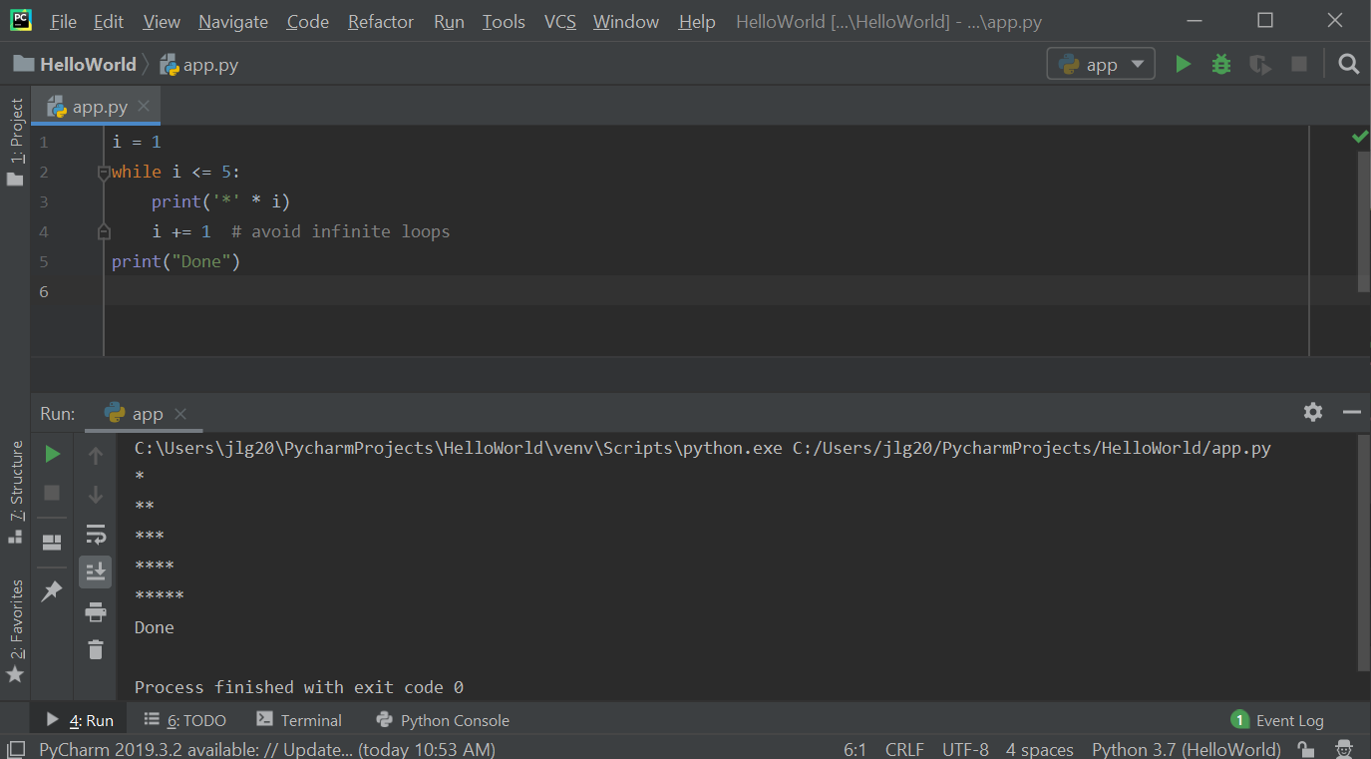

    - Example (using else statements with while loops): implement a guessing game by using a while loop to allow users to guess a number. In the below code sample, the user has up to three chances to guess the secret number. If they guess the secret number, then they won, and the program terminates. If they don't guess the secret number after three tries, then they lose, and the program terminates. Like if statements, while loops can also have else parts. So, at the level of the while loop, add an else block and the code written in this else-block will get executed if this while loop completes successfully without an immediately break. In other words, if the user guesses the right number, you break out of the loop (jump out of it) so the code in the else block will not get executed. But if the user cannot guess the secret number, they are never going to break out of the loop, and so the while loop will be executed to completion until the while-loop condition becomes false. In that case, the code written in the else block will get executed. This is the condition that the user made three guesses and lost.

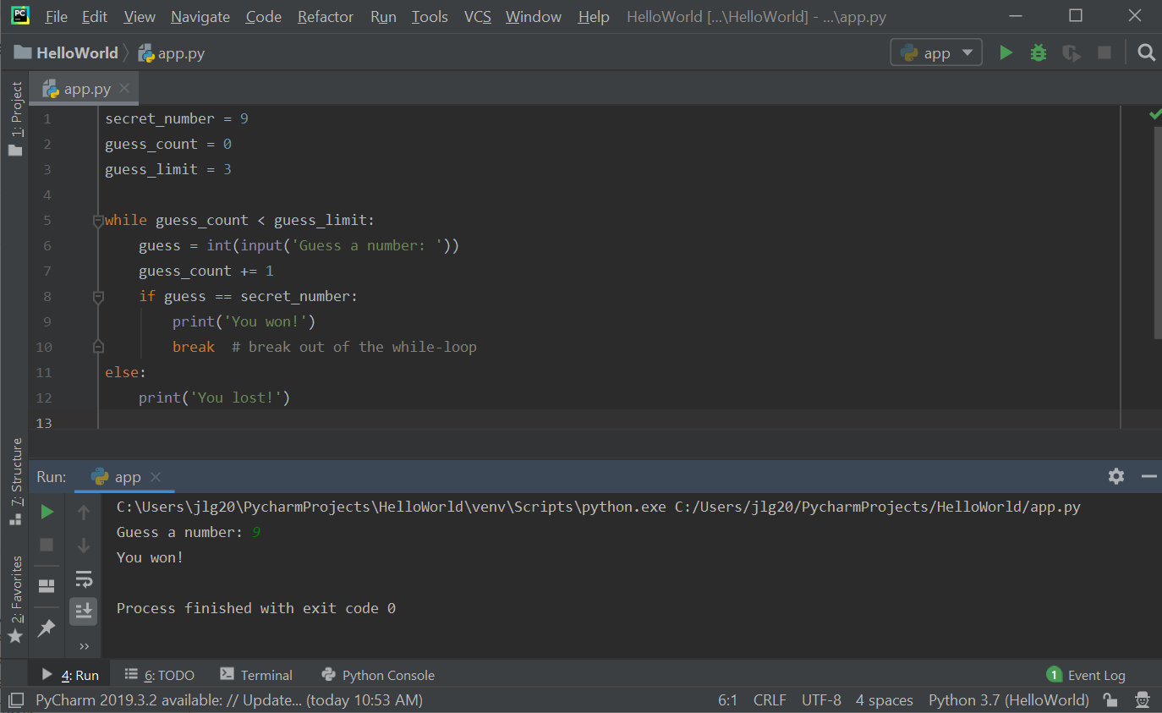

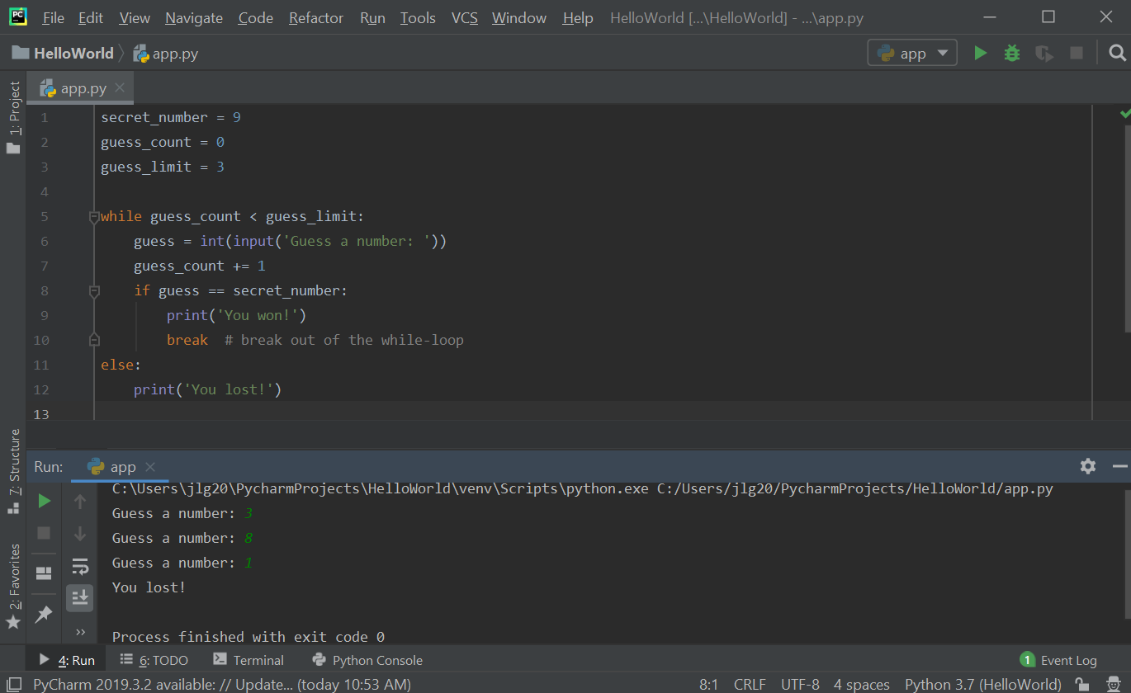

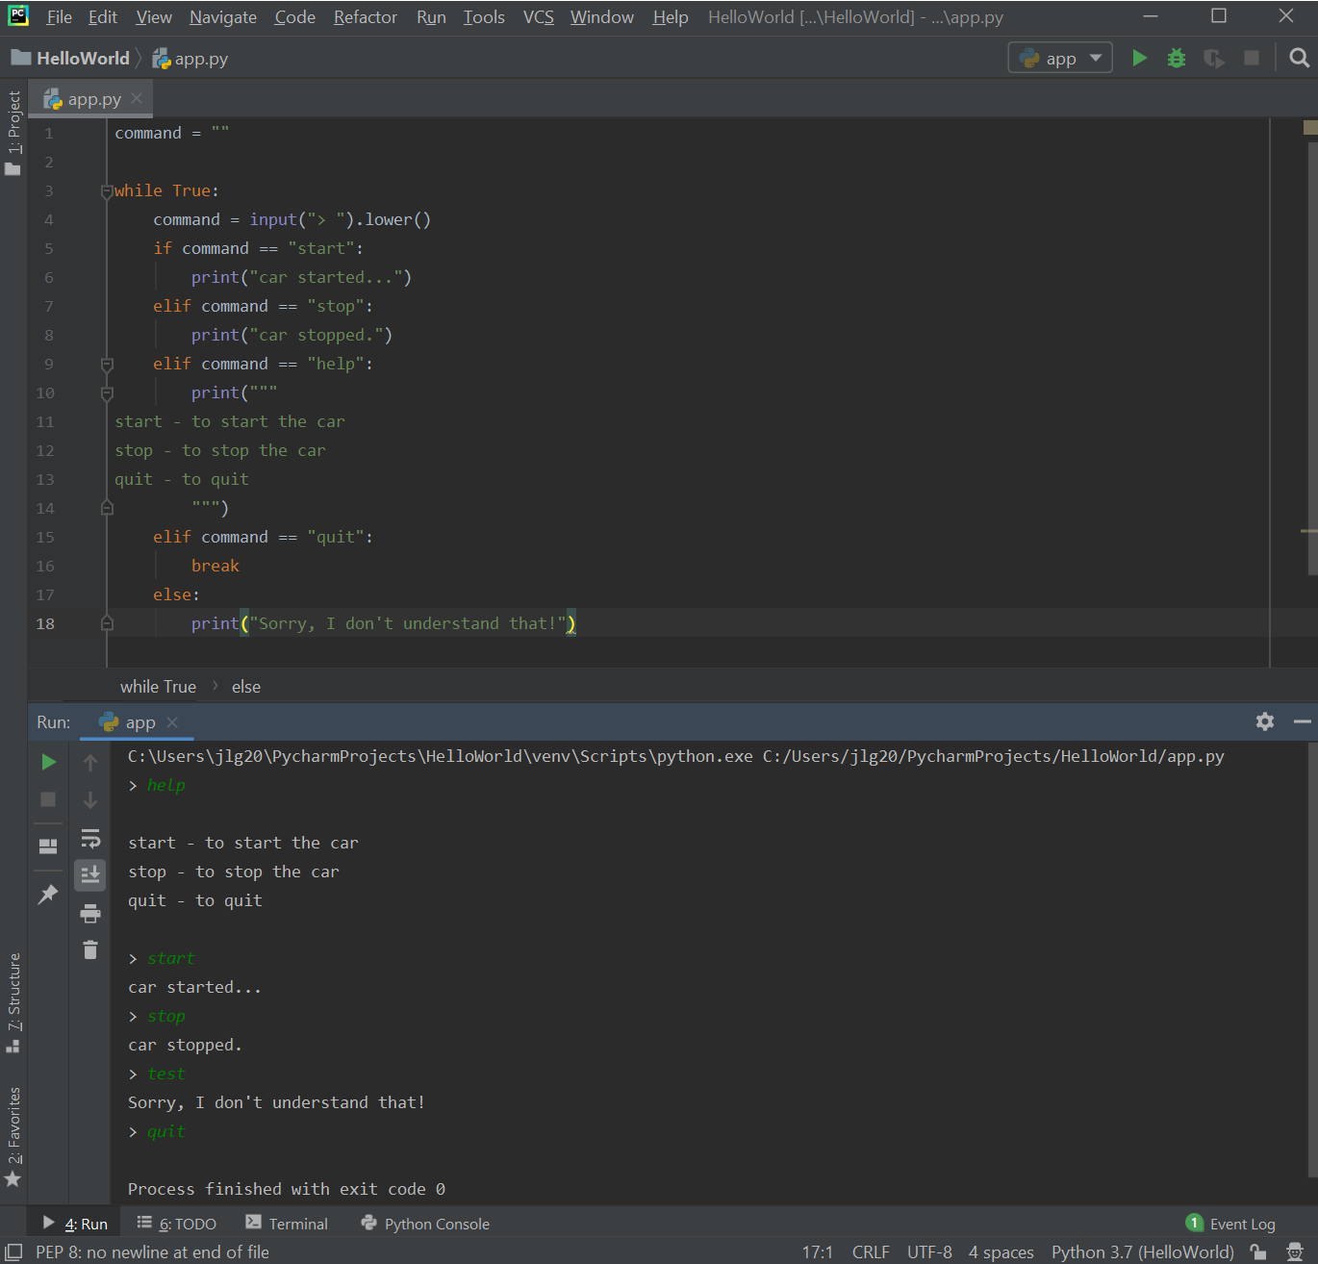
    - Car game: this program waits for the user to type a command. If the user types the "help" command (not case-sensitive) then the list of commands the program supports are printed to the console.

    - Challenge: take the above program to the next level. If a user types the "start" command the first time the message should be "car started…" but if the user types the "start" command a second time (without typing the "stop" command, then the message should say "the car is already started". The same for the "stop" command - if typed a second time without typing the "start" command then the message should say "the car is already stopped".
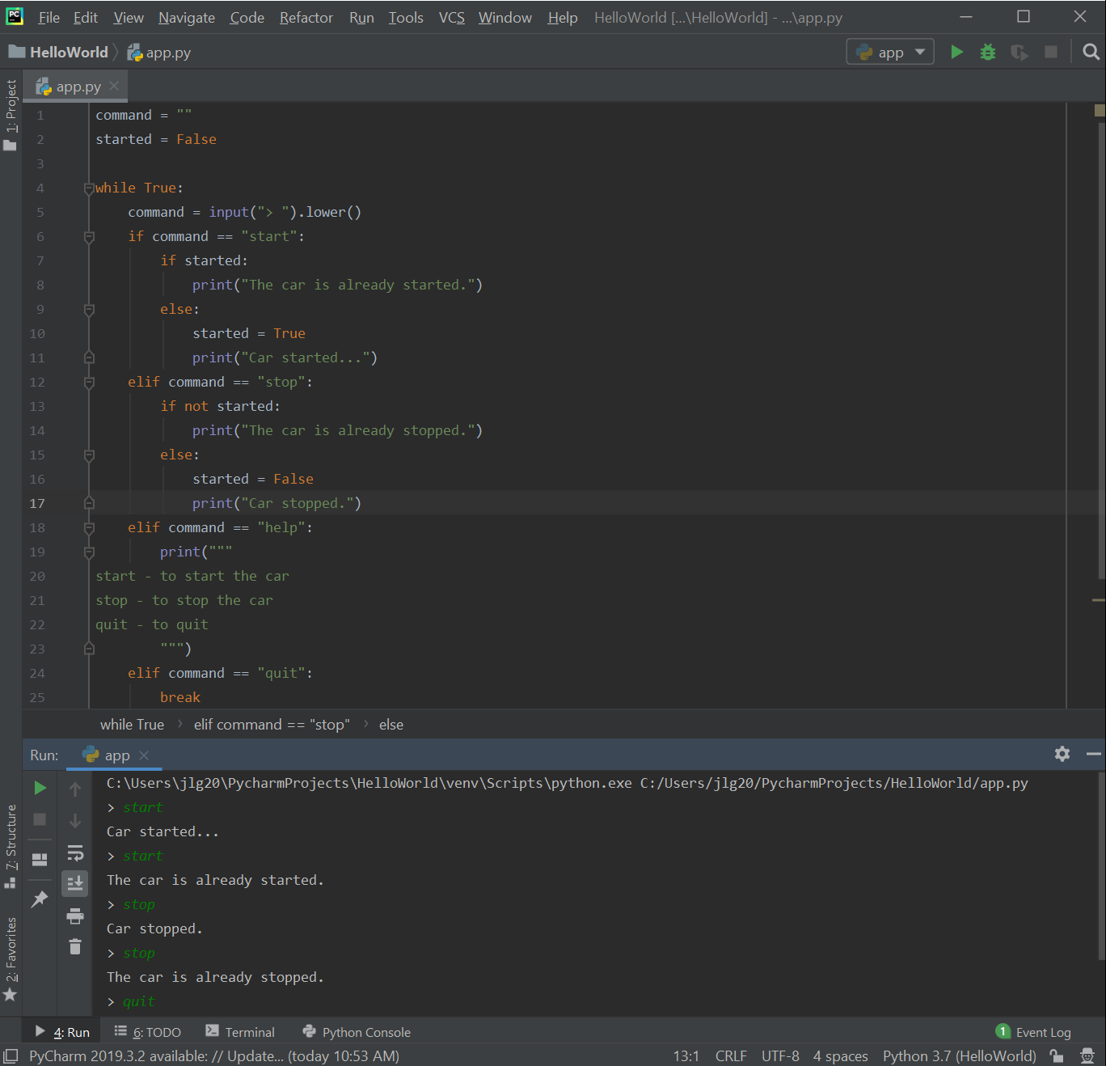

- For loops: while loops execute a block of code multiple times. Another kind of loop is the for loop used to iterate over a collection. For example, we can use a for loop to iterate over each character of a string (a string is a collection of characters) and do something with it.

  - Example: in the below sample code, the for loop iterates over the string "Python" and each "item" holds one character of the string. In the first iteration, item will be set to 'P' and in the second iteration, item will be set to 'y' and so on.

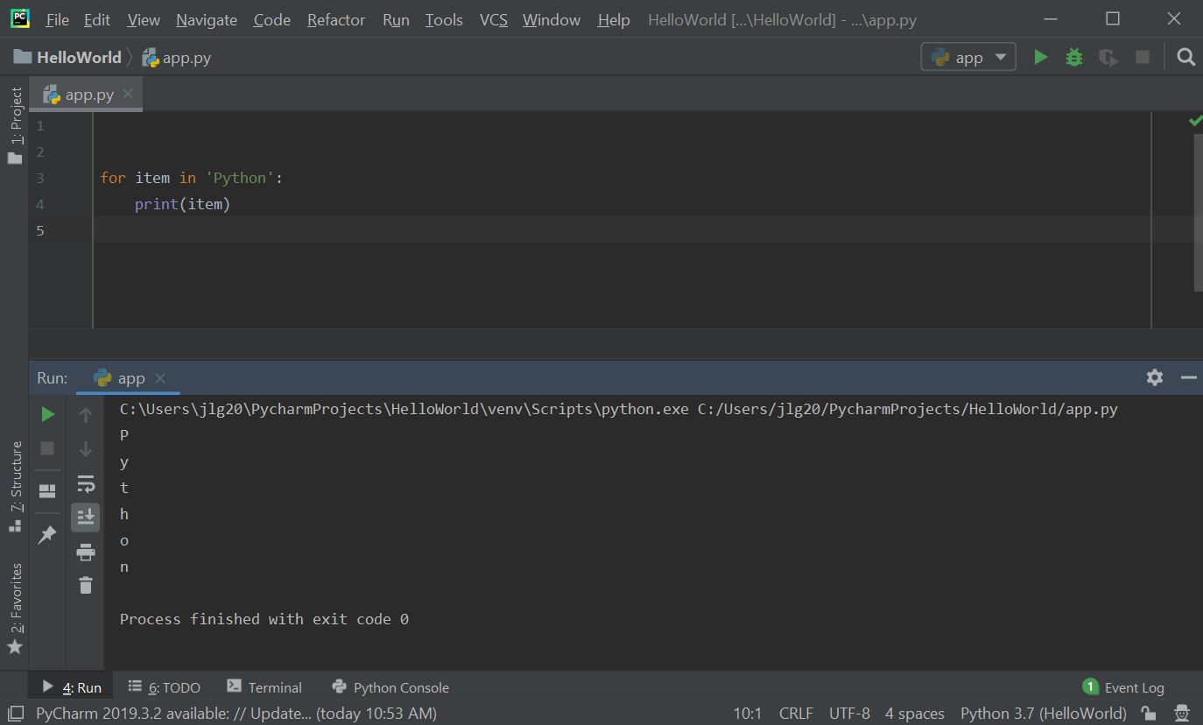

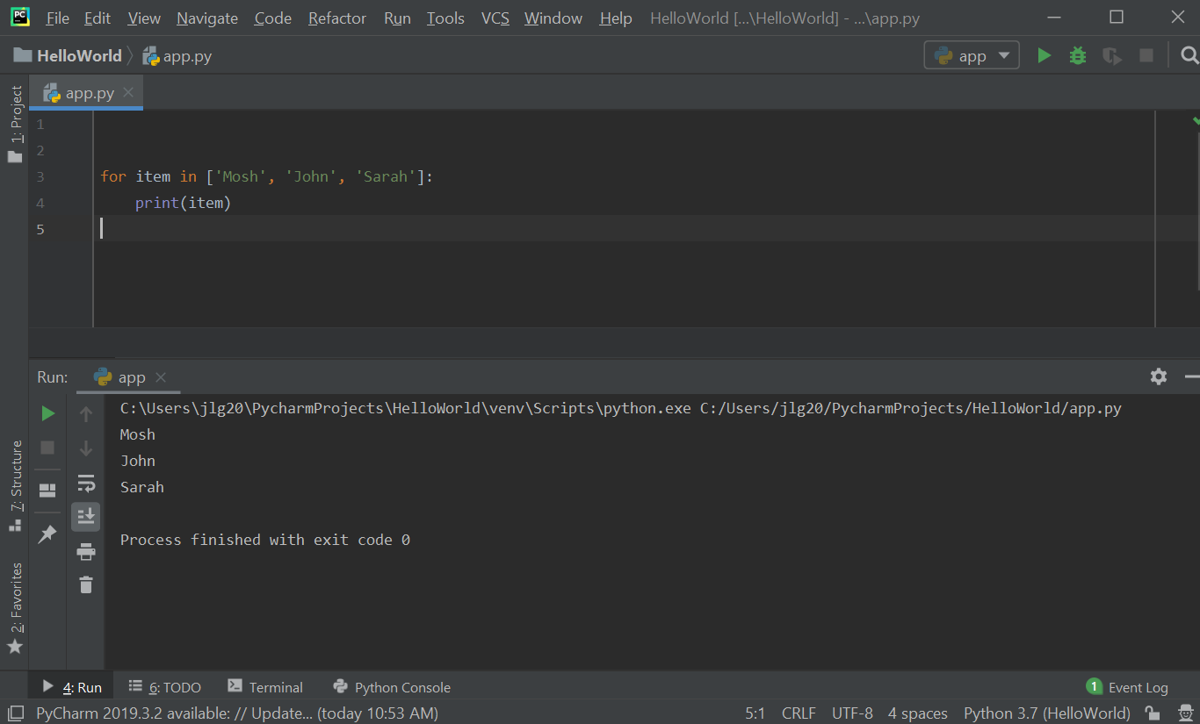

  - Example: using range functions - using the range() function allows for a range of integers without hard-coding a large list of numbers. The range() function creates a special kind of object (it is not a list) that you can iterate over. With the range() function, you can specify the range lower and upper limits, and can also include the step that allows a certain number of steps to be skipped.

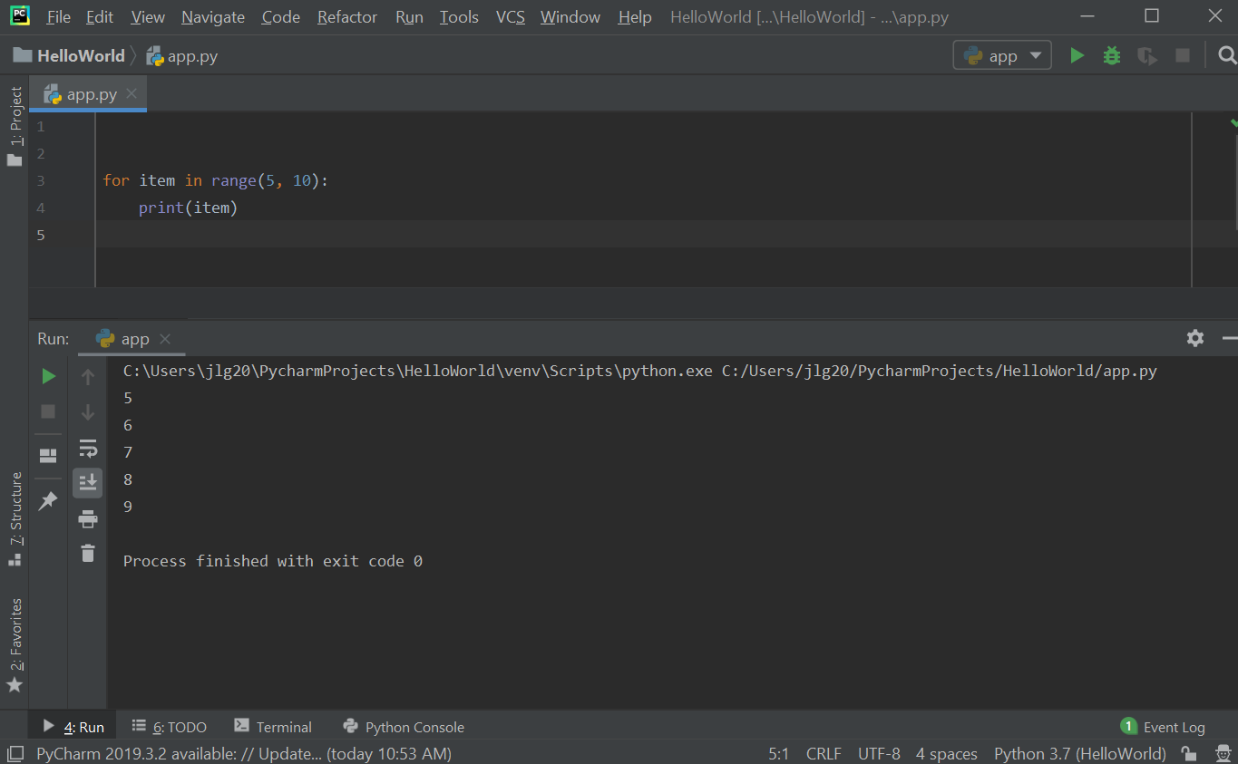

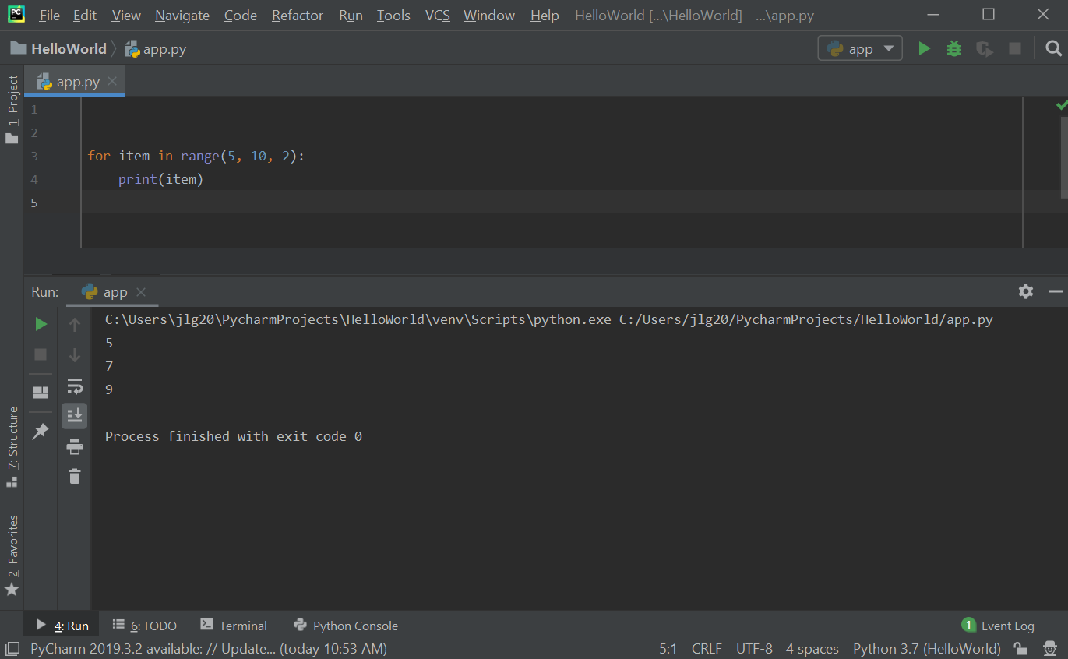

Note: the else clause can be used with both for loops and while loops. In an example above we saw an else clause used with a while loop. When used with a while loop, the else clause will be executed when the condition in the while loop becomes false. In the case of a for loop, the else clause will be executed when the loop terminates through exhaustion of the iterable.
  - Challenge: write a program that takes an integer, n, as input. Calculate the square of even number starting from zero less than and equal to n. Print the result if the square of that number is even.

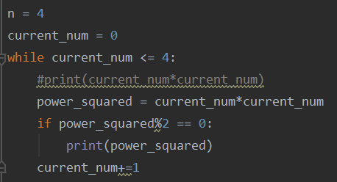

  - Nested Loops: in the first iteration of the outer loop, x is 0, and then in the inner loop, in the first iteration, y is 0 and so print 0,0 on the console. In the second iteration y is 1 but we are still in the first iteration of the outer loop and so x is still 0 but y is incremented to 1 - this is why see 0 for x and 1 for y. The control again goes back to the inner loop and will continue until the inner loop completes - when y = 2 (range() function generates 0, 1, and 2). After this inner loop completes, then the control will go back to the outer loop - at this point will be in the second iteration of the outer loop. This will set x to 1. It will then move to the inner loop and this inner loop will be executed three times with x = 1 and y = 0,1,2. It will go back to the outer loop again. This will continue until the outer loop completes when x = 3.

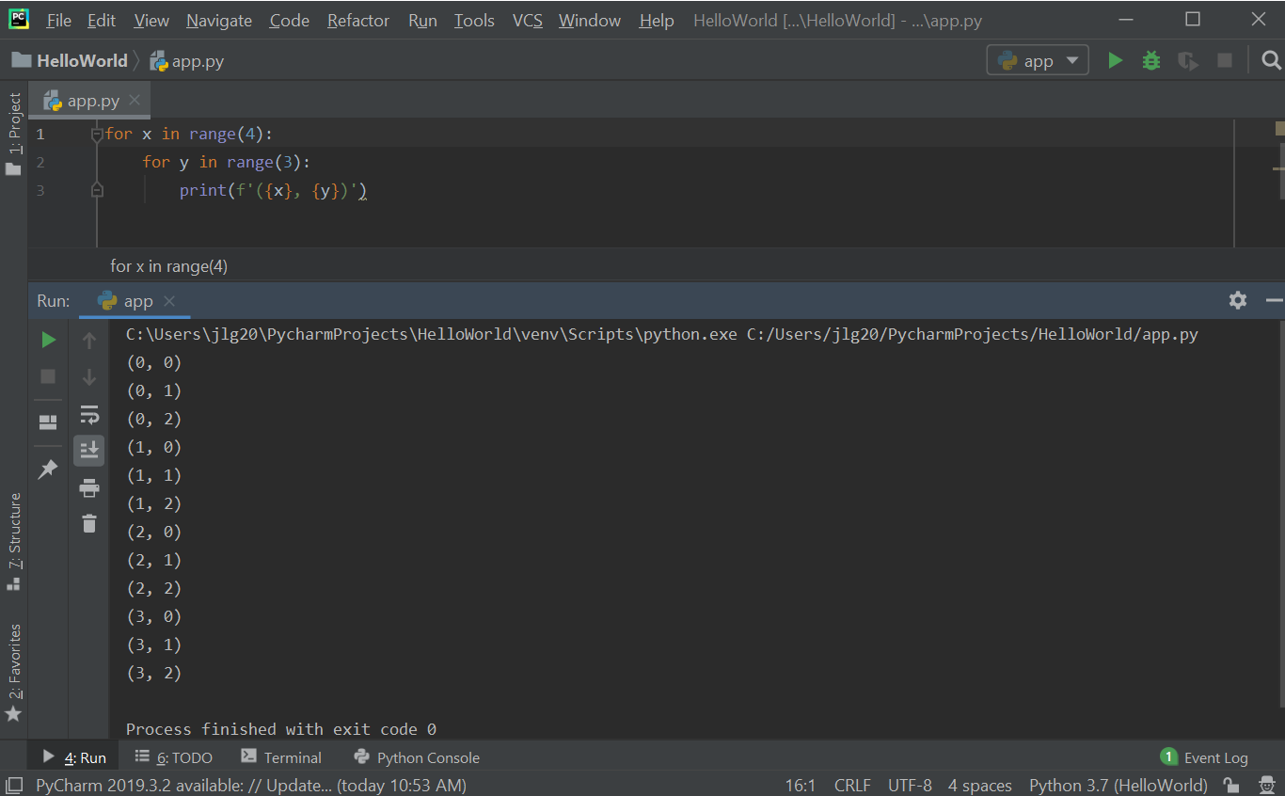

  - Challenge: generate the following "F" printout. Hint: use the following array: numbers = [5,2,5,2,2]:

*****
**
*****
**
**

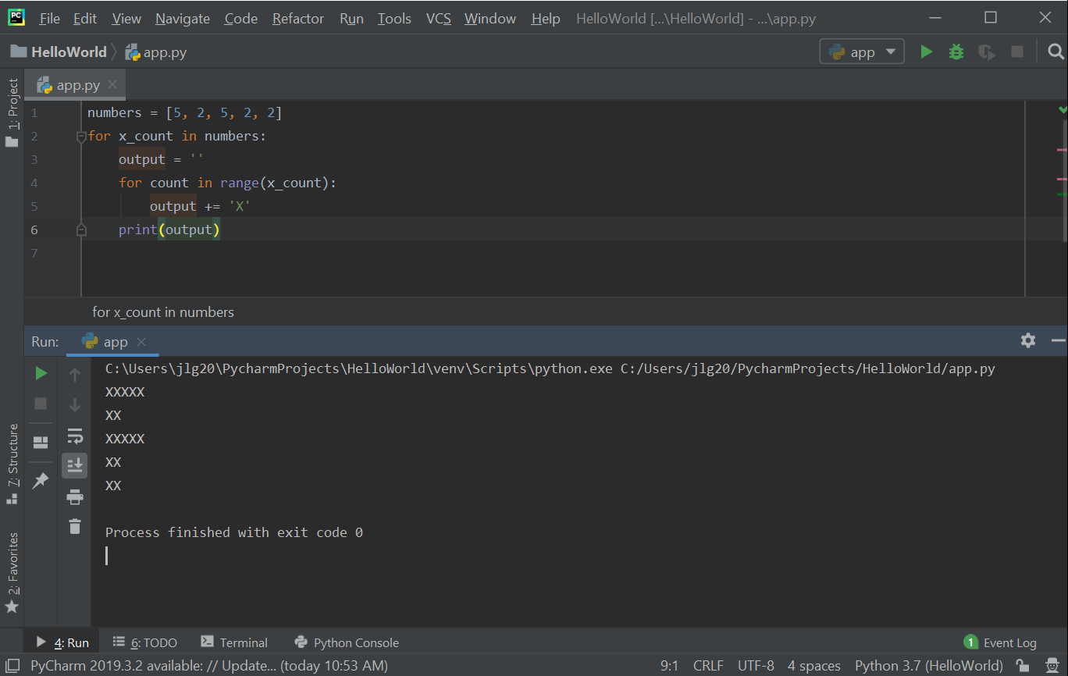

- Break and Continue Statements
  - Break statements: the break statement is used to break out of the innermost closing for or while loop. Below is a sample program that makes use of the break statement to break out of a for loop when a prime number is encountered.

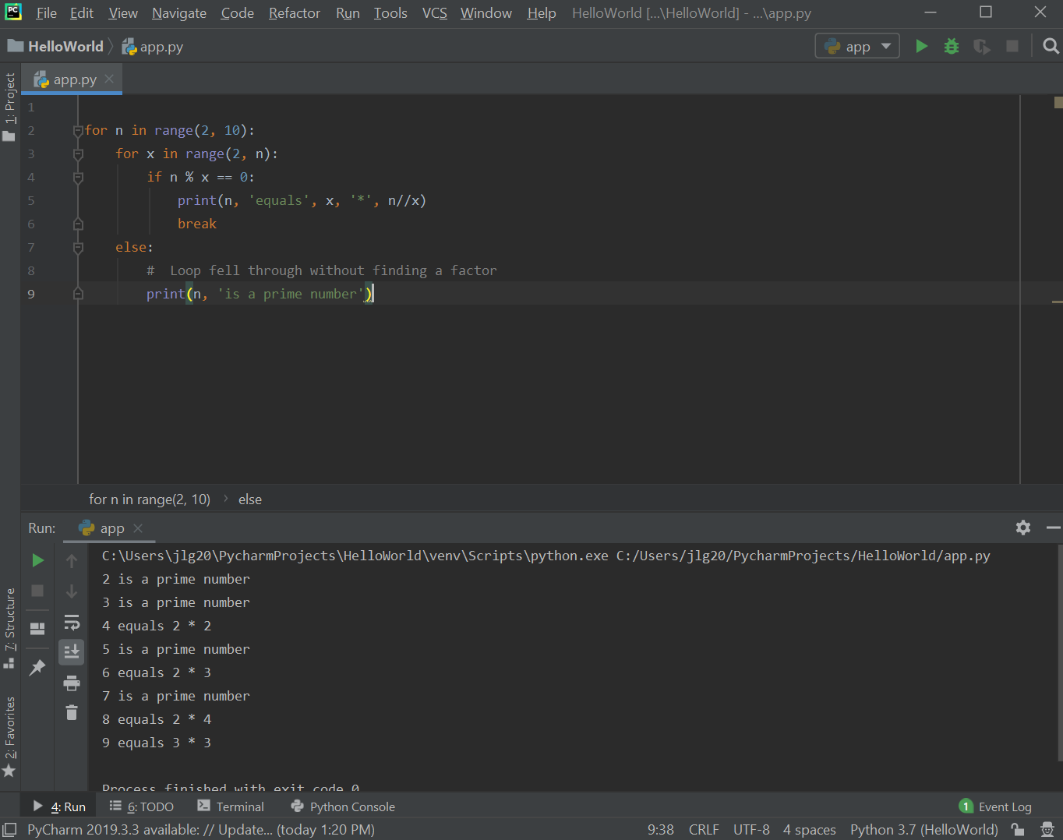

  - Continue statements: the continue statement continues with the next iteration of the loop. In the sample code below, the continue statement is used to continue onto the next iteration of the loop when it encounters an even number.

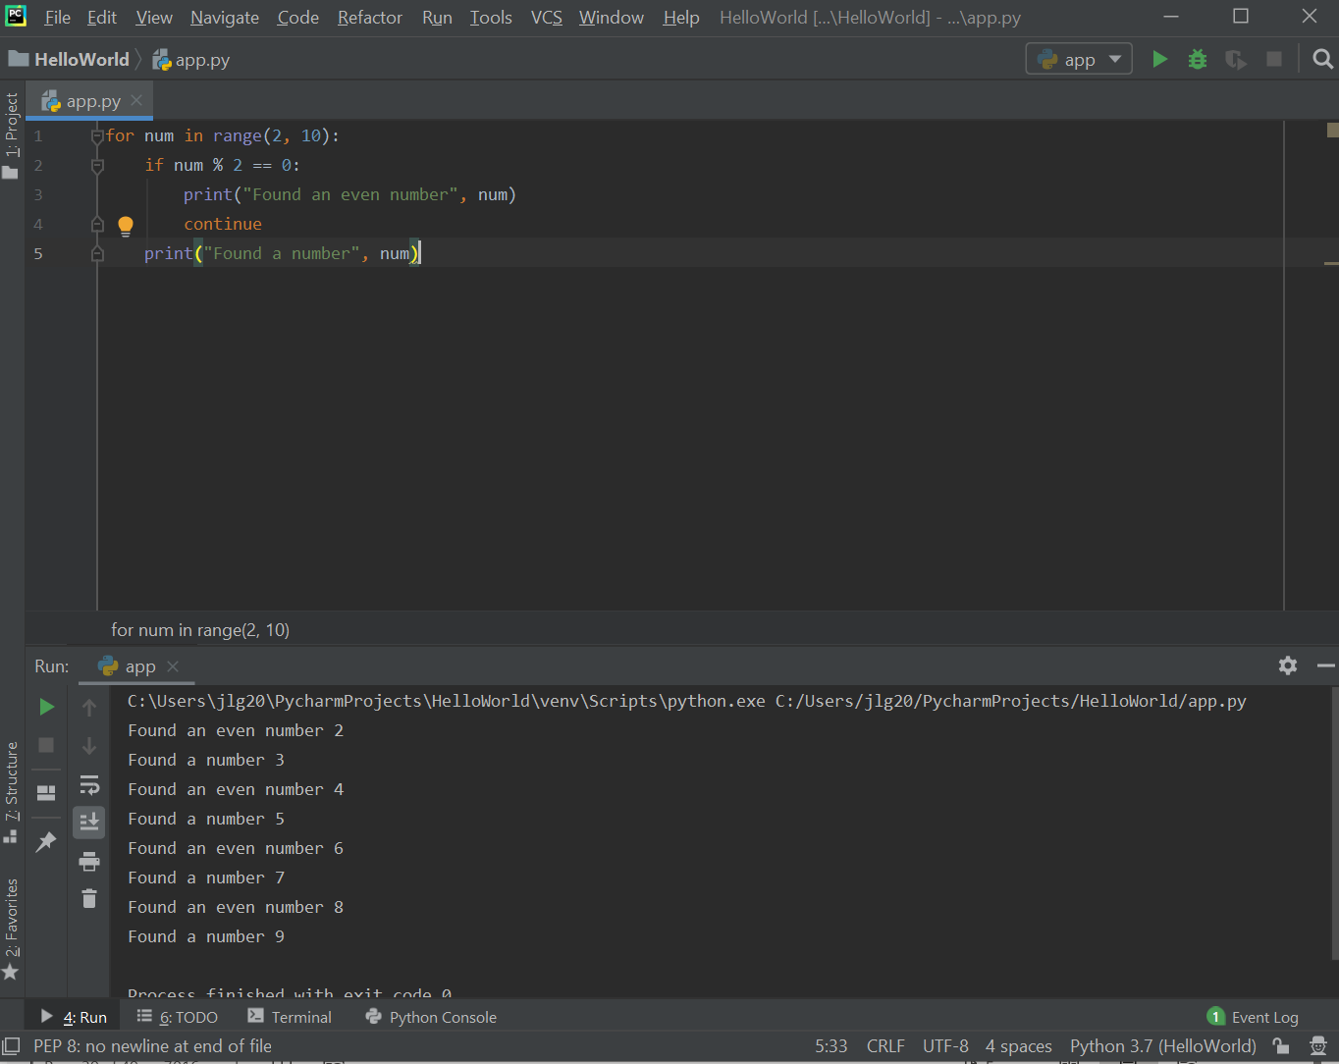

Resources
- Logical AND and OR Truth Tables: https://byjus.com/maths/truth-table/
- Python built-in operations: https://docs.python.org/3/library/stdtypes.html?highlight=integer
- Python math module: https://docs.python.org/3/library/math.html

Practice Exercises
- Write a program that uses one for loop and one if statement to print integers from 1000 (inclusive) to 2000 (exclusive) with five integers per line. Hint: use the % operator.
- Write a program that prints a table of the values of log n, n, n log n, n², and n³ for n = 2, 4, 8, 16, 32, 64, 128. Hint: use the math module.

