Lesson Plan
Title | Programming with Python
Time duration | 1 Hour
Review & Exercises | Review of concepts and exercises for practice

Lesson Review
- Data structures:
  - Lists
  - Lists: when print a subset of the list this does not overwrite the original list. Instead it creates a new list that gets printed.

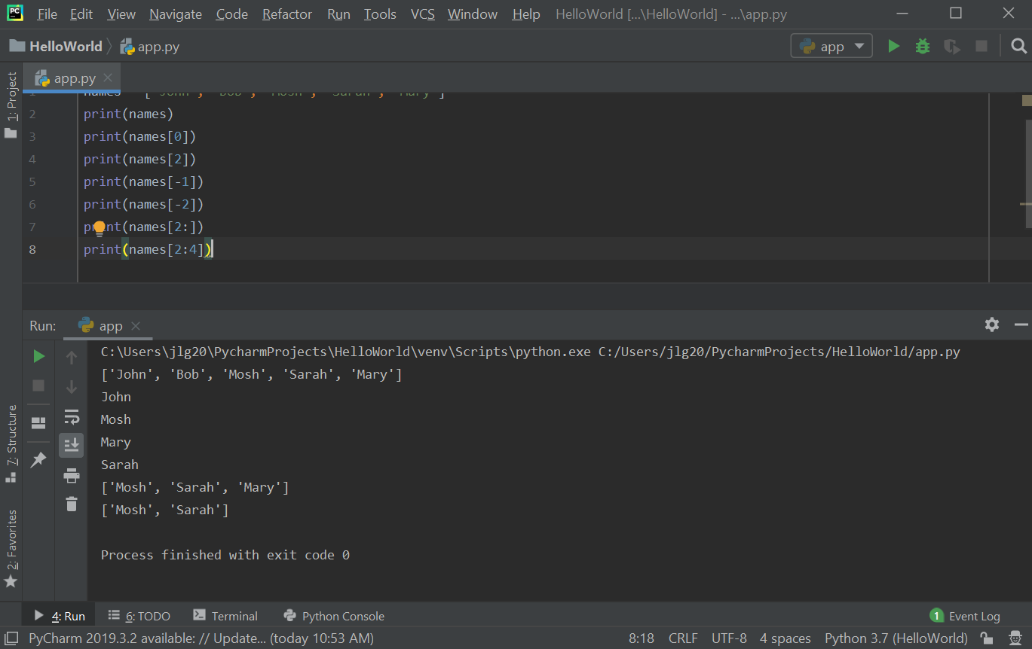

Values in the list can be modified using the index for that value.

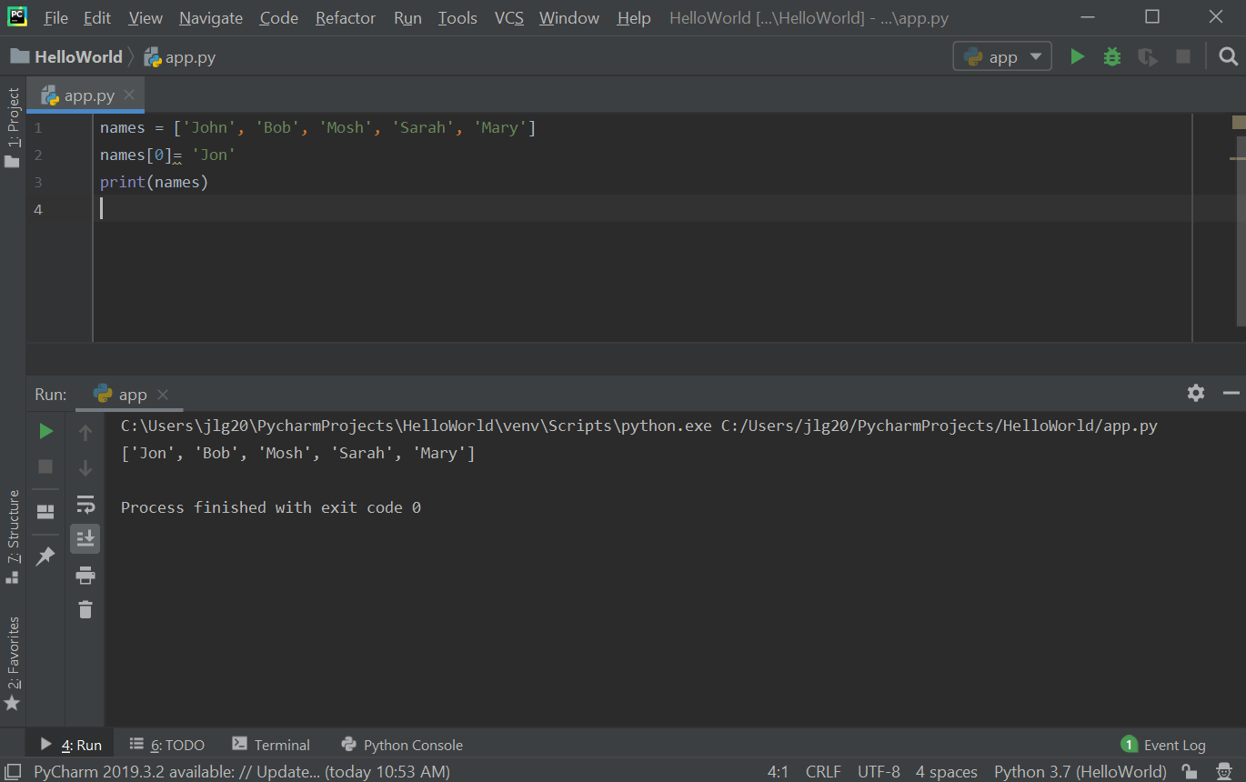

Exercise: write a program to find the largest number in a list.
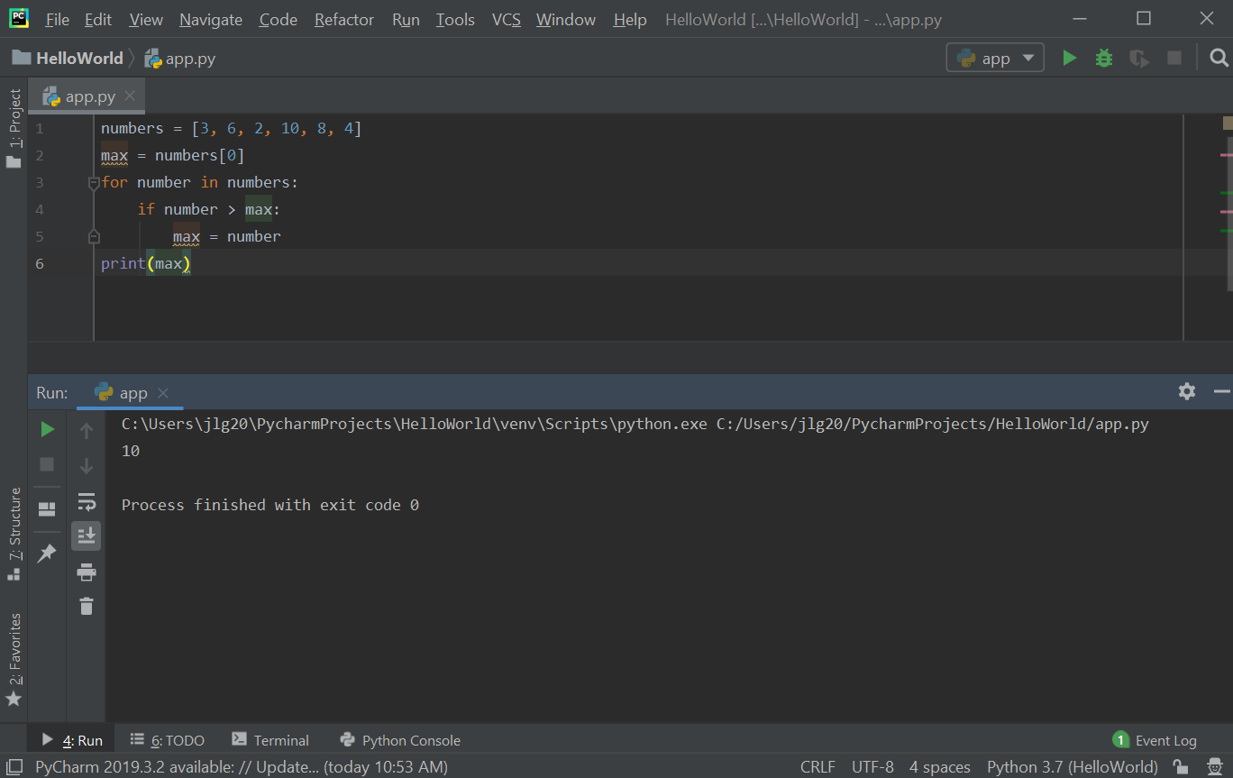

  - 2D Lists: 2D Lists: 2D lists have a lot of application in data science and machine learning. A 3-dimensional matrix (mathematics) can be represented in Python with a 2D list. 2D lists are where each item in that list is in another list. To access items in a 2D list, there is an outer list and then an inner list. The first [] refer to the outer list index and then the second [] refer to the inner list index. Nested loops can be used to iterate all the items in a 2D list.

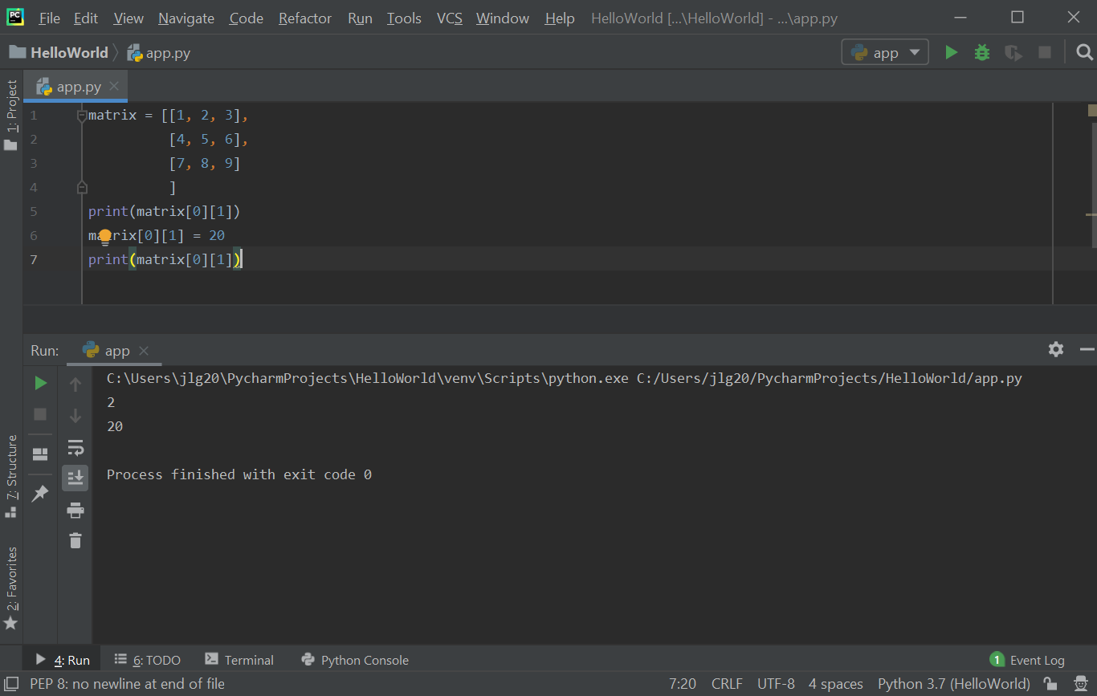

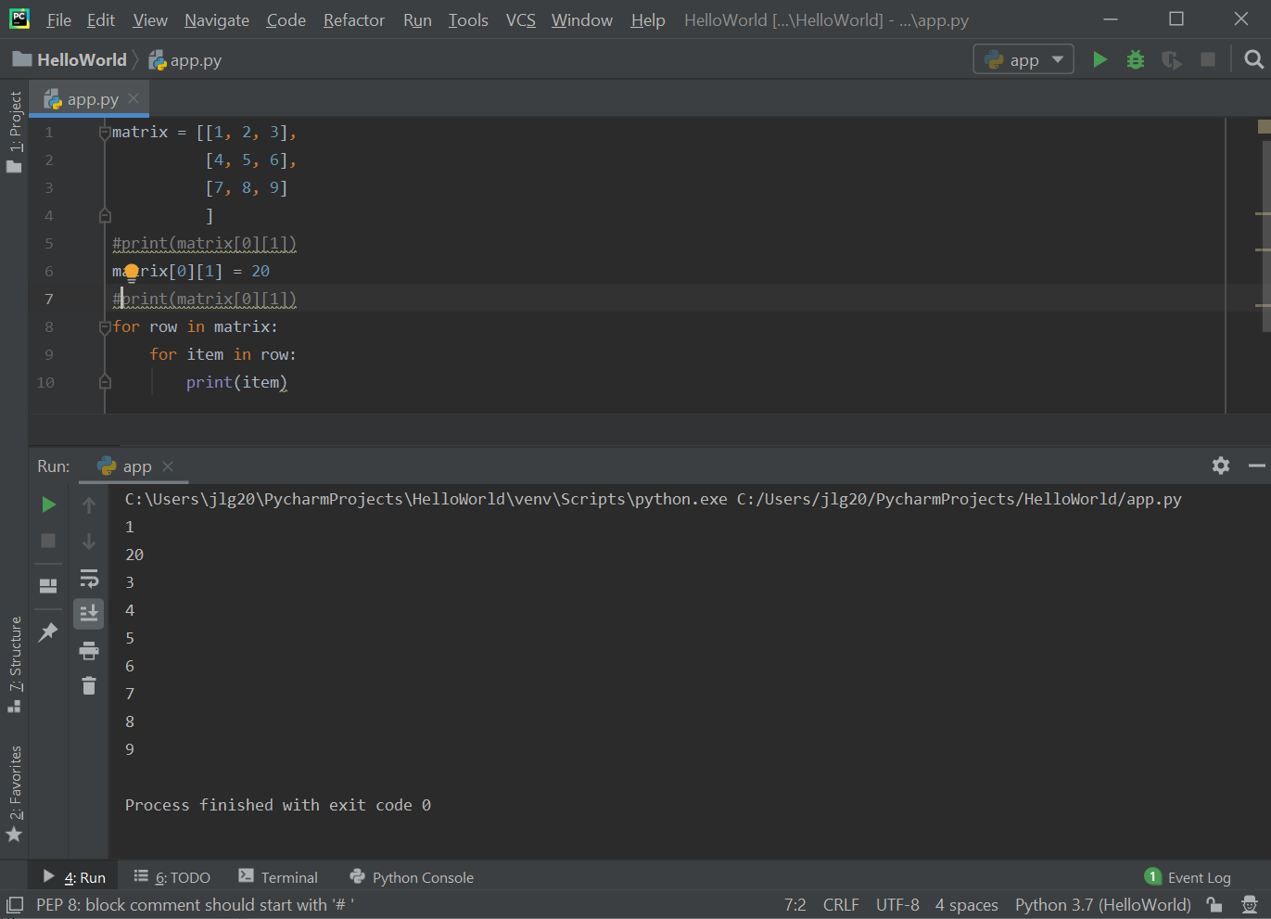

Practice Exercises
- Write a program that iterates through a 1-Dimensional array of integers and makes a copy of the array of elements 2 times the elements of the original array.
- Write a program that adds the elements of two 2-Dimensional arrays and puts the results in a third 2-Dimensional array (HINT: all of the arrays have to be the same length).

