- Docker build:
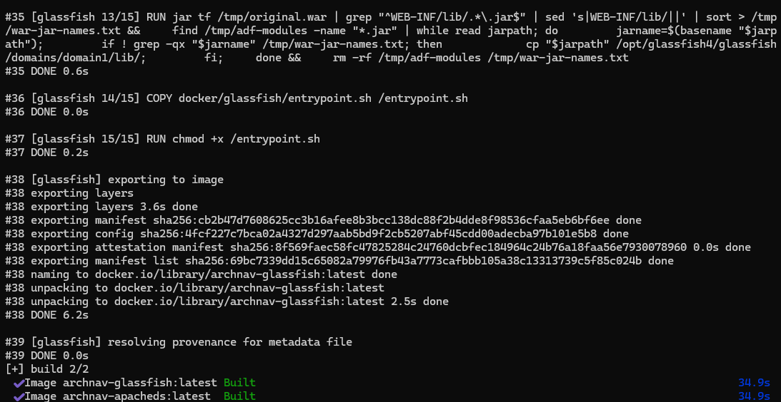

- Pack:
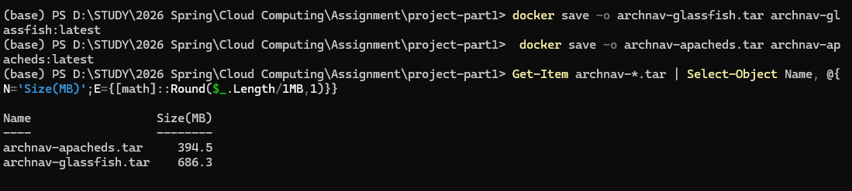

- AWS security group:
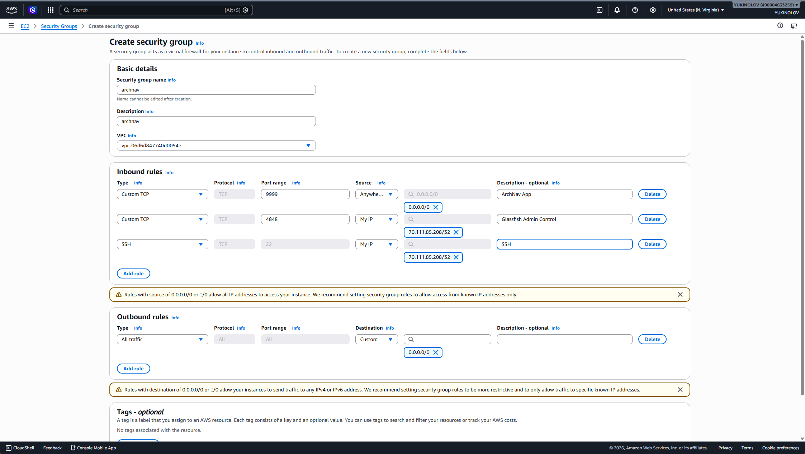
- EC2:
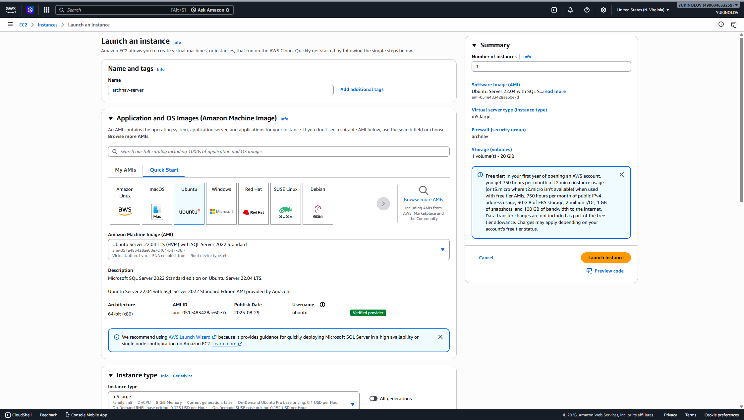
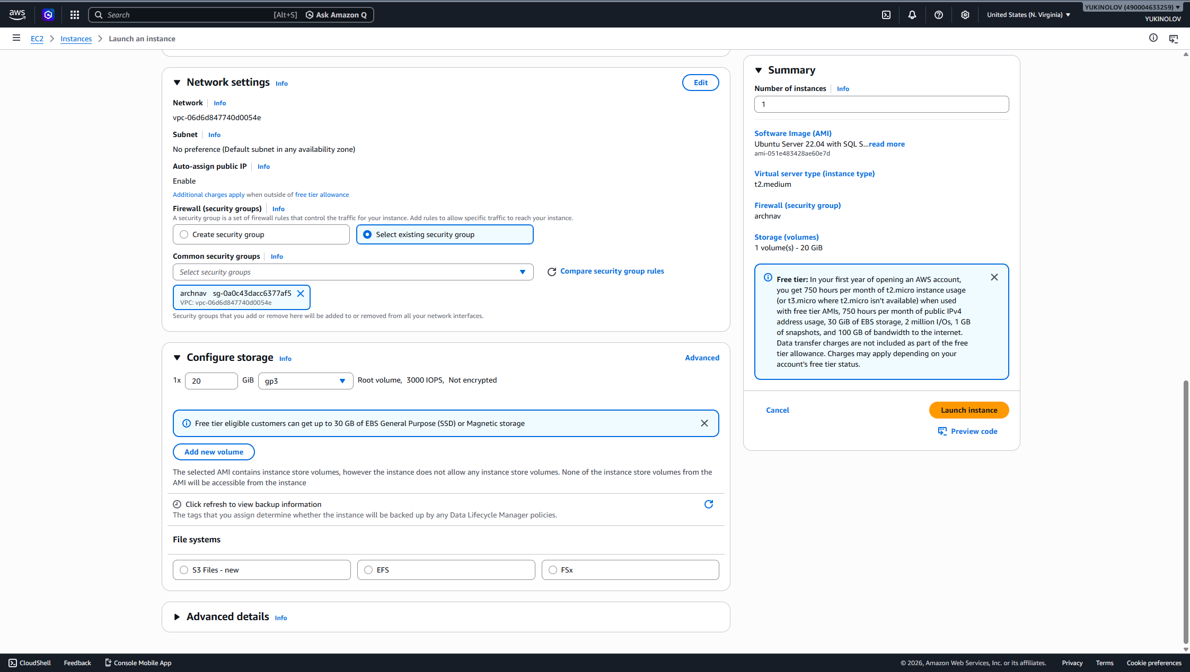

- Connect to EC2:
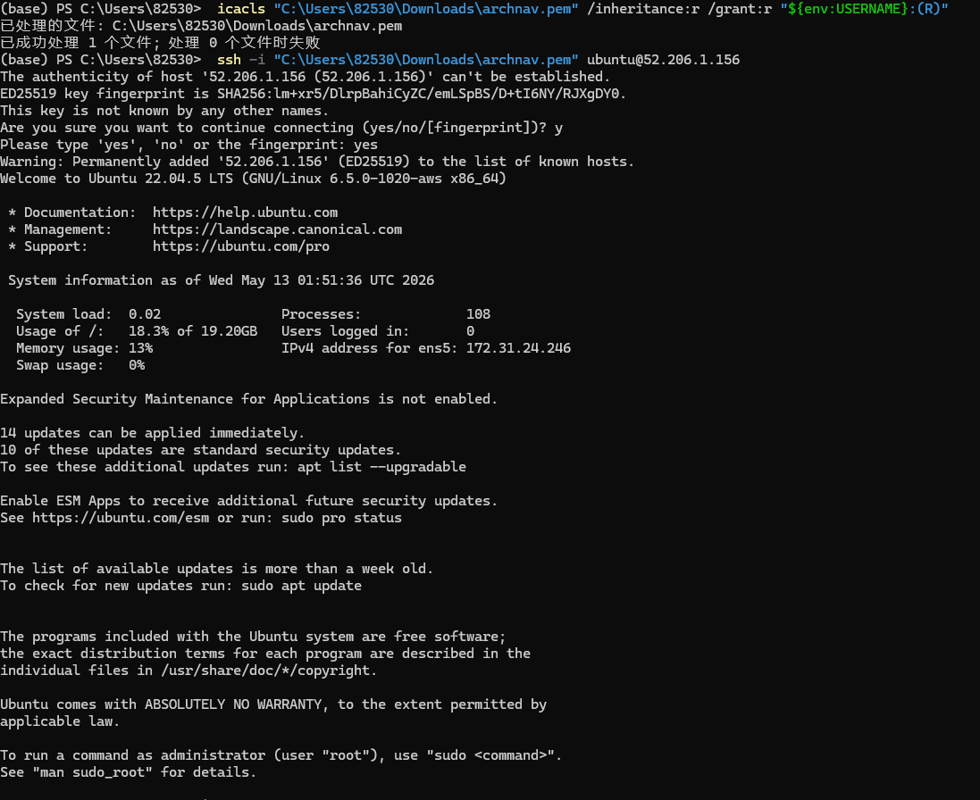

- Install docker:
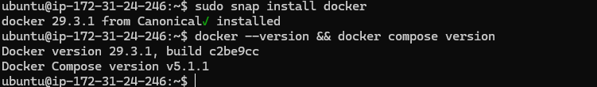

- Upload files:
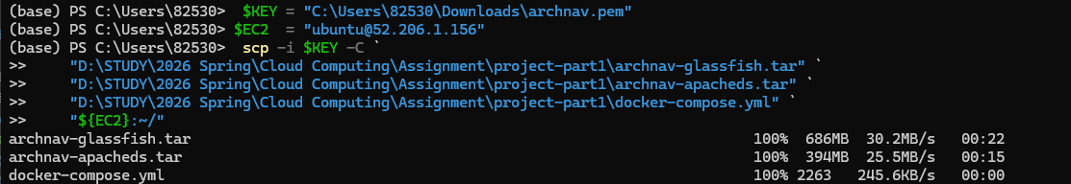
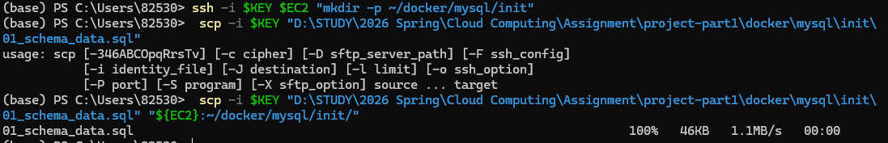
- Load image:
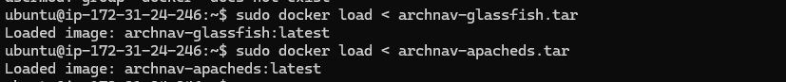
- Docker compose:
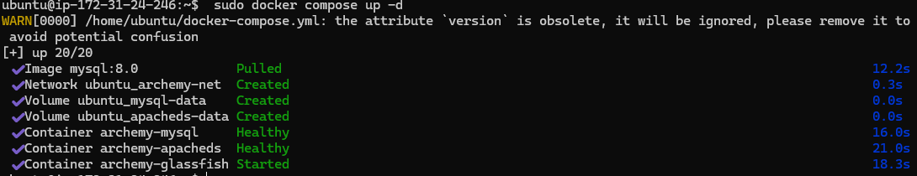

- Access service:
http://52.206.1.156:9999/archemy/faces/login.jspx
admin/password
OR
user1/password

https://52.206.1.156:4848
admin/admin123

