TV Spending Impact on Site Visits

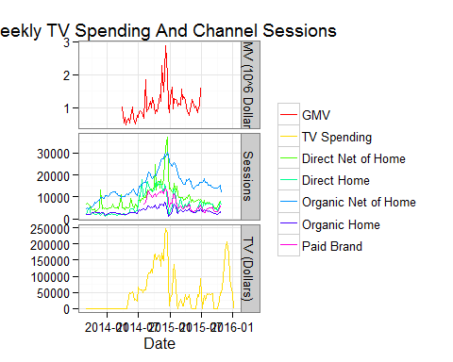

The graph below illustrates the residual effects of money spent on TV advertising on other variables. The points at lag 0 represent the direct correlation. The points at lag 1 represent represent the correlation of TV spending and the compared variable one week later and so on. At the weekly level we can see that the greatest relationship occurs with no lag element

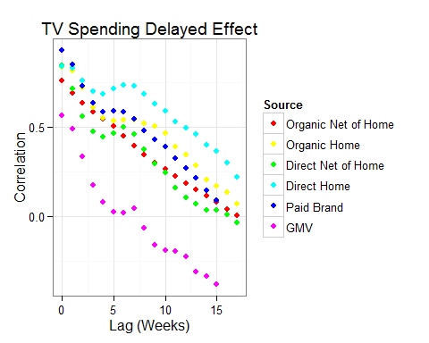

## Organic Net Of Home Channel

### Trend Decomposition

The graph below decomposes the time series into 3 parts. The first sub-graph is a simple plot of observed behavior over time. The second sub-graph is the seasonal factor. This data spans two years. We considered each year to be one season, as such the seasonal plot repeats itself once. The third sub-graph shows the larger smoothed trend of the entire span of data. The fourth sub-graph shows the residual values of the trend line and seasonal element, that is, how far from the true values the trend line and seasonal element is at each point in time. We can see that the residuals are not unrelated to time. This is diagnostic of trend behavior that can be accounted for using a time-series model. 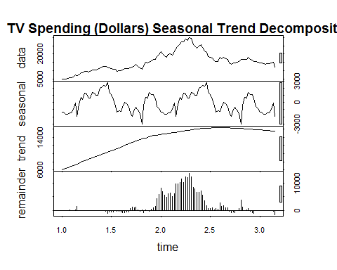

### ARIMAX model with TV spend

The graph below shows the general effect on TV spending on site visits by this channel. In this case the model is a combination of 1 lagged variables. This representation of the model can be thought of as the expected gain in site visits dissipated over 2 weeks per dollar spent on TV advertising dissipated over 2 weeks.

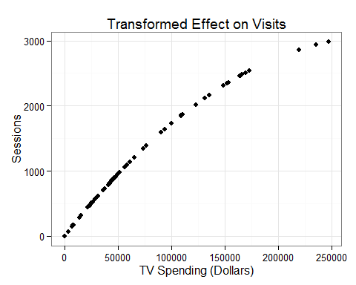

### Forecasts

The graph below shows the model fit and prediction intervals. It is important to note that predicition intervals, unlike confidence intervals, expand over time. This means that any forecast model should only be relied upon for short forecast periods.

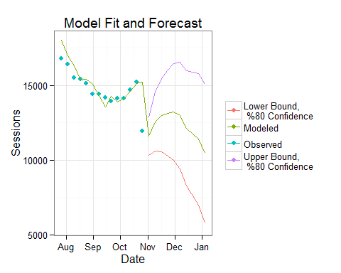

## Organic Home Channel

### Trend Decomposition

The graph below decomposes the time series into 3 parts. The first sub-graph is a simple plot of observed behavior over time. The second sub-graph is the seasonal factor. This data spans two years. We considered each year to be one season, as such the seasonal plot repeats itself once. The third sub-graph shows the larger smoothed trend of the entire span of data. The fourth sub-graph shows the residual values of the trend line and seasonal element, that is, how far from the true values the trend line and seasonal element is at each point in time. We can see that the residuals are not unrelated to time. This is diagnostic of trend behavior that can be accounted for using a time-series model.

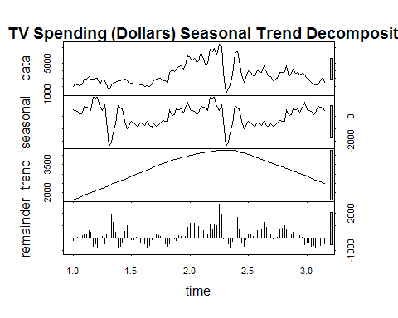

### ARIMAX model with TV spend

The graph below shows the general effect on TV spending on site visits by this channel. In this case the model is a combination of 3 lagged variables. This representation of the model can be thought of as the expected gain in site visits dissipated over 4 weeks per dollar spent on TV advertising dissipated over 4 weeks.

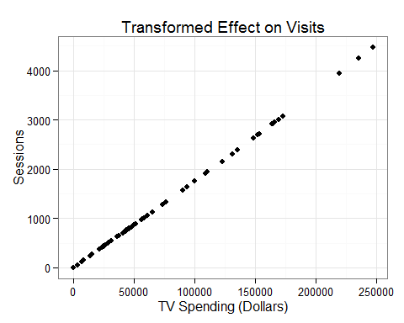

### Forecasts

The graph below shows the model fit and prediction intervals. It is important to note that predicition intervals, unlike confidence intervals, expand over time. This means that any forecast model should only be relied upon for short forecast periods.

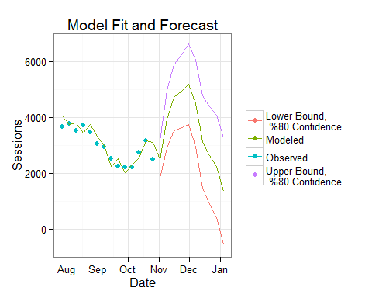

## Direct Net of Home Channel

### Trend Decomposition

The graph below decomposes the time series into 3 parts. The first sub-graph is a simple plot of observed behavior over time. The second sub-graph is the seasonal factor. This data spans two years. We considered each year to be one season, as such the seasonal plot repeats itself once. The third sub-graph shows the larger smoothed trend of the entire span of data. The fourth sub-graph shows the residual values of the trend line and seasonal element, that is, how far from the true values the trend line and seasonal element is at each point in time. We can see that the residuals are not unrelated to time. This is diagnostic of trend behavior that can be accounted for using a time-series model. 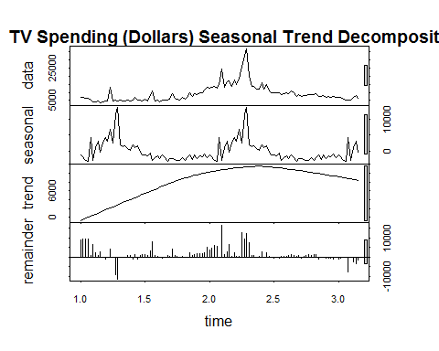

### ARIMAX model with TV spend

The graph below shows the general effect on TV spending on site visits by this channel. In this case the model is a combination of 1 lagged variables. This representation of the model can be thought of as the expected gain in site visits dissipated over 2 weeks per dollar spent on TV advertising dissipated over 2 weeks.

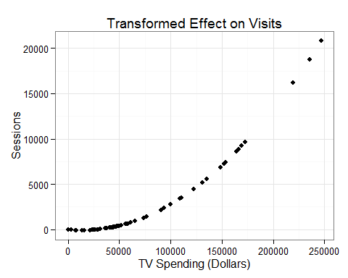

### Forecasts

The graph below shows the model fit and prediction intervals. It is important to note that predicition intervals, unlike confidence intervals, expand over time. This means that any forecast model should only be relied upon for short forecast periods.

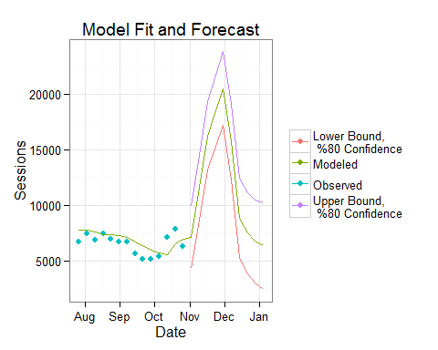

## Direct Home Channel

### Trend Decomposition

The graph below decomposes the time series into 3 parts. The first sub-graph is a simple plot of observed behavior over time. The second sub-graph is the seasonal factor. This data spans two years. We considered each year to be one season, as such the seasonal plot repeats itself once. The third sub-graph shows the larger smoothed trend of the entire span of data. The fourth sub-graph shows the residual values of the trend line and seasonal element, that is, how far from the true values the trend line and seasonal element is at each point in time. We can see that the residuals are not unrelated to time. This is diagnostic of trend behavior that can be accounted for using a time-series model.

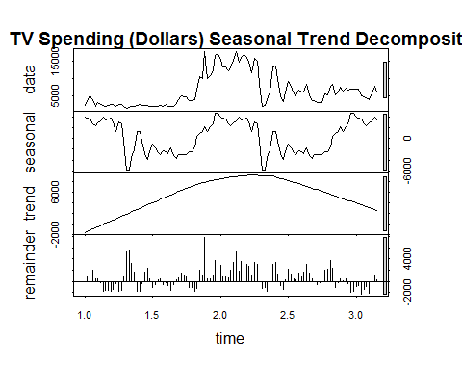

### ARIMAX model with TV spend

The graph below shows the general effect on TV spending on site visits by this channel. In this case the model is a combination of 1 lagged variables. This representation of the model can be thought of as the expected gain in site visits dissipated over 2 weeks per dollar spent on TV advertising dissipated over 2 weeks.

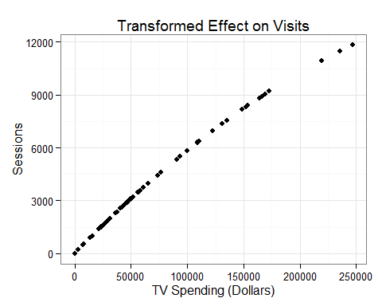

### Forecasts

The graph below shows the model fit and prediction intervals. It is important to note that predicition intervals, unlike confidence intervals, expand over time. This means that any forecast model should only be relied upon for short forecast periods.

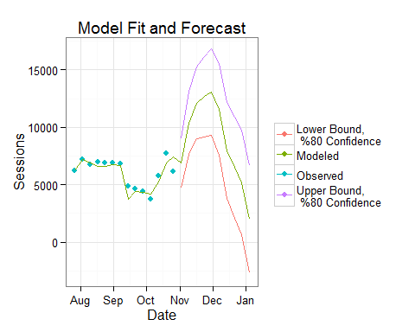

## Paid Brand Channel

### Trend Decomposition

The graph below decomposes the time series into 3 parts. The first sub-graph is a simple plot of observed behavior over time. The second sub-graph is the seasonal factor. This data spans two years. We considered 26 weeks to be one season, as such the seasonal plot repeats itself once. The third sub-graph shows the larger smoothed trend of the entire span of data. The fourth sub-graph shows the residual values of the trend line and seasonal element, that is, how far from the true values the trend line and seasonal element is at each point in time. We can see that the residuals are not unrelated to time. This is diagnostic of trend behavior that can be accounted for using a time-series model.

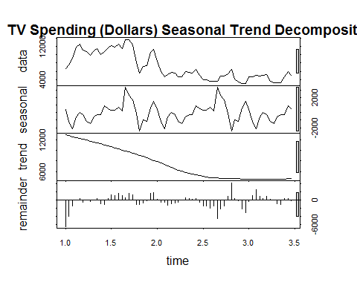

### ARIMAX model with TV spend

The graph below shows the general effect on TV spending on site visits by this channel. In this case the model is a combination of 1 lagged variables. This representation of the model can be thought of as the expected gain in site visits dissipated over 2 weeks per dollar spent on TV advertising dissipated over 2 weeks.

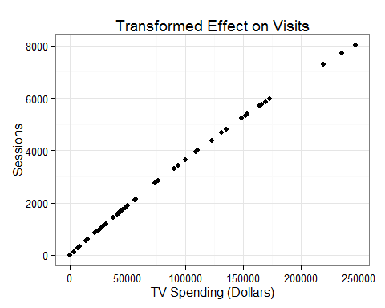

### Forecasts

The graph below shows the model fit and prediction intervals. It is important to note that predicition intervals, unlike confidence intervals, expand over time. This means that any forecast model should only be relied upon for short forecast periods.

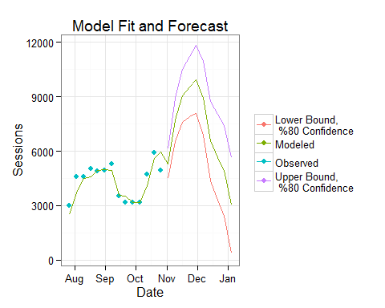

# Summary

After isolating TV spending from the independent trend and behavior of we can see that the impact of highly significant. These models bring several utilities. First, the relative effect of tv spend on each channel can be discerned by comparing their model coefficients (to be delivered). Second, the transformed impact can inform an appropriate amount of funds to allocate in the future. Third, the models can be used to forecast into the near future, which has potential fraud detection applications. All of these utilities will grow stronger as more data are gathered- allowing for adding seasonal comparison to the models. The models will also become more potent when provided with more granular data than a weekly aggregation.

# Appendix, Model Diagnostics

## Organic Net Home Channel

### 2nd order polynomial fit

|  |  |
| --- | --- |
|  | round.coef.poly_fit...3. |
| **(Intercept)** | 11523 |
| **tv** | 0.105 |
| **I(tv^2)** | 0 |
| **R2** | 0.5827 |

### Stepwise polynomial fit

|  |  |
| --- | --- |
|  | round.coef.stepwise_model...3. |
| **(Intercept)** | 10667 |
| **tv** | -0.439 |
| **I(tv^2)** | 0 |
| **I(tv^3)** | 0 |
| **I(tv^(1/2))** | 96.44 |
| **R2** | 0.6385 |

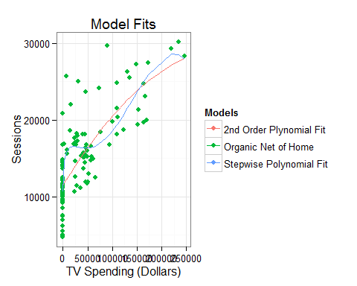 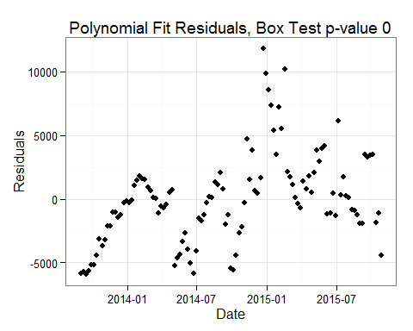

### ARIMAX model with TV spend

|  |  |
| --- | --- |
|  | Values |
| **Box Test p-value** | 0.8662 |
| **R2** | 0.97 |

ARIMX Model Performance Measures

### Model Validation

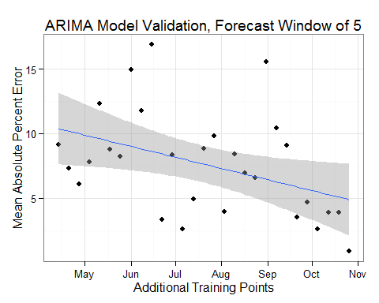

## Organic Home Channel

### 2nd order polynomial fit

|  |  |
| --- | --- |
|  | round.coef.poly_fit...3. |
| **(Intercept)** | 2495 |
| **tv** | 0.03 |
| **I(tv^2)** | 0 |
| **R2** | 0.7176 |

### Stepwise polynomial fit

|  |  |
| --- | --- |
|  | round.coef.stepwise_model...3. |
| **(Intercept)** | 2521 |
| **I(tv^2)** | 0 |
| **I(tv^3)** | 0 |
| **I(tv^(1/2))** | 3.653 |
| **R2** | 0.7254 |

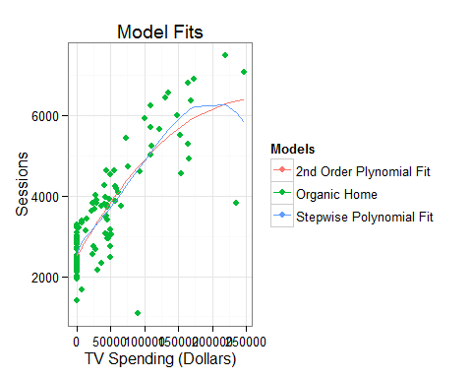 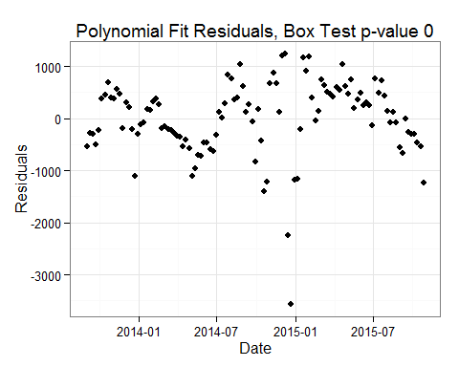

### ARIMAX model with TV spend

|  |  |
| --- | --- |
|  | Values |
| **Box Test p-value** | 0.97 |
| **R2** | 0.87 |

ARIMX Model Performance Measures

### Model Validation

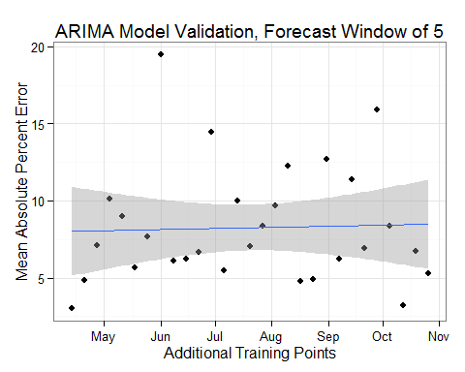

## Direct Net Home Channel

### 2nd order polynomial fit

|  |  |
| --- | --- |
|  | round.coef.poly_fit...3. |
| **(Intercept)** | 6549 |
| **tv** | 0.022 |
| **I(tv^2)** | 0 |
| **R2** | 0.7721 |

### Stepwise polynomial fit

|  |  |
| --- | --- |
|  | round.coef.stepwise_model...3. |
| **(Intercept)** | 6018 |
| **tv** | -0.112 |
| **I(tv^2)** | 0 |
| **I(tv^(1/2))** | 30.81 |
| **R2** | 0.7932 |

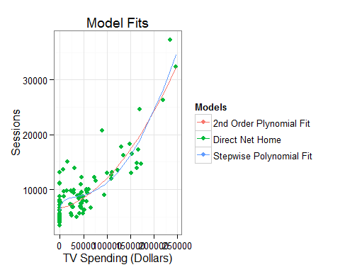 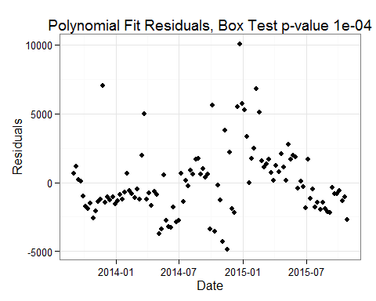

### ARIMAX model with TV spend

|  |  |
| --- | --- |
|  | Values |
| **Box Test p-value** | 0.9538 |
| **R2** | 0.85 |

ARIMX Model Performance Measures

### Model Validation

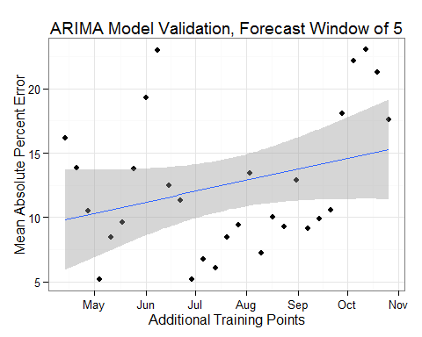

## Direct Home Channel

### 2nd order polynomial fit

|  |  |
| --- | --- |
|  | round.coef.poly_fit...3. |
| **(Intercept)** | 2477 |
| **tv** | 0.131 |
| **I(tv^2)** | 0 |
| **R2** | 0.7874 |

### Stepwise polynomial fit

|  |  |
| --- | --- |
|  | round.coef.stepwise_model...3. |
| **(Intercept)** | 2629 |
| **tv** | 0.107 |
| **I(tv^3)** | 0 |
| **R2** | 0.7929 |

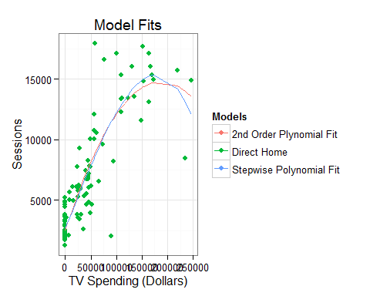 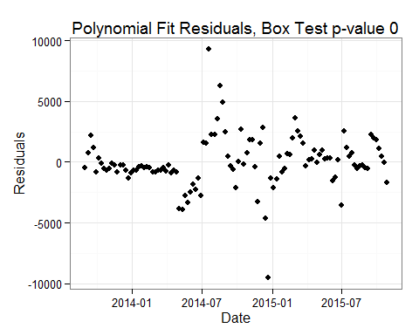

### ARIMAX model with TV spend

|  |  |
| --- | --- |
|  | Values |
| **Box Test p-value** | 0.9685 |
| **R2** | 0.88 |

ARIMX Model Performance Measures

### Model Validation

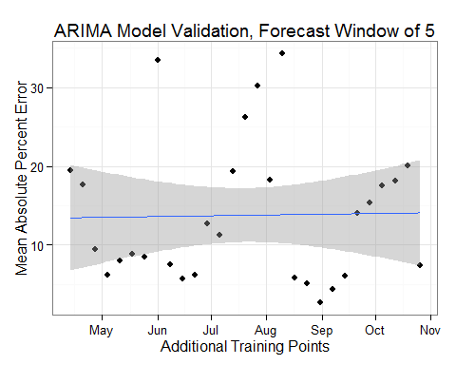

## Paid Brand Channel

### 2nd order polynomial fit

|  |  |
| --- | --- |
|  | round.coef.poly_fit...3. |
| **(Intercept)** | 3370 |
| **tv** | 0.069 |
| **I(tv^2)** | 0 |
| **R2** | 0.8784 |

### Stepwise polynomial fit

|  |  |
| --- | --- |
|  | round.coef.stepwise_model...3. |
| **(Intercept)** | 3443 |
| **tv** | 0.062 |
| **I(tv^3)** | 0 |
| **R2** | 0.8837 |

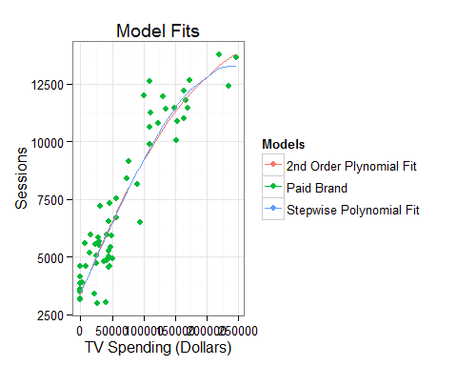 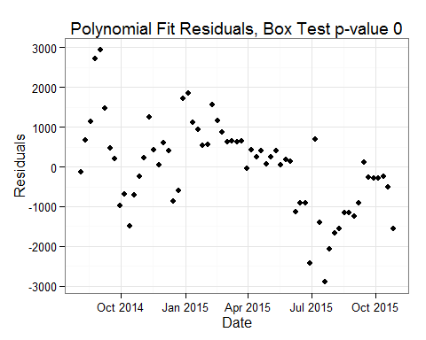

### ARIMAX model with TV spend

|  |  |
| --- | --- |
|  | Values |
| **Box Test p-value** | 0.2741 |
| **R2** | 0.96 |

ARIMX Model Performance Measures

### Model Validation

## [1] "There are not enough data to validate this model. You must have at least 70 observations"

## NULL