**Project Management – Class Assessment**

**Student Name:** Eryk Gloginski **(L00157413)**

**Course:** BSc Computing

**Module:** Project Management

**Lecturer:** Helen McMahon

**Submission Date:** 28/04/2023

## **1. Introduction:**

The assignment that was given to us by the lecturer requires us to create a project and implement the project using Microsoft Project (MSP). The implementation of the MSP includes a Gantt Chart, project calendar, assigned resources, levelled resources, critical path and tracking progress. The chosen project is based on building a house for a client. The project is set to start on the Monday, 3rd of April 2023.

## **2. Work Breakdown Structure (WBS):**

The WBS is split into 4 categories**: (1) Design & Planning**, **(2) House Construction**, **(3) Interior & Exterior** and **(4) Utilities**. These steps are based upon a more recent SDLC that keeps the client actively involved during the project. An overview of the project can be seen in Figure 1.  
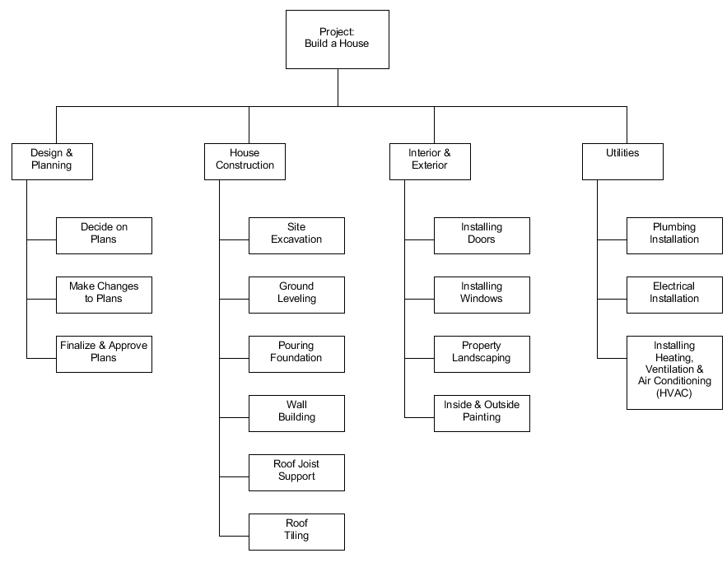  
*Figure 1: The work breakdown structure for building a house.*

## **3. Gantt Chart:**

The Gantt Chart shown in Figure 2 and Figure 3 is an implementation of the WBS shown in Figure 1. The chart includes **lag time**, for example 1.3. Another objective included is **lead time** between 1.2 and 1.3, 2.5 and 2.6, 3.3 and 3.4. **Parallel tasks** are also used as seen between 3.1 and 3.2. The **summary tasks** are clearly visible, relating to the WBS categories described earlier. Every phase end with a **milestone** that has a date next to it, as seen below. To further explain parallel tasks, lead and lag time, a more in-depth description will be given below:

1. **Parallel Tasks:**  
   Parallel tasks are those that can be done at the same time. During the Interior & Exterior category, for example, the tasks “Installing Doors” and “Installing Windows” can run parallel as they do not require each other’s completion.
2. **Lag Time:**  
   There are some tasks that must be completed before the next one may start. One example here is “Finalize & Approve Plans” which starts after “Make Changes to Plans”. The reason for this is that the client meets up with the project manager and the client must agree on the plans before any of the important house construction work begins.
3. **Lead Time:**  
   Lead time describes when a task start before another task is finished. It is the opposite of lag time. One example here is “Inside & Outside Painting” starting 2 days before “Property Landscaping” is finished. The reason is that the interior painting will begin first while the property is being landscaped and by the time the property landscaping is finished, the exterior painting can begin.

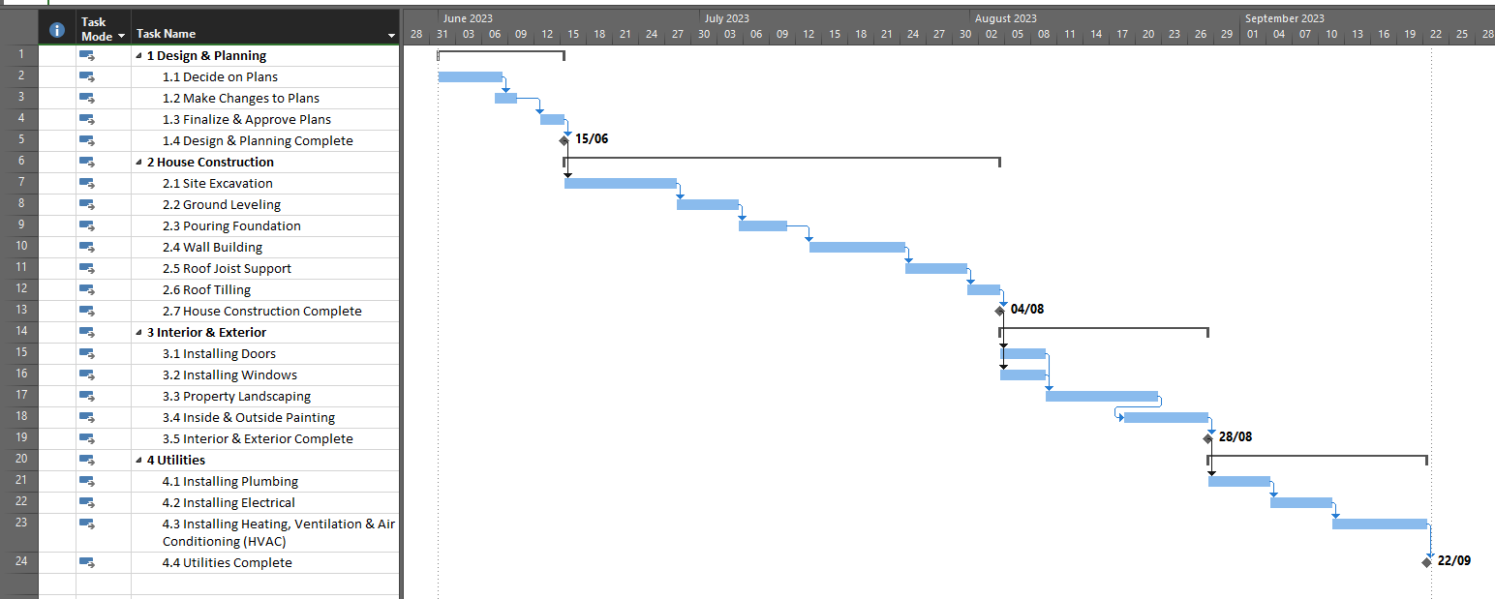  
*Figure 2: Basic Gantt Chart for building a house.*

## **4. Over-allocated Resources:**

The next step requires us to assign resources to the project and over-allocate the resources. Over-allocation is defined as one resource planned to work on more than 1 task at the same time. It is required for scheduling conflict for resources. Figure 4 shows multiple of these in scheduling conflicts. The following resources were used for the project:

1. **Client:**  
   The client is the individual that is commissioning the construction project. The client is responsible for defining the project scope, budget, and timeline. The client will work closely with the architect and designer to develop plans and oversee the construction process to ensure that their goals are met.
2. **Architect:**  
   The architect is responsible for designing the structure. They will work closely with the client to understand the requirements and preferences. With this, they develop a detailed plan that includes a layout, dimensions, and materials of the project. There are local building codes that the architect also needs to ensure that the plans comply with.
3. **Designer:**  
   The designer is responsible for creating the overall look and feel of the structure. They will work closely with the client and the architect to select colors and materials that will be used in the duration of the project. The designer’s role is to ensure that the finished product meets the client’s aesthetic goals while also being functional and practical.
4. **Contractors:**  
   The contractors are responsible for executing the construction project according to the plans and specifications developed by the architect and designer. They oversee the various aspects of the construction process, including site excavation, pouring foundation, wall building, roofing, and interior and exterior finishing. They are responsible for managing the schedule, budget, and resources to complete the project on time and within budget.
5. **Sub-contractors:**The sub-contractors are specialists who are hired to perform specific tasks within the construction project. Examples of such would include fenestration, landscaping, painting, plumbing, electricians, and HVAC technicians. Sub-contractors work under the contractors and are responsible to complete their work on time to the required quality standards.

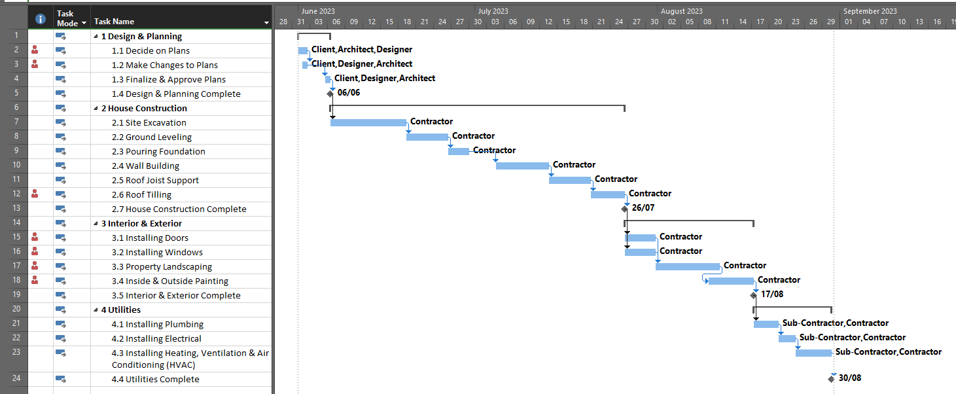  
*Figure 3: Gantt Chart for building a house with Conflicting Resources.*

## **5. Calendars:**

Every country, company and department have different holidays. That means that there are different work hours and off days. The calendar allows to account for those differences. However, due to the project schedule, 2 Irish public holidays were included in the calendar, as it can be seen in Figure 4 below. These days will be left out when the Microsoft Project calculates the project, therefore the project will be extended for 2 extra days.

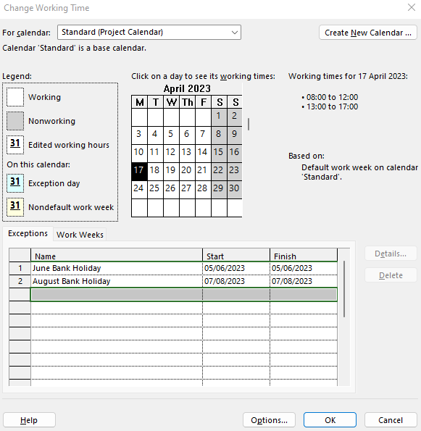  
*Figure 4: Calendar entries for the Project.*

## **6. Levelled Resources:**

The resources section assigned specific resources to the project. Unfortunately, these resources included scheduling conflicts. To fix this, a number of actions was taken which will be listed in detail below:

1. **Increased maximum of resource units:**  
   Increasing resources for a project is difficult, specifically when the initial budget is small. However, we do not have to worry about the budget in this case. Thanks to this, I used a second Contractor for the construction of the house. In the resource sheet, I changed the Contractor’s availability to 200%, implying that there is a second Contractor available. This in fact assumes that the second Contractor will be available for the entire project which speeds up the entire Project and increases the cost.
2. **Adjust task relationships or constraints:**This action can potentially lead to the extension of the project. However, the cost shouldn’t increase due to the fact that the specific task that we are altering does not require additional resources, just time. I changed the relationship between Decide on Plans and Make Changes to Plans.

The project time was increased by 1 day by making these adjustments as seen in Figure 5 and 6. Another benefit is that the project cost was not increased.

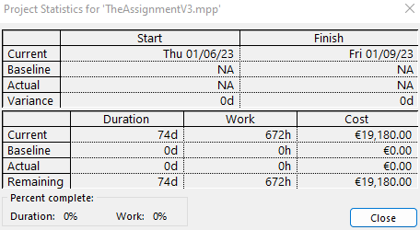  
*Figure 5: Project Statistics Overview.*

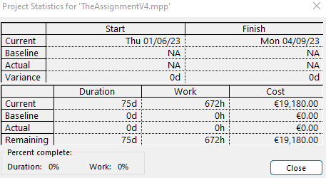  
*Figure 6: Project Statistics Overview after adjustments being made.*

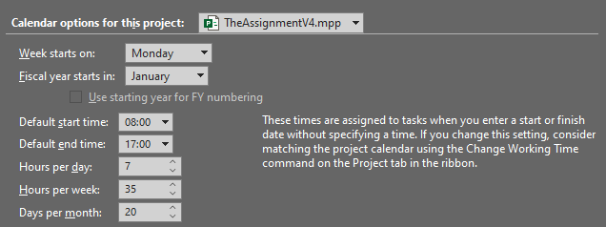  
*Figure 7: Work Hours for the Project.*

Figures 8 and 9 show the before and after of the increased maximum resource of a unit. There is no cost difference for the Contractor, therefore there was no change in the project cost.

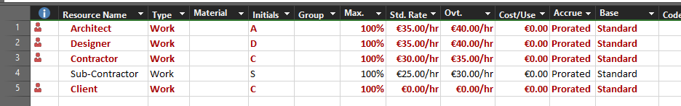  
*Figure 8: Project Resources and their associated cost before resource levelling.*

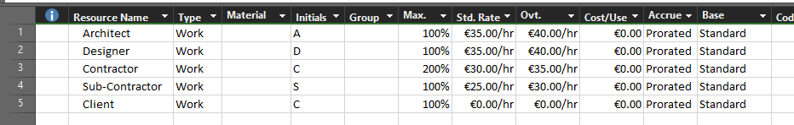  
*Figure 9: Project Resources and their associated cost after resource levelling.*

The final Gantt Chart after the levelling of resources is shown as Figure 10. When compared with Figure 2 and Figure 3, we can see that the project indeed might have been extended by two days, but it has been made more efficient when checking the resources as there are no conflicts.

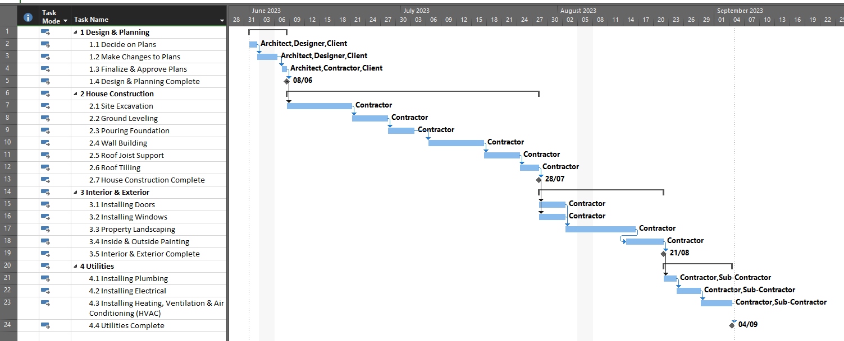  
*Figure 10: Gantt Chart after the levelling of the resources.*

## **7. Critical Path:**

The critical path is the longest time that it takes to finish a specific project. This project, without anything optimized, started out by finishing at 22nd of September 2023 and by being minimally optimized, it was shortened to finish on the 4th of September 2023.

  
*Figure 11: The Critical Path drawn for the Project before any optimization.*

We are still able to potentially shorten it even further by using the previous methods for resource levelling as the same optimization methods can be added, as well as a new one, to shorten the critical path:

1. **Allocating more resources.**
2. **Adjust task relationships or constraints.**
3. **Allocate alternative resources:**This is the preferred method as it doesn’t lead to an extension of the project or a higher cost of the project, keeping in mind that if a cheaper resource is used. This will be utilized for a few tasks since Sub-Contractors are cheaper than the Contractors and this will speed up the project by a few days.

I have decided to shorten the critical path using the methods listed above and additionally avoid adding extra costs. In the **(2) House Construction** phase, a few of the tasks were adjusted by adding a day or two of lead time as it should be possible to run most tasks earlier with enough resources available on a short notice. I have also increased the Max Units of Sub-Contractors to 200% which would allow me to assign them to the **(3) Interior & Exterior** phase, shortening the time and lowering the costs of completion.

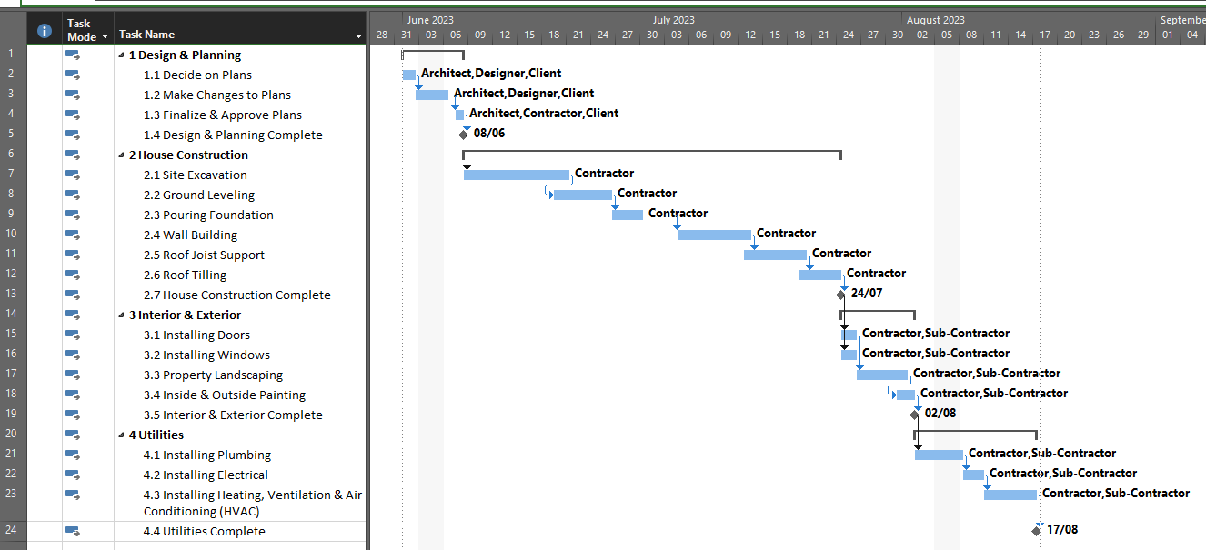  
*Figure 12: The Critical Path drawn for the Project after the optimization.*

The final project overview is shown below in Figure 13. It is important to note that the cost did go down a bit due to the Sub-Contractors being assigned to the tasks in the **(3) Interior & Exterior** phase. All other adjustments were made by adjusting mainly lead time as well as allocating resources that are priced the same or lower than Contractors.

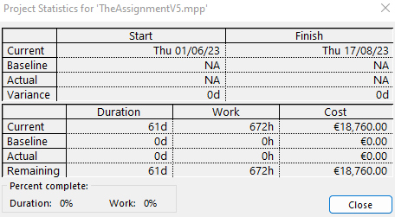  
*Figure 13: The Project Overview after applying optimization.*

## **8. Tracking Progress:**

A project plan is not a static product but a plan that will change as the project is underway. It is possible to track the project by setting a baseline, a planned timeline, and then adjusting the actual project flow as required.

I was not able to finish this part due to the fact that I cannot access Microsoft Project at home.