Условие:

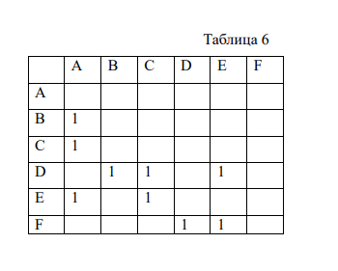

Схема:

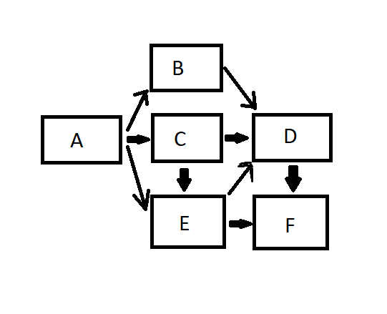

Код Программы:

#include <iostream>

using namespace std;

class A {

public:

A() {

cout << "A (- B C E - -)" << endl;

}

void f() {

cout << "A";

}

};

class B : public virtual A {

public:

B() {

cout << "B (- - - - D -)" << endl;

}

void f() {

cout << "B";

}

};

class C : public virtual A {

public:

C() {

cout << "C (- - - E D -)" << endl;

}

void f() {

cout << "C";

}

};

class E : public virtual A, public virtual C {

public:

E() {

cout << "E (- - - - D F)" << endl;

}

void f() {

cout << "E";

}

};

class D : public virtual B, public virtual C, public virtual E {

public:

D() {

cout << "D (- - - - - F)" << endl;

}

void f() {

cout << "D";

}

};

class F : public virtual D, public virtual E {

public:

F() {

cout << "F (- - - - - -)" << endl;

}

void f() {

cout << "F";

}

};

int main() {

F object;

object.f();

return 0;

}