Name: Aditya Bhavik Deshmukh

RollNo.: 77

#include <DHT.h>

#include <DHT_U.h>

#define DHTPIN 3

#define DHTTYPE DHT11

DHT dht(DHTPIN,DHTTYPE);

void setup() {

  Serial.begin(9600);

  delay(2000);

  Serial.println("");

  delay(2000);

  dht.begin();

}

void loop() {

  delay(2000);

  float h = dht.readHumidity();

  float t = dht.readTemperature();

  float f= dht.readTemperature(true);

  Serial.print("Humidity: ");

  Serial.print(h);

  Serial.print("%\t");

  Serial.print("Temparature: ");

  Serial.print(t);

  Serial.print("*C");

  Serial.print(t);

  Serial.print("*F\f");

  Serial.println("");

}

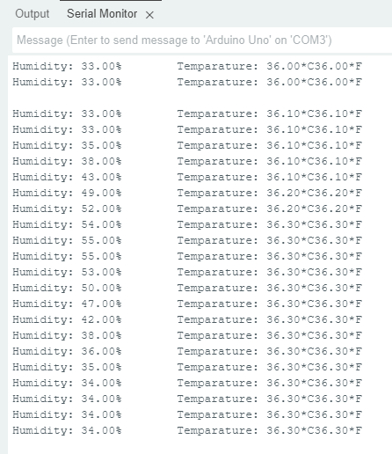

int LED1 = 3;

void setup() {

  pinMode(LED1,OUTPUT);

}

void loop() {

 digitalWrite(3,HIGH);

 delay(2000);

 digitalWrite(3,LOW);

 delay(2000);

}

