BonusQuiz

Sijia Liang

2/11/2018

# Question1  
# read the csv data and name the dataset "Quiz1"  
Quiz1=read.csv("/Users/sijialiang/Desktop/Eclipse/R/bones.csv")  
  
# compute X bar  
colMeans(Quiz1[,2:7])

## Dominant_radius Radius Dominant_humerus Humerus   
## 0.84380 0.81832 1.79268 1.73484   
## Dominant_ulna Ulna   
## 0.70440 0.69384

# compute corvariance for all variables excluding 1st column  
# since 1st column only indicates subject column  
cov(Quiz1[,2:7])

## Dominant_radius Radius Dominant_humerus Humerus  
## Dominant_radius 0.013001583 0.010378442 0.02234997 0.02008568  
## Radius 0.010378442 0.011417893 0.01853519 0.02109951  
## Dominant_humerus 0.022349975 0.018535190 0.08035723 0.06677620  
## Humerus 0.020085675 0.021099512 0.06677620 0.06948447  
## Dominant_ulna 0.009120708 0.008529783 0.01683692 0.01773548  
## Ulna 0.007957842 0.008908512 0.01284703 0.01679360  
## Dominant_ulna Ulna  
## Dominant_radius 0.009120708 0.007957842  
## Radius 0.008529783 0.008908512  
## Dominant_humerus 0.016836925 0.012847030  
## Humerus 0.017735483 0.016793598  
## Dominant_ulna 0.011568417 0.008071150  
## Ulna 0.008071150 0.010599140

# compute corvariance for all variables excluding 1 column  
cor(Quiz1[,2:7])

## Dominant_radius Radius Dominant_humerus Humerus  
## Dominant_radius 1.0000000 0.8518067 0.6914590 0.6682584  
## Radius 0.8518067 1.0000000 0.6119157 0.7490926  
## Dominant_humerus 0.6914590 0.6119157 1.0000000 0.8936456  
## Humerus 0.6682584 0.7490926 0.8936456 1.0000000  
## Dominant_ulna 0.7436926 0.7421780 0.5522215 0.6255502  
## Ulna 0.6778941 0.8097983 0.4402050 0.6188203  
## Dominant_ulna Ulna  
## Dominant_radius 0.7436926 0.6778941  
## Radius 0.7421780 0.8097983  
## Dominant_humerus 0.5522215 0.4402050  
## Humerus 0.6255502 0.6188203  
## Dominant_ulna 1.0000000 0.7288919  
## Ulna 0.7288919 1.0000000

# interpret pairwise correlations:  
# different bones with the same (non)dominance have higher correlation than same pair of bones but different (non)dominance

# Question2  
# access data from R  
data(EuStockMarkets)  
  
# read the head of the EuStockMarkets dataset  
head(EuStockMarkets)

## DAX SMI CAC FTSE  
## [1,] 1628.75 1678.1 1772.8 2443.6  
## [2,] 1613.63 1688.5 1750.5 2460.2  
## [3,] 1606.51 1678.6 1718.0 2448.2  
## [4,] 1621.04 1684.1 1708.1 2470.4  
## [5,] 1618.16 1686.6 1723.1 2484.7  
## [6,] 1610.61 1671.6 1714.3 2466.8

# using either boxplot.Matrix() or boxplot() to compute side by side boxplots  
boxplot.matrix(EuStockMarkets)  
boxplot(EuStockMarkets)

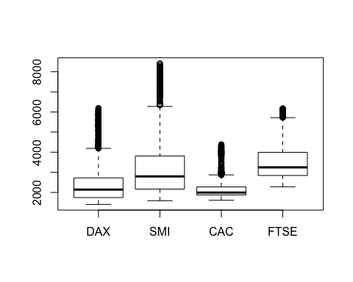

# plot scatterplot matrix, getting times series chart instead  
plot(EuStockMarkets)

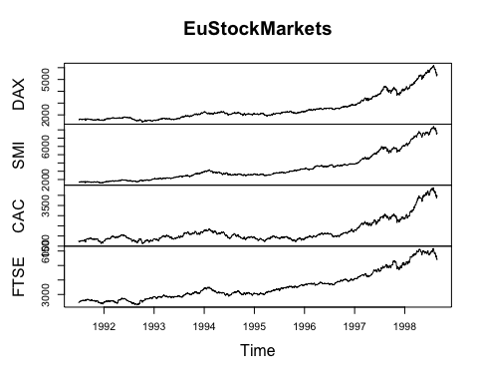

# plot scatterplot using paris()  
pairs(EuStockMarkets)

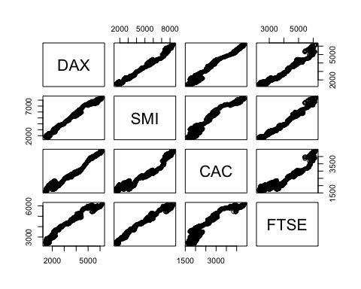

# interpret pattern show:  
# all indices pairs have positive correlation, EU stock market are postively correlated