CIT336 Midterm Exam Spring 2018

Code/Database will be 50% of the total grade, and the questions will be the other 50%, with each question having a value of 5 points.

We’re going to create an application that allows us to keep track of assignments for our classes, so that we have a list of all of the assignments we’ve done for all of our classes over time.

We want to know the course number (CIT336, CIS101, ENG210 etc.), the name of the assignment, and the due date.

So first, we will create a database to store this information.

We need one table, called ‘assignments’, that will store each assignment, including the class, name, and due date.

1. What would be the SQL to create this database and table?

CREATE DATABASE *database2*;

CREATE TABLE assignments (  
    class varchar(255),  
    assignment varchar(255),  
    dueDate date);

Now that we have a database set up, we need to create a form to enter each assignment. It should look like this:

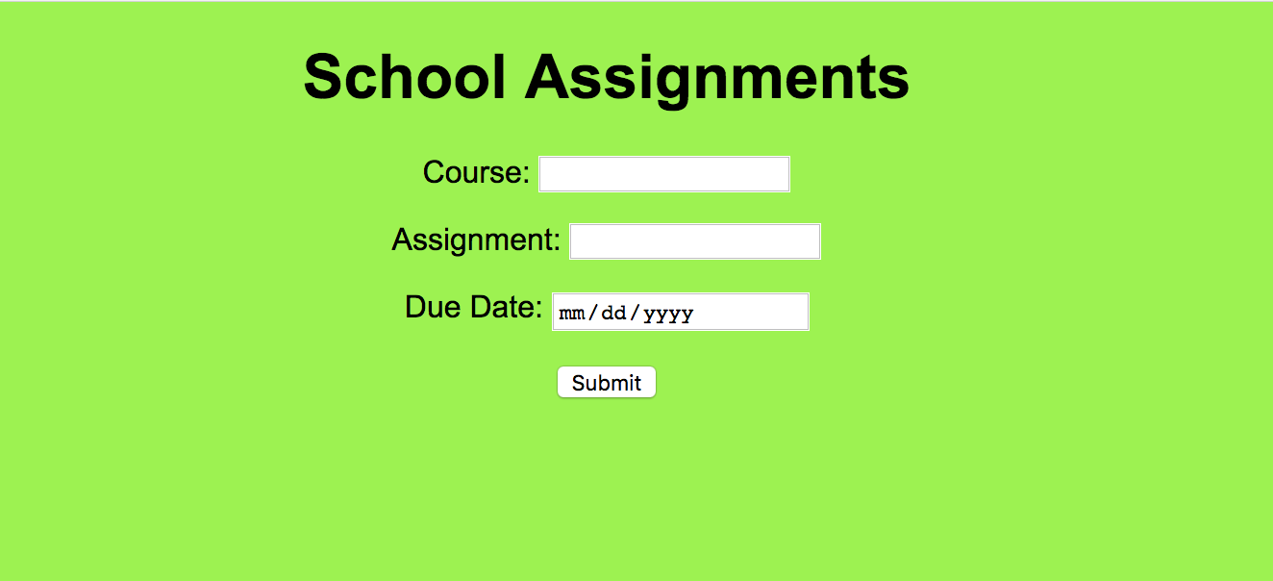

(Font is Arial, text is black, background color is #9bf442)

Now we need to write a PHP file that will allow us to add the information from the form to the database.

2. What type of software do we need to have running on our computers to run PHP?

MAMP

3. What type of variable must $link be if we’re using it **throughout the document**?

Global variable

Now we will write an AJAX function to send that data to the database without refreshing the page.

4. We’re using a GET request in this situation. In what situations might we choose to use a POST request instead?

GET vs. POST

- Both are treated as superglobals, can get them in any function

- GET sends via URL parameters

- POST sends inside the HTTP request

- Use GET if you want variables displayed in the URL. Only use for insensitive data

- Use POST for sensitive data, when you’re sending a lot of data, and when you need advanced features

- Do not send passwords in GET

5. What is AJAX and why are we using it?

The AJAX is part of a JavaScript script that uses HTTP requests and responses to send pieces of data back and forth for the PHP to process:

When the script runs, it creates and XML HTTP Request object. This XML HTTP Request is a GET request that asks for the PHP file, possibly passing it some information in the parameters. Then it will send the XML HTTP Request. When the HTTP state gives a response and the state is changed, and ready state is 4, and the server responded with a 200 status, then the JavaScript action is executed.

AJAX is a technique for creating fast and dynamic web pages. AJAX allows web pages to be updated asynchronously by exchanging small amounts of data with the server behind the scenes. This means that it is possible to update parts of a web page, without reloading the whole page.

6. What is an HTTP request?

HTTP requests are messages sent by the client to initiate an action on the server. HTTP is a request/response protocol, which means your computer sends a request for some file and the web server sends back a response.

7. Where do we tell the client-side code what to do with the response from the server?

Through JavaScript

Ajax get response from the server, then we use JavaScript to tell client side code what to do based on the response value

8. Is the AJAX on the server-side or client-side? Is the PHP on the client-side or server-side?

Ajax is Client-side, PHP is server side

Double-check in your database that the information is being submitted.

Make a few assignment entries.

Now we just want to take a quick peek at the assignments we’ve had. Write a PHP file that displays a table that shows all of those assignments. Add a link to this page from the form page, and a link to this the form from this page.

It should look like this:

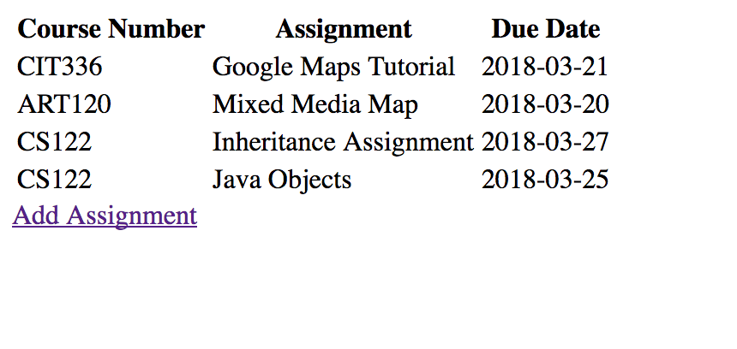

9. This application now does two of the functions of CRUD. Which two functions?

Create and Read

10. Give me an example of 3 key-value pairs from your data.

class:Cit240

assignment:homework2

dueDate:05/08/2018

11. If you were going to add this application to Github, what would be the steps to do that? Include the commands.

Create a new repository “midterm”

echo "# midterm" >> README.md

git init

git add README.md

git commit -m "first commit"

git remote add origin https://github.com/sl66617n/midterm.git

git push -u origin master

outline:

1.git init

2.git add .

3.git commit

4.git push

12. What would be the benefits of using Github?

1.     You can collaborate with other developers to the same project

2.     Good place to keep documentation

3.     You can track changes in your code across versions

Did you document your code? Put in comments that explain what your code is doing.

Yes, I document and put comments.

Zip up a file with all of your code and this document and upload it to Blackboard.

Great job! Next week we are going to look at what we can add to make this a little more useful, as well as some Python.