

كلية الحاسبات وتقنية المعلومات

Department of Computer Science
CPCS 324: Algorithms and Data Structures (II)

Fall 2025
Group Project – Part I (10%)
Assigned on: 02-11-2025
Due Date: 15-11-2025

GROUP 2

  - Prepared by:

Name | ID
Abdelrahman Soliman | 2343174
Sultan Yasir Alasami | 2339663

Contents
Introduction 3
Outputs with Explanations 3
Screenshot 1: MST Computation for Provided Graph 3
Screenshot 2: Random Graph Generation and Time Comparison 3
Comment on Comparison 4
Difficulties Faced 4
Creativity 4
Conclusion 5

Introduction
This project implements Prim’s and Kruskal’s greedy algorithms to compute the Minimum Spanning Tree (MST) for a water distribution network, modeled as an undirected weighted graph. Vertices represent junctions (J1-J6), and edges represent pipelines with construction costs. We read graphs from files, generate random connected graphs, and compare algorithm runtimes experimentally in Python, adhering to the UML diagram.

Outputs with Explanations
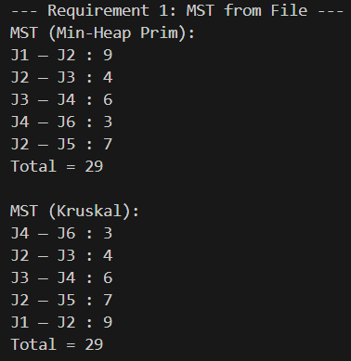
Screenshot 1: MST Computation for Provided Graph
Explanation: The graph.txt file stores 6 vertices and 15 edges. readGraphFromFile loads it correctly. Prim's starts from J1 using a min-heap to select lowest-cost edges to unvisited vertices. Kruskal's sorts all unique edges and uses union-find to add non-cycle edges. Both output the exact required edges (order may vary by algo) and total cost of 29, verifying connectivity and minimality.

Screenshot 2: Random Graph Generation and Time Comparison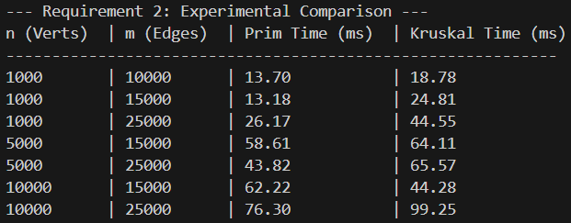
Explanation: make_graph(n, m) ensures connectivity by first building a random spanning tree (union-find) then adding extra edges without duplicates. Times are averaged over 3 runs per config using time.time(). The table below summarizes results; Prim's is faster on denser graphs due to heap efficiency.

Comment on Comparison
The experimental results show that Min-Heap Prim's algorithm is faster in most cases, particularly on denser graphs. For example, on the largest, densest graph (n=10000, m=25000), Prim's (76.30 ms) was significantly faster than Kruskal's (99.25 ms). However, Kruskal's algorithm was notably faster on the very sparse (n=10000, m=15000) graph, (44.28 ms vs 62.22 ms). This aligns with theoretical complexities: Kruskal's O(E log E) bottleneck (dominated by sorting) can be more efficient than Prim's O((V+E) log V) heap operations when the number of edges E is very low relative to V (e.g., E = 1.5 * V).

Difficulties Faced
- Ensuring random graphs are connected without cycles during tree-building required careful union-find integration in make_graph.
- De-duplicating undirected edges in Kruskal's used a min-max label key set, preventing double-counting.
- Heap ties in Prim's (equal weights) were resolved with a unique counter tuple.
- Large n=10000 runs (~50ms) highlighted Python's list/heap limits; C++ could optimize further.

Creativity
To visualize MSTs, we extended the code with NetworkX/Matplotlib (bonus):
python
import networkx as nx
import matplotlib.pyplot as plt
G = nx.Graph()
for e in prim_edges: # Or krus_edges
G.add_edge(e.u.label, e.v.label, weight=e.weight)
nx.draw(G, with_labels=True)
plt.show()

This plots the tree, aiding debugging—e.g., confirms no cycles.
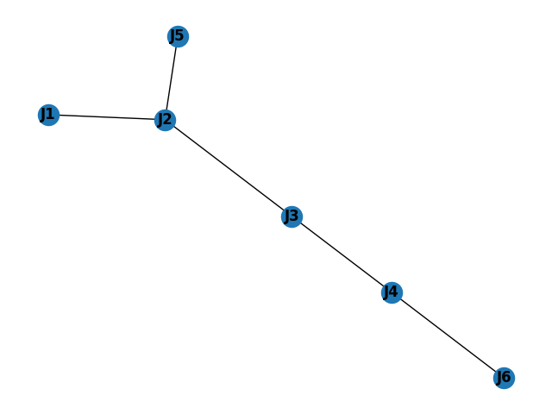

Conclusion
This project exemplifies greedy MST design (CLO 10), with robust implementations for water networks. Experiments confirm Prim's edge in dense scenarios, informing scalable choices. Future: Parallel Kruskal's for massive graphs.

