
!

King Abdulaziz University

Faculty of Computing & Information Technology
Computer Science Department

Designing a Counter using Flip Flops

CPCS-211 (CS3)
Final Project Report (Fall 2024)

Name: Sultan yasir alasami
ID: 2339663

Grading Rubric
 | Task Description | Marks obtained | Max Marks
1 | Correct state table for D flip flop implementation |  | 2
2 | Correct expressions for D_{C}, D_{B} and D_{A} |  | 3
3 | Expression for D flip flop correctly simplified using K-Map |  | 2
4 | Correct implementation of circuit using D flip flops |  | 3
5 | Correct state table for JK flip flop implementation |  | 2
6 | Correct expressions for J_{C}, J_{B} and J_{A} and K_{C}, K_{B} and K_{A} |  | 3
7 | Expression for JK flip flop correctly simplified using K-Map |  | 2
8 | Correct implementation of circuit using JK flip flops |  | 3
 | Total marks obtained |  | 20
Toggle | (Q2 Q1 Q0) | (Q2Q1Q0)* | D2 | D1 | D0
0 | 000 | 010 | 0 | 1 | 0
1 | 000 | 001 | 0 | 0 | 1
0 | 001 | 000 | 0 | 0 | 0
1 | 001 | 111 | 1 | 1 | 1
0 | 010 | 110 | 1 | 1 | 0
1 | 010 | 000 | 0 | 0 | 0
0 | 011 | 101 | 1 | 0 | 1
1 | 011 | 100 | 1 | 0 | 0
0 | 100 | 011 | 0 | 1 | 1
1 | 100 | 110 | 1 | 1 | 0
0 | 101 | 111 | 1 | 1 | 1
1 | 101 | 011 | 0 | 1 | 1
0 | 110 | 100 | 1 | 0 | 0
1 | 110 | 010 | 0 | 1 | 0
0 | 111 | 001 | 0 | 0 | 1
1 | 111 | 101 | 1 | 0 | 1
TT D Flip-Flops

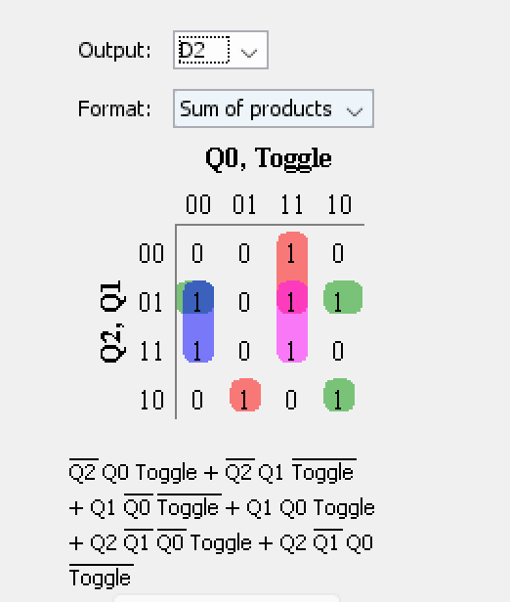
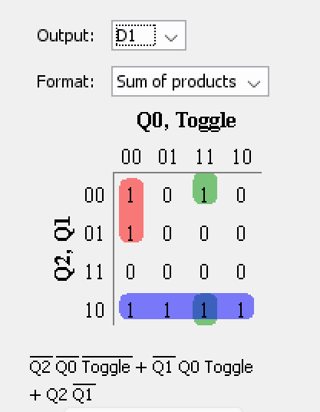
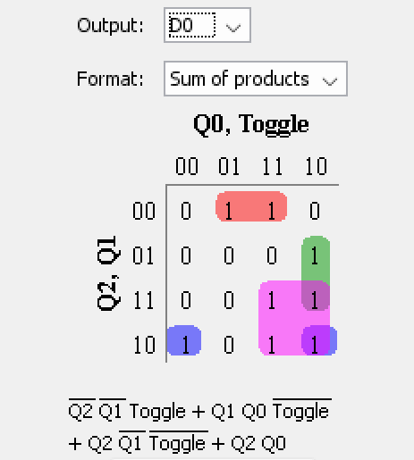

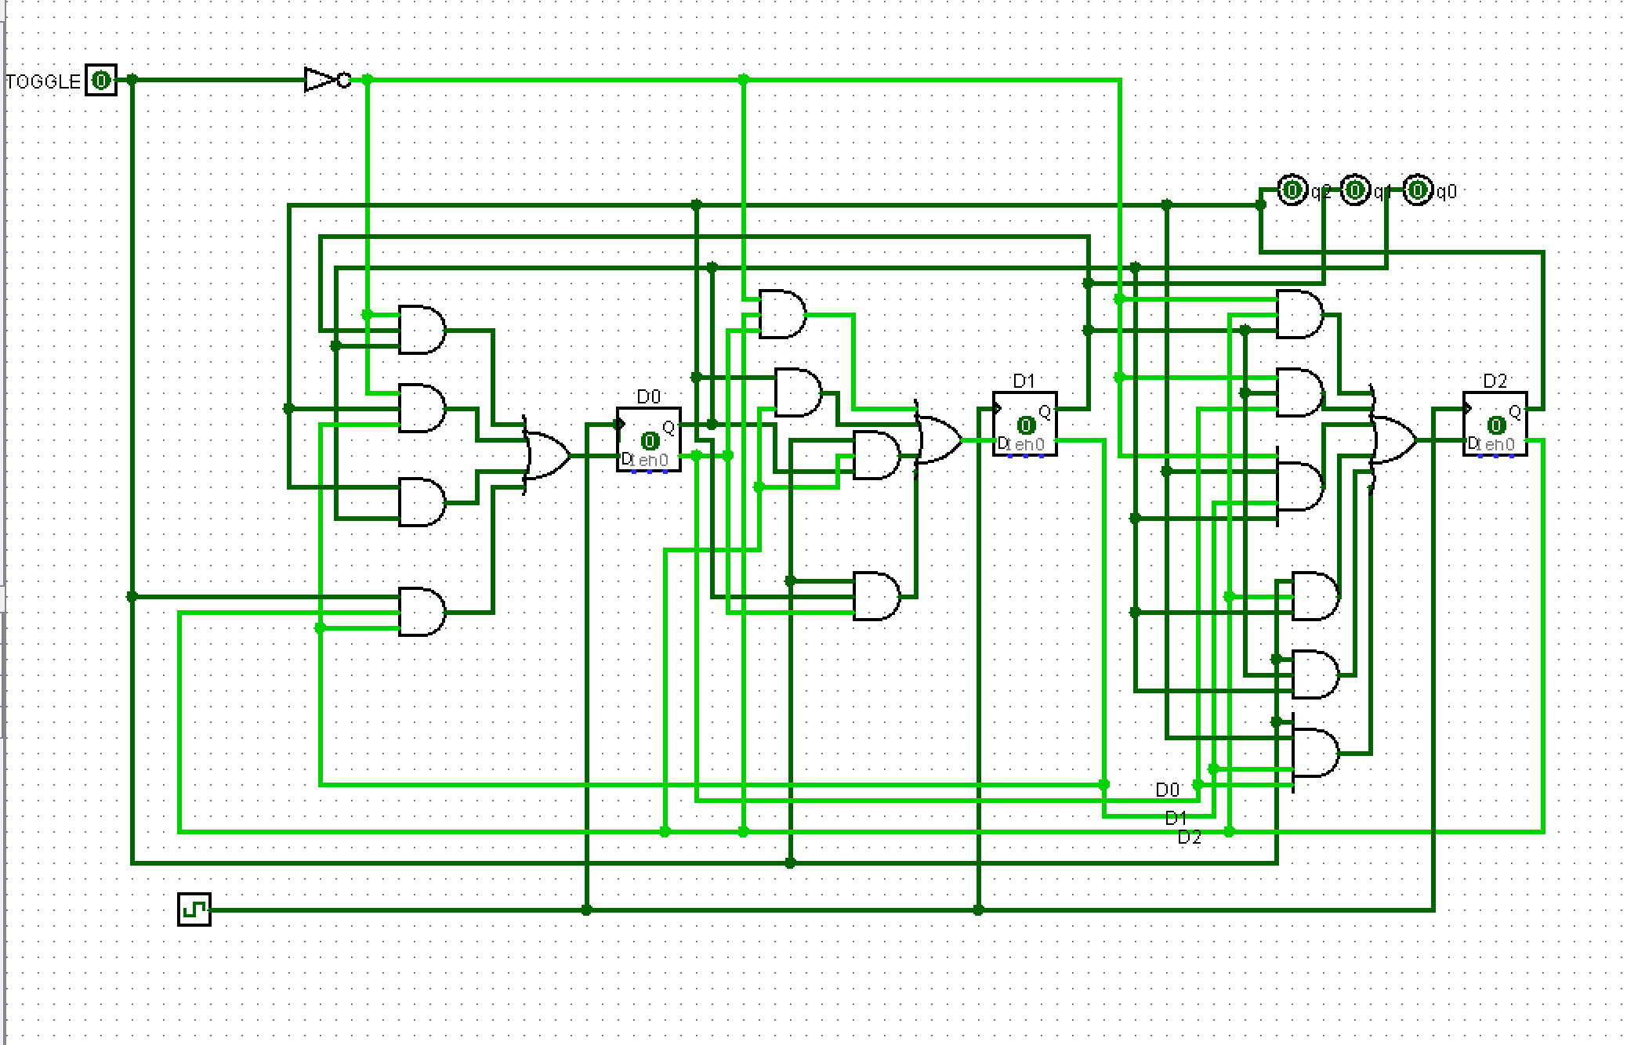

TT JK Flip-Flop

Taggle | (Q2 Q1 Q0) | (Q2 Q1 Q0)* | J2 | K2 | J1 | K1 | J0 | K0
0 | 000 | 001 | 0 | X | 0 | X | 1 | X
1 | 000 | 010 | 0 | X | 1 | X | 0 | X
0 | 001 | 111 | 0 | X | 0 | X | X | 0
1 | 001 | 000 | 0 | X | 0 | X | X | 1
0 | 010 | 000 | 0 | X | X | 1 | 0 | X
1 | 010 | 110 | 1 | X | X | 0 | 0 | X
0 | 011 | 100 | 1 | X | X | 1 | X | 1
1 | 011 | 101 | 1 | X | X | 1 | X | 0
0 | 100 | 110 | X | 0 | 1 | X | 0 | X
1 | 100 | 011 | X | 1 | 1 | X | 1 | X
0 | 101 | 011 | X | 1 | 1 | X | X | 0
1 | 101 | 111 | X | 0 | 1 | X | X | 0
0 | 110 | 010 | X | 1 | X | 0 | 0 | X
1 | 110 | 100 | X | 0 | X | 1 | 0 | X
0 | 111 | 101 | X | 0 | X | 1 | X | 0
1 | 111 | 001 | X | 1 | X | 1 | X | 0

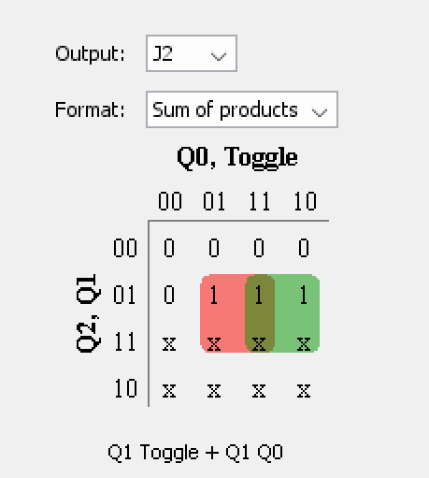
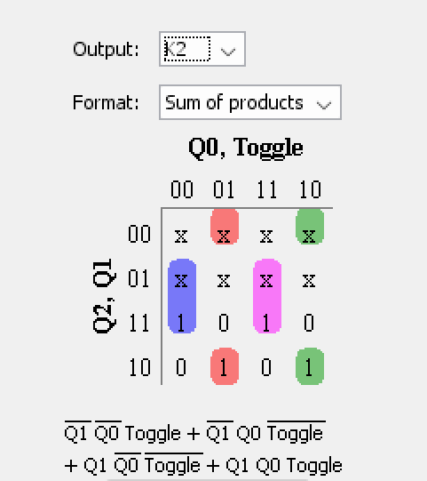

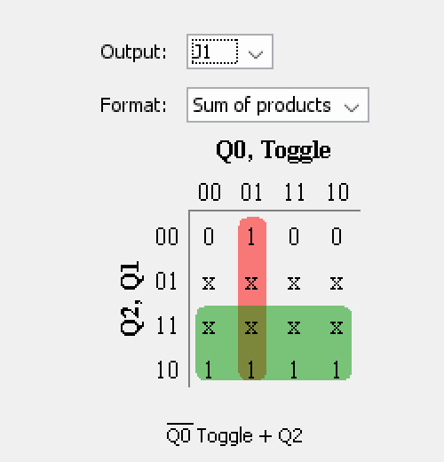
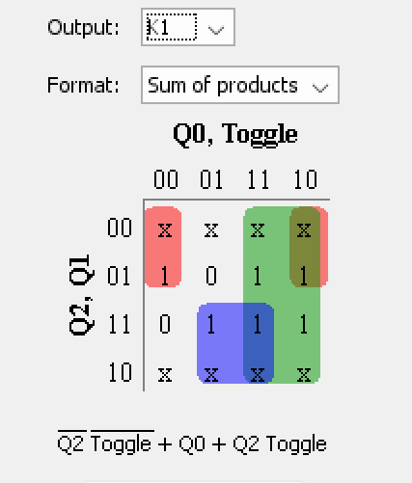

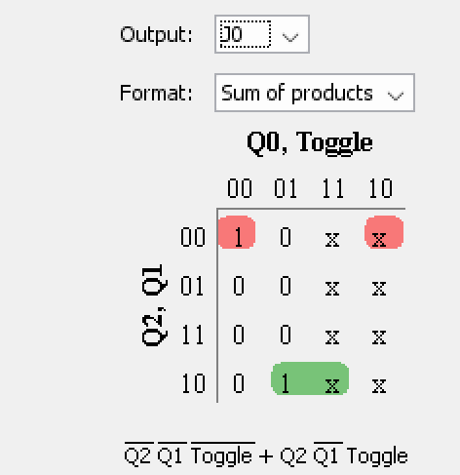
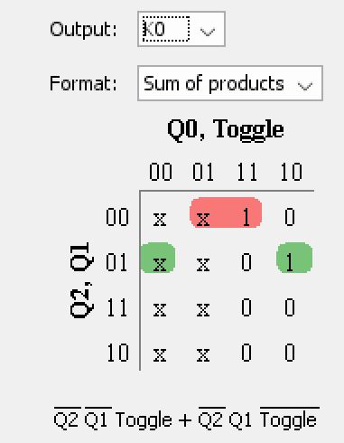

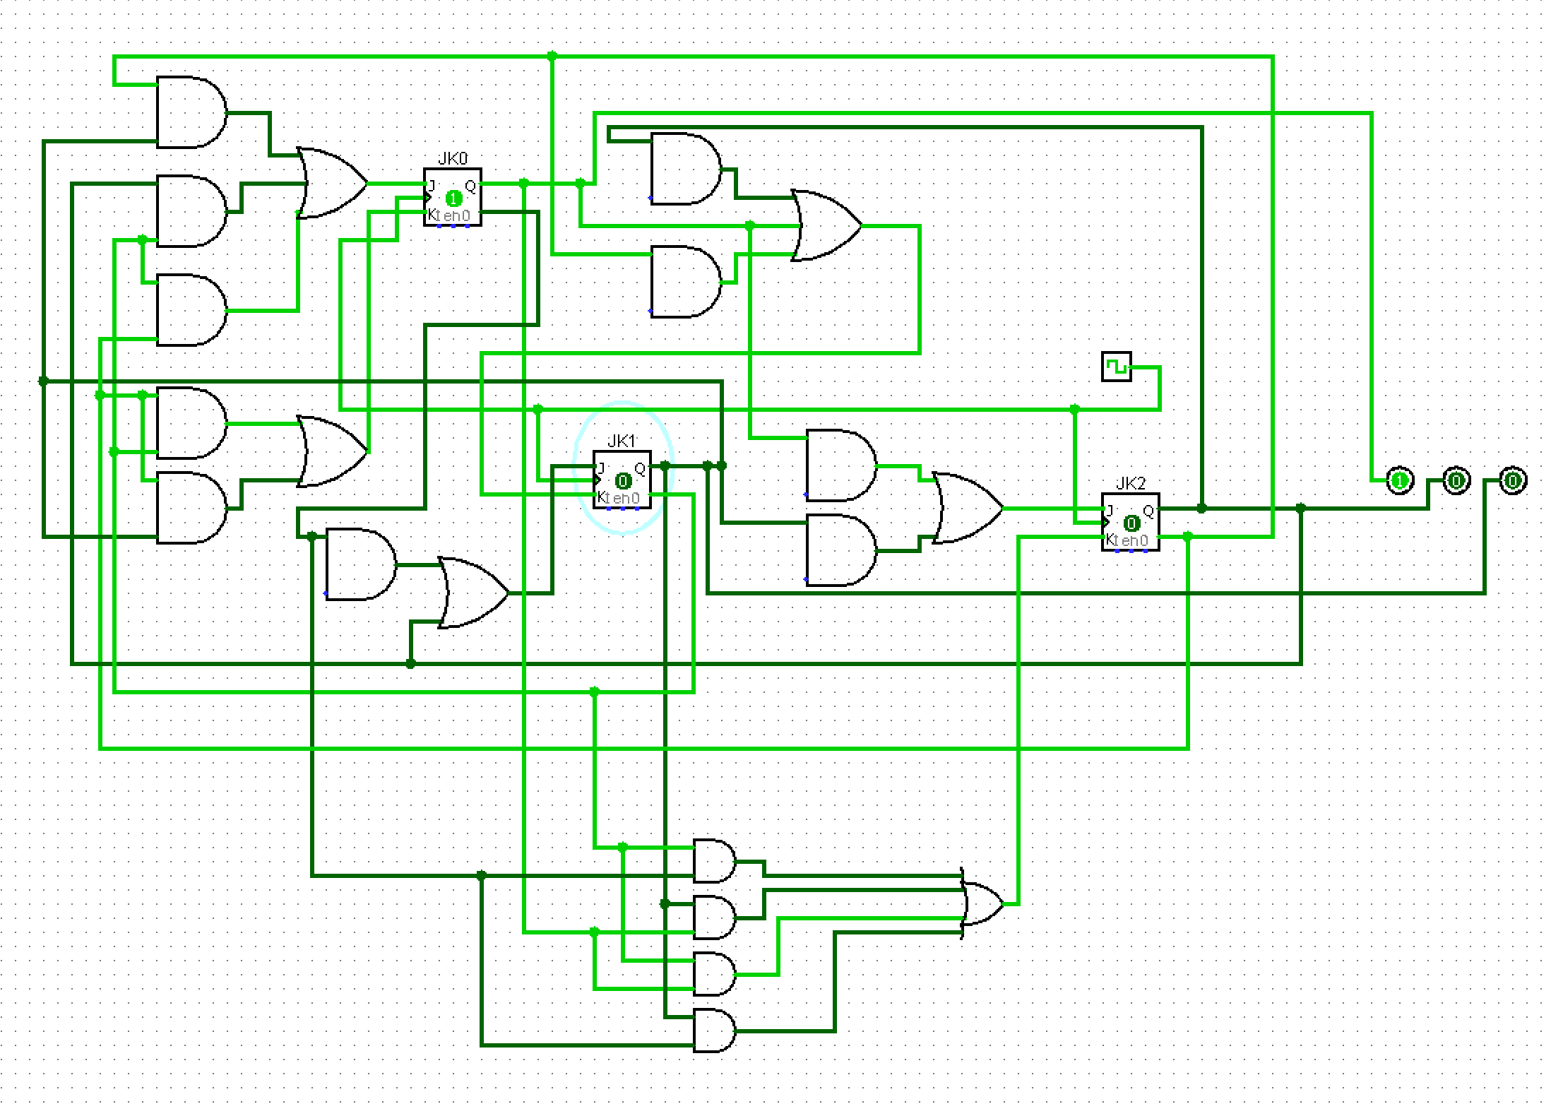

This are state: 0 => 1 => 7 => 5 => 3 => 4 => 6 =>2 => 0
0 => 2 => 6 => 4 => 3 => 5 => 7 =>1 => 0
forward Sequence T = 1

2
010

0
000

6
110

1
001

4
100

7
111

3
011

5
101

reverse Sequence T = 0
2
010
6
110

0
000

1
001

4
100

3
011

5
101

7
111

