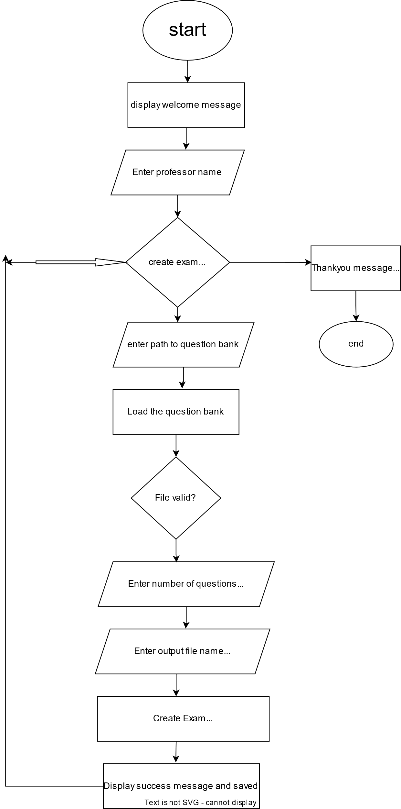
professor-assistant-exam-creation · PyPI

