ОТЛАДОЧНЫЙ ТЕСТ

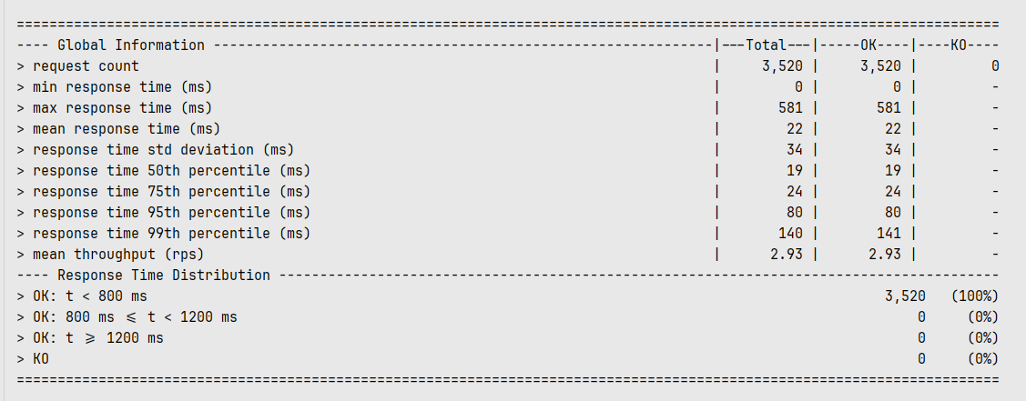

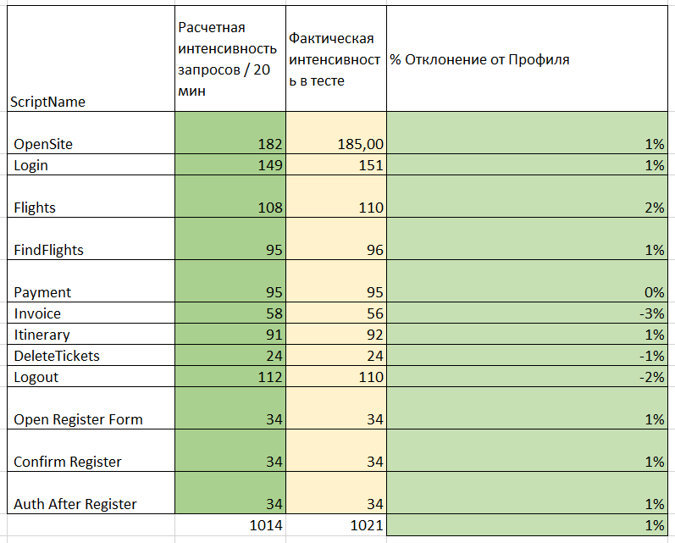

|  |  |  |  |
| --- | --- | --- | --- |
| ScriptName | Расчетная интенсивность запросов / 20 мин | Фактическая интенсивность в тесте | % Отклонение от Профиля |
| OpenSite | 182 | 185,00 | 1% |
| Login | 149 | 151 | 1% |
| Flights | 108 | 110 | 2% |
| FindFlights | 95 | 96 | 1% |
| Payment | 95 | 95 | 0% |
| Invoice | 58 | 56 | -3% |
| Itinerary | 91 | 92 | 1% |
| DeleteTickets | 24 | 24 | -1% |
| Logout | 112 | 110 | -2% |
| Open Register Form | 34 | 34 | 1% |
| Confirm Register | 34 | 34 | 1% |
| Auth After Register | 34 | 34 | 1% |
|  | 1014 | 1021 | 1% |

