

|  |
| --- |
| DevOps Lab  **CLoud Compute - GCP** |
| Account Basic Configuration  Home task |

## Task 1

It’s aiming to create own Google account and perform basic steps to billing configuration.

1. Register own Google account

( Use presentation as guide. or [codelabs: Open Account and Manage Billing and Projects](https://codelabs.developers.google.com/codelabs/gcp-aws-accounts-and-billing-v2/index.html?index=..%2F..index" \l "0))

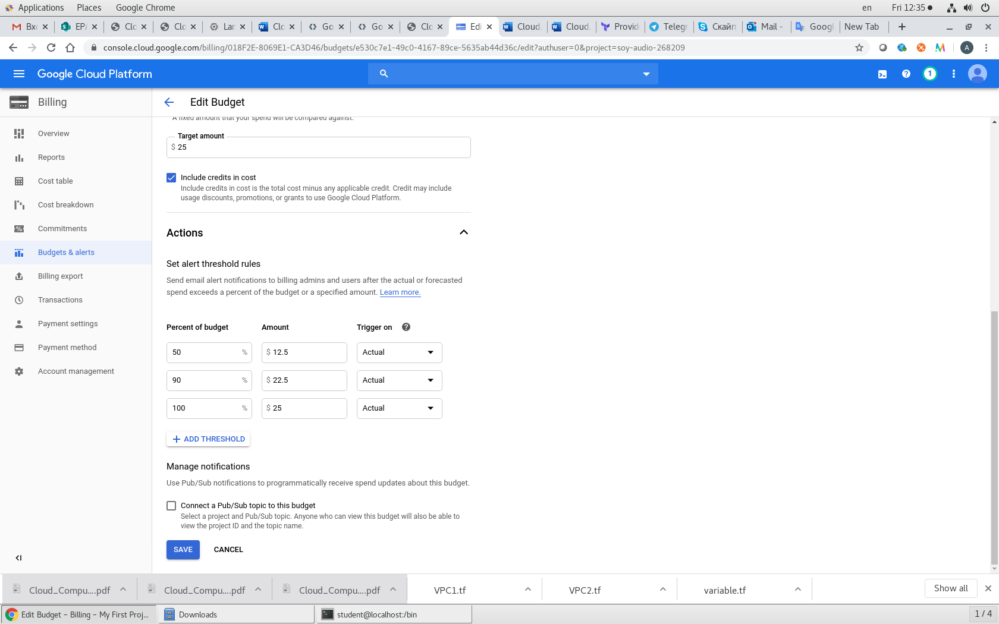

1. Activate 12 months free tier ( Use presentation as guide.)
2. Perform Budget configuration (Use presentation as guide or Pass this lab with own values [https://codelabs.developers.google.com/codelabs/gcp-infra-billing-administration/index.html?index=..%2F..cloud#0](https://codelabs.developers.google.com/codelabs/gcp-infra-billing-administration/index.html?index=..%2F..cloud" \l "0) )
3. Install and configure Google SDK( Use presentation as guide.)

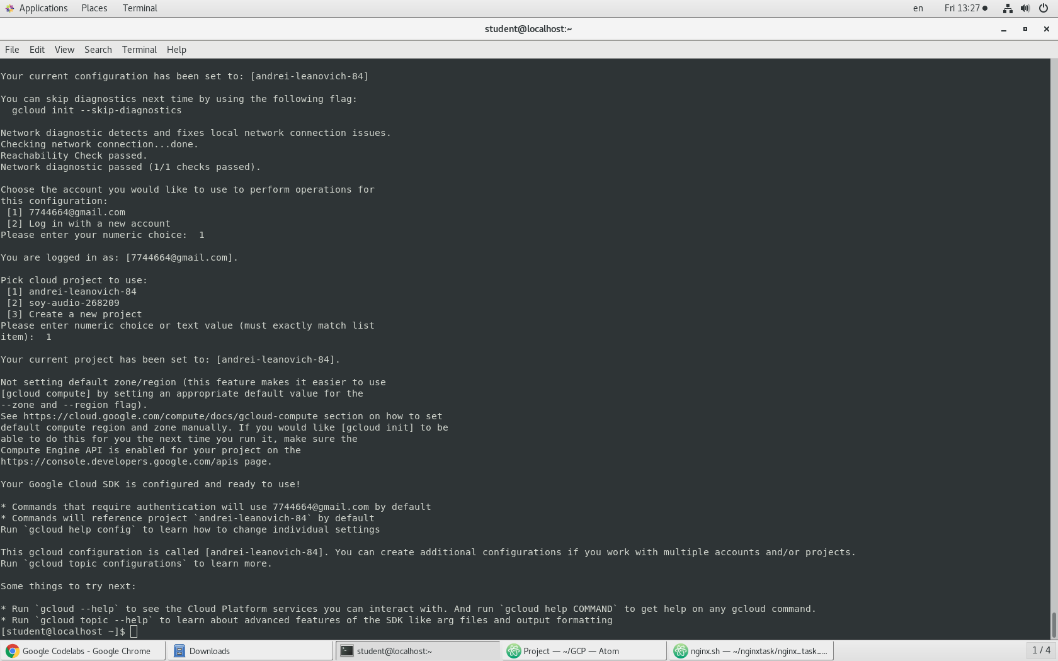

1. Complete the lab “Cloud IAM” [https://codelabs.developers.google.com/codelabs/gcp-infra-cloud-iam/index.html?index=..%2F..cloud#0](https://codelabs.developers.google.com/codelabs/gcp-infra-cloud-iam/index.html?index=..%2F..cloud" \l "0)

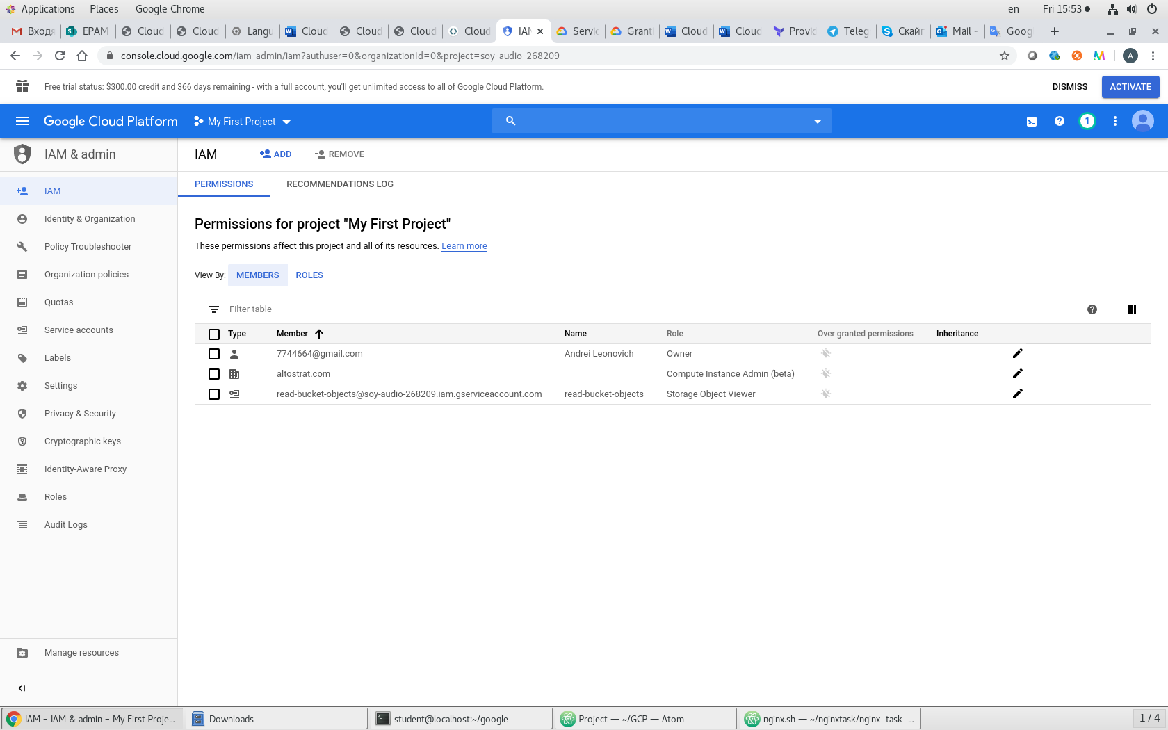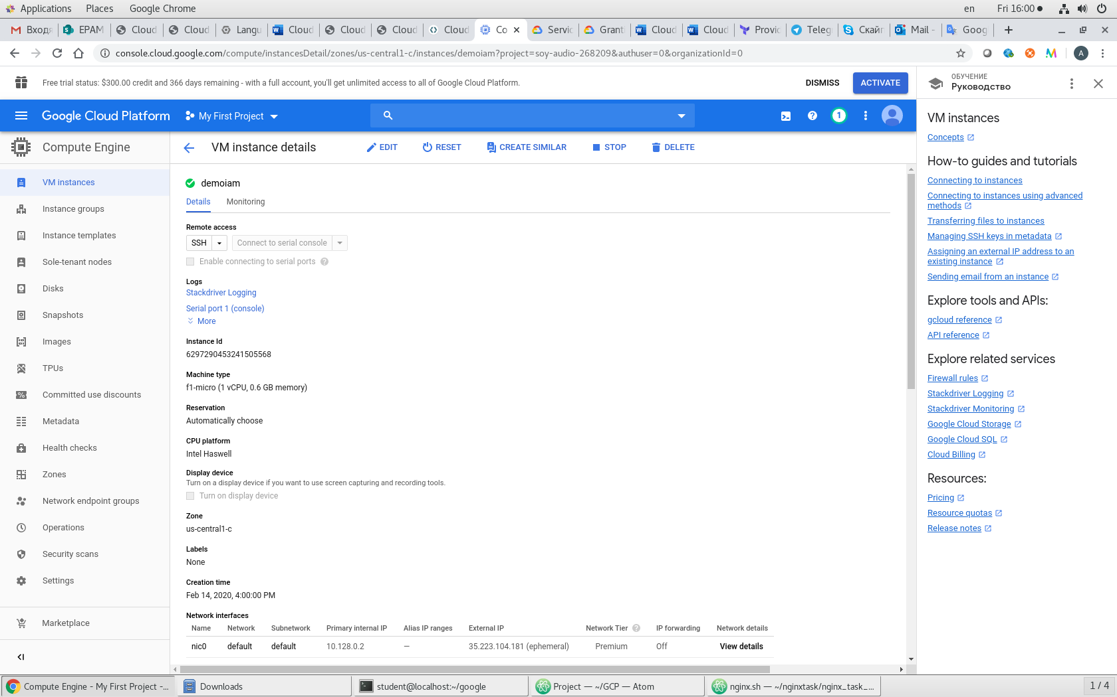

1. Create Service Account for Terraform( Use presentation or lab as guide.)
2. Configure terraform to access GCP via Service Account. ( Use presentation or lab as guide.)

provider "google" {

credentials **=** "${file("account.**json**")}"

project **=** "my-project-id"

region **=** "us-central1"

}

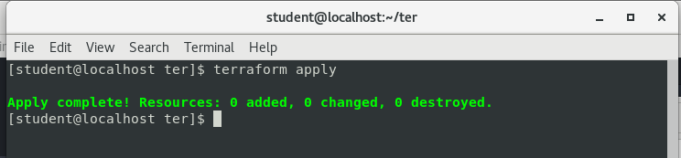

All **reports** please place into repository:

<https://github.com/MNT-Lab/google-cloud-module> into appropriate branches: *first char of name + surname*.

For example:

Student: Siarhei Ivanou

Branch Name: **sivanou**

Format: README.md

**Email pattern: [MNT-CD-8]-FirstName-LastName**

Email should contain the link to personalized branch.