

|  |
| --- |
| DevOps Lab  **CLoud Compute - GCP** |
| Compute: Virtual Machine creation  Home task |

## Task 1

It’s aiming to gain knowledge about the mechanisms of VMs creation in Google Cloud.

Create Virtual Machine in Google cloud by the following ways:

* gcp-ui (complete Lab: [google codelabs: VM creation](https://codelabs.developers.google.com/codelabs/cloud-create-a-vm/index.html?index=..%2F..index" \l "0))
* gcloud
* terraform (all settings should be provided via variables (tfvars), add URL (“http://IP. Address/” to output )

Virtual Machine Properties:

* InstanceName : nginx-${creation-way}
* Region: us-central1
* Zone: us-central1-c
* Type: General Purpose, n1, 1CPU 4.5GB RAM, Disk SSD 35Gb;
* OS: Centos7
* Allow http,https traffic
* Labels:
  + ServerType=NginxServer
  + OSFamily=RedHat
  + WayOfInstallation=${creation-way}
* The instance should be protected for deletion.
* VM should have the up and running Nginx (automatically provisioned after VM is started via yum, default configuration)
* The instance is running in **default** network

P.S.:

For **gcp-ui** way please use the following guide for reference:

<https://cloud.google.com/compute/docs/quickstart-linux>

First VM:

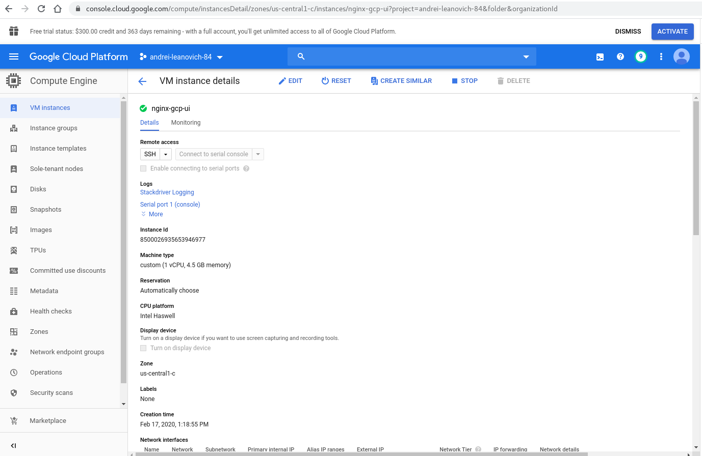

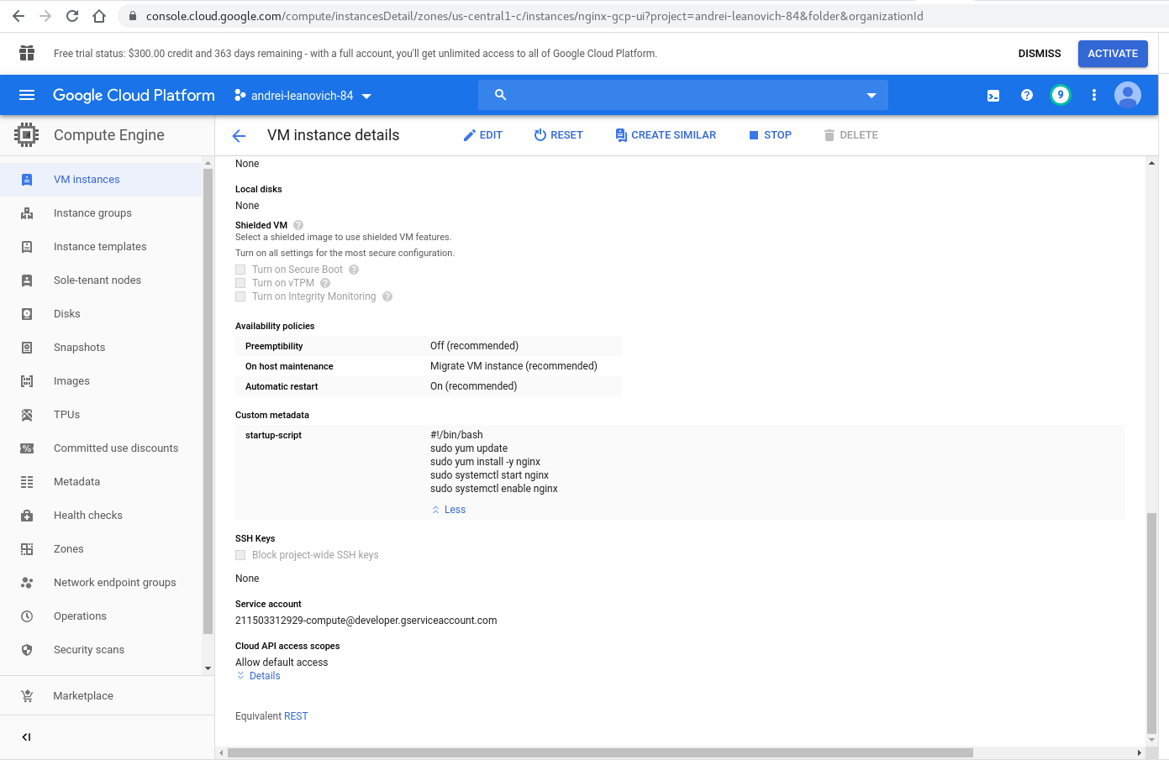

Run Nginx:

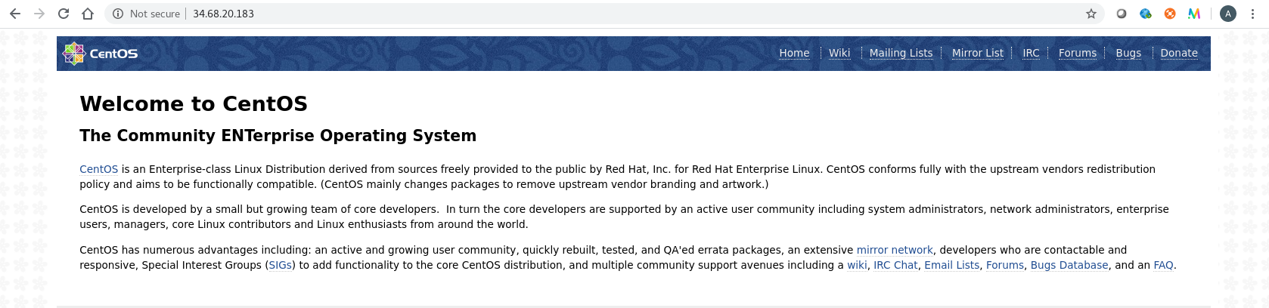

For **gcloud** way please use the following guide for reference:

<https://cloud.google.com/ai-platform/deep-learning-vm/docs/quickstart-cli>

Run VM with help gcloud



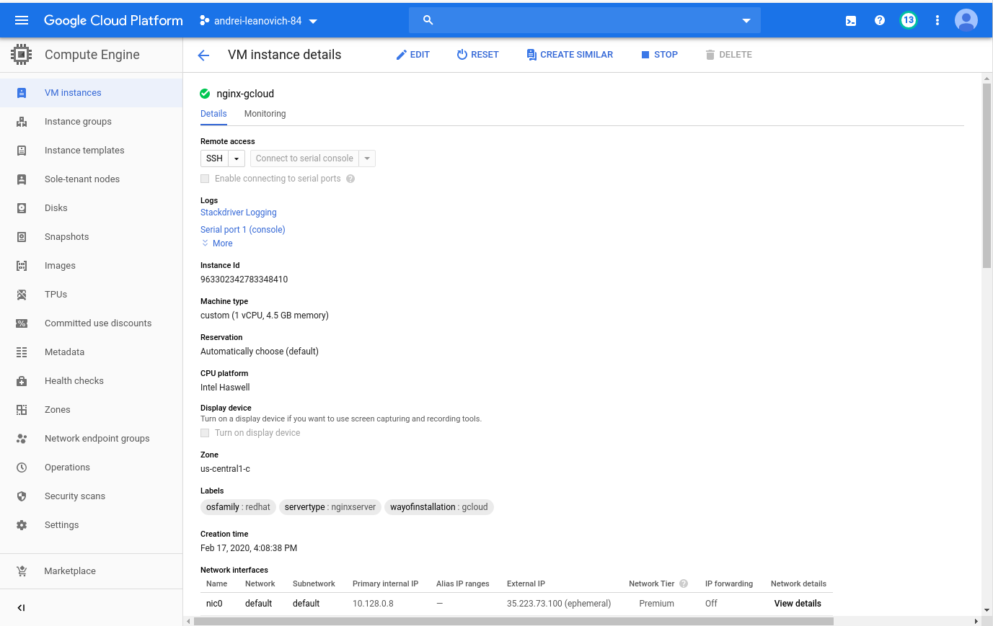

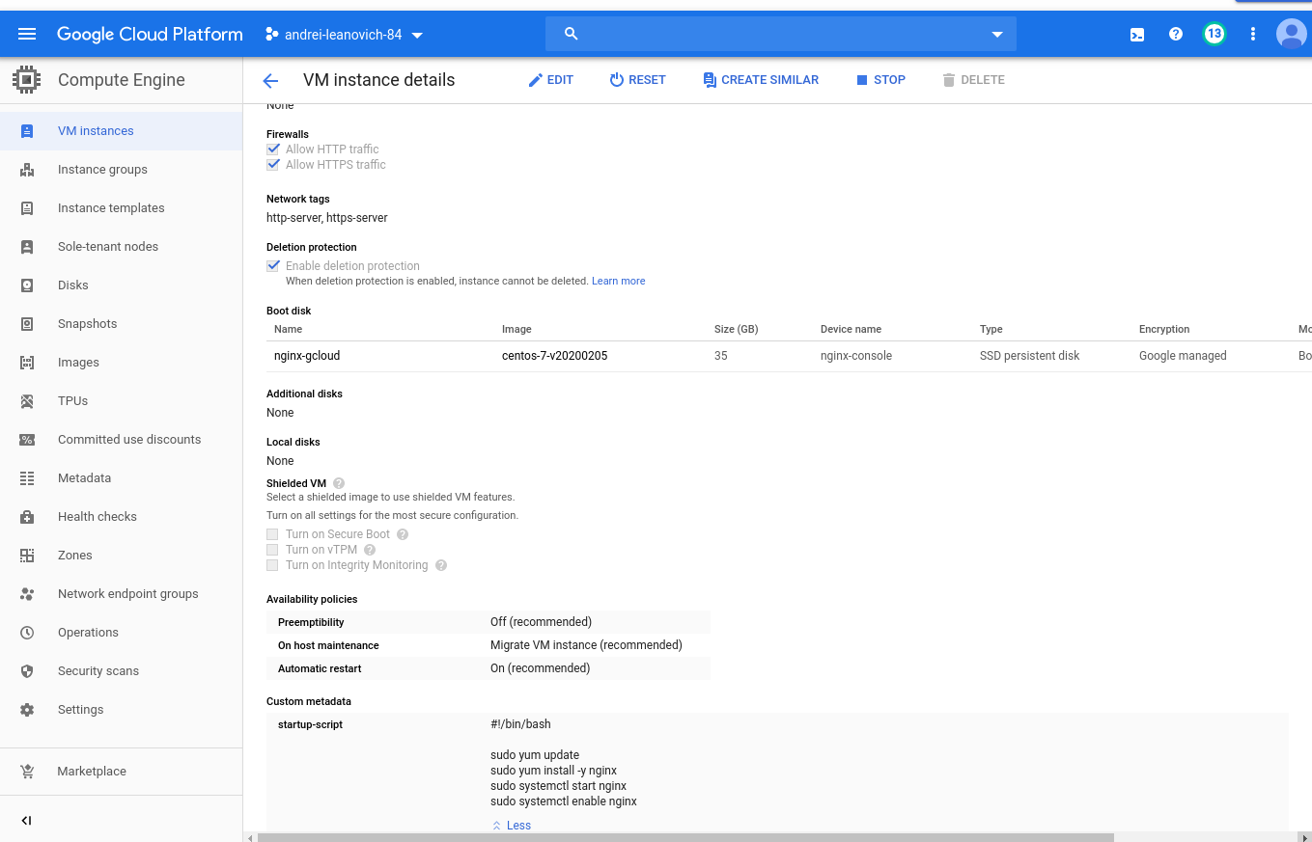

Run Nginx

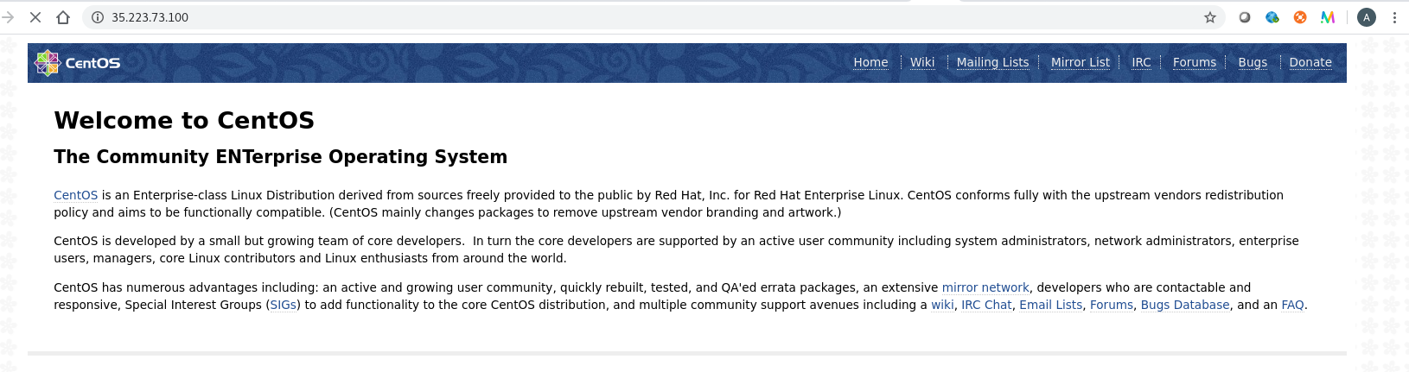

For **terraform** way please use the following guide for reference: <https://www.terraform.io/docs/providers/google/guides/getting_started.html>

<https://cloud.google.com/community/tutorials/managing-gcp-projects-with-terraform>

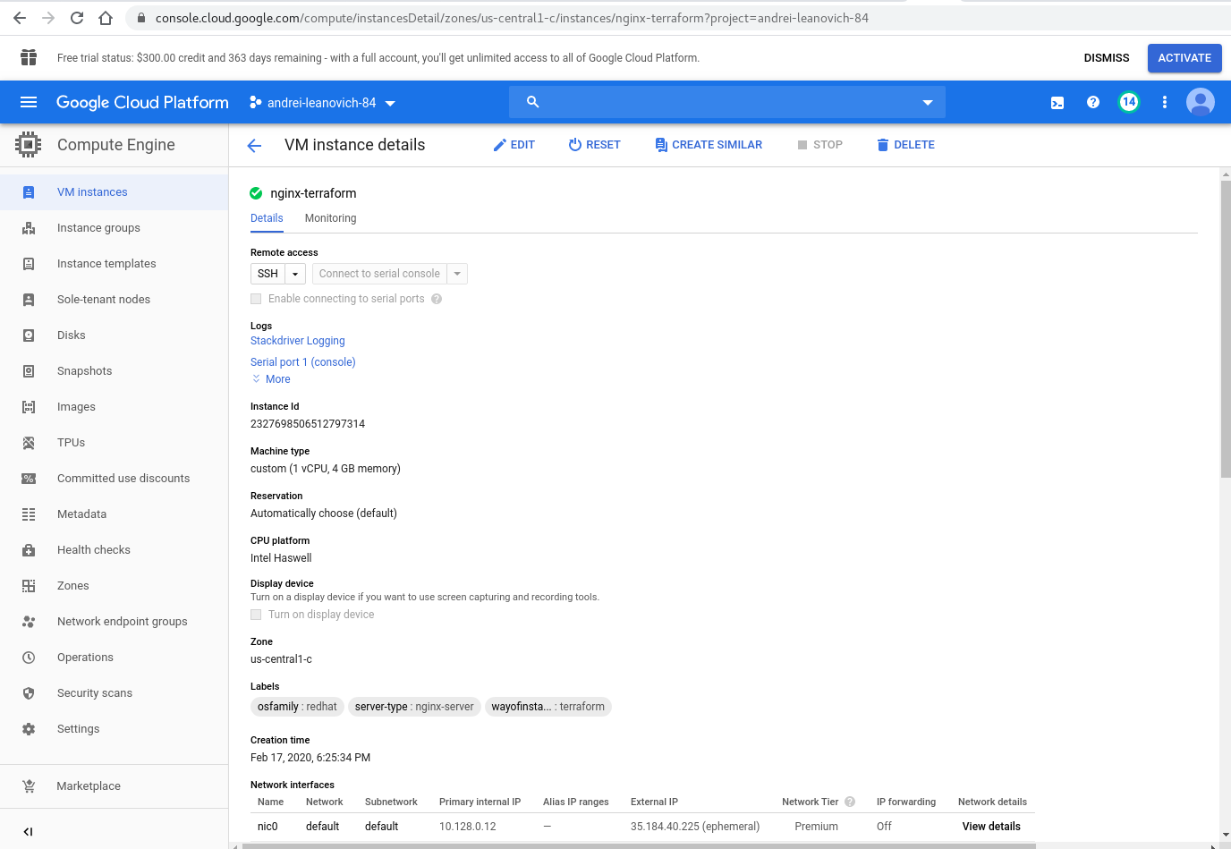

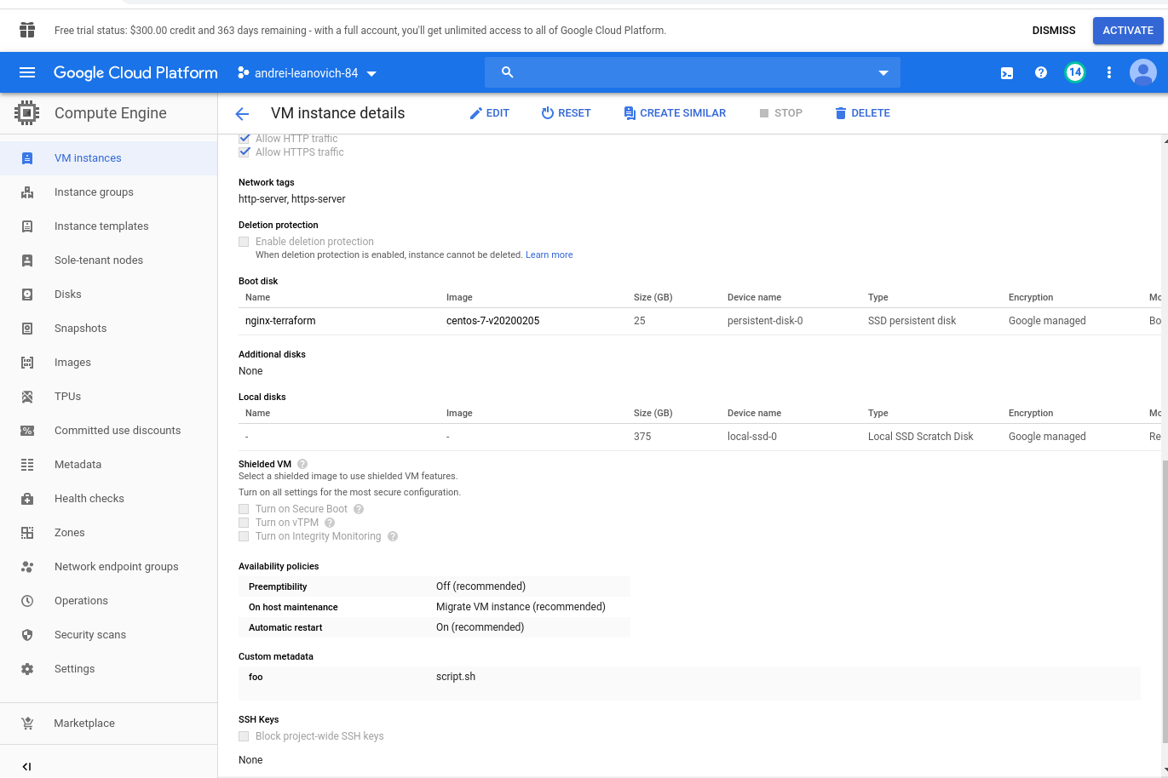

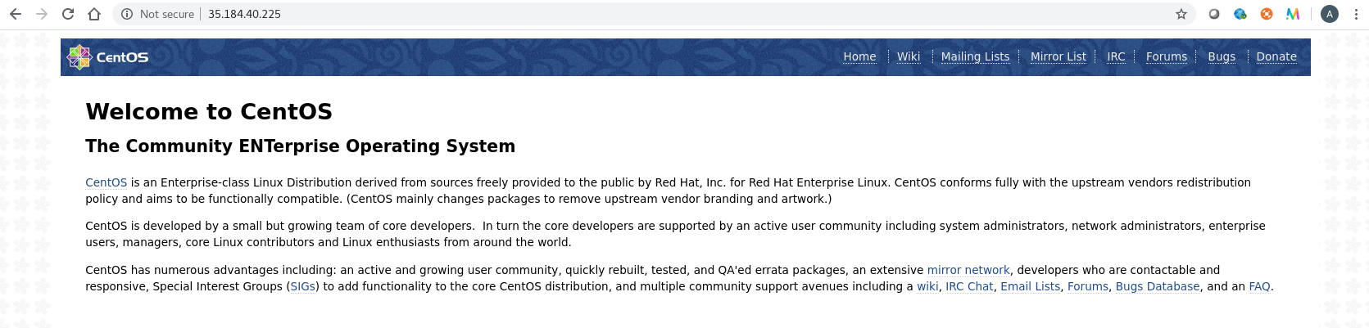

## Task 2

It’s aiming to gain knowledge about the mechanisms of Persistent disk creation in Google Cloud.

Create Persistent Disk and attach it to one of existing Virtual machine (nginx-gcp-ui).

1. Complete Lab [goolge codelabs: persistent disk](https://codelabs.developers.google.com/codelabs/cloud-persistent-disk/index.html?index=..%2F..index" \l "0) with using your VM name
2. Create terraform configuration to do the same via terraform (use VM: nginx-gcp-terraform).

**For reference**:

* [google_compute_disk](https://www.terraform.io/docs/providers/google/r/compute_disk.html)
* [google_compute_attached_disk](https://www.terraform.io/docs/providers/google/r/compute_attached_disk.html)

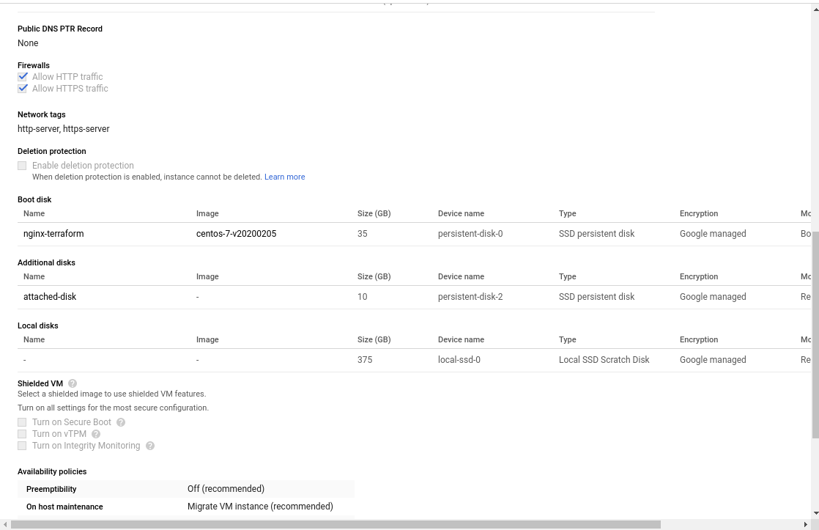

All **reports**/code please place into repository:

<https://github.com/MNT-Lab/google-cloud-module> into appropriate branches: *first char of name + surname*.

For example:

Student: Siarhei Ivanou

Branch Name: **sivanou**

Format depends on case: README.md/scripts/terraform files

**Email pattern: [MNT-CD-8.2]-FirstName-LastName**

Email should contain the link to personalized branch.