

|  |
| --- |
| DevOps Lab  **CLoud Compute - GCP** |
| NETWORKING  Home tasks |

It’s aiming to gain knowledge about Networking in Google Cloud.

## Task 1

Learn about two types of [load balancers in Google Cloud Platform](https://cloud.google.com/compute/docs/load-balancing-and-autoscaling" \l "network_load_balancing):

* a L3 [Network Load Balancer](https://cloud.google.com/compute/docs/load-balancing/network/)and
* a L7 [HTTP(s) Load Balancer](https://cloud.google.com/compute/docs/load-balancing/http/).

Lab Link: [codelabs: LoadBalancers](https://codelabs.developers.google.com/codelabs/cloud-load-balancers/index.html?index=..%2F..index" \l "0)

## 

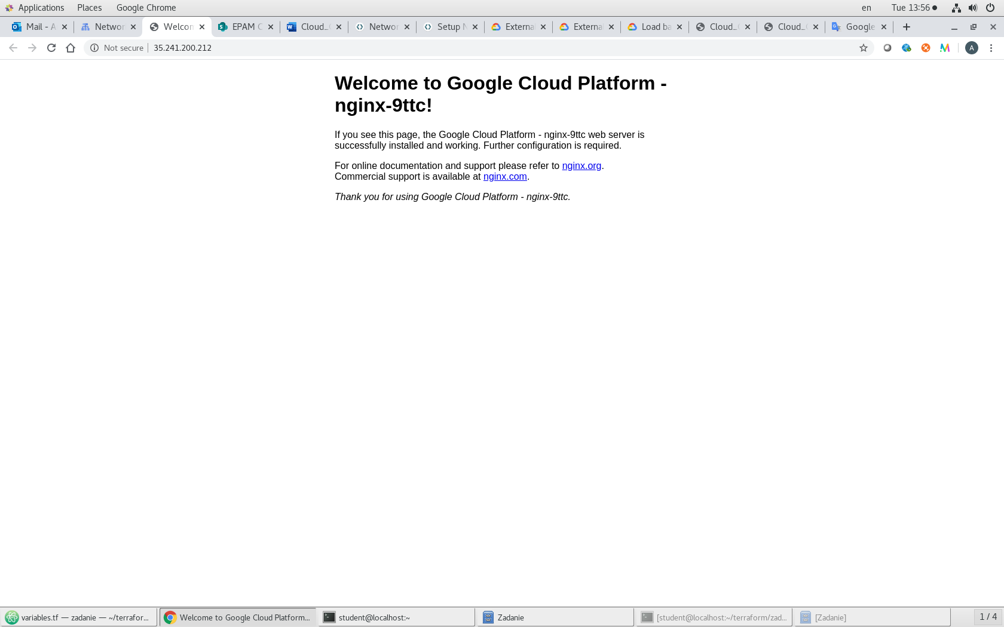

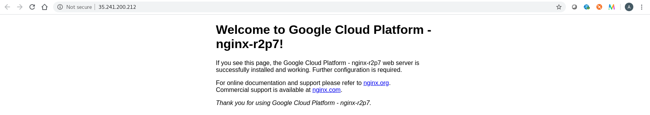

## Task 2

The Objectives are to learn:

* How to measure latency between Google Compute Engine [regions and zones](https://cloud.google.com/compute/docs/regions-zones/regions-zones)
* How to test network connectivity and performance using open source tools
* How to set up up basic firewalling to secure your networks
* How to set up a global HTTP Load Balancer with Managed Instance Groups to automatically scale your resources up and down based on request load
* How to test and monitor your HTTP Load Balancer setup

These exercises are ordered to reflect a common cloud developer experience as follows:

1. Set up your lab environment and learn how to work with your GCP environment.
2. Use of common open source tools to explore your network around the world.
3. Deploy a common use case: use of HTTP Load Balancing and Managed Instance Groups to host a scalable, multi-region web server.
4. Testing and monitoring your network and instances.
5. Cleanup.

Lab Link: [codelabs: Neworking 101](https://codelabs.developers.google.com/codelabs/cloud-networking-101/index.html?index=..%2F..index" \l "0)

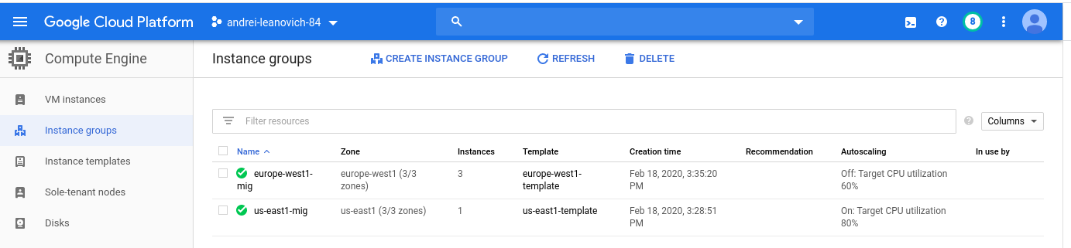



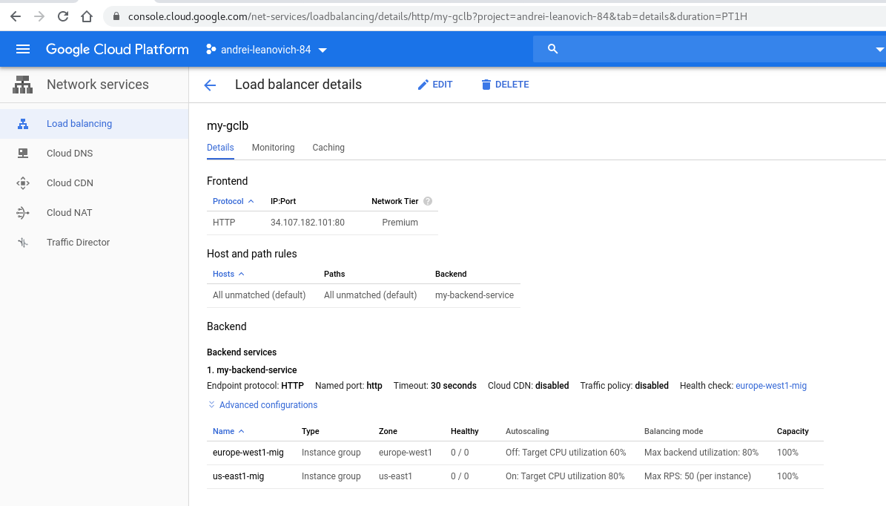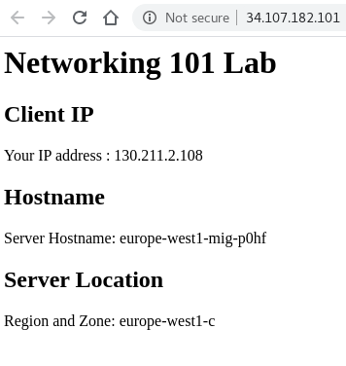

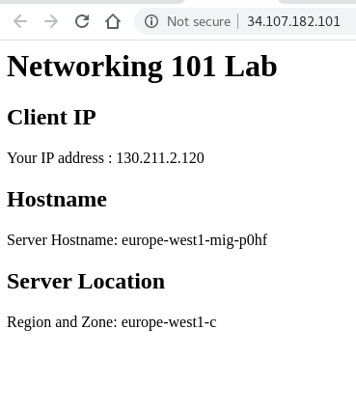

## 

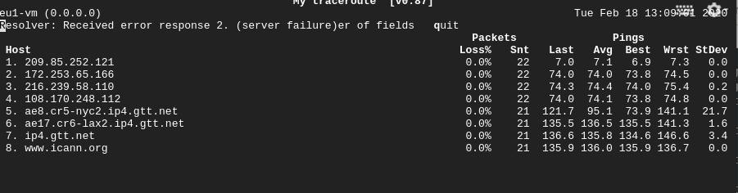

## Task 3

The Objectives are to learn:

* Setting up NAT gateways
* How to restrict network traffic that certain tiers of an app cannot talk to each other
* Setting up alternate connectivity options to instances
* Map an external service to look like an internal service
* How to setup an Egress proxy limiting access to specific resources

Lab Link: [codelabs: Neworking 102](https://codelabs.developers.google.com/codelabs/cloud-networking-102/index.html?index=..%2F..index" \l "0)

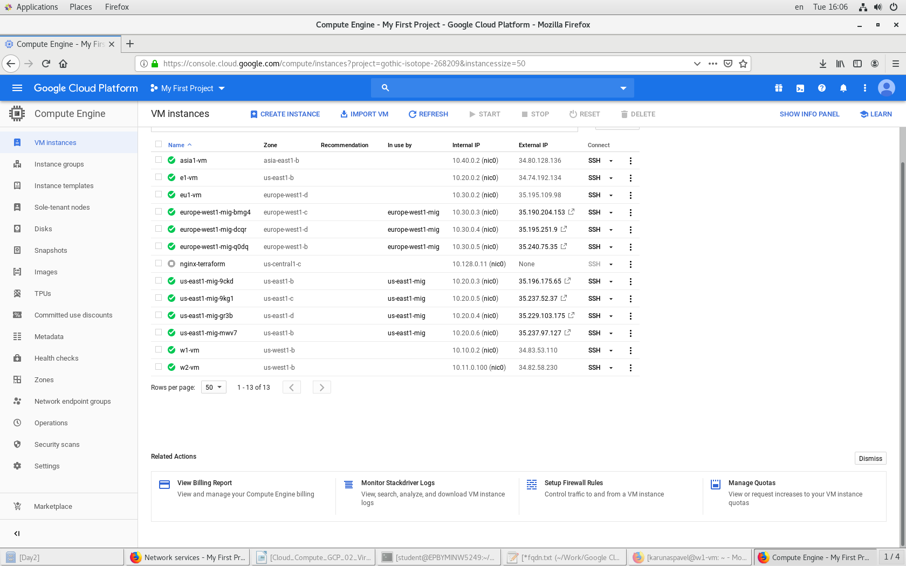

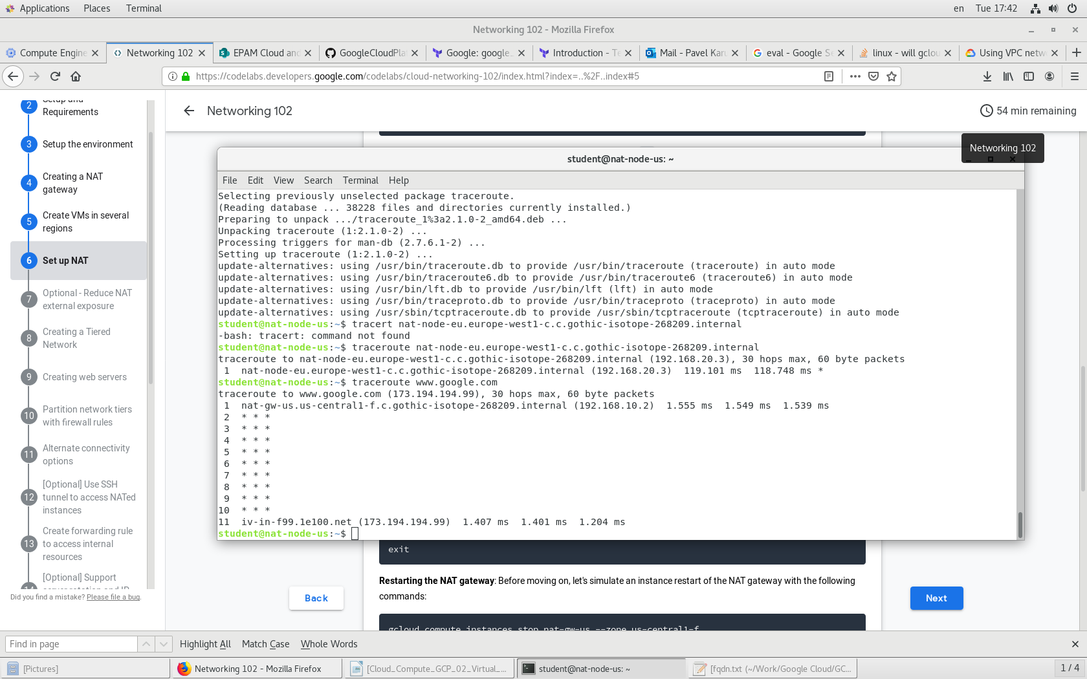

## 

## Task 4

The Objectives are to learn:

* Secure app in custom network

Lab Link: [codelabs: custom\_network](https://codelabs.developers.google.com/codelabs/gcp-aws-custom-networks/index.html?index=..%2F..index" \l "0)

## Task 5

Create network configuration via terraform.

Resources should be used:

* + - * 1. **google\_compute\_network** (to create network) <https://www.terraform.io/docs/providers/google/r/compute_network.html>

**Network name**: ${student\_name}-vpc

* + - * 1. **google\_compute\_firewall**

(to create rules for external (allow 80,22) /internal access (allow 0-65535) )

<https://www.terraform.io/docs/providers/google/r/compute_firewall.html>

* + - * 1. **google\_compute\_subnetwork**

<https://www.terraform.io/docs/providers/google/r/compute_subnetwork.html>

ranges:

* + - Public range: 10.”${student\_IDnum}”.1.0/24
    - Private range: 10.”${student\_IDnum}”.2.0/24

1. **google\_compute\_instance**

<https://www.terraform.io/docs/providers/google/r/compute_instance.html>

* + - 1. nginx with default page “Hello from ${student\_name}”

All resources should contain description (where it’s possible)

Network topology.

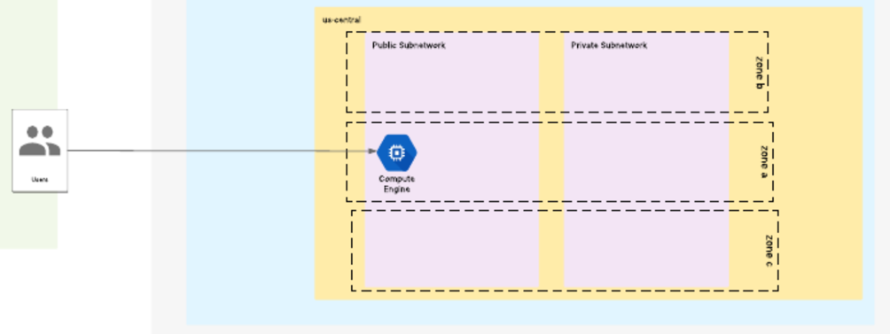

All **reports**/code please place into repository:

<https://github.com/MNT-Lab/google-cloud-module> into appropriate branches: *first char of name + surname*.

For example:

Student: Siarhei Ivanou

Branch Name: **sivanou**

Format depends on case: README.md/scripts/terraform files

**Email pattern: [MNT-CD-8.3]-FirstName-LastName**

Email should contain the link to personalized branch.